Paper #4551

Hydrogen from Steam/CO₂ Reforming of Waste
--- Renewable Biogas for Fuel Cells and Making Green Hydrogen

Richard M. Noling¹, David March², Terry R. Galloway¹, and Joe Waidl¹
1. Intellergy Corp., Richmond, CA, 2. Rockwell Automation, Charlotte, NC

Abstract:
This paper presents Intellergy’s method for producing hydrogen rich bio-syngas from a wide variety of renewable materials. The unique and patented technology, converts 85% of the mass to a highly pure syngas, suitable for direct connection with fuel cells, while the remaining 15% of the mass is converted to a carbon-enhanced PK fertilizer. During the process, all biohazardous waste are completely destroyed and heavy metals are reduced to a non-TCLP leachable state. Detailed thermodynamic data, clearly indicates that our unique steam reforming technology is the most thermodynamically efficient process for the conversion of renewable waste to green energy . Detailed financial analyses also show that the technology is also the most cost effective method for generating green renewable energy from waste. The unique mechanical design coupled with the patented technology renders most waste pretreatment, such as shredding, unnecessary, improving both ROI and carbon foot print. This technology has been operating commercially for the past decade processing medical and radiological waste and has a substantial track record of reliability and performance.

Motivation for Renewable Biogas
Intellergy’s patented technology is uniquely effective in addressing the global financial and regulatory pressure to reduce dramatically the volume of organic materials that have historically been waste generally going to landfill. In addition, the process destroys problematic streams such as organic byproducts from agricultural processors (canneries, wineries, etc.), agricultural producers (including dairies, livestock, stone fruit and nut growers, etc.) as well as biomass from urban green waste, sewage sludge, MSW and forest management. It converts these feedstock/organic streams into clean, “green” hydrogen without combustion and without depleting the earth’s limited fossil fuel resources. We are focused on the thousands of sites that have a year-round biomass problem.

Combined regulatory and financial pressure along with a general sense of environmental awareness among the general population have created an urgent need for Renewable Biogas especially by private and public utilities in order to meet their mandated renewables content requirements. Further, crop growers, waste haulers and sewage treatment facilities are under increasing pressure to clean up the way they handle and dispose of biomass/biowaste.

Syngas produced by our Steam/CO₂ Reforming of biomass qualifies as Renewable Biogas
(Note this syngas is Renewable since the Steam/CO₂ Reforming process is NOT fueled by natural gas). We can also co-produce green H₂ as well, without invoking reverse fuel cell operation as an inefficient electrolyzer.

The huge advantage of Renewable Biogas as well as Green H₂ is that it is fungible: that is it can be inserted into a customer’s natural gas or H₂ pipeline where it is generated and it can be removed as fossil natural gas or black H₂ from another pipeline location (even if discontinuous) receiving full renewable credits, as if totally green. This is the thrust of California’s new TREC program (Tradable Renewable Energy Credits). This is widely being used around the world and is now gaining popularity in the U.S. as sources of Renewable Biogas become commonplace.

Recently in California, the Administrative Judge (1) blocked PG&E and SCE from buying electricity from Bloom Energy’s (2) SOFCs as green electricity to the grid when these new fuel cells are fed by fossil-based natural gas. This is an urgent driver for having renewable biogas for driving fuel cells so they can qualify for making green power for our grid. But suppliers of green hydrogen can buy SOFC fuel cells [such as Bloom Energy’s (2)] and operate them on their green syngas produced from biomass to co-produce green electricity and some green hydrogen from the anode off gas as well. Co-marketing by Intellergy and SOFC suppliers, therefore, is an attractive opportunity to supply the green electricity the utilities desperately need. Our syngas is essentially free to these SOFCs when their target capital price drops to their projected $700/kW. So this is a natural complement with our process.

Overview and Process Schematic:
This paper focuses on the steam/CO₂ reformation of biomass (dairy feedlot manure, livestock waste, stone fruit, urban green waste, sewage sludge, MSW and forest management slash) into syngas for use in a fuel cell, to generate electricity, and heat, and to generate clean green renewable hydrogen. Steam reformation is a technology that has been practiced for many years by Intellergy to convert various forms of waste to gas (3-11). The technology, developed, patented and licensed by Intellergy, has been used for a decade to steam reform pharmaceutical waste in the U.S. It has also been used to steam reform nuclear waste, (again, developed and licensed by Intellergy) and tests have been performed on agri-biomass, medical waste, municipal solid waste, and astronaut community waste (for NASA). In addition, this technology is the only one that is approved by the California Department of Health Services to destroy the top 9 most harmful bacteria and viruses. The chemistry used does not involve combustion. To reinforce this, EPA has issued Intellergy a letter stating the technology is NOT incineration. This is very important for the environmental community and for public acceptance of the technology. Basically, the process reacts the waste with superheated steam in the absence of oxygen and the waste turns to a hydrogen-rich syngas. The gas is then purified and cleaned to extract the hydrogen for use in fuel cells or as a transportation fuel.

For pure biomass, the Intellergy system avoids the need to field-spread, or to use landfill for disposition. Our technology also produces a valuable fertilizer by-product (fifteen percent of the waste is converted into a clean sterilized carbon-enhanced phosphorus-potassium (PK) slow release fertilizer pellet product. The Intellergy system also controls greenhouse gas emissions, by capturing and reusing the CO₂ from the fuel cell anode, and by condensing the water vapor that is a by-product of the fuel cell, thus resulting in an extremely clean environmentally-friendly process.

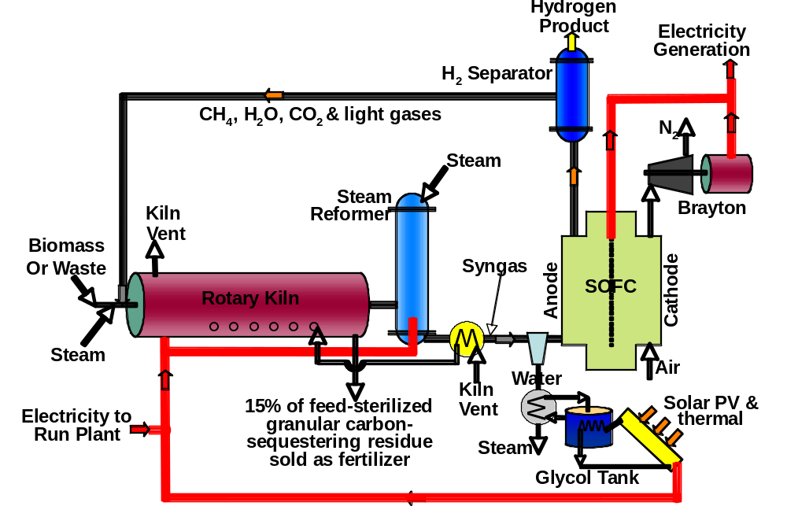
The fuel grade hydrogen produced from this proprietary technology (typically over 60% of the syngas) can power vehicles, trucks, and farm machinery to help achieve clean distributed transportation fuel with only condensed water as the exhaust. In fact, there are now several companies manufacturing hydrogen engines that can be used in farm vehicles and equipment (see Hydrogen Engine Center, www.hydrogenenergycenter.com) and hydrogen-fuel cell charged hybrid-electric trucks (www.visionmotorcorp.com). As a result of the process, the biomass source of the syngas is turned from an environmentally damaging waste into a sustainable, modular, distributed, and clean fuel.
Figure 1: Waste Reforming Process Schematic

Figure 1 shows that the technology consists of three primary assemblies. The feeder assembly accepts a combination of liquid slurry and solid biomass. The biomass is transferred to the next assembly, a rotating indirectly-heated kiln in which the waste conversion chemistry begins. As the steam-reforming chemistry starts to vaporize organic liquids and gasify organic solids within the kiln, temperatures are raised and superheated steam and CO₂ are added. Finally, at temperatures of 1,900 degrees F to 2,100 degrees F, the remaining residue is detoxified and reduced to a solid safe carbon-rich PK fertilizer product.

The fuel cell interface is another feature adding to the success of the project and so the choice and fit of the fuel cell technology chosen is deemed very important. High temperature fuel cells come in two versions; molten carbonate, and solid oxide. In our case, for a number of reasons, we prefer solid oxide fuel cells. Paramount among these is that they are capable of being stopped and started easily and frequently, as needed. For the fuel cell component, Intellergy has teamed with proprietary solid-oxide fuel cell (SOFC) technology which has been commercialized. Incentivized by DOE’s SEQA program, the special SOFC captures the CO₂ from their fuel cell anode. We like this because it provides the hot CO₂ we inject into the system, and because it nearly eliminates this greenhouse gas emission from the system. The increased mass production of syngas as a result, can be used to create more electricity and fuel.

The technology is designed with advanced process controls and monitoring. The control system achieves high levels of safety demanded by operators. The operation is highly automated and includes distributed process controllers, fail-safe circuitry logic, redundancy, on-line process modeling, and error checking. Operator errors are minimized by a menu-driven system and all technology functions are monitored from an off-site support center which identifies and tracks critical operating data 24/7 and supports the customer.

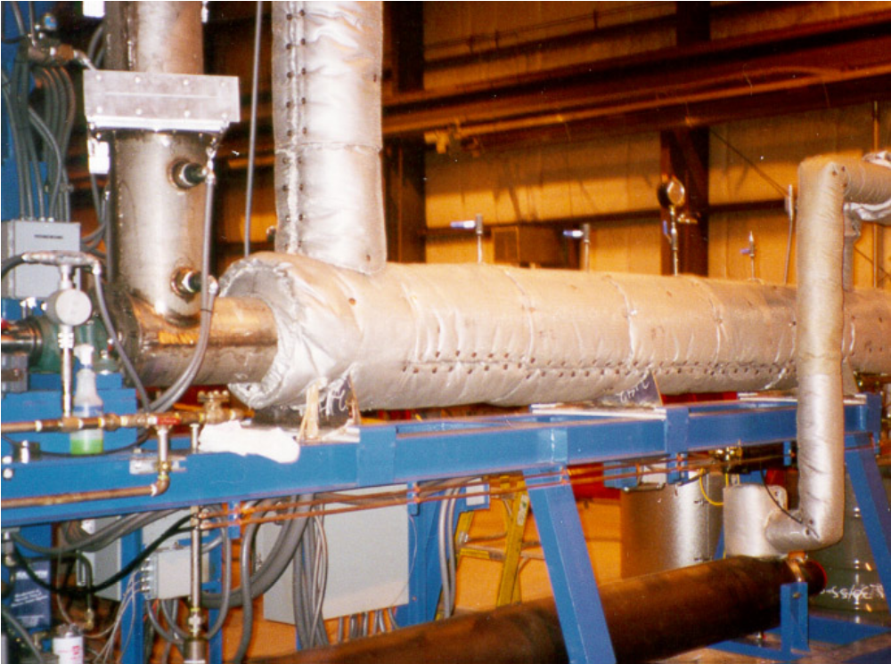
Figure 2: Commercial Steam Reforming Kiln with 2 tons/day Capacity

Our technology also automatically monitors all operating parameters, including feed flow and chemistry, pressure levels, heat exchanger, turbine, vessel walls, adsorption bed, core temperature, gas content, process chemistry, and vent emissions. In addition, a fully automated on-line, real-time chemistry monitor checks critical emissions, reducing environmental health risks to very low levels or eliminating them entirely. In the event that any parameter falls outside of a narrow range, the automated process controller notifies the operator and the support center is contacted. The technology automatically shuts down if the problem is not fixed within five minutes.

Further, the technology checks biomass feed composition to prevent operator error or deliberate abuse such as processing hazardous materials or processing under conditions not previously approved. Each waste type has an optimal set of operating conditions and a characteristic operating “fingerprint” stored in the system. The system continually checks the feed’s chemical composition, the process selection, and the facility’s own waste identification; if there is any error, treatment is stopped.

At the same time the biomass is converted to syngas to make green hydrogen and electricity, the process also co-produces a carbon-enhanced, Phosphorus-Potassium (PK) fertilizer slow release pellet. Plant growth is enhanced by active carbon associated with or contained in the slow release fertilizer pellet.

Recent Pilot data
A number of pilot runs have been made to demonstrate that Intellergy’s Steam/CO₂ process can handle a variety of biomass feedstocks as follows:
  - Agri-biomass – winery pomace
  - WWTP Biosolids
  - MSW (i.e. Medwaste)
  - Poultry bedding
  - PK Fertilizer sequestering carbon (slow release pellets)

Making Renewable Biogas is nearly independent of type/source of organic feedstock. We illustrate these with the first biomass consisting of agri-biomass from the wine industry consisting of winery pomace.

There are hundreds of chemical reactions going on in our process. The understanding is simplified, however, by looking at the few main chemical reactions. They can be considered to be chemical reduction, occur from the kiln through the final reformer reactor and are as follows:

C_{a}H_{b}O_{c}+ d CO₂ + (a-c-d) H₂O ----> (a+d) CO + (a+0.5b-c-d) H₂
elect. heat
C + H2O => CO + H2
C + CO2 => CO + HEAT
H2 + CO2 ⬄ H2O + CO
C + 2H2 => CH4
....etc.

Note that this top reaction specifies a particular molar quantity of CO₂ and steam, depending on the atomic make-up of the feedstock as specified by the empirical formula, C_{a}H_{b}O_{c}, which is quite different from common practice. This amount of steam and CO₂ critically needed to completely convert the organic compounds to H₂ and CO depends on the atomic composition of the feedstock. Some Examples:

- C₅H₂O₂ represents coal at 80% by mass carbon
- C₅H_{6.6}O_{2.7} represents crops at 54% carbon
- C₅H_{9.2}O_{4.6} represents cellulose at 44% carbon

Therefore it can be seen that manure and cellulose have considerably more hydrogen and oxygen than coal.

The steam/CO₂ reforming is optimized to produce >99.99% conversion in a specially-designed steam reforming reactor. For nasty feedstocks the total system Destruction and Removal Efficiency, DRE, is even greater than that achieved in this reactor. The reactor produces a clean gas product sufficient to meet the tough federal and state air emissions requirements of California. For feedstocks containing high halogen levels or sulfur, the addition of caustic or lime to the kiln is used to remove the acid gas components. Typically NOx is not an issue since air is not used, and the chemistry is reductive. The syngas composition is shown with the conventional substoichiometric quantities of steam added to convert the animal feedlot waste feedstock as follows:
Figure 3: Traditional Steam Reforming
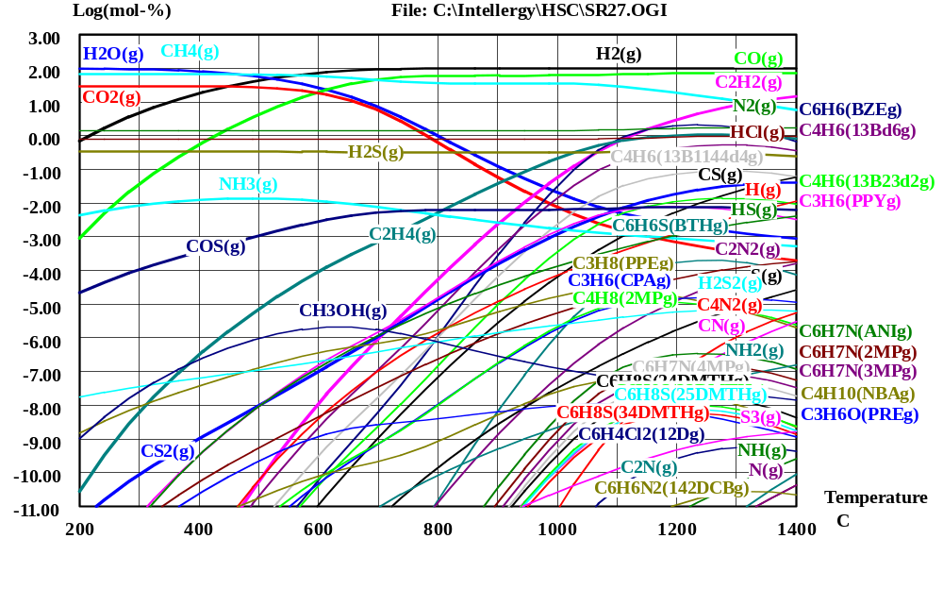

The ordinate (y) axis is log-scale of the composition in volume percent, with 2.0 being 100% and 1.0 being 10% and so on, downward. At –4.00, this represents one part per million or ppm. The abscissa (x) axis represents the temperature of the steam reforming reactor. The two lines at the upper right of the diagram show hydrogen at the highest and just under that of carbon monoxide, CO. The other species are shown as legends for each of the curves. Note that compounds such as benzene (C₆H₆), acetylene (C₂H₂) and ethylene (C₂H₄) are between 1 and 0.1% and are high enough to be objectionable in the product syngas formed by conventional steam reforming. If long residence times are provided and graphitic carbon is kinetically allowed to be formed, these contaminants are lower, but unfortunately are replaced with the problem of carbon soot and carbon deposit formation that fouls and blocks process equipment. Adding more steam will improve the situation, but will cost more for the added steam and require a license (i.e. from EnergySolutions).

A much preferred approach, however, is to maintain the low steam levels (substoichiometric) to help the economics and recycle the very hot carbon dioxide (CO₂) from the hydrogen production steps. This approach will help the chemistry and supply additional endothermic heat to enable the steam/CO₂ reactions to be accomplished. In this way, the chemistry is still substoichiometric in steam, but is superstoichiometric in total reactants of steam and CO₂ combined. In the figure below, the improvement in the quality of syngas is greatly increased.
Figure 4: Intellergy Optimized Steam/CO₂ Reforming

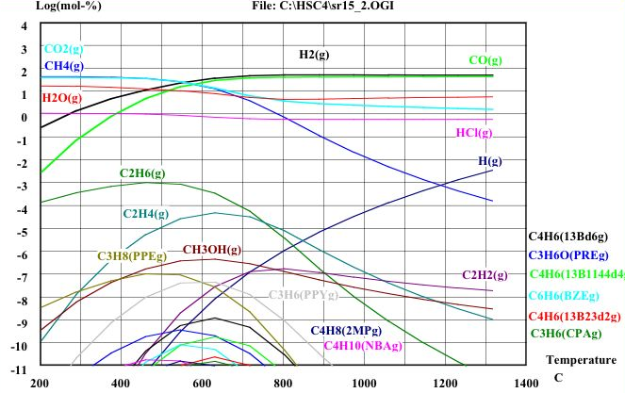

Note that the objectionable contaminants of benzene, acetylene, ethylene, etc. are reduced between one million to one billion times. Acetylene is now at desired parts per billion levels. Note also that CO₂ is being consumed and converted to more syngas. This new chemistry using superstoichiometric combined reactants of steam and CO₂ now allows Intellergy to practice its own, proprietary chemistry. Intellergy has been awarded basic chemistry patents (U.S. Patent No. 6,187,465, 7,132,183, 7,220,502, 11/636,930) plus foreign patents to provide very strong intellectual property protection to the company.

The above chemistry is initiated in the kiln and continues to very-near completion as the gas temperature increases through the system into the final reformer reactor where the reaction is completed with additional superheated steam. The residence time in the steam reformer of one second is entirely at the elevated, nearly isothermal conditions. Unlike combustion technologies, there is not the very brief exposure to high temperatures typical of an incinerator flame region.

With this steam/CO₂ chemistry, biomass waste conversion to green hydrogen is viable and avoids using landfills. Further, handling the feedstock in this manner also produces recyclable materials. Intellergy’s steam/CO₂ reforming provides syngas for hydrogen production, electrical power, steam, hot water, space heating, space cooling, potable water, and other materials, or for transportation fuel. The syngas also provides the raw material for small chemical plants to synthesize useful chemical co-products (not burned in their life-cycle), thus avoiding the release of large quantities of problem greenhouse gases into the environment.

Intellergy has selected a unique set of suppliers of the patented process equipment used to steam-reform feedstock to produce syngas of low organic content and clean it for hydrogen production or for fuel cells. Intellergy (www.intellergy.com) will provide its patented process for its customers for controlling their greenhouse gas emissions, like carbon dioxide, methane, and other substances through the integration of the steam-reforming of feedstock with the production of energy and production of carbon-containing commercial co-products that are not burned in their life-cycle.

The syngas produced from this proprietary technology (hydrogen is typically near or over 60% of the syngas as shown in Table 1 below for typical agri-biomass:

Table 1 Syngas from Agri-biomass
Component Volume Basis
Hydrogen | 59.4 %
Oxygen + Argon* | 0 %
Nitrogen* | 0 %
Carbon Monoxide | 32.4 %
Carbon Dioxide | 2.96 %
Methane | 5.1 %
Ethane, acetylene, ethylene | 570 ppm
Propane | 98 ppm
Butanes | 60 ppm
Benzene | 198.4 ppm
C7 and above | 380 ppm
Hydrogen Sulfide | 59.8 ppm
Carbonyl Sulfide | 1.74 ppm
Methyl Mercaptan | 16.6 ppb
Carbon Disulfide | 35.3 ppb
*Air leakage corrected for.

Intellergy Corp.’s steam reforming chemistry is at elevated temperatures so that feedstock containing bio-toxic organisms is completely detoxified over a million-fold as shown in Table 2 below. The converter is heated electrically, eliminating fuel combustion particulates that adsorb products of incomplete combustion (PICs) and produce fly ash. The technology produces no problematic dioxin, furans, or NOx emission levels as do incinerators. Vent gases are non-toxic CO₂ and H₂O. In addition, the absence of fuel and oxygen reduces the explosive potential of a volatile chemical mix.

TABLE 2 DESTRUCTION OF BIOTOXIC ORGANISMS
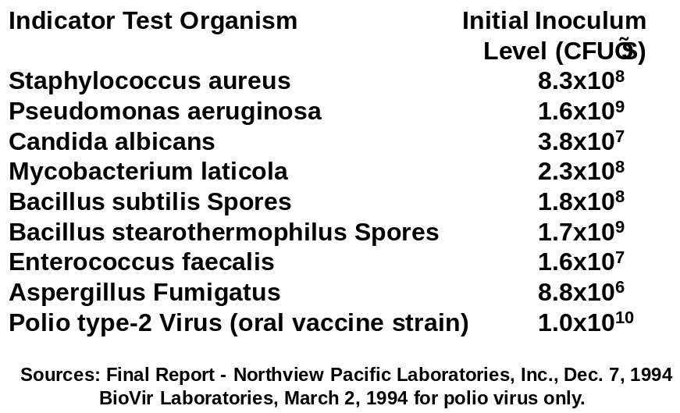

Carbon Sequestration:
It is likely that green CO₂ (i.e. “Renewable CO₂”) would qualify for this kind of beneficial transferable renewable energy credits (TREC) environmental treatment as well as our green hydrogen, since it would displace CO₂ obtained from polluting fossil sources.

We have multiple approaches for sequestering carbon for lucrative credits:
[1] We permanently sequester 10 to 12% carbon now for what we have seen with our "fertilizer product" coming out of the kiln at 15%wt of feed. Therefore with a renewable biomass feed-stock, we are carbon negative.

[2] Process simulation suggests that we can increase our CO₂ recycle from pilot demonstrated 20% and raise it up in increments toward 70%. At some point the blower cost, electric load, and process equipment and piping sizes will start to affect the economics. We believe there will be an optimum amount of carbon sequestration given the carbon credits available to us or EPA penalties for CO₂ emissions that MAY come in this year.

[3] For our larger plant installations over 200 tpd, the liquid CO₂ or Dry Ice operation will become economic. The compressor loads of 170 kWe/ton are large so that an inexpensive source of electricity is needed locally, such as from waste heat recovery or future attractively priced SOFCs.

[4] With SOFC fuel cells (or even MCFC, if FuelCell Energy would accept syngas) we can generate electric power and heat with 78 to 50% CO₂ emission reductions over conventional power generation practice.

[5] Algae consumption of our CO₂ is being considered by one of our teams.

Our making more carbon-rich fertilizer and interfacing with Fischer-Tropsch is attractive, if cap and trade happens or a simple carbon tax at the carbon source generation. Even making dry ice and displacing fossil carbon sources is attractive at sizes 200 tpd or larger.

Plant Configuration Options
There are number of plant configuration options depending on what green eco-products that are desired and electricity output needed as follows:
  - Green H₂ and PK Fertilizer
  - Green H₂, fertilizer, and electricity (realtime selectable)
  - Green H₂, fertilizer, and Green CO₂
  - Green H₂, fertilizer, Green CO₂ and electricity (realtime selectable)
  - Brayton Cycle (without burning) versus SOFC generating of electricity and cogen heat
The scale of the plant is only driven by the economy of scale of the CO₂ production, which requires a production level over over 200 tpd of liquid CO₂ to be economic.

Economics
We have done many proforma studies for a variety of our potential customers without environmental incentives, since today many are skeptical of any dependence on such incentives. These incentives may go away as the result of unpredictable changes in governmental policy, as recently shown well by the corn-ethanol plants being closed down from failing economics without incentives. It is true that there are enhanced proforma economics with a long list of environmental incentives varying across the U.S. and around the world, but they are not needed today because of the very strong demand for green hydrogen from biomass. Although we do not include incentives in our projections, we intend to aggressively exploit any incentives available to us. We do not include them in projections as it would be unwise to come to depend on them.

Included below is an analysis of a 20 dry ton per day unit with four different selections of products, ranging from green H₂ and green CO₂, syngas only, green H₂ only with no green CO₂, and with green H₂ and SOFC generated green electricity. The payback analysis is for single quantity plants and production of identical plant in quantities of 5 and above.

It can be seen clearly that the negative economics of the production of green liquid CO₂ at this small scale drags down the economics of green H₂, so that this integrated plant does not payback. Production of only green syngas and CO₂ exhausted to the atmosphere does payback, but not for 5.84 years for green syngas sold at $15/mmBtu. Next, a plant configuration making green H₂ only pays back well at 3.37 years. Finally, this green H₂ plant can be augmented by the production of green electricity which payback attractively at 2.70 years, and even in single plant manufacturing, pays back in 3.38 years.

Next we show the same study for the 75 dry ton/day scale.

Looking at various environmental incentives at $45/ton CO₂ and $165/ton of carbon in the fertilizer, results from our economic models are as follows;

Table 3: Payback for plants produced at scale
 | 20 dry ton/day Plant | 75 dry ton/day Plant
No environmental credits - H2 + CO2 | negative | negative
– Syngas Only | 5.84 | 6.82
- H2 Only | 3.37 | 2.27
- H2 + Electricity | 2.70 | 1.93
CO2 environmental credits - H2 + CO2 | negative | 130
– Syngas Only | 5.84 | 6.82
- H2 Only | 3.37 | 2.27
- H2 + Electricity | 2.70 | 1.93
Full environmental credits - H2 + CO2 | negative | 32.20
– Syngas Only | 5.30 | 5.60
- H2 Only | 3.15 | 2.14
- H2 + Electricity | 2.56 | 1.85

Optimization of plant configurations can be tuned from the above analysis to suit the customer’s operation. An even more sophisticated real time tuning can be done in the combined green H₂ and electricity case with the relative of the amounts of green H₂ and green electricity changed real time with input from real market price signals. The green H₂ markets can be quite volatile and having this real time tuning capability is quite an advantage. In fact, there are some very intriguing possibilities of operating the SOFC reversibly when power is very cheap off peak to make more green H₂ to be stored. This also provides SOFC load-following capability driven by real-time market triggers.

As we showed in the Figure 1, solar thermal can be added to further make use of solar production of heat during peak power load times when the sun is out and strong. With the reversible fuel cell, the added solar option allows more capability reducing plant parasitic electrical load and to make more green electricity. This power can be sold during peak electric load times, whereas at night cheaper electricity allows for increased green H₂ production. There are many attractive real-time tuning options that can be done, which is a very novel and intriguing capability not seen in refineries or chemical plants. In the future, such real-time market driven optimization is likely to become even more attractive as the energy market become more dynamic.

Conclusions
- Renewable Biogas (syngas) made from biomass by Intellergy’s steam/CO₂ reforming permits the production of green H₂ quite economically.
- Green H₂ production capability, integrated with a SOFC in the plant process allows one to make green electricity that can be added to the grid at a premium price which the utilities are demanding today
- Intellergy’s renewable Biogas can make Green H₂, as well as a carbon-enhanced PK carbon-sequestering pellet fertilizer, together with Renewable electricity.
- Solar thermal can be added as well to further make use of solar production of heat during peak power load times when the sun is out and strong.
5. There are many attractive real-time tuning options that can be done, which is a very novel and intriguing capability not seen in refineries or chemical plants.
6. The marketplace has now opened and it is time to launch new green U.S. manufacturing and jobs.

REFERENCES
- EnergyCentral newletter, April 21, 2010
- BloomEnergy ES-5000 Energy Server data sheet, www.bloomenergy.com/products/data-sheet, April 20,2010
- L. F. Zacher, L. D. Price, T. Galloway and J. Kalejs, “A Sustainable Carbon-free Technology and Community Concept for a National Energy Policy,” ASME 2010 4th International Conference On Energy Sustainability, May, 17-22, 2010, Phoenix, Arizona,
- Terry R. Galloway, Joe Waidl, and Rick Noling, “Hydrogen from Steam/CO2 Reforming of Waste,” National Hydrogen Association, Hydrogen Conference & Expo, May 3-6, 2010, Long Beach, CA.
- T. R. Galloway, F. H. Schwartz and J. Waidl, “Hydrogen from Steam/CO₂ Reforming of Waste,” Nat’l Hydrogen Assoc., Annual Hydrogen Conference 2008, Sacramento, CA March 30 – April 3, 2008.
- F. H. Schwartz and T. R. Galloway, “Producing Hydrogen from Waste,” 2006 Hydrogen Production & Storage Forum, Vancouver, B.C., Canada, Sept. 11-13, 2006.
- T. R. Galloway, F. H. Schwartz and J. Waidl, “Hydrogen from Steam/CO₂ Reforming of Waste,” Nat’l Hydrogen Assoc., Annual Hydrogen Conference 2006, Long Beach, CA March 12-16, 2006.
- T. R. Galloway, J. Waidl, J. Zweirschke & E. Dueck, “Hydrogen from Steam/CO₂ Reforming of Municipal Solid Waste,” 15th Annual Hydrogen Conference, Los Angeles, CA April 26-29, 2004.
- T. R. Galloway, & Joe Waidl, "Waste-to-Energy: Why it Should be on any Country’s Portfolio,” REFocus, The International Renewable Energy Magazine, International Solar Energy Society, pp 30-31, Mar/Apr 2003.
- T. R. Galloway, Joe Waidl, K. Annamalai, J. Sweeten, T. L. Tomlinson, E. M. Bellet & Dave Weigle, "Energy Resource Recovery Applications Using Gasification and Steam Reforming,” paper and presentation at International Conference on Incineration and Thermal Treatment Technologies, New Orleans, LA, May 11-17, 2002.
- T. R. Galloway & R. T. Kusiolek, "A New Vision for America: Develop Environmentally Smart Renewable Energy and Advanced Wireless Convergent Solutions," presented to Congressional Energy & Water Committee, Sen. Richard Gephardt, Feb. 12, 2002.
10. Private communication, July 5, 2006.
11. Private communication, March, 2008.

