COST-EFFICIENT OFF-BOARD TANK STORAGE FOR COMPRESSED HYDROGEN GAS

M. Olson and K. Klug

ABSTRACT

HyPerComp Engineering Inc. (HEI) and Concurrent Technologies Corporation (CTC) have demonstrated a Type II (steel liner) composite overwrapped pressure vessel (COPV) for off-board storage of compressed hydrogen gas. A computational program was developed to explore the effects raw materials, tank geometry and pressure have on storage tank purchased capital cost ($/kg of H2 stored), volumetric efficiency (kg H2/liter of storage volume) and weight efficiency (H2 capacity to tank weight ratio). Based partly upon the results of this optimization program, a Type II COPV utilizing a steel liner and carbon composite overwrap was selected as the most cost-efficient tank design. The 6,700 psi service pressure COPV demonstrated a storage tank purchased capital cost of $641 per kg of hydrogen stored. By comparison, the Department of Energy’s (DOE’s) cost targets for off-board compressed hydrogen gas storage are $500 and $300 per kg of hydrogen stored by 2010 and 2015, respectively. Although the nature of the Type II COPV does not lend itself to optimum weight efficiency, the volumetric capacity approaches the DOE target of 0.030.

This manuscript presents data obtained from this COPV development, including burst data, fatigue cycle testing data and data from drop/impact testing followed by fatigue cycle testing. The results of the computational study as well as the demonstrated COPV volumetric and weight efficiencies are also presented.

This material is based upon work supported by the Department of Energy under Award Number DE-FC36-04GO14229.

INTRODUCTION
HyPerComp Engineering Inc. (HEI) and Concurrent Technologies Corporation (CTC) have completed a two-phase effort to develop prototype composite overwrapped pressure vessels (COPVs) for off-board storage of hydrogen gas. The Phase I effort was based on the Department of Energy’s (DOE’s) early published goals for hydrogen storage, [1] which focused on increased weight efficiency and did not distinguish between on-board and off-board storage. The Phase II effort was targeted to meet the DOE’s revised goals [2, 3] for off-board hydrogen gas storage and is therefore the focus of this document. The DOE’s revised goals for off-board storage, in decreasing order of priority, are:

- Cost efficiency – defined by cost per kilogram of hydrogen gas stored. The DOE’s goals for off-board gaseous hydrogen storage tanks are $500 and $300 per kilogram of hydrogen stored for years 2010 and 2015, respectively. [2]
- Volumetric efficiency – defined by kilograms of hydrogen stored per liter of volume. The DOE’s goals for volumetric efficiency of off-board gaseous hydrogen are 0.030 and 0.035 kilograms of hydrogen per liter of storage volume for years 2010 and 2015, respectively. [2]
- Hydrogen weight efficiency – defined by weight of hydrogen stored at service pressure divided by the weight of the COPV. The DOE’s goals for on-board hydrogen weight efficiency for 2010 and 2015 are 6 % and 9 %, respectively. [3]

TECHNICAL APPROACH

Design, Material, and Fabrication Details
Prior to Phase II, several iterative computer optimization programs were developed by HEI and executed to better understand the relationships among COPV type, geometry, design pressure, hydrogen weight efficiency, hydrogen cost efficiency, hydrogen volume efficiency and other parameters. The intent of these optimization programs was not to determine exact hydrogen weight, cost, and volumetric efficiencies, but rather to discover trends in these efficiencies and to answer questions such as which configuration would give the best weight efficiency and which configuration would give the best cost efficiency. HEI provided the assumptions and results of these optimization programs to CTC in a material and assessment report. [4] Based upon the results of that report, the DOE’s goals, availability of materials, and other factors, CTC and HEI pursued a Type II COPV design during the second phase of this project to improve the cost efficiency for off-board hydrogen storage.

Design Optimization Program Details
Fortran 90 was the programming language used by HEI to determine the type of COPV design to pursue during Phase II. Table 1 lists the COPV characteristics and values analyzed with the design optimization program.
Table 1. Design Optimization Program Variables
Characteristic | Values Explored
Pressure Vessel Type | Type II, Type III, Type IV, and Linerless
COPV Diameter | 4 to 20 inches
COPV Volume | 5 to 150 liters
Storage Pressure | 3,000 psi, 9,000 psi, 15,000 psi
Fiber for Composite Overwrap | T700, M30SC, T1000, E-Glass, Panex 35, SGL 50

The following observations were made from the optimization program results and formed the basis of the remaining technical approach.

Cost efficiency
- For a given service pressure, COPV geometry can have a significant effect on cost efficiency, regardless of COPV type.
- Cost efficiency decreases with increasing pressure for Type II, Type III, and Type IV COPVs.
- For a linerless design, cost efficiency initially increases with increasing pressure, but then begins to decrease as pressure is increased further.
- COPV cost efficiency is very dependent on fiber selection for all types of COPVs studied.
- Given a 50 liter (L), 9,000 pounds per square inch (psi) service pressure COPV with T1000 fiber, the lowest cost COPV is a Type II.

Volume efficiency
- At a given temperature, volumetric efficiency is exclusively dependent on pressure and the relationship between the two is nonlinear. Decreased temperature could have a huge effect on volumetric efficiency.

Weight efficiency
- For a given service pressure, COPV geometry can have a significant effect on weight efficiency, regardless of COPV type.
- Hydrogen weight efficiency decreases with increasing pressure for all types of COPVs studied.
- COPV weight efficiency is very dependent on fiber selection on all types of COPVs except for Type II COPVs, where fiber selection contributes very little to weight efficiency.
- Given a 50 L, 9,000 psi service pressure COPV with T1000 fiber, the least weight efficient COPV is a Type II.

Down-Selected Design
Based upon the results of the design optimization, the DOE’s goals, availability of materials, scalability of prototype (remembering that off-board hydrogen storage and larger volume is the ultimate goal), and other factors, HEI recommended targeting a Type II COPV wrapped with Toray T700 carbon/epoxy for further evaluation. The Type II COPV was designed to meet the following specifications:

- Service Pressure: 6,700 psi. This service pressure corresponds to a room temperature volume efficiency that nearly meets the DOE goal for volumetric storage for the year 2010. 6,700 psi was determined to be the maximum allowable given the sidewall and dome thicknesses of the liners available for use in a Type II COPV prototype within the time and budget constraints of the project
- Cycle Test Pressure: 8,375 psi (1.25 X Service Pressure)
- Hydrostatic Test Pressure: 10,050 psi (1.50 X Service Pressure)
- Minimum Burst Pressure: 15,075 psi (2.25 X Service Pressure).

The COPVs were designed to fail in the sidewall in a “hoop-failure” mode, resulting in more consistent and predictable performance. This type of failure is required by most governmental standards (e.g., EN 12245 [5] and DOT CFFC [6]) regulating COPV fabrication and usage, because a “hoop-failure” burst mode represents a safer COPV design. A sketch of the COPV used for this project is presented in Figure 1, and a summary of the design details is included as Table 2.

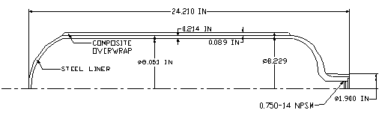
Figure 1. Schematic of Type II COPV Design
Table 2. Type II COPV Design Details
COPV Dimensions
Water Volume, Liters (after autofrettage) | 15.09
Outer Diameter Max, in | 8.400
Nominal, in | 8.261
Liner Outer Diameter, in | 8.051
Length, in | 24.21
Total COPV Weight, lb (mean achieved) | 39.59
Total COPV Weight, kg (mean achieved) | 17.95
Pressures
Fill Pressure (FP), psi | 6,700
Cycle Test Pressure, psi | 8,375
Pressure Cycles Achieved, 0 to 125 % FP | 9,054 mean cycles
Pressure Cycles Achieved, 0 to 125 % FP, Post Drop Test | 7,730 mean cycles
Hydrostatic Test Pressure, psi | 10,050
Autofrettage Pressure, psi | 12,500
Minimum Required Burst, psi | 15,075
Mean Burst Pressure Achieved, psi | 15,640
Steel Liner
Material | 34CRM04
Nominal Sidewall Thickness, in | 0.214
Minimum Recorded Yield Strength, psi | 117,897
Mean Recorded Yield Strength (two tensile tests performed), psi | 122,832
Water Volume (pre- autofrettage), Liters | 15.0
Weight, lb | 37.56
Pressure Port | 0.750-14 NPSM
Composite Overwrap
Reinforcing Fibers | Toray T700 12K
Resin | Epoxy 828, Lindride 52, BDMA
Hoop Composite Thickness, in (65 % Fiber Volume) | 0.071
Knuckle Composite Thickness, in (65 % Fiber Volume) | 0.018
Total Thickness, in | 0.089
Mean Weight of Composite, lb | 2.12

Details of Material Selection
Commercial grade Toray T700 12K was selected as the fiber of choice. T700 is an appropriate fiber for this small prototype, although arguably a heavier tow fiber may be better suited for larger COPVs. Epon 828, an epoxy resin, was selected as the resin material. In HEI’s experience, T700 and Epon 828 are commonly used in COPV applications.

Finding the smaller size liners required to make multiple test articles within the budget and lead time constraints of this program was difficult. Many potential suppliers required minimum order quantities far exceeding the budget of this program. After an extensive search, a high-strength chromium molybdenum (34CRM04) steel SCUBA tank made by FABER was selected as the best of the available liner options for this project. Two “dog-bone” specimens were cut from one of the liners and tensile tested; the mean yield strength, tensile strength, elongation and reduction of area were 122.8 ksi, 141.1 ksi, 14 % and 51 %, respectively. The effects of hydrogen on the down-selected liner are currently unknown, but may be significant given the relatively high strength of the steel. Accordingly, and prior to using the Type II COPV produced during this program, the compatibility of the liner material with hydrogen should be verified or a new liner with similar mechanical properties but enhanced hydrogen resistance should be identified.

Figure 2 shows a cross-sectioned piece of one of the liners. The liner aft dome and sidewall thicknesses limited the ultimate burst pressure and hence the service pressure of the COPV. For future off-board full-scale applications, the liner thickness should be sized appropriately to mitigate this issue.

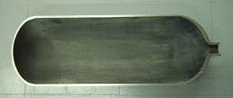
Figure 2. Cross-Section of Steel Liner Used in Phase II

Finite Element Analysis
A finite element analysis (FEA) was conducted in order to better understand and verify the Type II COPV design. A nonlinear analysis was conducted in order to account for the two-component, steel/composite design. Algor FEA software was used for the analysis. Tables 3 and 4 show the FEA inputs and results, respectively.
Table 3. FEA Inputs
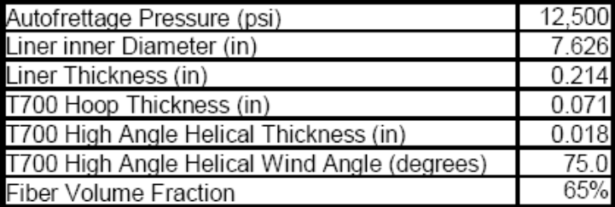
Table 4. FEA Results
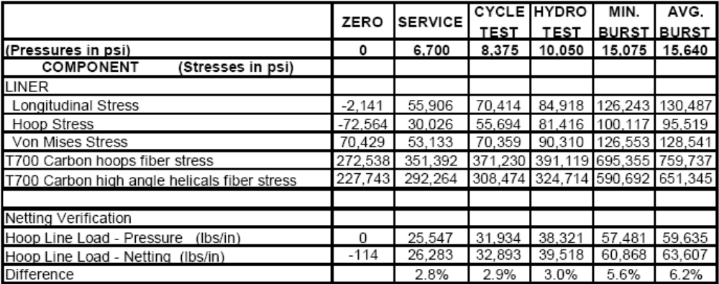

Fabrication Details
Following design verification, the Type II COPVs were fabricated using a four-axis computer numerical controlled (CNC) filament winder manufactured by Entec Composite Machines Incorporated (Figure 3). The exterior paint on the as-received liners was left intact. Alternating hoop and high angle helical wrap patterns were applied according to HEI’s in-house wrap pattern and design technology. The COPVs were fabricated using four (4) tows with wind tension at delivery head of approximately 8 pound (lb) per tow. The wrapped pressure vessels were then cured in a vertical non-rotating position in HEI’s walk-in oven at approximately 290°F for 3 hours.

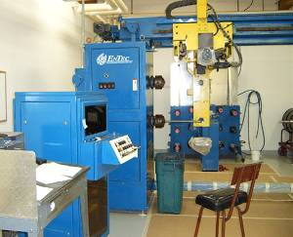
Figure 3. Entec Filament Winder
A total of 14 COPVs were fabricated and tested. A photograph of 13 of the test articles is presented in Figure 4.

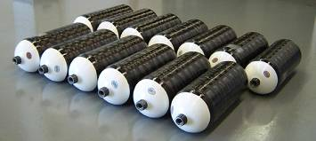
Figure 4. Thirteen Completed COPVs

Test Setup
In order to qualify a COPV for service, HEI typically conducts testing on the proposed COPV design prior to sending the COPV for final qualification. The most revealing tests are the hydrostatic burst, the pressure cycle fatigue test, and drop impact with subsequent fatigue pressure cycle test. Accordingly, these tests were down-selected to evaluate the prototype COPVs produced under this project. For Phase II of the project, the following tests were conducted on the Type II COPV design:

- 4 COPVs were hydrostatically burst tested
- 4 COPVs were fatigue cycle tested
- 4 COPVs were fatigue cycle tested after impact

The following subsections discuss the different test setup configurations.

Burst Testing Setup
A total of four Type II COPVs were hydrostatically burst tested. During this process, the COPVs were filled with water and pressurized at a manually controlled rate until failure. The pressure at failure was recorded as the burst pressure for the individual tank. HEI used its in-house, two-stage Haskel burst pump system for these tests (see Figure 5). This pump configuration was assembled by SunSource and is capable of pressures up to 50,000 psi. All burst tests were performed in a steel safety enclosure designed to direct the energy of the bursts in a safe manner.

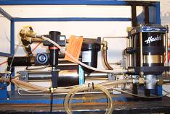
Figure 5. The Haskel Burst Pump System Used for COPV Hydrostatic Burst Testing

Cycle Testing Setup
Four Type II COPVs were hydrostatically cycle tested. The test medium used was a water/glycol mix to prevent corrosion from playing a role in any resulting failure. During this test, each COPV was pressurized to 1.25 X Service Pressure (8,375 psi) or slightly higher, depressurized to approximately zero pressure, pressurized back up again, and so on. Pressure cycling continued until failure occurred. A photo of a COPV that failed during the cycle test is pictured in Figure 6. All cycle test failures in this program occurred by a fatigue crack in the liner, followed by leakage, which is typical of fatigue cycle tests for well-designed COPVs. All cycle testing for this program was conducted by Arrowhead Industrial Services Inc.

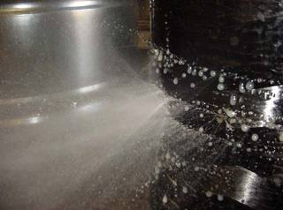
Figure 6. Leaking COPV, from Cycle Failure

Drop/Impact & Cycle Testing Setup
Four Type II COPVs were impacted by dropping each of them once at various vertical, horizontal and offset angles. The drawing in Figure 7 shows the drop test orientations used for each COPV. The COPVs were dropped in the horizontal and vertical positions such that the minimum height of the cylinder was 72 inches from the concrete. The COPVs were dropped onto the domes such that the center of gravity was a minimum of 72 inches from the concrete. After drop testing, the COPVs were subjected to the same cycle test mentioned in Section 2.2.2. All drop cycle testing for this program was also conducted by Arrowhead Industrial Services Inc.

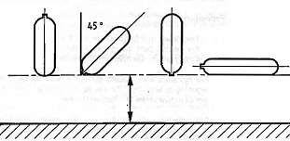
Figure 7. Drop Test Orientations

RESULTS AND DISCUSSION
The following mean test results were achieved by the Type II COPVs developed in Phase II of this project.

- Average Burst Pressure Achieved: 15,640 psi
- Cycles at Cycle Test Pressure: No minimum required, mean cycles achieved: 9,054
- Cycles at Cycle Test Pressure (Post Drop Test): No minimum required, mean cycles achieved: 7,730.

The following subsections provide additional information regarding the test results.

Burst Test Results
The photographs in Figures 8, 9, 10, and 11 are of the hydrostatically burst Type II COPVs. The mode of failure pictured (sidewall and hoop failure) is characteristic of all burst tests conducted and is representative of a good COPV design. The maximum and minimum pressures observed at failure were 15,955 psi and 15,193 psi, respectively. The mean burst pressure of all four COPVs tested was 15,640 psi and the coefficient of variation of the four pressure vessels was determined to be 2.40 %. Based on HEI’s previous experience and observation of the COPV industry, a coefficient of variation less than 3.0 % is the mark of excellent COPV design and fabrication. The burst pressure results for all four pressure vessels are presented graphically in Figure 12 and a summary is given in Table 5.

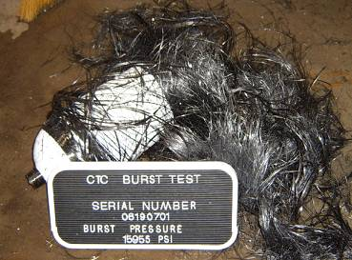
Figure 8. SN: 061907-01, Burst Pressure: 15,955 psi

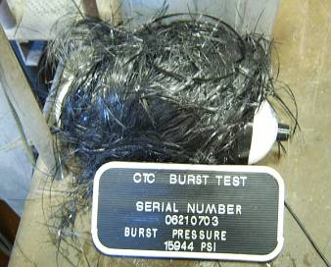
Figure 9. SN: 062107-03, Burst Pressure: 15,944 psi

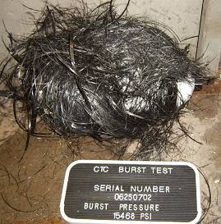
Figure 10. SN: 062507-02, Burst Pressure: 15,468 psi

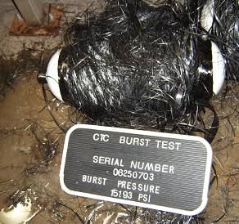
Figure 11. SN: 062507-03, Burst Pressure: 15,193 psi

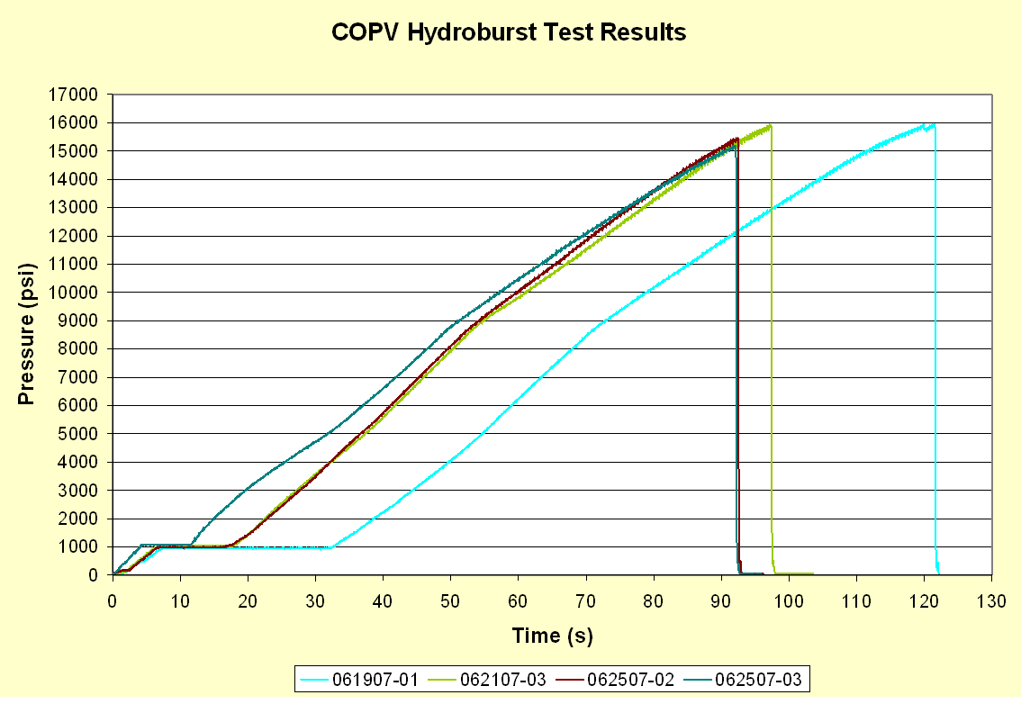
Figure 12. Data Traces of Hydrostatic Burst Tests
Table 5. Summary of Burst Test Results
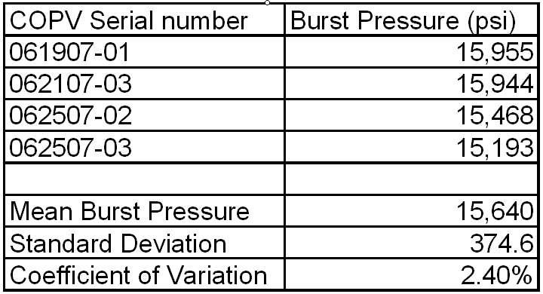

Cycle & Drop Cycle Test Results
Tables 6 and 7 show the cycle and drop/cycle test data, respectively. Each Type II COPV failed by a liner crack followed by leakage, as expected. The mean cycles achieved prior to failure in the cycle and drop/cycle tests were 9,054 and 7,730, respectively. Greater variation was observed in the cycle testing than in the drop/cycle testing. This is due mainly to COPV SN 062507-01, which displayed much lower cycle capability than the other COPVs that were cycled.
Table 6. Summary of Cycle Test Results
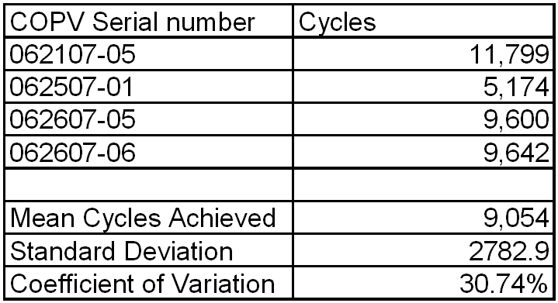

A brief failure analysis was conducted on COPV 062507-01 to see why the COPV was lower than the others. No conclusive reason has been determined to explain the lower-than-expected cycle failure.
Table 7. Summary of Drop Cycle Test Results
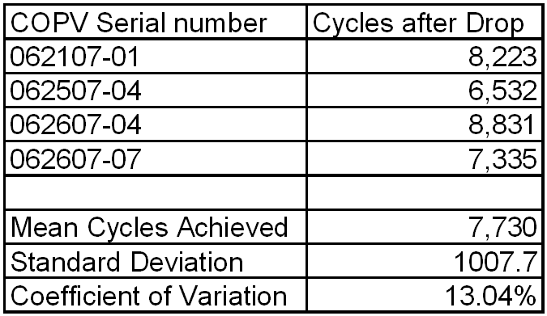

Efficiency Calculations
The cost and weight efficiencies are affected greatly by the amount of hydrogen stored within the COPV. All calculated hydrogen weights are based on the assumption that the COPVs are being stored at room temperature (20° C). The efficiencies achieved in the first phase of this project all used Van der Waals equation of state [7] to calculate the weight of hydrogen. Discussions between HEI and CTC representatives determined this method of calculation to be conservative. Further calculations have utilized an equation derived by CTC to estimate the weight of hydrogen contained in the COPVs. The results of using this equation have also been compared to actual hydrogen data as provided by the National Institute of Standards and Technology (NIST) Standard Database Reference. [8] Table 8 shows the different hydrogen weights calculated utilizing the different methods discussed. Note that the NIST database includes data in increments of 10 MPa. The listed NIST figures have assumed linearity between the increments to estimate weight. Although this is an approximation, the listed weights do provide a good reference for comparison purposes.
Table 8. Calculated Hydrogen Weights
 | Phase I |  | Phase II
COPV Type | III |  | II
COPV Volume (L) | 7.75 |  | 15.09
COPV Weight (lb) | 11.375 |  | 39.59
COPV Stored H2 Weight Calculation | (kg) | (lb) | (kg) | (lb)
Van Der Waals Equation of State | 0.266 | 0.59 | 0.407 | 0.90
CTC-derived equation | 0.303 | 0.67 | 0.441 | 0.97
Interpolated from NIST data | 0.300 | 0.66 | 0.440 | 0.97

Table 9 shows the assumptions included in the calculation of cost efficiency as well as the other efficiencies for the 10,000 psi service pressure 7.75 L Type III COPV fabricated in Phase I of this project. Note the cost figures assume a fully mature fabrication process and material purchases based on large volumes.

Table 9. Phase I, 10,000 psi, 7.75 L, Type III COPV Efficiency Results
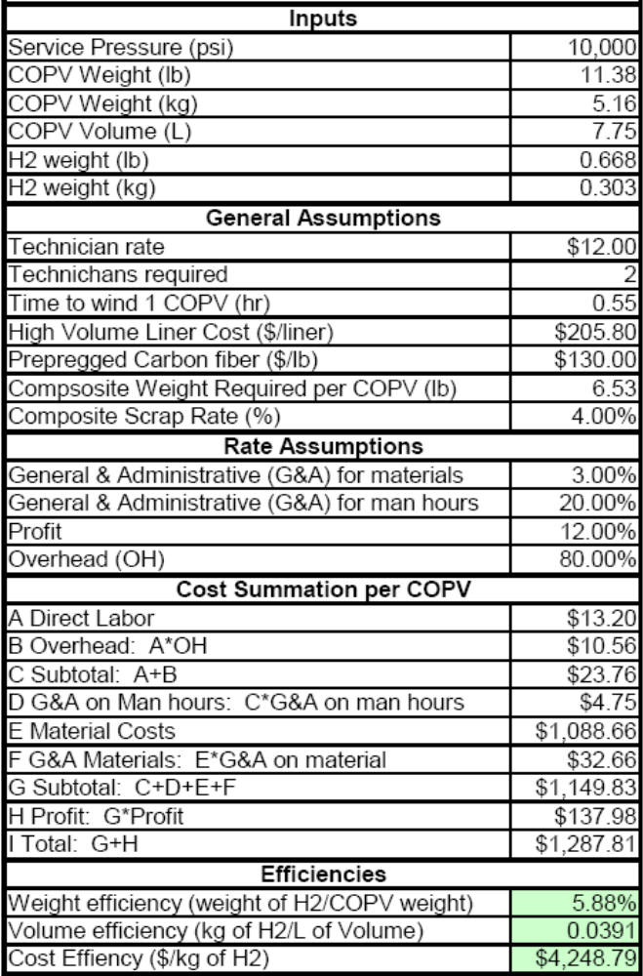

Table 10 shows the assumptions used to calculate the cost, volume and weight efficiencies of the Type II COPV fabricated during Phase II of this project. Note that the cost figures assume a fully mature fabrication process and material purchases based on large volumes. Most of the costs associated with the COPV are material costs.
Table 10. Phase II, 6,700 psi, 15.09 L, Type II COPV Efficiency Results
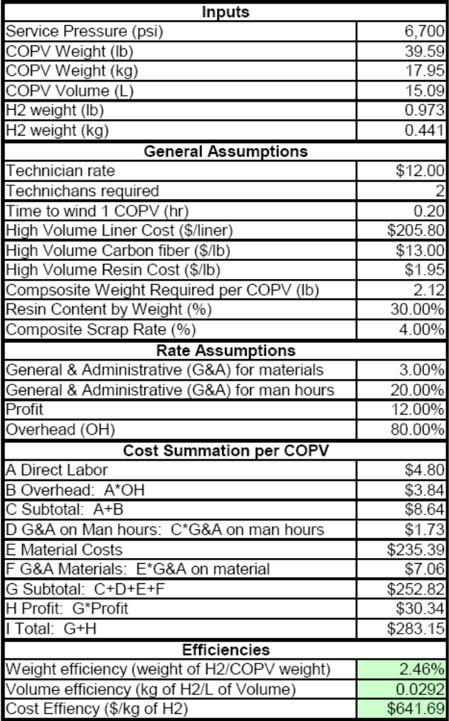

Comparison with DOE Goals
As stated earlier, Phase I of the CTC/HEI collaboration was targeted at COPV weight reduction, while Phase II was focused on cost reduction. Figures 13, 14 and 15 compare the Phase I and Phase II cost efficiency, volumetric efficiency and weight efficiency results, respectively, to the DOE’s goals in those areas for the years 2010 and 2015.

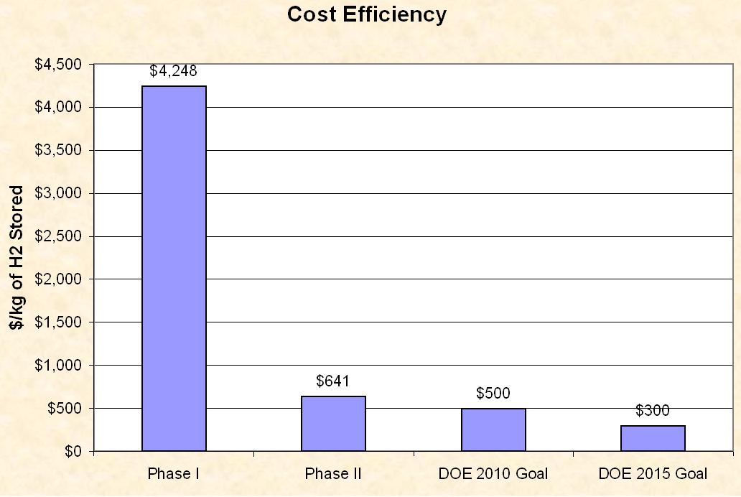
Figure 13. Cost Efficiency Comparison
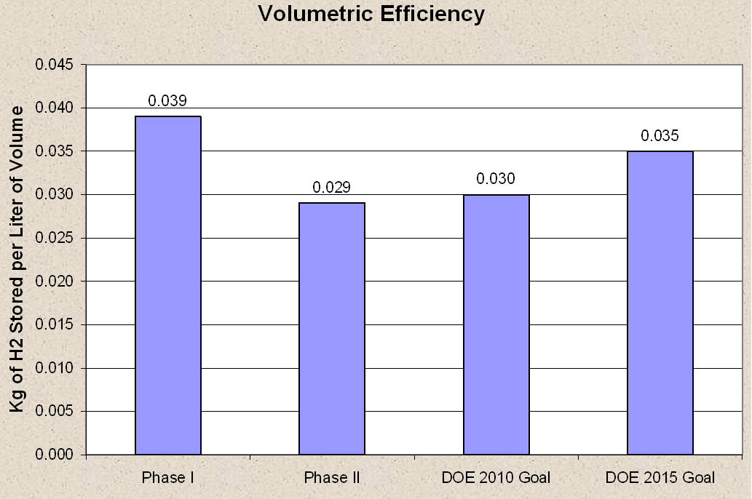
Figure 14. Volumetric Efficiency Comparison
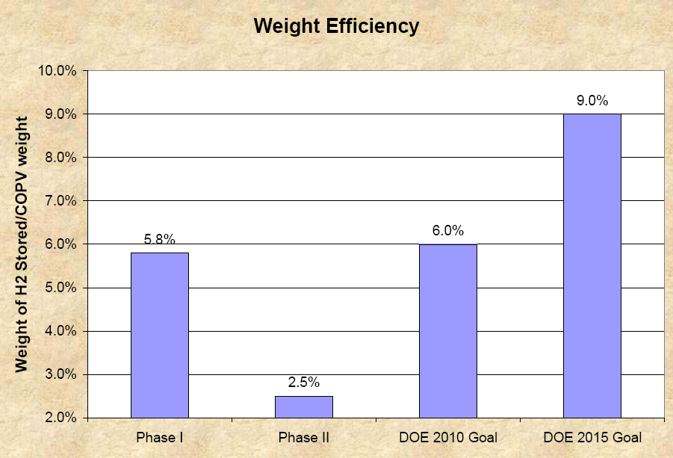

Figure 15. Weight Efficiency Comparison (for information only; on-board storage goals listed)

SUMMARY
CTC and HEI have completed a two-phase effort to develop prototype COPVs for off-board hydrogen gas storage. The Phase I efforts targeted the DOE’s originally published goal of weight efficiency, while the Phase II activities were targeted to address the DOE’s revised primary goal of cost efficiency for off-board hydrogen storage. The following results, in comparison to the DOE’s goals, were achieved for the two phases:

- Cost efficiency – defined by cost per kilogram of hydrogen gas stored. The DOE’s goals for off-board gaseous hydrogen storage tanks are $500 and $300 per kilogram of hydrogen stored for years 2010 and 2015, respectively. [2] The Type III tank from Phase I of this project demonstrated a cost efficiency of approximately $4,248/kg of hydrogen stored. The Type II tank designed for Phase II of the project demonstrated a cost efficiency of $641/kg of hydrogen stored.
- Volumetric efficiency – defined by kilograms of hydrogen stored per liter of volume. The DOE’s goals for volumetric efficiency of off-board gaseous hydrogen are 0.030 and 0.035 kilograms of hydrogen per liter of storage volume for years 2010 and 2015, respectively. [2] The Type III tank from the first phase of this project demonstrated a volumetric efficiency of 0.039 kg of hydrogen per liter of storage volume. The Type II tank from the second phase of the project demonstrated a volumetric efficiency of 0.029 kg of hydrogen per liter of storage volume.
- Hydrogen weight efficiency – defined by weight of hydrogen stored at service pressure divided by the weight of the COPV. The DOE’s goals for on-board hydrogen weight efficiency for 2010 and 2015 are 6 % and 9 %, respectively. [3] The Type III tank from Phase I of this project demonstrated a weight efficiency of 5.8 %. The Type II tank from Phase II of the project demonstrated a weight efficiency of 2.5 %.

The design optimization and prototype construction portions of this two-phase effort have confirmed that cost efficiency and weight efficiency are inversely proportional. In order to achieve better cost efficiency, some weight efficiency is sacrificed and vice versa. The exact balance between those two factors needs to be determined for each application based on the available resources and imposed constraints associated with that application.

The DOE’s future cost efficiency goals may be difficult to reach without finding a way to reduce COPV raw material costs, since raw material cost is such a large percentage of the overall COPV cost. In addition, some cost reduction for a Type II COPV may be achieved by fabricating a full-scale COPV, rather than the smaller, prototype sizes that were produced within this project’s time and budgetary constraints.

REFERENCES
- DOE Multi-Year Research, Development and Demonstration Plan—Hydrogen Delivery (Revision 1, 2005; Table 3.2.2).
- DOE Multi-Year Research, Development and Demonstration Plan—Hydrogen Delivery (Revision 2007; Table 3.2.2).
- DOE Multi-Year Research, Development and Demonstration Plan—Hydrogen Storage (Revision 2007; Table 3.3.2).
- Material Assessment Report, delivered to Concurrent Technologies Corporation by HyPerComp Engineering Incorporated on March 16, 2007.
- European Standard EN 12245, Transportable Gas Cylinders-Fully Wrapped Composite Cylinders, February 2002.
- United States Department of Transportation Standard CFFC-Basic Requirements for Fully Wrapped Carbon Fiber Reinforced Aluminum Lined Cylinders, Fourth Revision, November 2000.
- Çengel, Yunus A. and Boles, Michael A., Thermodynamics An Engineering Approach, Third Edition, McGraw-Hill Companies, Inc., 1998, pp. 84-85.
- Available at www.nist.gov/srd/index.htm.

HyPerComp Engineering, Inc., Brigham City, UT 84302
Concurrent Technologies Corporation, Johnstown, PA 15904
“On-board” refers to hydrogen storage on vehicles, while “off-board” refers to stationary storage, such as at fueling stations.
Weight efficiency is not a specific goal for off-board hydrogen storage; the on-board storage weight efficiency targets are listed here for information only.
COPVs are distinguished by their configuration: Type II are metal-lined composite reinforced designs with load sharing liners that can alone resist the operating pressure, normally termed hoop-wrapped; Type III are metal-lined composite reinforced designs with load sharing liners that cannot resist the operating pressure alone, normally termed full-wrapped; Type IV are plastic lined full-wrapped designs.
Autofrettage is the processes of pressuring the COPV to introduce residual compressive stresses in the liner material.
www.faber-italy.com
A tow is an untwisted bundle of continuous filaments.
A rate of approximately 180 psi/sec was used for this work.
www.arrowheadindustrial.com.
, where  is hydrogen density in kg/m³, is pressure in MPa, and 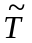 is characteristic temperature that is a ratio of actual and room temperatures given in Kelvin

