THE HYBRID CU-CL THERMOCHEMICAL CYCLE.
I. CONCEPTUAL PROCESS DESIGN AND H2A COST ANALYSIS. II. LIMITING THE FORMATION OF CUCL DURING HYDROLYSIS.

Magali S. Ferrandon, Michele A. Lewisª, David F. Tattersonb, Rohit V. Nankanic, Munish Kumar^{c}, Lewis E. Wedgewood^{c} and Ludwig C. Nitsche^{c}.

The submitted manuscript has been created by UChicago Argonne, LLC, Operator of Argonne National Laboratory (“Argonne”). Argonne, a U.S. Department of Energy Office of Science laboratory, is operated under Contract No. DE-AC02-06CH11357. The U.S. Government retains for itself, and others acting on its behalf, a paid-up nonexclusive, irrevocable worldwide license in said article to reproduce, prepare derivative works, distribute copies to the public, and perform publicly and display publicly, by or on behalf of the Government.

1. Introduction
The hybrid copper-chlorine (Cu-Cl) cycle is one of the most promising thermochemical cycles for hydrogen production using nuclear or solar heat. The advantage of the hybrid CuCl cycle relative to other cycles is the relatively lower temperature heat (550ºC) source required. Several types of nuclear reactors can be used as a heat source. Examples are the supercritical water reactor being developed in Canada, CANDU Mark 2, the lead cooled reactor, or the high temperature gas reactor. Solar heat can be provided using the commercially proven tower technology. All these provide heat near or above 600ºC, the maximum temperature required for the cycle. The lower temperature should mitigate some of the demands on the materials of construction.

The copper-chlorine cycle consists of the three major reactions shown in Table 1. The electrolysis reaction (1) in which cupric chloride (CuCl₂) is produced at the anode and H₂ at the cathode is carried out electrochemically. The CuCl₂(a) from (1) is hydrolyzed to copper oxychloride (Cu₂OCl₂) according to the hydrolysis reaction (2). Molten cuprous chloride (CuCl) is then produced from the decomposition reaction (3).

Table 1. Reactions in the Copper-Chlorine Cycle
Reaction Conditions
(1) CuCl(a) + HCl(a) + 2H₂O → CuCl₂·2H₂O(a) + ½ H₂(g) 100ºC, 24 bar
(2) 2 CuCl₂(s) + H₂O(g) → Cu₂OCl₂(s) + 2HCl(g) 400ºC, 1 bar
(3) Cu₂OCl₂(s) → ½ O₂(g) + 2CuCl(s) 540ºC, 1 bar

All reactions have been experimentally demonstrated. The early experiments indicated technical challenges in the hydrolysis (2) and electrolysis reactions (1). The two thermal reactions, the hydrolysis of CuCl₂ (2), and the decomposition of Cu₂OCl₂ (3) have been proven at Argonne National Laboratory. In bench scale experiments, all of the oxygen was recovered at 530ºC from reaction (3). The electrolytic reaction (1) was demonstrated at the Atomic Energy of Canada, Ltd. (AECL) at Chalk River recently. Meeting performance (500 mA/cm² at 0.5V) and cost target ($2500/m²) is the primary challenge for the electrolysis reaction.

We consider the hydrolysis reaction to be the most challenging reaction because of two factors: (i) a competing reaction of CuCl₂ and (ii) the need for excess water.

The competing reaction is the thermal decomposition of CuCl₂:
2CuCl₂ (s) ⇔ 2CuCl (s) + Cl₂ (g). (4)

Because CuCl is a product of the subsequent reaction, this competing reaction is not a showstopper, provided the chlorine can be scavenged and the amount of chlorine formed is minimal. We believe that this competing reaction can be minimized by the choice of operating conditions and the reactor design.

A sensitivity study and the experimental results indicate that the steam must be in excess for high yields of the desired Cu₂OCl₂ and HCl. The excess steam increases capital costs significantly because of the larger number of vessels required.

In the first sub-section, a conceptual process design for the cycle is presented. It consists of two sections: (1) the electrolyzer and crystallizer, and (2) the hydrolyzer and oxychloride decomposition reactors. In order to determine the potential of the Cu-Cl cycle, an Aspen Plus™ flowsheet was developed using this process design and the cycle’s efficiency was calculated. The energy and mass balances, the heat exchanger duties and shaft work were calculated, and heat recovery was optimized with pinch analysis. Because there are no performance data for the electrolyzer needed in the Cu-Cl cycle, we used the same performance targets as those for the hybrid sulfur cycle. The hydrogen production cost was estimated using the hydrogen analysis (H2A) methodology [1]. Capital costs and operating costs for the thermal processes were estimated using Capcost software [2].

In the second section of this paper, an experimental matrix is presented to show which experimental variables had the greatest impact on the CuCl formation during the hydrolysis reaction. The goal is to inhibit CuCl₂ thermal decomposition while minimizing the steam-to-copper molar ratio (S/Cu). The latter is critical for high efficiency since vaporizing the water is energy intensive. The parameters studied included test temperature, test duration, particle size and carrier gas flowrate. Two types of experiments were done - thermal gravimetric analysis in which weight loss was measured and the hydrolysis experiments in which the product was analyzed for CuCl using a wet chemistry method.

2. Methodology
The system calculation was carried out using the commercial process simulation package – Aspen Plus which has been widely used in chemical engineering and energy engineering [3,4]. The chemical reactions in the hydrolysis, the electrolyzer and the decomposition reactors are assumed to achieve thermodynamic equilibrium under the specified flow rates and operating conditions. Therefore the RGibbs reactor model is used to calculate the composition of products by the minimized Gibbs free energy method. The HeatX module of Aspen Plus is used to model the heat exchangers. The output stream data which is produced by this Gibbs reactor is then used in a stoichiometric reactor. The thermodynamic data used in Aspen are summarized in Table 2. The system efficiency is defined as (LHV base):

Efficiency = Mol. of H₂ Produced * LHV____________
(Shaft work + Electrochemical work + Pinch Heat)

Table 2. Thermodynamic data used in the Aspen Plus Database.
Compound DHSFRMª DGSFRM^{b}
(kJ/mol) (kJ/mol)
CuCl₂(s) -217.4 -173.6
CuO(s) -162.0 -129.4
CuCl(s) -137.0 -120.0
Cu(s) 0 0
Cu₂OCl₂ (s) -381.3 -310.45
ª DHSFRM = Enthalpy of formation at 298.15K and 1 bar
^{b} DGSFRM = Gibbs free energy of formation at 298.15K and 1 bar

3. Experimental
The thermal decomposition of CuCl₂ was studied in a ThermoCahn 2121 thermogravimetric analyzer with 0.1 µg sensitivity. A weight of around 100 mg sample was placed in a quartz basket and heated in 50 mL/min Ar (99.999%) from room temperature to 150ºC at a heating rate of 2ºC/min and hold it for 30 min, followed by heating up to 375ºC at the same heating rate and hold it for 60 min. A thermocouple was placed underneath the basket. The weight loss as a function of time and temperature were continuously recorded.

The hydrolysis studies were conducted using a microreactor system which consisted of a 0.5 or 0.25-in OD quartz tube heated by a split temperature-programmed furnace. The temperature above the sample bed was monitored using an Omega K-type thermocouple. The typical sample loading was 0.30 g of copper chloride dihydrate (as received CuCl₂ • 2 H₂O, 99.99%, Sigma Aldrich) packed between two layers of quartz wool. In order to vary the particle sizes, the material was first dried in a dessicator, crushed and sieved to the desired particles sizes and then re-hydrated. Ballmilled materials were obtained by placing dried CuCl₂ particles in a shaker with zirconia balls overnight and then re-hydrated. The argon (99.999%) flowed between 50 and 250 mL/min through a humidifier with a set temperature varying between 30 and 95ºC. During the hydrolysis experiments, the sample was heated rapidly (within 10 min) in humidified Ar to reaction temperature, between 300 and 400ºC, and then held at the test temperature for a period, between 30 and 90 min. After the end of the experiment, the furnace was opened to allow the sample to cool rapidly in humidified Ar down to 250ºC. Dry Ar was then used to cool the sample down to ambient temperature. During the experiments, water and HCl in the gaseous product stream were condensed; any remaining HCl was trapped using a NaOH solution and Cl₂ was trapped using Fe wool. The solid product samples were stored in closed vials in a dessicator to prevent any air and moisture exposure.

Analyses of CuCl, Cu₂OCl₂ and CuCl₂ were performed using a wet chemistry method by the Analytical Chemistry Laboratory at Argonne.

4. Results

4.1. Conceptual Process
The design of the thermo-chemical portion of the conceptual CuCl plant is based on a three-reaction copper chlorine cycle, as mentioned in the introduction.

Aspen was used to develop mass and energy balances for a process based on these 3 reactions. The Aspen simulation provided stream flows and properties as well as heat exchanger duties and work requirements for pumps. The overall process flow sheet is shown in Figure 1. Mass flow rates of key streams are given in Table 3.
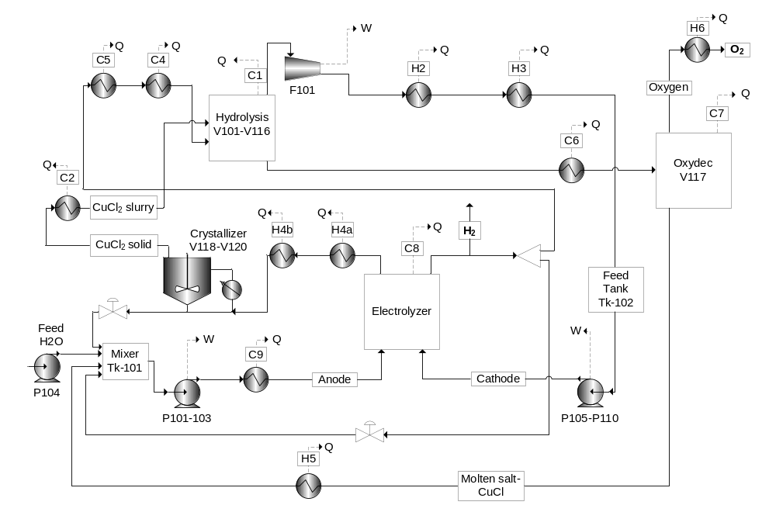 Figure 1. Aspen flow sheet of the CuCl cycle. Hot streams are defined by H and cold streams by C.

Table 3. Mass Flow Rates (MT/hr) of Key Process Streams
H₂O HCl CuCl Cu₂OCl₂ CuCl₂·2H₂O H₃O⁺ Cl⁻ CuCl⁺ O₂ H₂
H₂O feed 46.8 0 0 0 0 0 0 0 0 0
Electrolyser:
Anode feed 327.7 3.4 514.8 0 0 39.8 107.3 92.7 0 0
Cathode feed 1172.9 0.03 0 0 0 98.9 184.3 0 0 0
H₂ product 0 0 0 0 0 0 0 0 0 5.2
Crystallizer feed 168.0 0.2 0 0 978.9 414.4 91.2 39.0 0 0
Hydrolyzer:
CuCl₂ feed 197.7 2.5 0 0 0 0 187.5 519.4 0 0
H₂O feed 1153.0 0 0 0 0 0 0 0 0 0
Decomposition reactor:
Oxydec feed 0 0 0 561.4 0 0 0 0 0 0
O₂ product 0 0 0 0 0 0 0 0 41.6 0
CuCl recycle 0 0 514.7 0 0 0 0 0 0 0

A CuCl cycle plant producing 125 MT H₂/day requires 210 MW of thermal energy and 87.8 MW of electrical energy. A process energy summary is shown in Figure 2.
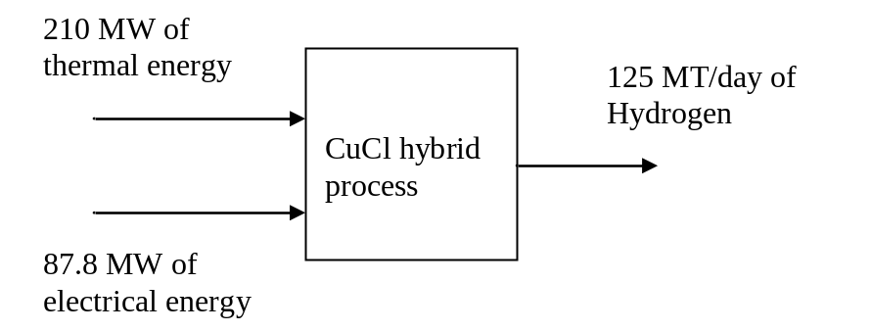
Figure 2. Cu-Cl cycle energy requirements

In conjunction with the Aspen results, a pinch analysis was used to develop an integrated heat exchange network which will effectively recover waste process heat. The heat exchanger network is presented in Figure 3 and its specifications are presented in Table 4.

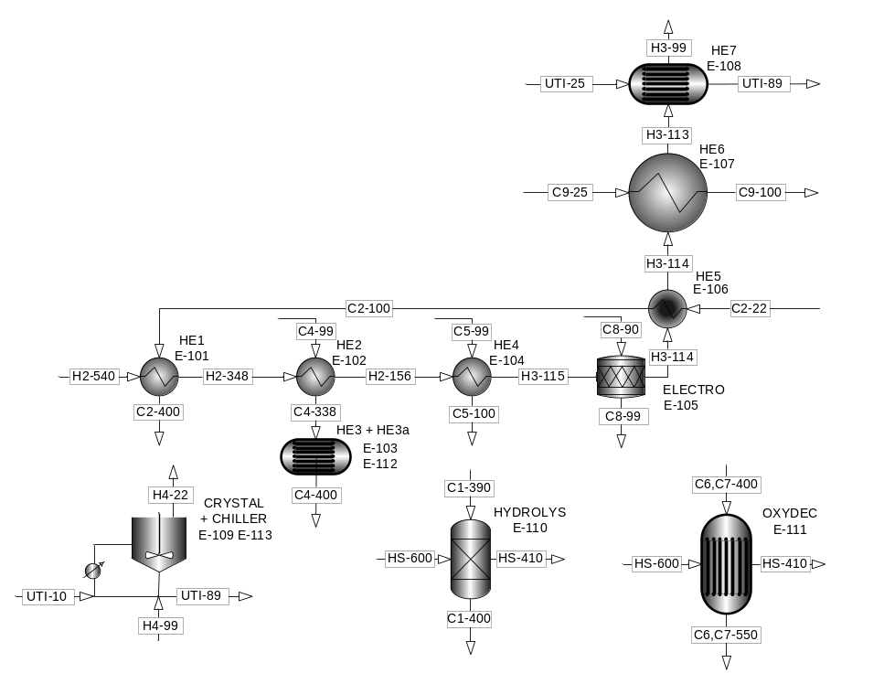
Figure 3. Aspen flow sheet of the heat exchangers’ network. HS=Heat source. UTI=Utilities. Hot streams are defined by H and cold streams by C. Temperatures (ºC) are added.

Table 4. Heat exchanger specifications. HS=Heat source. UTI=Utilities.
Heat Hot Stream Cold Stream Heat Duty
Exchanger ID Temperature (ºC) ID Temperature (ºC) (cal/sec)
In Out In Out
HE1 H2 540 348 C2 100 400 7226.7
HE2 H2 348 156 C4 99 338 708700.7
HE3 H5 540 366 C4 338 356 53730
HE3a HS 600 410 356 400 111575.3
HE4 H2, H3 156 115 C5 99 100 3336983
ELECTRO H3 115 114 C8 90 99 36627
HE5 H3 114 114 C2 22 100 7226.7
HE6 H3 114 113 C9 25 100 75885
HE7 H3 113 99 UTI 25 89 1547467
CRYSTAL H4a 99 30 UTI 25 89 151999
CRYSTAL
CHILLER H4b 30 22 UTI 0 12 39955
OXYGEN H5+H6 540 99 UTI 176438
HYDRO LYS HS 600 410 C1 390 400 348556
OXYDEC HS 600 410 C6,C7 400 550 506183

The energy efficiency of the process is defined as energy out divided by energy in. The formula is described in Part 2. Methodology. Based on Figure 2 and the low heating value for hydrogen, the efficiency of this process is:

Efficiency = 125,000 x 33.3/ 24(210,000 + 87,800/0.4) = 40.4%

Based on the Aspen results, a conceptual process design for the CuCl cycle was developed. The process is divided into 2 sections:
- The electrolyzer/crystallizer system (Figure 4)
- The hydrolysis/oxy-decomposition system (Figure 5).

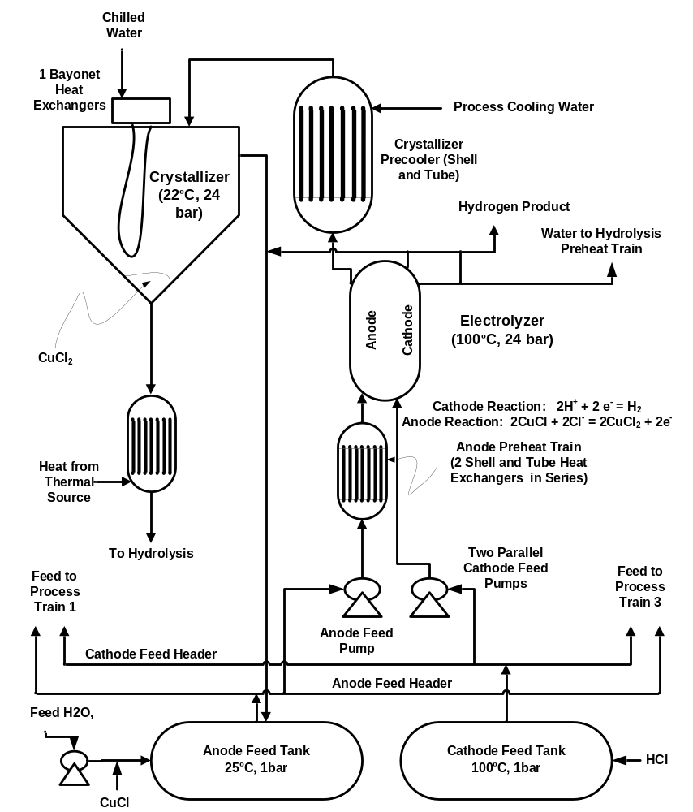
Figure 4. Electrolyzer and crystallizer section.

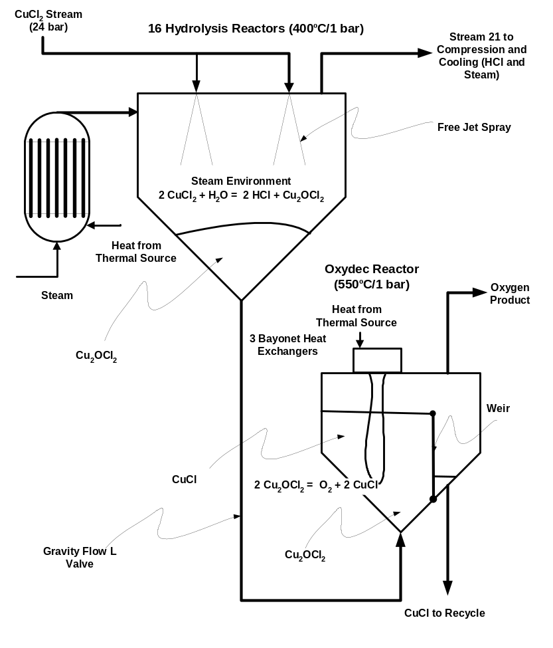
Figure 5. Hydrolysis and oxy-decomposition section.

The electrolyzer/crystallizer system consists of 3 parallel trains. The number of trains was determined by assuming a 5 min residence time for the crystallization to occur. Volume flow rates and vessel size restrictions then determined the number of crystallizers required. Very little is known about the details of the electrolyzer. The electrolyzer assumptions are discussed below.

In Figure 4, feed water along with CuCl is added to the anode feed tank. Any make up HCl would also be added to the feed to keep the CuCl dissolved. The dissolved CuCl is then pumped (24 bar) via a pre-heater (100ºC) to the anode section of the electrolyzer. Chloride ion migrates from the cathode across the electrolyzer membrane and reacts at the anode with the CuCl to form CuCl₂. The aqueous CuCl₂ is then cooled (process and chilled water) to 22ºC in the crystallizer. The CuCl₂ settles to the bottom of the crystallizer. Some water, HCl and CuCl will be entrained with the CuCl₂ but the extent of this entrainment is unknown. The CuCl₂ flows (via a pressure drop of 23 bar) to the hydrolysis reactor in Figure 5. The un-crystallized dissolved CuCl₂, CuCl and water from the crystallizer is recycled to the anode feed tank.

In Figure 4, aqueous HCl is pumped (24 bar) from the cathode feed tank through a pre-heater (100ºC) to the cathode. At the cathode the H⁺ ion is reduced to H₂. The chloride ion migrates across the electrolyzer membrane as described above. Water from the cathode is vaporized and superheated to 400ºC and sent to the hydrolysis reactor.

In Figure 5, the hydrolysis/oxy-decomposition system consists of 16 hydrolysis reactors feeding one oxy-decomposition reactor. In order to keep the number of hydrolysis reactors at a reasonable number, short residence times had to be assumed. It was assumed that the steam residence time in the hydrolysis reactor is 5 second. These short residence times are required by the large (17/1) steam to CuCl ratio dictated by the experimental results. However, a short residence time of the CuCl₂ in the hydrolysis reactor is desirable to prevent the formation of CuO and CuCl.

Thermal energy is used to preheat the streams to the hydrolysis reactor and to decompose the Cu₂OCl₂ in the oxy-decomposition reactor. The oxy-decomposition reactor was sized for a residence time of 60 min to allow plenty of time for the copper oxychloride time to decompose.

In Figure 5, the hot CuCl₂ is sprayed into the superheated (400ºC) steam environment. The CuCl₂ stream at 24 bar is sprayed into the hydrolysis reactor where it forms a free jet. As the jet expands it aspirates the superheated steam into the jet resulting in high mass and heat transfer between the CuCl₂ in the jet and the steam. The CuCl₂ is converted to Cu₂OCl₂ and HCl. The HCl and steam exit the hydrolysis reactor to be cooled and fed to the cathode of the electrolyzer. Dry, free flowing solid Cu₂OCl₂ accumulates at the bottom of the hydrolysis reactors. The solid copper oxychloride flows by gravity through an L valve to the oxy-decomposition reactor. The stand pipe below the hydrolysis reactor can be fluidized with steam if necessary and the stand pipe to the oxy-decomposition reactor can be fluidized with air if required. In the oxy-decomposition reactor, the Cu₂OCl₂ is heated to 550ºC. At 550ºC, the Cu₂OCl₂ decomposes to oxygen and molten CuCl. The oxygen leaves the oxy-decomposition reactor as a gas and the CuCl spills over a weir and is pumped back to the anode feed tank.

4.1.1. Key Operational Assumptions
As with any conceptual process that is proposed with little experimental results and data, a number of key assumptions had to be made. These were:

- Electrolysis reactor operates at:
  - 0.5 volts
  - 500 milliamps/cm²
These conditions were assumed to be consistent with other hybrid processes which have electrochemical steps, for instance the hybrid sulfur process [5].
- The material of construction is porcelain coated carbon steel. This assumption is based on a private communication with Porcelain Industries of Dickson, TN [6].
- The crystallizer operates with minimal water, HCl and CuCl entrainment.
- In the hydrolysis reactor, copper oxychloride forms rapidly in a zone of high heat and mass transfer in short residence time (5 sec).
- The sublimation of CuCl in the oxy-decomposition reactor will be negligible.
- Crystals of CuCl₂ will flow from the crystallizer to the hydrolysis reactor given the large pressure drop (22 to 1 bar).
- Ideal separators are used for the entire process.

4.1.2. Capital and Operating Cost Estimates
The equipment in the conceptual design was sized based on the Aspen Plus™ results, the pinch analysis and process design heuristics provided by Turton et al. [2]. Aspen provided heat exchange duties, shaft work for pumps, stream flow rates and conditions. The pinch analysis provided the log mean temperature differences for the heat exchangers. A 10 degree C temperature approach was assumed. Overall heat transfer coefficients for scoping estimates provided by Turton et al. [2] were used. The vessels were sized as discussed above.

Capcost, a software package developed by Turton et al. [2], was used to estimate equipment and installation costs. Capcost is based on the method of Guthrie [7] as modified by Ulrich [8]. In all cases, the material of construction was carbon steel.

Capcost generates an equipment list with key design parameters, equipment cost and installation cost (bare module cost). The list of equipments shown in both Figures 1 and 3 for this conceptual design is given in Table 5.

Table 5. Equipment List.
Exchangers Type of Exchanger Shell Tube Purchased Bare
Pressure Pressure Equipment Module (barg) (barg) Cost ($) Cost ($)
E-101 HE1 Shell and Tube 5 30 31,300 105,000
E-102 HE2 Shell and Tube 5 5 2,250,000 7,390,000
E-103 HE3a Shell and Tube 5 5 500,000 1,640,000
E-104 HE4 Shell and Tube 5 5 1,140,000 3,740,000
E-105 ELECTRO Shell and Tube 5 30 147,000 492,000
E-106 HE5 Shell and Tube 5 30 30,500 102,000
E-107 HE6 Shell and Tube 5 30 221,000 741,000
E-108 HE7 Shell and Tube 5 30 3,040,000 10,200,000
E-109 CRYSTAL Chiller 3 Bayonet 30 5 541,000 1,890,000
E-110 HYDROLYS Shell and Tube 5 5 399,000 1,310,000
E-111 3 OXYDEC Bayonet 5 5 756,000 2,490,000
E-112 HE3 Shell and Tube 5 5 267,000 878,000
E-113 CRYSTAL 3 Shell and Tube 30 5 168,000 587,000
Subtotal : 9,490,800 31,565,000
Fans Type Gas Flowrate Purchased Bare
/ Blowers (m³/s) Equipment Module
Cost ($) Cost ($)
F-101 Centrifugal Radial 921 441,000 1,390,000
Subtotal : 441,000 1,390,000
Pumps Pump Type Power No Purchased Bare
(with drives) (kW) Equipment Module
Cost ($) Cost ($)
P-101-P-103 Centrifugal 31.5 3 7,690 36,800
P-104 Centrifugal 102 15,400 73,900
P-105- P-110 Centrifugal 182 6 23,300 112,000
Subtotal : 178,270 856,300
Storage Tank Type Volume Purchased Bare
Tanks (m³) Equipment Module
Cost ($) Cost ($)
Tk-101 Anode Feed Fixed Roof 227 61,400 67,600
Tk-102 Cathode Feed Fixed Roof 611 86,500 95,200
Subtotal : 147,900 162,800
Vessels Orientation Length Height No Purchased Bare
/Diameter (m) Equipment Module
Cost ($) Cost ($)
V-101-V-116 Hydrolysis Vertical 24/4 16 219,000 991,000
V-117 Oxydec Vertical 9.3/3.09 57,600 243,000
V-118 Crystallizer 1 Vertical 10.4/3.47 77,600 1,700,000
V-119 Crystallizer 2 Vertical 10.4/3.47 77,400 1,690,000
V-120 Crystallizer 3 Vertical 10.4/3.47 77,600 1,700,000
Subtotal : 3,794,200 21,189,000

The utility and labor operating cost were also estimated. The electrical and cooling (chilled water) costs were estimated using Aspen and Capcost. The labor cost was estimated based on Turton et al.’s equations [1]:
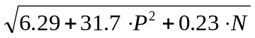
Operator/shift = (eqn 1)

where P = the number of process steps involving solids (3 in our case)
N= the number of pieces of equipment. (16 in our case)
Total operators = 4.5 X operators/shift

Other investment (land, contingency, etc) and operating costs (price for labor, water, electric rate, etc) were provided by the H2A spread sheet. The initial chemical inventory costs were estimated from vessel inventory and residence times.

4.1.3. Key Economic Assumptions
In completing the economic analysis a number of assumptions had to be made. These are:
- The base year for the economic analysis was 2005 so the CEPCI = 468.
- The plant produces 125 MT/day of hydrogen.
- The cost of the electrolysis cell (vessel and electrodes) was $2500/m² of total active cell area.
- Bulk HCl cost is $241/metric ton.
- Bulk CuCl cost is $7200/metric ton.
- The carbon steel equipment costs were increased by 6% to allow for coating the steel with porcelain to withstand the high temperature corrosive environments of the Cu-Cl process [6].
- Electricity is available for $60/MWe-hr.
- A thermal utility is available for $20/MWt-hr. (cost of the 210 MW thermal in Figure 2)
- The labor rate is $50/hr.
- Land is available for $5000/acre.
- Plant operating factor is 90%.
- The plant is 100% equity financed.

4.1.4. H2A Economic Results
DOE has developed the H2A spread sheet [1] to evaluate potential hydrogen production projects. The H2A is a discounted cash flow analysis. It calculates the cost of producing hydrogen if a 10% return on equity is required.

Based on the above assumptions, the capital investment in the electrolyzer is $69.7MM. The total capital investment for the CuCl plant is $131MM. This figure does not include the offsites which are estimated at $23MM. The number of operators required to operate the plant is 80. This number is high because of the 3 (crystallizer, hydrolysis and oxy-decomposition reactor) process steps which involve solids.

When this investment, labor force and cost for energy (both thermal and electrical) are plugged into the H2A spread sheet, the estimated cost of hydrogen is $3.30/kg. A number of sensitivities were run on the economics. These are shown in Figure 6. Depending on the sensitivity tested, the cost of hydrogen can range from $3.95 to 3.00/kg. As would be expected the cost is most sensitive to the plant capital cost, the operating factor and the cost of energy (both electrical and thermal). The cost is relatively insensitive to the size of the labor force and the amount of equity financing.
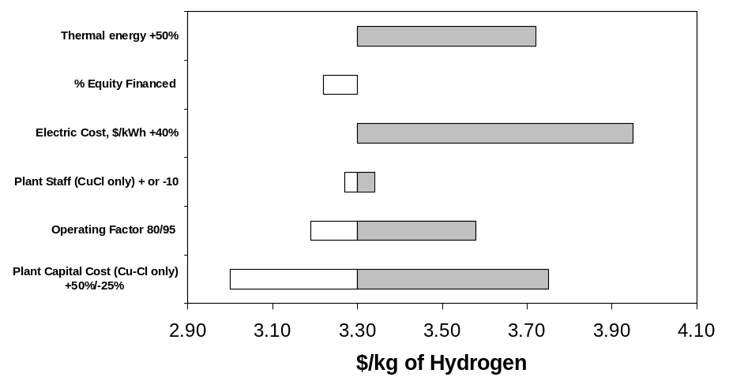
Figure 6. Economic sensitivities

4.2. Model of the Hydrolysis Reaction
The hydrolysis reactor was modeled with Aspen Plus with a feed of 100 kmol/hr of CuCl₂ and various amounts of water. Figure 7 shows the effect of temperature on the Cu₂OCl₂ yield as a function of the steam-to-copper (S/Cu) ratio as calculated by Aspen Plus™ model. An excess of steam is required for achieving high yields of Cu₂OCl₂. For instance, to achieve the maximum yield of 50 mol of Cu₂OCl₂ below 400ºC, a steam-to-copper ratio of 17 is needed. Below 400ºC, the model also predicts that the thermal decomposition reaction of CuCl₂ to CuCl occurs to a small extent, as seen in Figure 8. (No argon is present in the system probed by these sensitivity studies in Figures 7 and 8.)
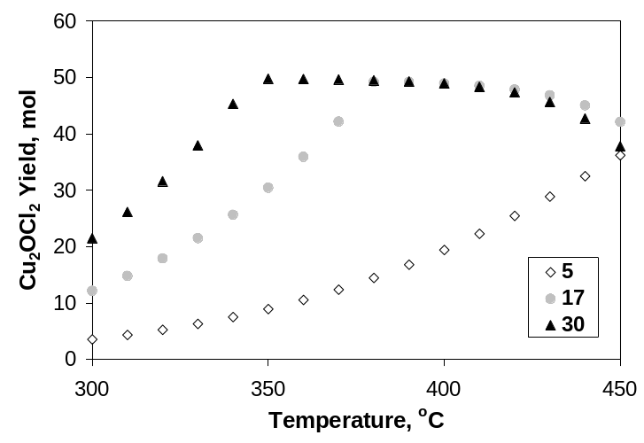
Figure 7. Effect of temperature on the Cu₂OCl₂ yield as a function of the steam/Cu ratio, calculated by Aspen Plus model (Ar=0).
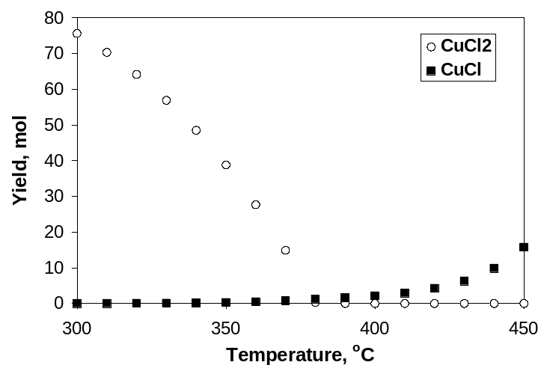
Figure 8. CuCl and CuCl₂ yields as a function of temperature (steam/Cu=17), calculated by Aspen Plus model (Ar=0).

4.3. Experimental Results

4.3.1. Thermogravimetric Studies
Thermal gravimetric analysis (TGA) was performed using CuCl₂ and Cu₂OCl₂ in pure Ar (no steam) to determine the thermal stability of these two materials. Figure 9 shows that, a significant weight loss occurred around 100ºC for CuCl₂ ▪ 2H₂O due to the removal of water. A smaller weight loss started to occur at 340ºC. At 375ºC, the weight loss was more pronounced and increased with time. It is assumed that the weight loss at 340ºC is due to the removal of gaseous products as the CuCl₂ decomposes into CuCl and Cl₂ at 375ºC. Some CuCl sublimated. A white material, subsequently identified as CuCl, was found as a deposit on the quartz wall of the instrument. The sublimed CuCl may account for an extra weight loss. After 60 min in Ar at 375ºC, the weight loss was 5.2%. If the only mechanism for mass loss was Cl₂ evolution at 375ºC, then the amount of CuCl in the sample after 60 min at 375ºC should be 15 wt%. If the mass loss is due to both Cl₂ and CuCl (g) losses, then the decomposition of CuCl₂ should be somewhat less than 15%. On the other hand, the weight loss of Cu₂OCl₂ during a similar TGA experiment is small, indicating that Cu₂OCl₂ is stable compared to CuCl₂. Indeed, the weight loss is only 0.5% for Cu₂OCl₂ at 375ºC after 60 min in flowing Ar.
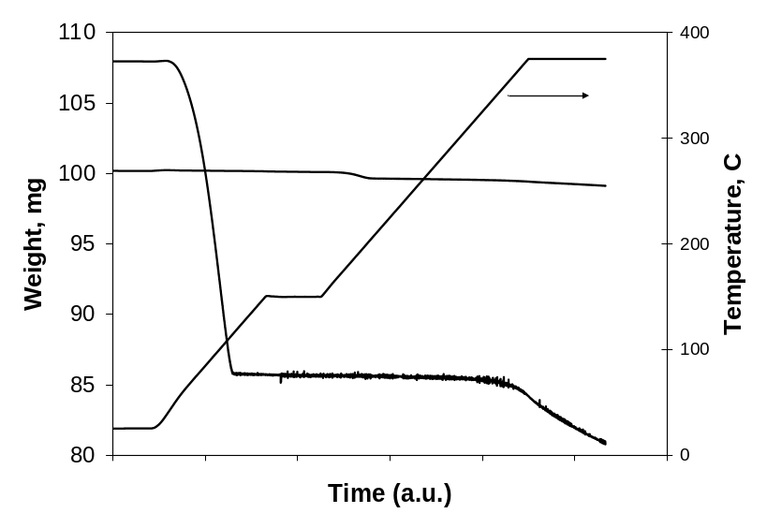
Figure 9. Temperature profile and weight change of CuCl₂ dihydrate and Cu₂OCl₂ in Ar as a function of time during.

4.3.2. Hydrolysis Reactor
Preliminary tests were performed at 375ºC in the 0.5-in OD quartz tube using CuCl₂•2H₂O as received. The tests conditions and the products analyses are listed in Table 6. The first group of tests was performed keeping the space velocity and the S/Cu molar ratio constants. The second group of tests was performed keeping the space velocity and the H₂O vapor concentration constants.

Table 6. Experimental conditions and elemental analyses of the products after the hydrolysis of as received CuCl₂ • 2H₂O in the 0.5-in OD tube.
Test Steam/Cu Ar Time GHSV H₂0 Vapor CuClª CuCl₂^{b} Cu₂OCl₂^{c}
# Molar Ratio (mL/min)(min) (h⁻¹) (%) (wt%)
1 28.3 200 60 43327 8 12.1 1.0 86.9
2 27 195 43 43313 10 15.5 1.3 83.2
3 27.1 185 28 43079 14 14.8 5.2 80.0

4 38 160 20 43135 26 16.4 10.8 72.8
5 52 160 30 43135 26 8.0 3.2 88.8
6 66 160 40 43135 26 11.1 1.5 87.4
ª error: ±0.3; ^{b} error: ±0.3-0.7; ^{c} error: ±0.5-0.7

The test results were promising as they showed high yields of Cu₂OCl_{2,} up to 89% when the S/Cu molar ratio was high, i.e., 52 and 66. The percent CuCl in these tests varied between 8 and 16%. While the high yield of Cu₂OCl₂ is encouraging, the amounts of CuCl are unacceptably high.

Longer times should result in more CuCl formation due to the thermal decomposition of CuCl₂, as seen by thermogravimetric studies (Figure 9). However, that was neither observed in the first nor the second group of experiment, where the longer experiment has the smallest amount of CuCl. The longer time gave the highest amount of Cu₂OCl₂ and the lowest amount of CuCl and CuCl₂ in both groups.

Higher S/Cu molar ratios should produce more Cu₂OCl₂. But we see very little difference in the amount of Cu₂OCl₂ when the steam to CuCl₂ ratio increases from 27 (exp. # 2) to 66 (exp. # 6). Experiments # 2 and # 6 were run for about the same amount of time.

In order to minimize the decomposition reaction while keeping a low S/Cu ratio, operating parameters, such as the test temperature, the test duration, the particle size of the starting CuCl₂ material, the carrier gas flowrate and the steam concentration were varied. In order to increase the gas velocity in the bed the reactor tube diameter was reduced to 0.25-in.

The amount of CuCl was significantly decreased when the reaction temperature was decreased (Figure 10). At 340ºC, the amount of CuCl in the sample was only 2.1 wt%. However, as the temperature was decreased, less Cu₂OCl₂ was produced and more CuCl₂ remained unreacted.
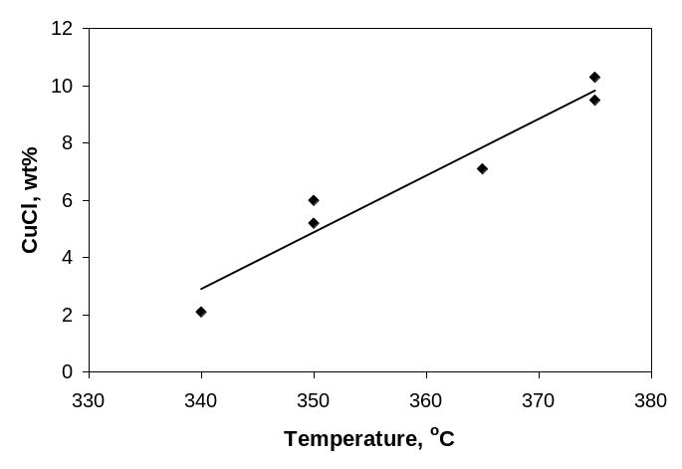
Figure 10. Amount of CuCl (wt%) as a function of reaction temperature using sieved 150-250 µm CuCl₂ • 2H₂O, for 60 min and steam/Cu=22 in the 0.25-in OD tube.

The amount of CuCl was also significantly increased when the reaction time is increased. CuCl increased from 4 to 10% as the length of the experiment increased from 30 to 90 min as shown in Figure 11. When the experiment time was increased from 30 min to 60 min, the amount of CuCl more than doubled. The amount of CuCl was nearly constant for test durations of 60 and 90 min. The plateau observed is due to the limited amount of CuCl formed which is governed by the total amount of CuCl₂ remaining which has not been converted into Cu₂OCl₂. As observed by TGA experiments, once Cu₂OCl₂ is formed, it is stable and does not decompose further.
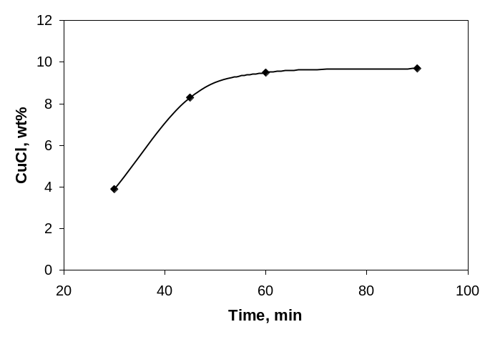
Figure 11. Amount of CuCl (wt%) as a function of reaction time using sieved 150-250 µm CuCl₂ • 2H₂O, at 375ºC and steam/Cu=22 for four test durations in the 0.25-in OD tube. Ar=200 mL/min.

The effect of particle size on the hydrolysis reaction products was studied. Experiments were done with three particle sizes of CuCl₂ • 2H₂O. The amount of CuCl formed decreased with decreasing particle size as shown in Figure 12. Tests with ball milled material showed the smallest amount of CuCl (around 3%) in the hydrolysis products. The impact of the particle size on the CuCl formation was more pronounced at low S/Cu, suggesting that the formation of CuCl was mass transfer controlled.
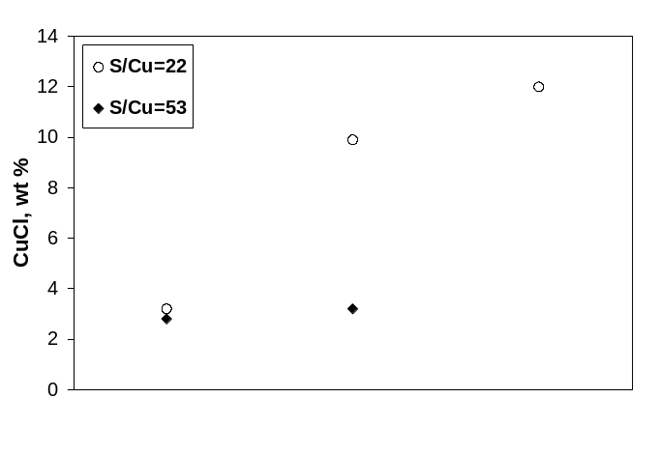
Figure 12. Amount of CuCl (wt%) as a function of CuCl₂ • 2H₂O particle size at 375ºC, steam/Cu-22 and 53, for 60 min in the 0.25-in OD tube.

Because the steam was introduced together with Ar in our experimental setup, the impact of the flow rate of the carrier gas was studied. The Ar flowrate was varied between 50 and 150 mL/min. The S/Cu changed from 10 to 30 as a result of the different Ar flow rates and humidifier temperatures.

At low flowrates (50 mL/min), little CuCl formed (0.6 and 0.7%), as seen in Figure 13. The decomposition reaction of CuCl₂ is indeed limited due to poor mass transfer of chorine out of the particles. When the Ar flowrate is increased, at a S/Cu ≤ 15, the amount of CuCl increased. The higher flowrates promote the higher removal of Cl₂ formed as the CuCl₂ decomposed. The decomposition reaction of CuCl₂ (4) is shifted toward the right with higher Ar flowrate.
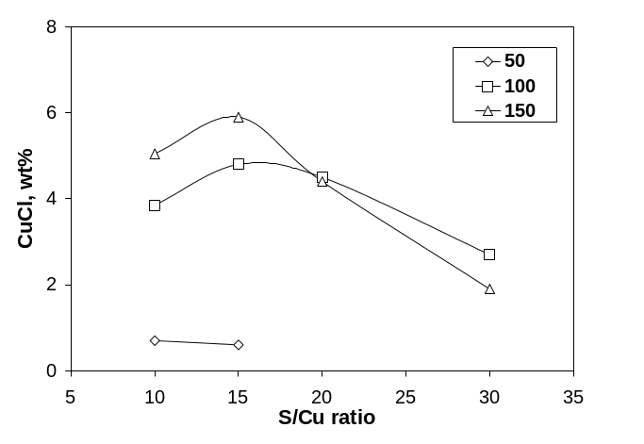
Figure 13. Amount of CuCl (wt%) as a function of steam/Cu ratio and Ar flowrate (50, 100 and 150 mL/min) using ballmilled CuCl₂ • 2H₂O, at 375ºC for 30 min in the 0.25-in OD tube.

The amount of CuCl is also higher at S/Cu=15 compared to S/Cu=10 for both Ar=100 and 150 mL/min. This is because at S/Cu=15 the total flowrate is larger than at S/Cu=10, thus the removal of Cl₂ is larger, and thus the formation of CuCl.

When the S/Cu ratio is increased (above 15), the larger amount of steam provides the driving force needed for mass transfer and the hydrolysis reaction becomes more important relative to the decomposition reaction. Thus, less CuCl and presumably more Cu₂OCl₂ are formed.

In the plant-scale design, there would not be any carrier gas because of the large cost associated with its heating and recycling.

5. Conclusions
A conceptual process design based on the 3 reaction CuCl cycle has been developed to produce 125 MT of hydrogen /day. The process is based on an Aspen Plus simulation which provides mass and energy balances for the process. An integrated heat exchange network for the conceptual process captures process heat. External heat and utility requirements are 210MWt and 87.8 MWe respectively. Defining efficiency as energy out divided by energy in results in estimated efficiency of around 40%. Capital requirements for the conceptual process were estimated using Capcost software. The chemical plant investment including the electrolyzer is $131MM (2005$). Operating costs were also estimated and an H2A analysis was preformed. The estimated cost of producing hydrogen is $3.30/kg. The results of the economic analysis are guiding the further development efforts, both experimental and modeling. Efforts are being focused in areas which will improve process efficiency and reduce capital investment.

During the hydrolysis of CuCl₂, high yields of Cu₂OCl₂ can be achieved, up to 89 wt%, however at high steam/Cu ratio and at the expense of undesired CuCl formation. The conditions to limit the formation of CuCl, the undesired product of CuCl₂ decomposition, have been studied. The formation of CuCl has been reduced to less than 1% at a low steam/Cu ratio of 10 when using ballmilled CuCl₂ • 2H₂O at low total flowrate (steam + Ar) for a reaction temperature of 375ºC and a reaction time of 30 min. However, at that condition, the amount of Cu₂OCl₂ appears to very low based on the visual observation of the relative amount of black material in the sample. Because the current reactor design provides insufficient mass transfer, another type of reactor needs to be used. A reactor system that sprays a fine mist of a CuCl₂ solution into a hot zone, followed by rapid quenching may be able to improve mass transfer between steam and CuCl₂ while inhibiting the decomposition into CuCl. We are currently designing this type of reactor.

6. Acknowledgements
Argonne National Laboratory's work was supported by the U.S. Department of Energy, Office of Nuclear Energy, Nuclear Hydrogen Initiative Program, under contract DE-AC02-06CH11357. The authors gratefully acknowledge the assistance provided by Dr. Paul Mathias, who developed the physical properties database for the Aspen Plus simulation and completed the sensitivity analyses, and Dr. Pascal Anziew for providing the schematic concept for relating changes in clerical expertise.

7. References
- www.hydrogen.energy.gov/h2a_analysis.html.
- Turton R, Baillie RC, Whiting WB and Shaeiwitz JA, Analysis, Synthesis and Design of Chemical Processes (2nd Ed), Upper Saddle River, NJ: Prentice Hall, 2003.
- ASPEN PLUS User Guide; Aspen Technology, Inc.: Cambridge, MA, 1988.
- William L. Luyben, Distillation Design and Control using Aspen Simulation, April 2006.
- Gorensek MB, Summers WA, Buckner MR, Qureshi AH. Conceptual design for a hybrid sulfur thermochemical hydrogen production process. Presented at the 2005 ANS Annual Meeting, San Diego, CA, June 2005.
- Pew S and Walsh P, Private communication, Porcelain Industries, Inc., Dickson, TN, April 2007.
- Guthrie KM, Process Plant Estimating Evaluation and Control, K. M. Guthrie, Craftsman Book Co, Carlsbad, CA, 1974.
- Ulrich GD, A Guide to Chemical Engineering Process Design and Economics, Wiley, Hoboken, NJ, 1984.

Argonne National Laboratory, Chemical Sciences and Engineering Division, 9700 S. Cass Ave., Argonne, IL 60439 Phone 630-252-6603; Fax 630-252-5246, e-mail lewism@cmt.anl.gov.
b Orion Consulting Co, 1240 Gilbert Ave, Downers Grove, IL 60515.
c University of Illinois-Chicago, 810 S. Clinton Ave. Chicago, IL.

