New York State’s Hydrogen & Renewable Resource Initiatives

Raymond J. Kenard

President, American Wind Power & Hydrogen, LLC

1. Today’s Energy Situation
Not much has improved on a national basis since the last NHA meeting. Energy security remains an important concern as the US consumes 26% of the world’s output of petroleum and imports about 60 to 65% of the petroleum consumed. This requires that we export over $400 billion of capital to countries, many of whom are unfriendly, or worse, toward the US. The expanding use of electricity in the economy and continued use of polluting vehicles has led the US EIA to predict the further increases in the consumption of petroleum and natural gas. Everyone is concerned and thinks something should be done about it.

The Federal Government has initiated two significant energy initiatives. First the Federal Government has provided a large incentive to produce ethanol from corn and now proposes to expand the production. This certainly does not address the energy security problem as imported energy is needed to make ethanol and ethanol is only 80% as efficient as gasoline in driving a car. Recent papers have been issued suggesting that the net effect of ethanol from corn is to increase global warming emission and to increase tail pipe emissions.

The second initiative, the very important FutureGen project, which would have demonstrated coal gasification and sequestration of carbon dioxide, isn’t going address energy security either. The project was recently postponed after three to four years of effort trying to decide where the demonstration project should be located, who should be involved, and what the costs were. The postponement is expected to be multi-yeared.

In the case of hydrogen activities,the Federal Government has funded the FreedonCAR program which was established in 2003. This program provided $1.2 billion to demonstrate that a fuel cell car was viable by 2015. Funds were not provided, however, to deal with the more pressing and immediate problems of reducing petroleum demand, energy security and reducing global warming.

Congress has chosen not to deal with the practical issues that impact on today’s problems. In particular, congress has refused to make a long term commitment to an investment tax credit for wind, solar and fuel cell projects. Also Congress has been unable to enact a Renewable Portfolio Standard.

2. California’s Hydrogen Initiatives
While California has been the leader in the development of the hydrogen transportation economy, its recent experience suggests that there are concerns about the cost. Recently, there have been concerns about the cost and number of the fuel cell vehicles available for which California has been building a hydrogen infrastructure. It is difficult to justify building multiple numbers of highway sited fueling stations if there are only a relatively few fuel cell vehicles in the area around a fueling station.

3. New York’s Hydrogen Concepts
New York State Energy Research & Development Authority (NYSERDA) has the responsibility of executing many of the State’s energy-related initiatives. NYSERDA funds the demonstration and development of many technologies using a System Benefit Charge collected from the State’s consumers of electricity.

As a result of a series of hydrogen industry stakeholders’ meetings in 2004 and 2005, NYSERDA produced a Hydrogen Roadmap. While most stakeholders were focused on the FreedomCAR program and the target year of 2015, a few pointed out that internal combustion engine vehicles could be fueled by hydrogen. If the vehicles were added to existing fleets, they could be fueled at dedicated fueling stations thereby eliminating the need for multiple fueling stations on highways. Furthermore, it was identified that New York had a unique source of renewable energy – Niagara Falls in the Buffalo area as well as some sustainable wind resources.

This has resulted in New York concentrating on hydrogen-fueled internal combustion engine vehicles (HICE) and on fleets of these vehicles that can be fueled at dedicated fueling stations.

NYSERDA’s first hydrogen transportation funding round (PON 889) in the amount of $1.2 million, was awarded to two projects. American Wind Power & Hydrogen’s (AWP&H) received an award for its SUNY Buffalo campus project consisting of two hydrogen-fueled Prius vehicles, a small fueling station, and a supply of hydrogen by cylinders. The other award was for a fueling station in Albany associated with Honda’s providing the State with two fuel cell vehicles.

NYSERDA had a second small funding for hydrogen activities which included a fuel cell driven service vehicle.

4. Current NYSERDA Funding of Hydrogen Projects
In 2006 then-Governor Pataki decided that there should be a maximum number of hydrogen-fueled vehicles on the road in New York and provided $5 million of funding from the State’s budget. This funding (PON 1082) has led to a multiple number of projects which are in various stages of development.

NYSERDA is providing funding for eight hydrogen projects which will be in operation by the end of 2008. Five projects will be located at sites where there are CNG fueling stations. A total of 22 internal combustion engine vehicles are being converted to hydrogen fuel and a multiple number of CNG-fueled vehicles will be operated on blends of hydrogen and CNG.

5. The Albany International Airport’s HyIMPACT Project
The first award made under PON 1082 was to AWP&H for a project that combined the interests of the Albany International Airport and the Capital District Transportation Authority (CDTA). The Award ($1.2 million) covered the procurement of two hydrogen-fueled Prius vehicles to be used by CDTA’s route supervisors on their daily rounds, two hydrogen-fueled Silverado pickup trucks to be used at the Airport for general maintenance purposes, a modest-sized fueling station supplied by Air Liquide, and a two years’ supply of hydrogen also supplied by Air Liquide.

CDTA was interested in having a hydrogen-fueled internal combustion engine transit bus. Efforts were made to get funding directly from Federal agencies. However, funding was available only for fuel cell vehicles.

Since the Airport has six CNG shuttle buses AWP&H and the Airport discussed converting them to HYTHANE. In addition, plans were proposed to build a larger fueling station as General Motors plans on driving their hydrogen-fueled vehicles from Rochester to New York City and stopping in Albany for refueling. This larger scope would require the production of low cost hydrogen at the Airport. However, funding was not then available for the larger scope.

The unfunded larger scope of the project has now become Phase II of the HyIMPACT Project which will be focused on a commercial effort that will validate the concept of dedicated fueling stations serving fleets of vehicles.

There is considerable industrial development around the Airport and a number of motels serve the airport. There is a sufficient variety of HICE and HYTHANE vehicles available to meet the needs of these entities. An effort will be made with local industry to involve them with the hydrogen transportation economy and provide them with vehicles that can be fueled at the Airport’s fueling station.

The Airport has an anaerobic digester that converts deicer fluid runoff to methane which is flared. Sufficient methane is flared to fuel a 300 kw molten carbonate fuel cell during five or six months of the year. The Airport is seeking to process other industrial organic water waste from nearby sources and increase the amount of methane produced. The potential exists to use this waste gas supplemented by natural gas to fuel a molten carbonate fuel cell.

Molten carbonate fuel cells are high temperature fuel cells that convert methane to hydrogen at the anode in the unit. This hydrogen can be tapped off and purified. A 300 kw fuel cell will produce 135 kg of hydrogen a day in addition to 250 kw of electricity. The final scheme for the Airport is illustrated below.

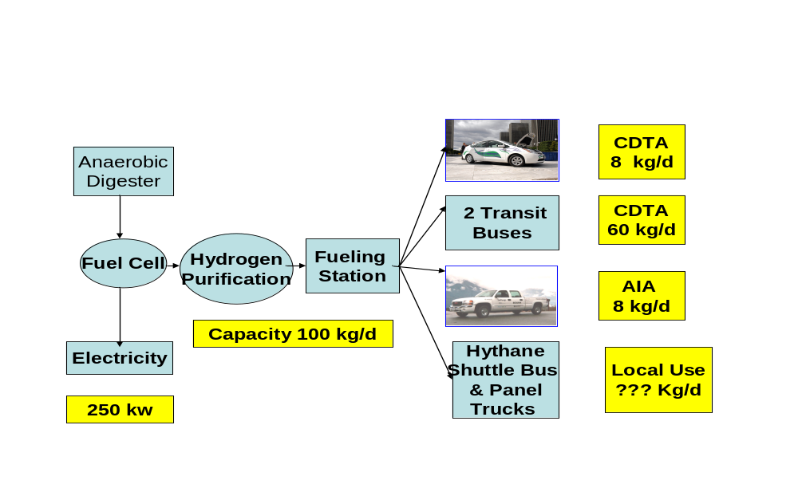

6. Office of General Services, Albany Project
Governor Pataki’s Executive Order No. 111, which was continued by Governor Spitzer and is likely to be continued by Governor Patterson required an early effort by state agencies to build fleets of alternate fuel vehicles. The Office of General Services has responsibility for the State’s extensive fleet of vehicles which includes 3000 to 4000 CNG-fueled service vehicles. There are about 50 CNG fueling stations in the State. One of these, in Albany at an exit of Interstate 87, is a public access fueling station open 24 hours a day,

OGS will install and operate an electrolyzer, hydrogen compression, storage, and hydrogen and hydrogen/CNG dispensers at the CNG fueling station. CNG fueled vehicles will be tested with blends of hydrogen and CNG. The potential exist for a large scale conversion of fleets of CHG vehicles to blends of hydrogen and CNG. This could lead to adding hydrogen fueling stations at multiple CNG locations on highways eventually leading to a Hydrogen Highway

7. City of White Plains Project
The City currently operates a CNG fueling station. Shell Hydrogen has installed a
30 kilogram per day hydrogen fueling station at the CNG site. Three Prius vehicles and one Silverado pickup truck will be converted to operate on hydrogen. In addition a Silverado pickup truck converted to run on CNG is also being acquired and added to the existing fleet of five CNG vehicles. The CNG vehicles will be fueled with a blend of hydrogen and CNG. The fueling station has the capability of dispensing hydrogen at 700 bar pressure so as to fuel the GM fuel cell vehicles that are being placed in service in the New Yok City/Westchester area.

8. Hempstead, Long Island Project
The Town of Hempstead will add hydrogen generating capacity by electrolysis of renewable energy to its CNG fueling station. Possible sources of energy are solar or wind. Two HICE vehicles will be acquired and two of the Town’s CNG vehicles will be converted to a blend of hydrogen and CNG

9. Rochester Institute of Technology Project
RIT will acquire three hydrogen-fueled Ford Escape SUVs and setup a hydrogen fueling station using hydrogen delivered by cylinder. RIT will be responsible for monitoring the performance of all the vehicles included in the PON 1082 funding.

10. West Babylon, Long Island Project
Vogelbilt Corporation will add hydrogen generation by electrolysis to its existing alternate fuel filling station. The Town of Babylon will acquire one Silverado pickup truck and have it converted to run on hydrogen. The vehicle will be added to the Town’s fleet of vehicles.

11. The Bronx, New York City Project
Shell Hydrogen has joined forces with the New York City Department of Transportation and convinced the City’s Fire Department to respond favorably to the idea of a hydrogen fueling station in the Bronx. A mobile fueler will be installed. Six Prius vehicles will be acquired by the City and converted to be fueled by hydrogen.

12. NYSERDA’s Low Cost Hydrogen Initiative
The combined NYSERDA funding for PONs 889 and 1082 amounts to only $6.2 million. By the end of 2008, New York will have a fleet of 22 HICE vehicles and eight fueling stations. The effort to date has established a basis for future growth. It is hoped that the variety of low cost HICE and HYTHANE vehicles will make it possible to attract local industry to acquire and fuel vehicles at the fueling stations being installed. The potential exists for expanding CNG fueling stations to dispense hydrogen and serve local fleets of vehicles. These stations would also make up a hydrogen highway.

In the future, airports, universities, and transportation centers can build dedicated fueling stations which would support fleets of HICE vehicles in their area. The public would have the exposure to a dynamic growing effort that addresses today’s problem today.

13. General Motors’ Hydrogen Initiatives in New York State
As a result of its involvement in the FreedomCAR program, General Motors will be operating 30 Equinox Fuel Cell Vehicles in the New York City/Westchester County area. Four 700 bar pressure fueling dispensers will be available at various fueling stations to fuel the vehicles.

A fuel cell vehicles maintenance center has been established in Ardsley NY. One of the 700 bar pressure dispensers is located there. A second fueling station, noted above, is located in White Plains. The third station, also noted above will be located in the Bronx Borough of New York City. For the fourth station GM has proposed establishing a mobile fueler fueling station at the Kennedy Airport

GM’s R&D Center is located in Honeoye Falls, NY near Rochester. GM has driven one of its fuel cell vehicles from Honoeye Falls to Westchester a distance of 300 miles with one stop for refueling.

14. New York Power Authority’s Hydrogen Initiative
The New York Power Authority is developing two 120 kilogram per day electrolysis units in the Buffalo/Niagara Falls area. One facility will be used by the Buffalo transit authority and the other by the State Park. The transit authority has received funding from the Federal Transit Administration to fuel two hydrogen-fueled buses. The Park will convert their fleet of vehicles. The electricity will be Niagara Falls generated renewable resource energy.

15. Expanding the Scope of Hydrogen Applications
The 2007 activities involved stand alone vehicle projects using technologies that have been applied in projects elsewhere. It appears that 2008 will present unique opportunities to expand the scope of the hydrogen activities.

For instance, Farmingdale State College which is part of the State University of New York, located at Farmingdale, Long Island wants to become a renewable energy center. It has a large-scale ground mounted solar array and wants to encompass a variety of other green energy technologies including a large scale fuel cell, a solar/hydrogen green building and hydrogen transportation vehicles.

AWP&H is discussing with the staff of the Farmingdale State College a four phased deployment of green energy technologies that would start with a 300 kw molten carbonate fuel cell supplying the campus with electricity and nearby dormitories with heat. In later phases, when large quantities of hydrogen are required, it will be produced by the fuel cell.

New York City has identified that buildings are responsible for 76% of the greenhouse gas emissions and transportation only 24%. Building “green” buildings reduces the amount of greenhouse gas emissions. However, by adding a solar/hydrogen system the building can be come independent of the grid electricity. The Farmingdale College hopes to include such a building in their deployment of green technologies.

