INTRODUCTION OF FUEL CELL TECHNOLOGY
INTO DEVELOPING COUNTRIES

M. Binder

1. Introduction
The International Finance Corporation (IFC) is the private sector affiliate of the World Bank Group. IFC’s mission is to promote sustainable private sector investment in developing countries. IFC is taking the lead in introducing fuel cells as a preferred technology for privately-financed, distributed, stationary power applications in developing countries. In this role, IFC acts as an executing agency for the Global Environment Facility (GEF), a multilateral finance program which is administratively housed in the World Bank. The GEF serves as the official financial mechanism for the United Nations Framework Convention on Climate Change (UNFCCC) and has identified fuel cells as a promising technology to be supported under the GEF’s Operational Program #7: “Reducing the Long-Term Costs of Low Green House Gas (GHG) Emitting Technologies”. In May 2002, the GEF Secretariat agreed to allocate up to US$54 million in two stages for this fuel cell initiative. The first stage of this initiative is planned to use up to US$9 million of GEF funding, and consist of up to three individual pilot projects that will demonstrate the value of stationary fuel cell technology in economic and environmental terms in developing countries (US$2,000/kW – US$3 million maximum per project). The second phase is planned to provide the remaining US$45 million for advanced projects that will further advance the objectives of Phase 1. Mike Binder and Associates, Inc. serves as a technical due diligence consultant for this program.

The first stage of the aforementioned initiative is currently under way. In December, 2005, a US$3 million grant was awarded to the team of IST Holdings Ltd (Pretoria, South Africa) and Plug Power Inc (Latham, NY) for the installation of 400 Plug Power manufactured fuel cells in remote locations and cities in South Africa over a three-year period. The 400 fuel cells are to consist of 286 GenCore and 114 GenSys models. GenCore is a nominal 5-kW hydrogen-fueled fuel cell power plant intended for backup power application at telecommunications facilities. The GenSys is a nominal 5-kW propane-fueled fuel cell power plant intended for prime power application at remote telecommunications facilities. As the project was almost half way through the 3-year performance period, I was requested to make a site visit to South Africa in May 2007 to assess the progress being made on this project as part of the overall IFC due diligence effort. This trip consisted of a number of interviews with pertinent individuals, and site visits to installation and evaluation sites. This paper provides a summary of the activities undertaken as part of my trip, and recommendations which resulted from this visit. All details apply to the time of my visit – a follow-up trip is planned to be scheduled in the near future to update progress.

2. IST Holdings Ltd
IST Holdings Ltd served as the host organization for my trip to South Africa. IST Telecom is a provider of leading edge network solutions and state of the art power electronic solutions to the telecommunications industry in South Africa and other sub-Saharan Africa countries. Their role in the IFC-funded project includes sales of fuel cells to their customers, installation of the fuel cell systems, system maintenance, and coordination of refueling efforts. Hydrogen is purchased from AFROX. IST said that they have an interest in fuel cells in general, including sizes and applications beyond that for the telecommunications market. In particular, they have a strong interest in fuel cell implementation for the 2010 World Cup scheduled to be held in South Africa. Their primary target telecom customers for the IFC fuel cell program are Eskom, Vodacom, and MTN. Interviews were conducted with each of these companies.

The South African electric grid is by far the most reliable in sub-Saharan Africa; however, it is highly unreliable by United States standards (I am personally aware of four power outages in excess of 6 hours in the two weeks of my visit). The grid is expected to lose reliability over the next few years due to the lack of a sufficient buffer reserve. The system is old and no new capacity has been allowed to be added in the last 20 years (a new power generation facility is currently planned but will be some time before it comes on line). Batteries are the current incumbent technology for telecom backup applications. Diesel gensets are transported to sites within reasonable travel time when the outages are expected to extend beyond battery capacity. However, where 2-hour backup capability used to be considered sufficient, the industry is now moving toward a minimum 12-hour backup capability given the anticipated declining South Africa grid quality. Thefts of batteries and gensets, as well as copper wire, and illegal tapping of electric grid power lines, especially in remote regions, contribute further to telecom power lack of reliability. Fuel cells offer a potential solution to these problems. The only fuel cell implementation in South Africa, other than the IFC-funded effort, was a four-month field trial of a P21 GmbH Premion T 6-kW hydrogen-fueled backup system in conjunction with Vodacom in Spring 2007.

The IST/Plug Power team feels that they have a good understanding of telecom backup power requirements due to a major investment they have made in accomplishing that. They feel that the GenCore technology is becoming well acknowledged by telecom companies, but hydrogen infrastructure and project financing issues (in the absence of IFC grant funding) remain as problems.

They feel that the GenSys product will not find a major market in South Africa, except in remote areas where grid extension is not practical, or thefts of batteries and gensets are highly likely. However, they feel that it would be perfect for mass deployment in other African countries with extremely unreliable grids (e.g. Nigeria). However, given the political situation in some of these countries, they feel it would be best to prove the technology in South Africa, and then once confidence in the product’s reliability is proven, to do mass deployments in other countries.

3. Eskom (Cape Town, South Africa)
Eskom is a South African electric public utility, established in 1923 as the Electricity Supply Commission (ESCOM). The utility is the largest producer of electricity in Africa, is among the top seven utilities in the world in terms of generation capacity, and among the top nine in terms of sales. Eskom has traditionally used Ni-Cd and Lead-Acid wet cell batteries as backup power for Eskom’s telecommunications control network. These batteries need considerable maintenance and there are environmental concerns connected with battery disposal. They decided to look for alternative technologies. The company felt that fuel cells needed to be considered as an alternative based on their reliability and environmental characteristics. The company performed a literature search and thus became aware of PEM fuel cell technology as used for backup power. Eskom decided that they would do a demonstration project. Eskom had for some time been buying rectifiers from IST, and from them learned about the Plug Power line of backup power fuel cell products. As a result, they did a demonstration of a 48 V output GenCore at the University of the Western Cape, and then later moved it to their Hawekwasberg mountain top communications tower site. They also installed two 108 V output GenCore units at distribution substations.

Eskom personnel indicated that wide-spread implementation of fuel cell backup power systems will require a major paradigm shift. The amount of backup power time available from batteries depends on the state of charge of the batteries at the time – as little as 1-hour is guaranteed. Eskom wants to have a minimum of 12 hours for their sites. However, before they are willing to adopt fuel cells as the standard for backup power requirements, they must become assured of fuel cell and hydrogen fuel supply infrastructure reliability. Initially, the fuel cells were used as secondary backup power with the existing batteries as primary. At the time of my visit, the fuel cell backup power systems were serving as primary backup power with batteries as secondary. As confidence in system startup reliability increases, they will eventually move to using the fuel cells as the sole backup power source. Of the three systems installed so far, the shortest time of operation was almost one year, and the maximum was around 2 years. Initial impressions were that fuel cell interfaces are extremely easy from a user’s perspective, and that the system start-up reliability was proving out. The fueling infrastructure issue still needed to be adequately addressed.

I visited the Hawekwasberg mountain top site (Figure 1). The load at this site is just less than 2 kW. Three hydrogen cylinders provide 12-15 hours of backup time for the GenCore fuel cell. There are two banks of 3 cylinders on site (Figure 2). There is a low-fuel alarm to alert when the first bank of 3 cylinders is empty. Typically that signals the immediate replacement of the empty cylinders, except in cases where the local depot is out of hydrogen.

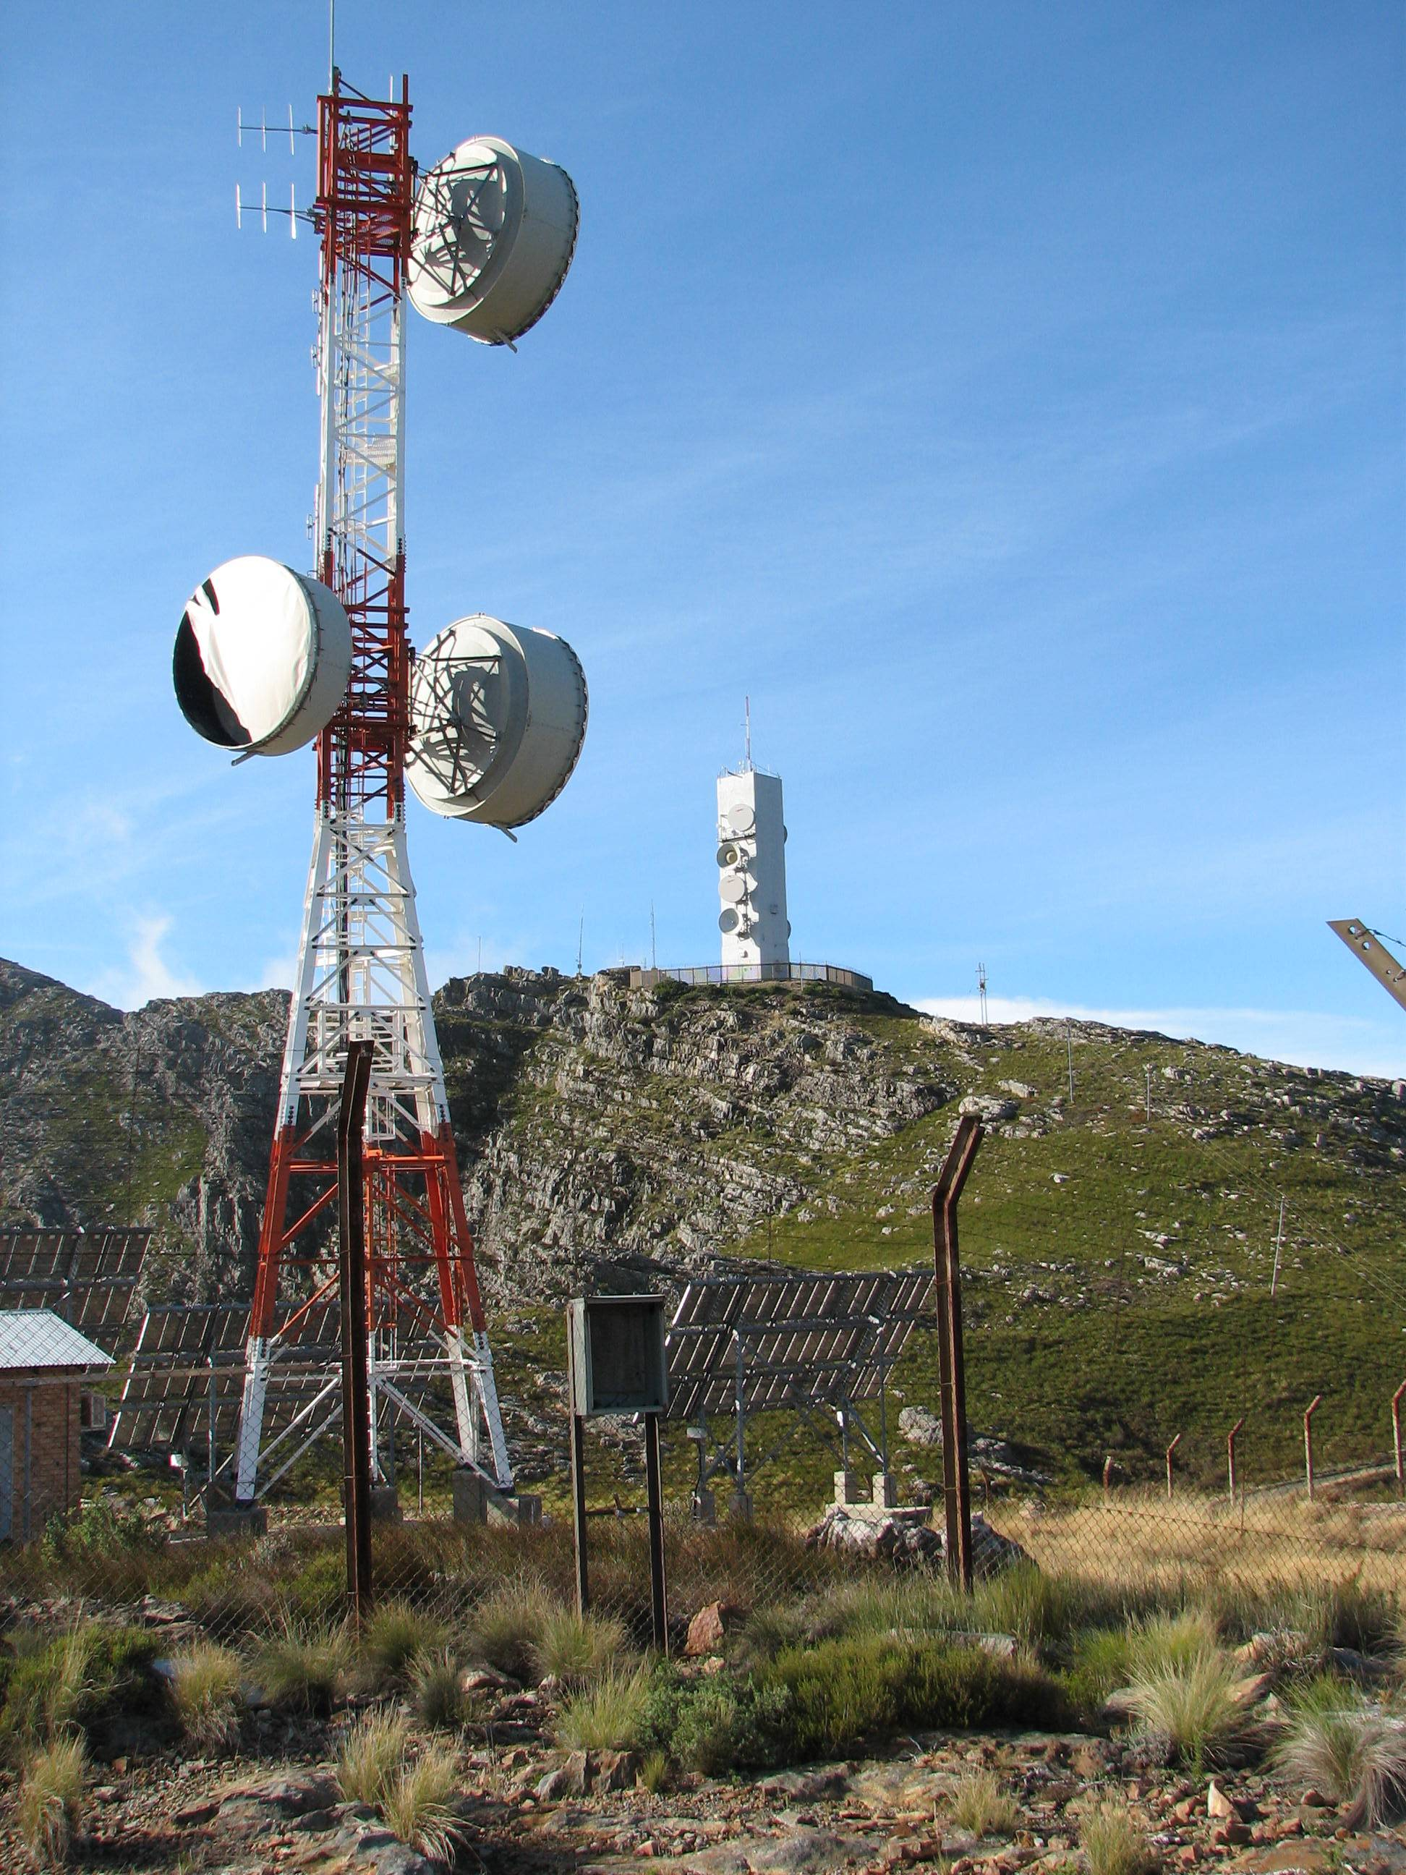

Figure 1. The Eskom Hawekwasberg site

At the time of my visit, Eskom was planning what they felt would constitute a statistically significant 24-GenCore unit test of the reliability of the hydrogen supply infrastructure reliability. They intend to install these GenCore units at seven transmission sites, five telecom sites, and twelve distribution sites. These units were planned to be installed by the end of 2007 for a one-year test period. If the results of this test prove satisfactory, then the GenCore product will become one of the Eskom standard backup options available to site designers. At this time, Eskom has a five-year plan for new sites and refurbishment of existing sites.

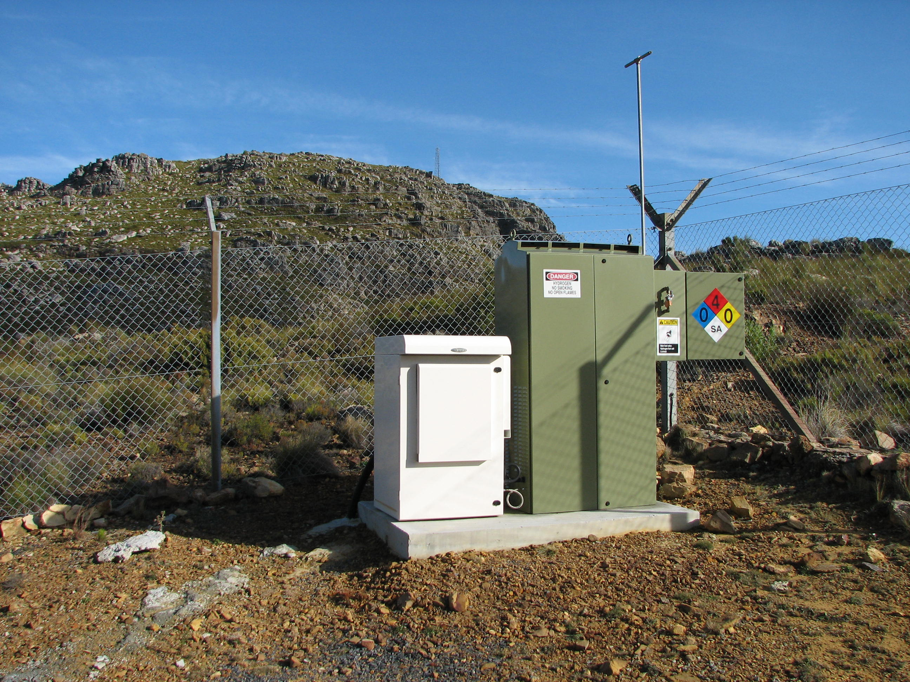

Figure 2. The GenCore fuel cell and battery cabinet at the
Eskom Hawekwasberg site

Eskom indicated that they are interested in looking at on-site generation of hydrogen to avoid the need for cylinder replacement. They are looking at on-site electrolyzers, sodium borohydride, etc. Plug Power is also pursuing a number of refueling options and have requested Eskom input to assist the optimization of this effort. Eskom is also considering the application of fuel cells for depots and UPS applications. They currently have discussions ongoing with IST concerning a potential GenSys demonstration in 2008.

I inquired as to what Eskom anticipated the most likely number of total sites that would be adapted for fuel cell use would be if the results of the 24-unit test were satisfactory. They estimated that 10-15% of 3,500 distribution sites, 50% of 1,000 telecom sites, and possibly 40% of 250 transmission sites could be possible. The percentage of transmission sites was still being analyzed. The actual numbers would be dependent on the results of an ongoing life-cycle cost analysis. Initial results indicated that fuel cells for new sites are more compelling than refurbishment of existing sites.

4. Vodacom
Vodacom has eight separate regions in South Africa. My visit included the Western Region (Cape Town) and the Northern Border Region – West (Pretoria). Both of these regions have ongoing fuel cell backup power applications.

The Western Region’s interest in fuel cells came about from a desire to have long-term backup capability – at least 24 hours. They knew that fuel cells could offer them 2-3 days backup time. In November 2006, they installed GenCore fuel cells at two different sites. Both of these sites average around 0.5 kW demand. The fuel cells were installed as secondary backup to the existing battery banks during a confidence building period. By the day of our meeting, they had placed the fuel cells as primary backup with the batteries as secondary. As confidence builds, they will disconnect the batteries and then eventually remove them. So far, they have determined that the capital expense of fuel cells is on a par with batteries. However, the operational costs are more due to the need for hydrogen delivery. This may be offset somewhat by the fact that with the batteries as backup, the rectifier is always floating, consuming a constant 270 W of electricity. Since the fuel cells are event-driven (operating only when the grid is down), they can use a smaller rectifier and also save the 270 W of electricity. The overall effect on the economics has yet to be analyzed.

The Western Region was planning a third demonstration, likely to be installed in July 2007. In keeping with the Western Region’s strategic plan to introduce fuel cells in their territory, they will again target a low power application. This demonstration is designed to test a number of characteristics of fuel cell backup systems. The demonstration site will be at their Sendelingsdrif facility located on the South Africa/Namibia border. The site is subject to temperature extremes and the nearest hydrogen supply depot is ~750 km away. The site averages 200 W power demand. A GenCore fitted with 6 bottles of hydrogen should be able to provide 4-5 days of backup, allowing ample time for delivery of replacement hydrogen. This site will also feature the first ever demonstration of the Alcatel (who recently acquired Lucent technologies) Compact Base-station Outdoor (CBO) system in combination with a fuel cell (it will also be the first application of the CBO by Vodacom). This is a very small system designed to be used outdoors. Thus there is no need for a building to house the communications equipment at the site. Typically the communications gear and the batteries are housed in the same building. The fuel cell in combination with the CBO thus alleviates the need for batteries, and hence for any building at all, resulting in lowered initial site cost. The CBO/GenCore combination was being tested at the Western Region offices at the time of our meeting (Figure 3). Once confidence is built in fuel infrastructure and temperature extremes capabilities, the Western Region will consider applications for larger metro sites. They feel that the next logical step in taking fuel cell telecom backup systems to market would be the integration of the CBO and the GenCore.

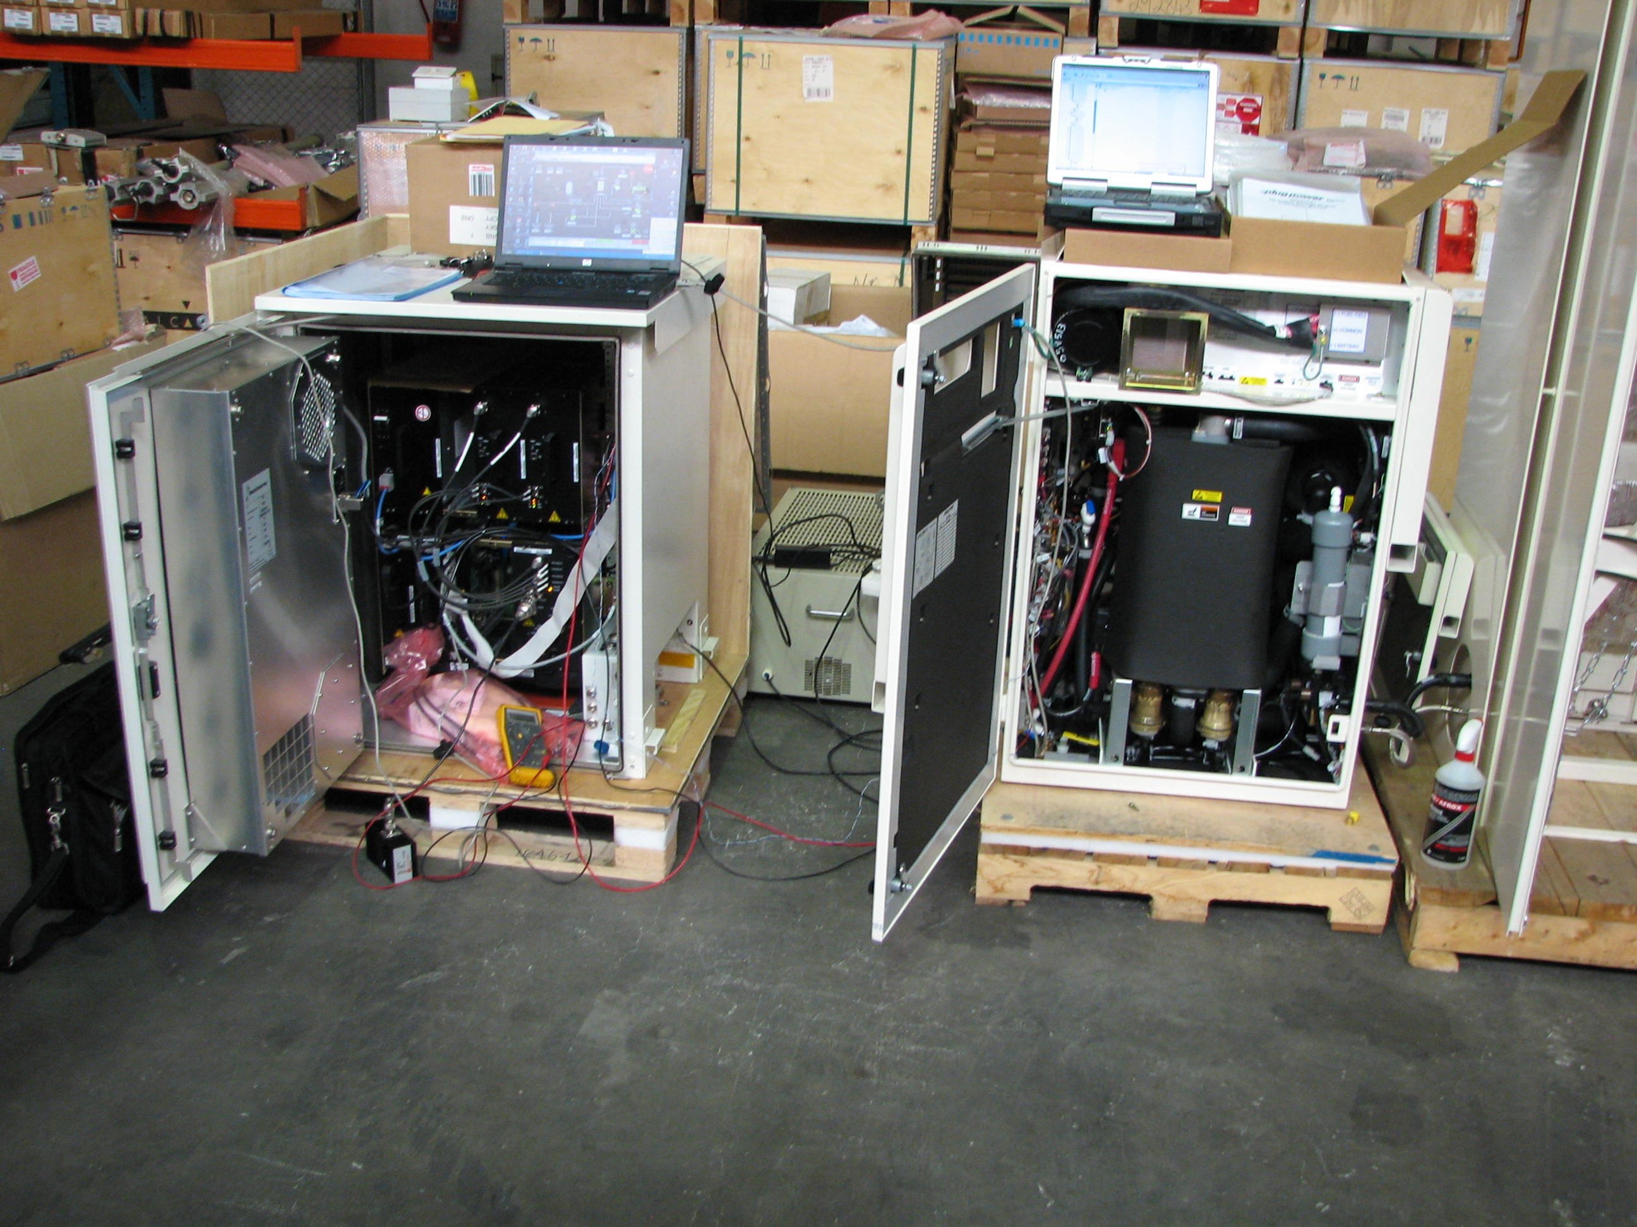

Figure 3. The Alcatel CBO and GenCore combination under test
at the Vodacom - Western Region

The Western Region doesn’t want to rush into things. They want to do a complete technical (operational) and financial analysis first. They have a few portable gensets that they move to sites when the grid fails, to act as backup to the batteries. These sites are limited to those for which the driving time is less than the anticipated battery backup time. There are a few sites with permanent gensets. There are a few sites for which an armed security guard is required due to political situations. Existing gensets are 15 kW to serve multi-user sites. Power requirements at all sites are increasing as technology develops. The plan is to eventually move to 30 kW gensets. They would like to see fuel cells mounted on trailers to act as genset replacement as a future option.

The Western Region was to do its financial planning for 2008 during the July-September 2007 period. Their plans at that time called for a progressive continuation of fuel cell demonstrations. Their first application will be rural/remote sites for which the travel time is relatively long. They will do 10-15 units maximum in this category. They will then move on to nodes, where there may be five sites coexisting in one place. Last, they will look at metro sites. For these, they feel that larger fuel cells would be beneficial (~12 kW). Remote sites are ideally suited for fuel cell backup systems. These sites tend to have lower power requirements which provide more backup time per cylinder of hydrogen. This fits well with the longer travel times required to reach these sites.

There are currently 25 GenCore fuel cells in the Vodacom Northern Borders – West region. This region has experienced numerous power failures in its service territory (~15/month), frequently of long duration. Some sites even have power outages daily. These outages cause extensive battery drain. At sites at which the GenCore units are deployed, the batteries are allowed to drop to ~47.5 volts, at which time the GenCore fuel cells are tripped on as secondary backup power. Eventually, they will remove the batteries and the GenCore fuel cells will be the sole standby power source. Once the batteries are removed, additional hydrogen bottles will be needed at some of these sites to provide the additional storage time previously provided by the batteries. Hydrogen is very expensive, and AFROX refuses to sell the hydrogen bottles, electing instead to refill them for safety reasons. AFROX also insists on running pressure tests after every three refills. As a result, Vodacom indicated that they would eventually like to see reformer technology integrated within the GenCore system. In the meantime, they are considering buying hydrogen tanks from someone else (possibly composite tanks) and a large electrolyzer to serve their customers. At this point, they are very satisfied with the results of their experience with fuel cell backup power systems. If fuel cell technology were to be made a standard for Vodacom sites, it is likely that the West Region would retrofit around 60 sites (~10% of their total sites). The West Region adds about 40-50 new sites per year, all of which would employ fuel cells as well. However, they did make it very clear that were it not for the economic assistance of the IFC grant, they would not be implementing fuel cell technology and would stick with batteries and backup diesel generators until the cost of fuel cells drops sufficiently.

I was able to visit a Vodacom rooftop site located in downtown Pretoria on Skinner Street (see Figures 4 and 5). Vodacom felt that the Skinner Street site was a good site to really put IST to the test due to logistic installation and fueling difficulties. This site provided a major challenge to IST for installation, and continues to provide a challenge for hydrogen refueling. The site is located on the roof of an 8-story building in downtown Pretoria. The building elevator only goes to the 7th floor. Access to the 8th floor and roof must be gained by climbing a couple flights of stairs. Further, the roof is divided in two by a large domed skylight running lengthwise. On either end of the skylight is a channel approximately 5 feet in depth, 10 feet across, and 20 feet long. On either side of the channel is a vertical ladder bolted to the side of the channel. The fuel cell and telecom equipment are located on the other side of this channel from where the roof access point is. Installation of this fuel cell required the use of a helicopter to lift and transport it into place. Delivery of hydrogen bottles to the site requires taking the bottles up the elevator to the 7th floor, pulling them up a couple flights of stairs to the roof, moving them to the channel, descending a vertical ladder on one side of the channel, crossing the channel, and ascending a vertical ladder on the other side of the channel, and moving them to the hydrogen storage cabinet.

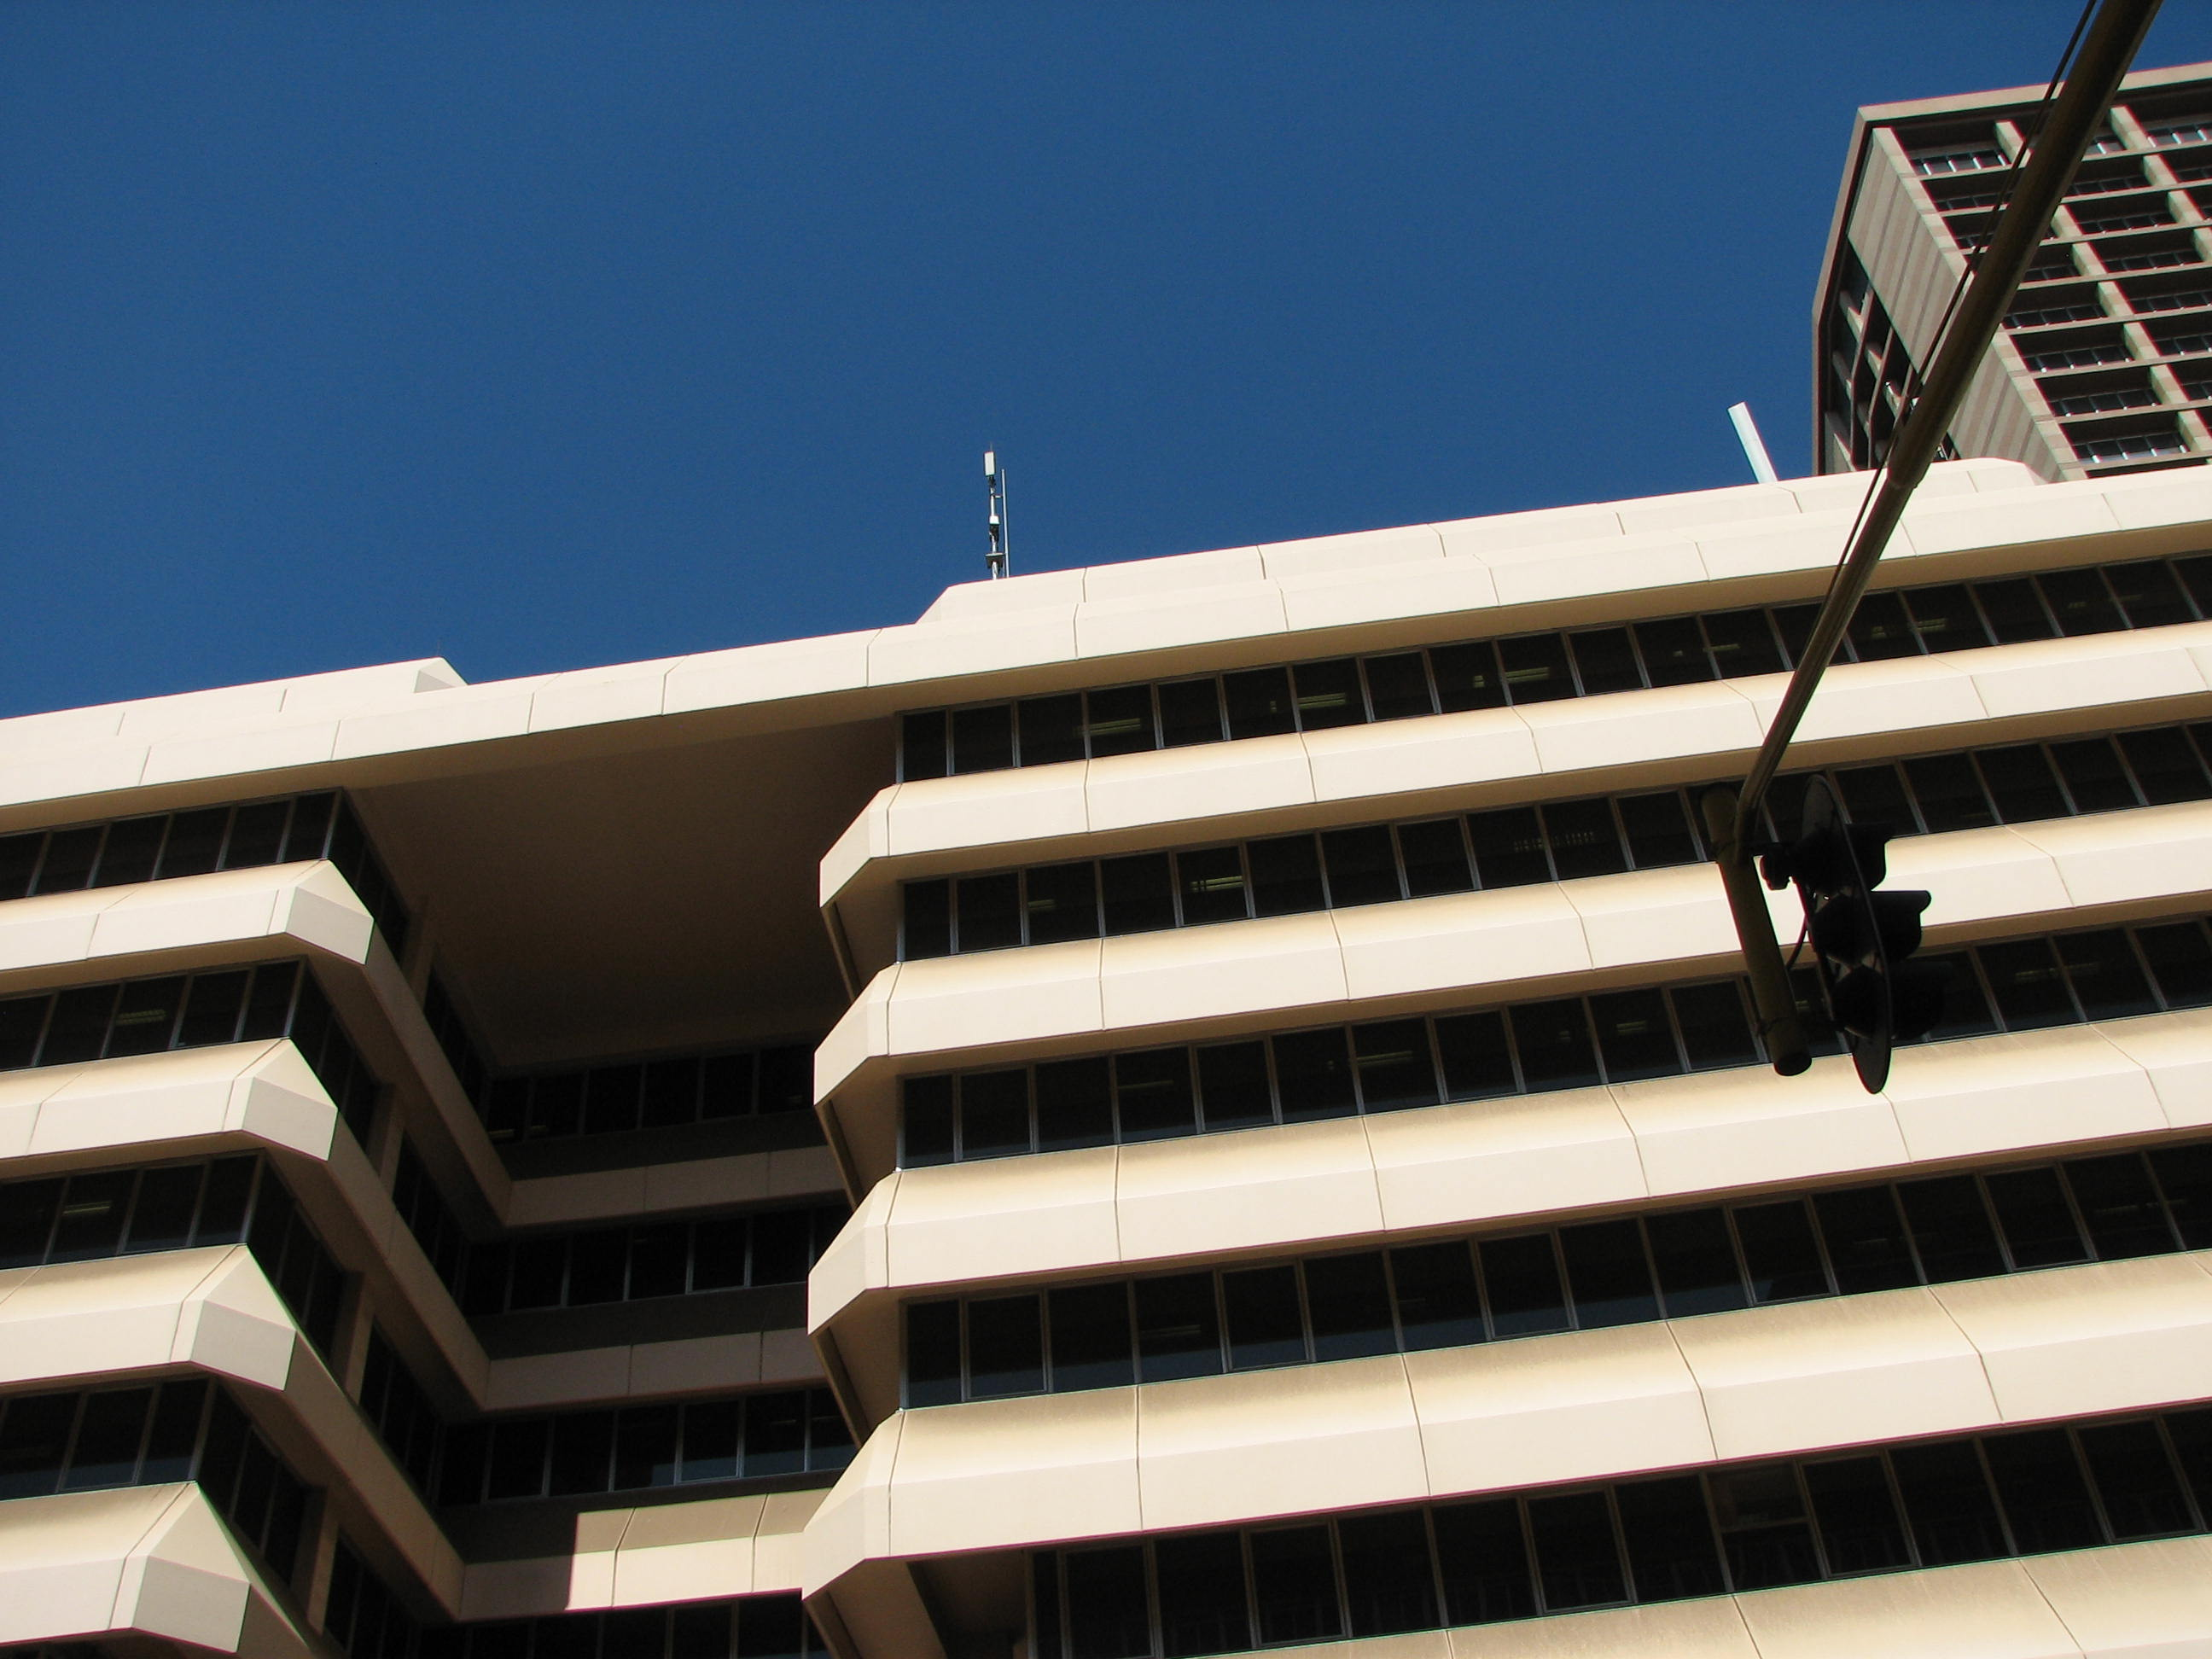

Figure 4. The Vodacom Skinner Street site is located on the
rooftop of an 8-story building in Pretoria

Vodacom - West personnel indicated that they have a shared site at which power is currently being stolen that might be a good candidate for implementation of a GenSys unit. The system currently needs 48 V, but they are considering moving the 48-V equipment to other sites and replacing the current equipment at this site with 24-V systems along with a 24-V GenSys unit. At the time of my visit, there was about a 3-month lag time to take delivery on a Gensys unit. AFROX has agreed to supply the needed propane tank free if the GenSys were to run continuously (Vodacom would just pay for the LPG itself). They also noted that they are looking to go to AC power at some sites in which case they would need to obtain an inverter for the GenSys systems. In some cases, security would be needed to avoid power theft.

The Northern Borders Regions - East and - West each have 750 telecom sites. Approximately 50% of these sites are considered viable candidates for fuel cell implementation. They said that they would implement all these sites now if they had the budget. Vodacom profit requirements are set by the stockholders. In approximately October of each year, the budget requirements are set for the next fiscal year (Apr 1 – Mar 31) for all of Vodacom (eight regions). The Board must review these requirements subject to any imposed budget cap and company priorities. The budget then goes back and forth between the Board of Directors and the regions until a consensus is reached. Improving and expanding their current telecom capability is the current company priority.

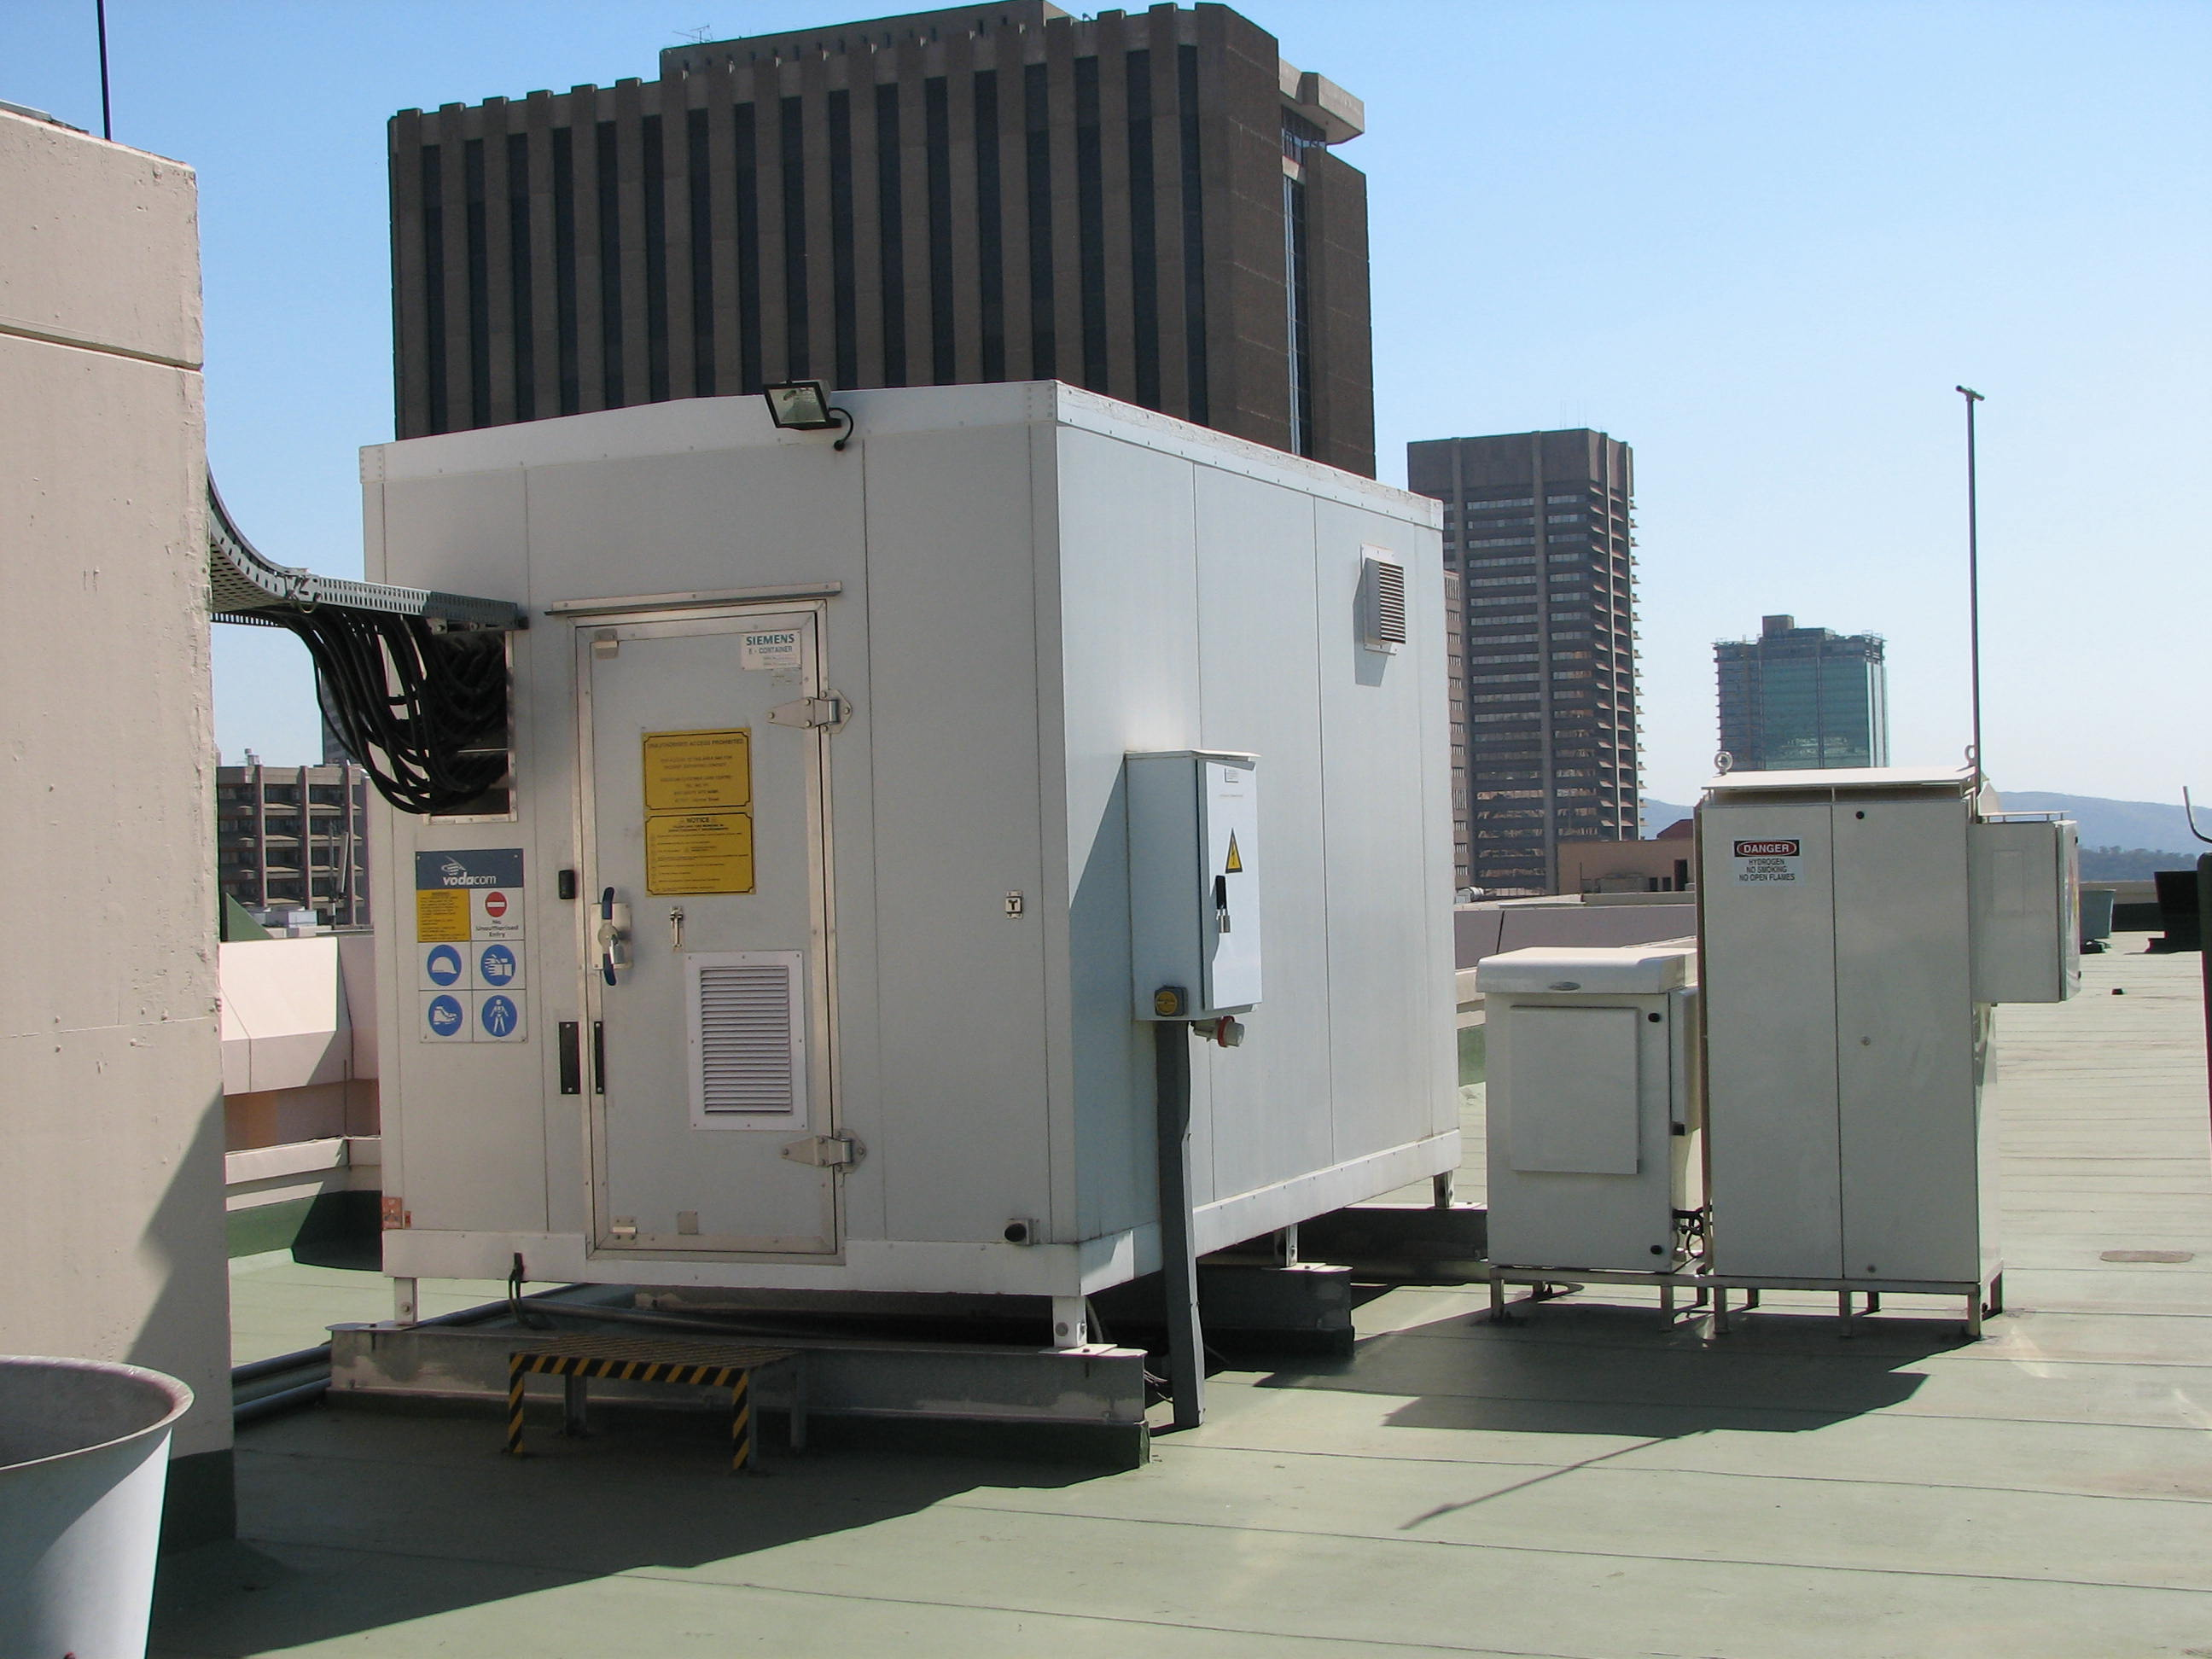

Figure 5. A front view of the GenCore installation at the
Vodacom Skinner Street site

At this point, the number of GenCor units in each of the 8 regions is as follows:

- Northern Borders West – 25
- Northern Borders East – 0
- Gauteng-North – 0
- Gauteng-South – 1
- Kwa-Zulu Natal (KZN) – 1
- Eastern Cape – 1
- Central Region – 1
- Western Cape – 3

While typically Vodacom purchases necessary equipment by going out on tenders, they won’t do that as long as there is an IFC rebate for Plug Power units, as this grant is the only thing that makes fuel cell implementation financially viable given today’s fuel cell costs.
5. MTN
I visited with personnel at the MTN Corporate Office in Johannesburg. They stated that MTN’s major interest in fuel cells involves GenSys applications in Nigeria. MTN’s electric bills there are extremely high and they use a lot of diesel fuel very inefficiently in backup power mode. They currently have over 2,000 sites that could use a grid-independent prime mover, soon to be increased to 3,000 (in Nigeria alone).

They do not consider Nigeria to be a good site for demonstrations due to the political climate. They would rather prove out the technology elsewhere and then do mass deployment in Nigeria. They have previously used Cameroon as a demonstration site for other technologies. However, they feel that it would be best to test fuel cell technology in South Africa. They have a test of a GenCore unit currently in progress at their Waterfall Islamic cell site. They are planning a GenSys demonstration as well – perhaps on the rooftop of a 20-story building in Johannesburg. GenSys cost can be a major factor in mass deployment – they can buy two 7-kVA diesel generators for around US$20,000, about 1/3 the price of a GenSys.

They stated that both Rwanda and Uganda have major grid problems and would be good candidates for GenSys units. Cameroon would also be a good place to install a few units. They noted that Government regulations do not allow telecommunications companies to “cherry pick”. They require equipping rural areas as well as cities (i.e. social responsibility as well as making money). This might provide for some sites in South Africa for which GenSys would be practical – especially sites for which grid extension would be prohibitively expensive or where power and/or wire theft would be a distinct possibility. Rural sites have a maximum power requirement of around 3 kW.

MTN has historically been more cautious in adopting new technology than have their competitors. They need to gain confidence in each of the following:

- Fuel cell technology
- GenCore startup capability
- Fuel infrastructure
- Maintenance infrastructure
- Monitoring capability

MTN planned to complete an 8-week trial period of GenCore by the end of May 2007. They planned to implement and complete a 4-week trial period of GenSys by the end of September 2007. This GenSys unit may remain on site permanently after the trial period is over. These tests are building confidence in the first two items above. IST is considering offering a turnkey package to MTN including all maintenance activities. MTN likes this idea, as they feel that fuel cells are the best alternative that they have right now. They are ready to start in-country feasibility studies now. They had previously looked at other potential energy solutions (wind, solar, etc.), but feel that fuel cells are the only technology feasible enough to consider further.

MTN’s deployment strategy, even in Nigeria which has the biggest problem with the grid, is to implement fuel cell technology first at new cell sites, then for existing sites as the existing generators need replacement. Altogether, MTN serves customers in 21 countries in south central and western Africa and in the Near-East (Iran, Syria, Yemen, and Afghanistan).

5. Conclusions
The IFC grant awarded to IST and Plug Power calls for the installation of 400 fuel cells in South Africa over a three year period – 286 GenCore and 114 GenSys. Assessment of progress towards this goal needs to be looked at separately for GenCore and GenSys deployments.

Current or in-progress GenCore installations represent over 20% of the overall goal. This can be considered to represent excellent progress toward the overall goal of 286. Deployment of a new technology cannot be expected to occur in a linear fashion. This is due to the requisite learning curve and confidence building period required. For successful deployment of GenCore fuel cells as backup power for telecommunications systems, the following must be accomplished:

- The customer must be made familiar with the basics of fuel cell technology and the potential advantages it can provide.
- The customer must become confident that fuel cell technology works and that it can provide a suitable alternative solution to their power supply options.
- The customer must become confident that the GenCore will start up reliably upon loss of grid power.
- The customer must gain confidence in the ability of the fuel infrastructure to provide fuel in a reliable manner no matter where the system is located.
- The customer must gain confidence that the maintenance infrastructure is sufficient to assure minimal down time no matter where the system is located.
- The customer must be convinced that fuel cell technology offers an economically viable power supply solution.
- The customer must budget funds to deploy fuel cells for sites for which they are felt to be a viable option.

At the present time, Steps 1, 2, and 3 have been successfully accomplished for the most part. Steps 4 and 5 are in the process of being accomplished with near-term customer demonstrations. Step 6 is in progress as well as customers are determining the factors affecting the economics of their specific sites. Assuming that Steps 4 and 5 are accomplished successfully from the planned demonstrations, the various customers are expected to make the GenCore a standard option in their power supply portfolio. This should lead to a major growth of GenCore installations.

The GenSys side of the grant is another matter. At the time of my visit, none of the 114 GenSys units had been installed. Only two GenSys units had been ordered. Deployment of all 114 GenSys units in South Africa at any time in the foreseeable future appears to be highly unlikely. The primary reason has to due with the inability to identify customers willing to employ this product in South Africa sites. While the South African grid may seem highly unreliable in comparison with U.S. standards, it is considered reliable enough that a GenCore with 6-bottle hydrogen backup cabinet is deemed sufficient to provide reliable service. The only market for GenSys within South Africa appears to be limited to the few remote sites for which grid extension is prohibitively expensive, or where theft of electricity, generators, etc is likely. This would appear to be a very limited market.

All of the companies I conducted interviews with indicated that they had sites in other African countries for which the grid, even with generators, was totally unreliable, with daily grid outages occurring in some areas. These companies expressed great interest in employing GenSys systems in these locations, and indicated that the overall potential GenSys deployment would be considerably more than the 114 units involved in the IFC grant. Nigeria, in particular, was mentioned almost unanimously as being a desired country for GenSys deployment. Approval has been sought from IFC by IST/Plug Power to allow deployment of the contracted GenSys units within these other sub-Saharan Africa countries.

Mike Binder and Associates, Inc. 808 Oakcrest Drive Champaign, IL 61821-4170 (217) 352-0115 mikebinder@mikebinderassoc.com

