ADVANCES IN WIRELESS HYDROGEN SENSOR NETWORKS

T. Anderson, H.T. Wang¹, C. Li, Z.N. Low², B.S. Kang¹, J. Lin²,
S. J. Pearton, A. Osinsky, A. Dabiran⁴, P. Chow⁴, C. Balaban⁵, J. Painter⁶, and F. Ren¹

Abstract
We have demonstrated a wireless hydrogen sensing system using commercially available wireless components and Schottky diodes fabricated on an AlGaN/GaN High Electron Mobility Transistor (HEMT) structure with platinum as the sensing metal. The effect of bias voltage polarity and temperature on the hydrogen sensing characteristics of the diode is reported. Under forward bias, there was a maximum observed in the sensitivity for hydrogen detection. For reverse bias, the hydrogen detection sensitivity increased proportionally to the bias voltage. A detection mechanism is proposed to explain this observation. The response can be related to the hydrogen concentration, making this system very attractive for commercial applications.

1. Introduction
There is significant interest in developing GaN diodes for use in applications such as gas sensing and power switching control[1-11]. The GaN materials system has a high breakdown field and can operate at high temperatures (~500°C) and in harsh environments. The use of simple Schottky diode structures with thin Pt contacts allows for detection of hydrogen at concentrations of hundreds of ppm at wide temperature range (room temperature-500°C)[12-22]. There is a strong need to develop hydrogen sensors for use with proton-exchange membrane (PEM) and solid oxide fuel cells applications. Higher detection sensitivity can be obtained with more advanced structures such as AlGaN/GaN based High Electron Mobility Transistors (HEMTs) with the penalty of relatively processing complexity[22]. There are also applications for detection of combustion gases for fuel leak detection in spacecraft, automobiles and aircraft, fire detectors, exhaust diagnosis and emissions from industrial processes[12-17].

Typically the sensing mechanism of the semiconductor Schottky diodes with Pt as the Schottky contacts is ascribed to the dissociation of the molecular hydrogen on the Pt gate contact, followed by diffusion of the atomic species to the oxide/semiconductor interface where it changes the piezo-induced channel charge and effective barrier height on Schottky diode structures. This effect has been used in Si, SiC, ZnO and GaN–based Schottky diode combustion gas sensors [1-16].

2. Experimental
The device layer structures were grown on C-plane Al₂O₃ substrates in a molecular beam epitaxy (MBE) system. The layer structure included an initial 2μm thick undoped GaN buffer followed by a 35nm thick unintentionally doped Al_{0.28}Ga_{0.72}N layer. Mesa isolation was achieved by using an inductively coupled plasma system with Ar/Cl₂ based discharges. The Ohmic contacts were formed by lift-off of Ti (200Å)/Al (1000Å)/TiB₂ (200Å)/Ti (200Å)/Au (800Å). The metals were deposited by Ar plasma-assisted RF sputtering. The contacts were annealed at 850 °C for 45 sec under a flowing N₂ ambient in a Heatpulse 610T system. A 100 Å thick Pt Schottky contact was deposited by e-beam evaporation for the Schottky metal. This is needed for making the device sensitive to hydrogen through catalytic dissociation of molecular hydrogen. The final step was deposition of e-beam evaporated Ti/Au (300Å/1200Å) interconnection contacts. The individual devices were diced and wire bonded to carriers. Figure 1 shows a schematic and optical image of completed active devices. These were then placed in an environmental test chamber and connected to an electrical feed-through for testing. The current-voltage(I-V) characteristics were recoded on an Agilent 4145B parameter analyzer. Mass flow controllers were used to control the gas flow through the chamber, and the devices were exposed to either 100% pure N₂, or H₂ concentrations of 500 ppm down to 1 ppm in N₂.
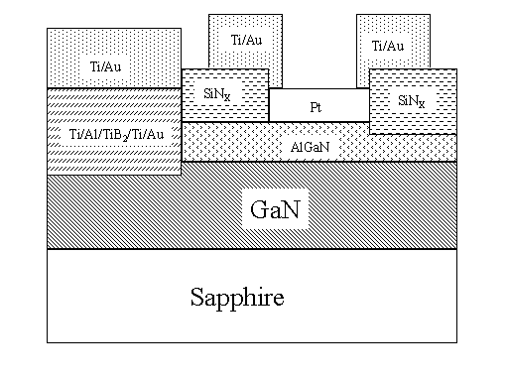
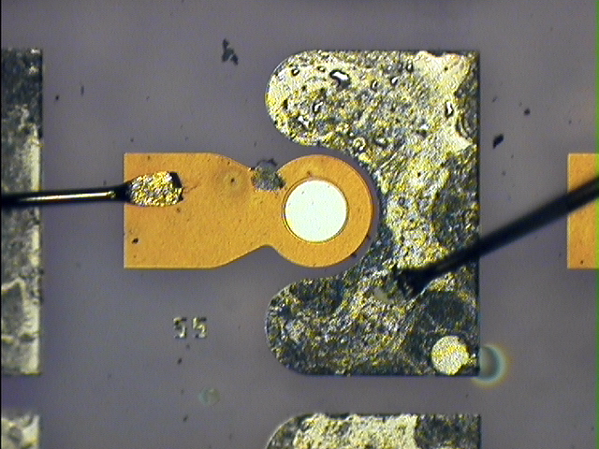
Figure 1. Cross-section schematic (top) and optical plan-view image (bottom) of HEMT diode hydrogen sensor

3. Results & Discussion
Devices were tested under both forward and reverse bias conditions at room temperature (25°C) in a nitrogen atmosphere. There was an increase in current under both forward and reverse bias conditions upon exposure to hydrogen, as shown in Figure 2. This is consistent with previously discussed mechanisms in which the hydrogen molecules dissociate into hydrogen atoms through the catalytic action of the Pt gate contact, and diffuse to the Pt/AlGaN interface. The hydrogen atoms form a dipole layer, lower the Schottky barrier height, and increase net positive charges on the AlGaN surface as well as negative charges in the 2DEG channel. The calculated barrier height decrease for 500 ppm and 100 ppm hydrogen is 5 meV and 1 meV, respectively. The ideality factors were calculated to be 1.25 and 1.23 in 500 and 100 ppm hydrogen, respectively, compared to 1.26 in 100% nitrogen.
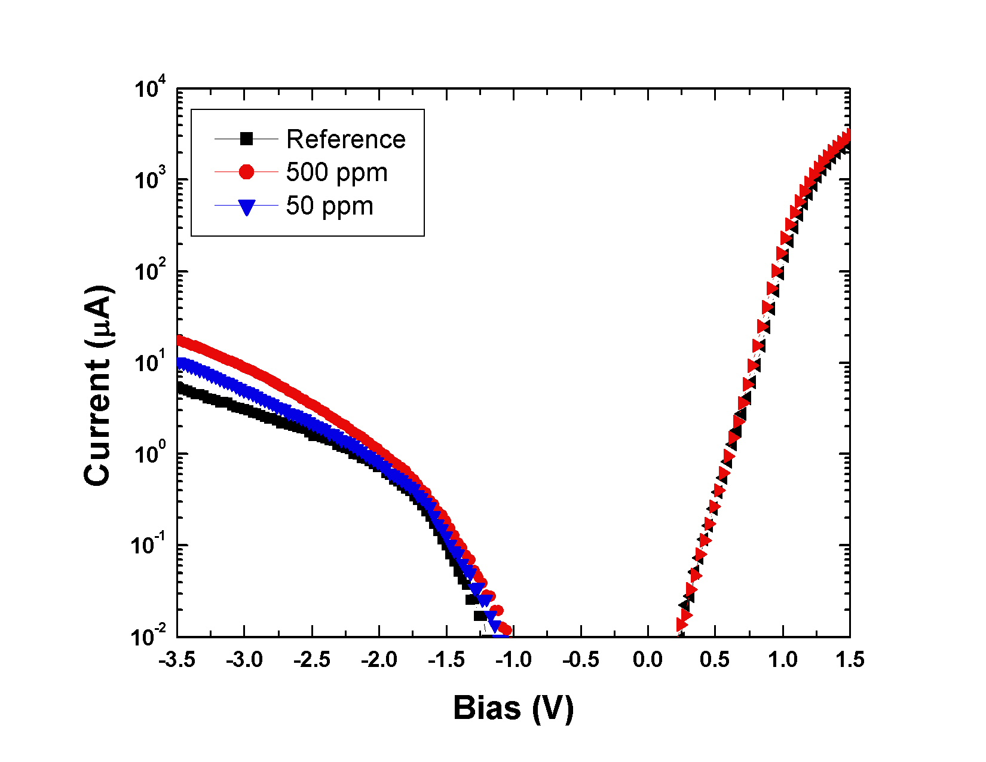
Figure 2. Forward and reverse bias plot of diode current in varying atmospheres
However, a plot of hydrogen sensitivity (defined as the drain current change over the initial drain current) versus bias voltage shows different characteristics for forward and reverse bias polarity conditions at 500 ppm of H₂, as shown in Figure 3.
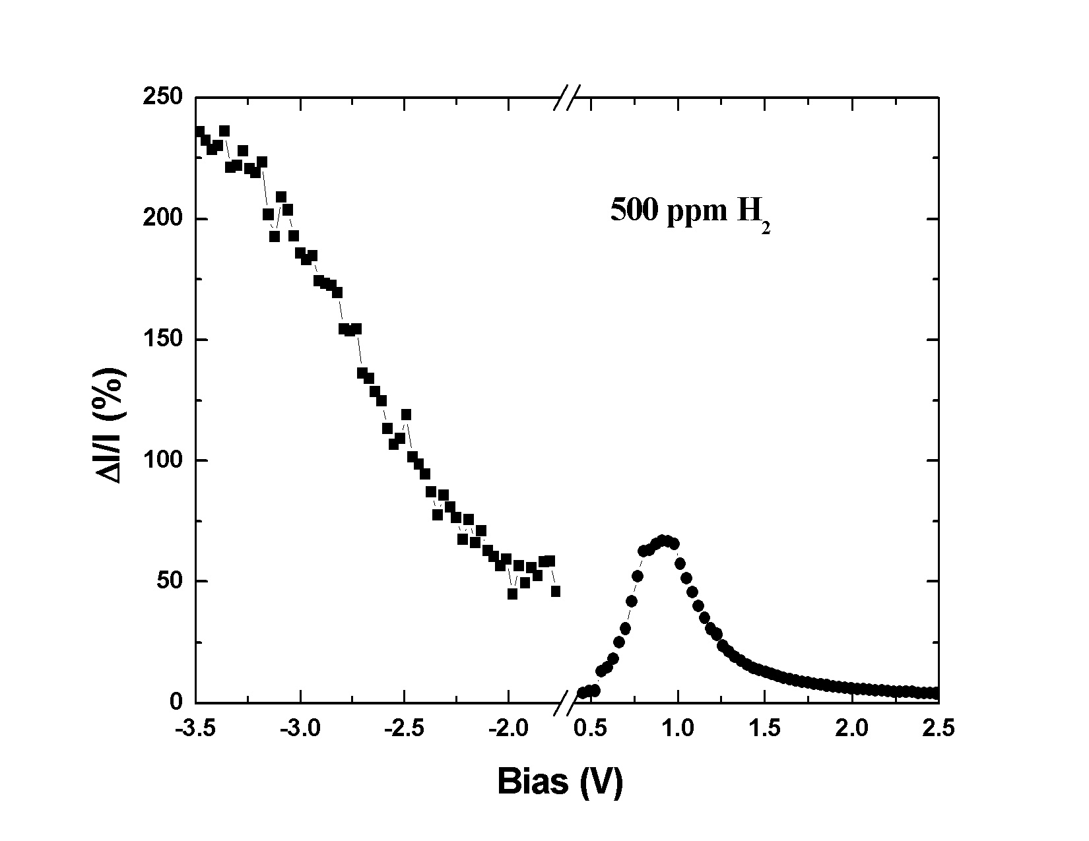
Figure 3. Percentage change in current as a function of bias at 500 ppm H₂
For the forward bias condition, there is a maximum sensitivity obtained around 1 V and further increase of bias voltage reduces the sensitivity. The sensitivity for the reverse bias condition is quite different and it increases proportionally to the bias voltage. We propose the following mechanism for the change in sensitivity under forward and reverse bias conditions: (1) The initial increase in the sensitivity is due to the Schottky barrier height reduction. (2) Further increase in forward bias allows electrons to flow across the Schottky barrier. These excess electrons bind with H⁺, form atomic hydrogen, and gradually destroy the dipole layer at the interface, therefore losing the hydrogen detection sensitivity. (3) For the reverse bias condition, electrons given away by the hydrogen atom may be swept across the depletion region. At higher reverse bias voltage, a higher driving force is applied to the electrons to move across the depletion region. Thus the dipole layer is amplified at the Pt/AlGaN interface for higher reverse bias voltage. Due to this dipole layer amplification, the detection sensitivity is enhanced at higher reverse bias voltage.
Figure 4 demonstrates concentration dependence on two different scales – ppm levels and percentage levels. A detection limit of 100 ppm is achieved under forward bias, but the reverse bias detection limit is an order of magnitude lower, 10 ppm. This is consistent with published reports indicating improved sensitivity under reverse bias [23]. More importantly, as shown in Figure 4b, the upper detection limit approaches 50%. The reliability of the hydrogen sensor may be quite different under the two bias voltage polarities, since different degradation mechanisms in GaN devices are accelerated by either the presence of high voltage depletion regions (reverse bias) or current injection (forward bias in this experiment) [24].

Temperature effects were studied next. A hydrogen concentration of 25 ppm was chosen to study the temperature effects since it demonstrated a large response at room temperature. The diode current was measured in both 25 ppm H₂ and 100% N₂ atmospheres at temperatures from 25 °C to 500 °C. The percentage change in current as a function of temperature is shown in Figure 5. At temperatures above 550 °C, the device was irreversibly damaged. It is interesting to note the peak in the response at around 200 °C. This is due to competing effects on the surface. It is expected that with increasing temperature, the cracking of the hydrogen on the surface will become more efficient. This will result in more molecular hydrogen, which will also diffuse to the metal-semiconductor interface faster at increased temperature. This effect is countered by basic kinetics. There will also be a decreased surface concentration of hydrogen, since there will be more transport to and from the surface at elevated temperature.

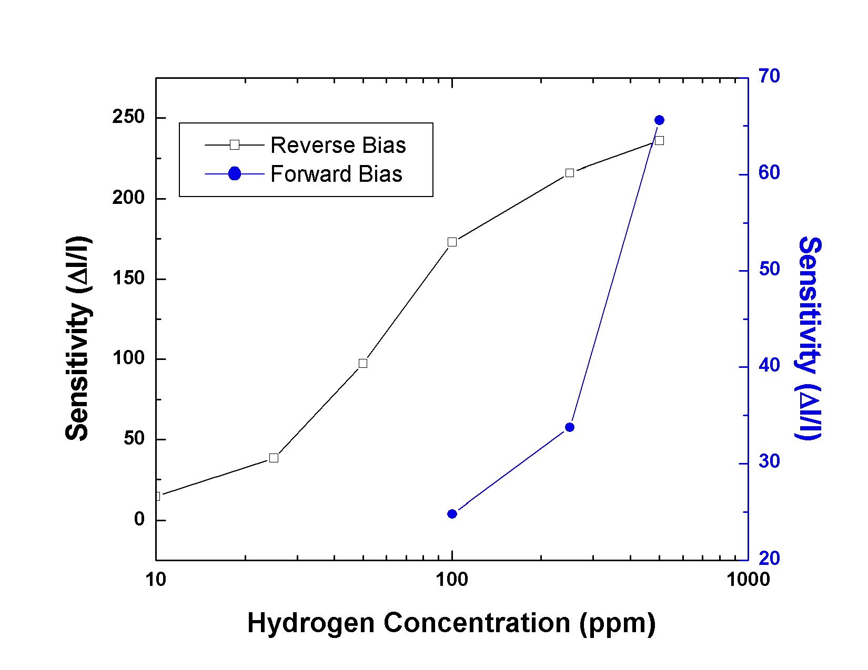
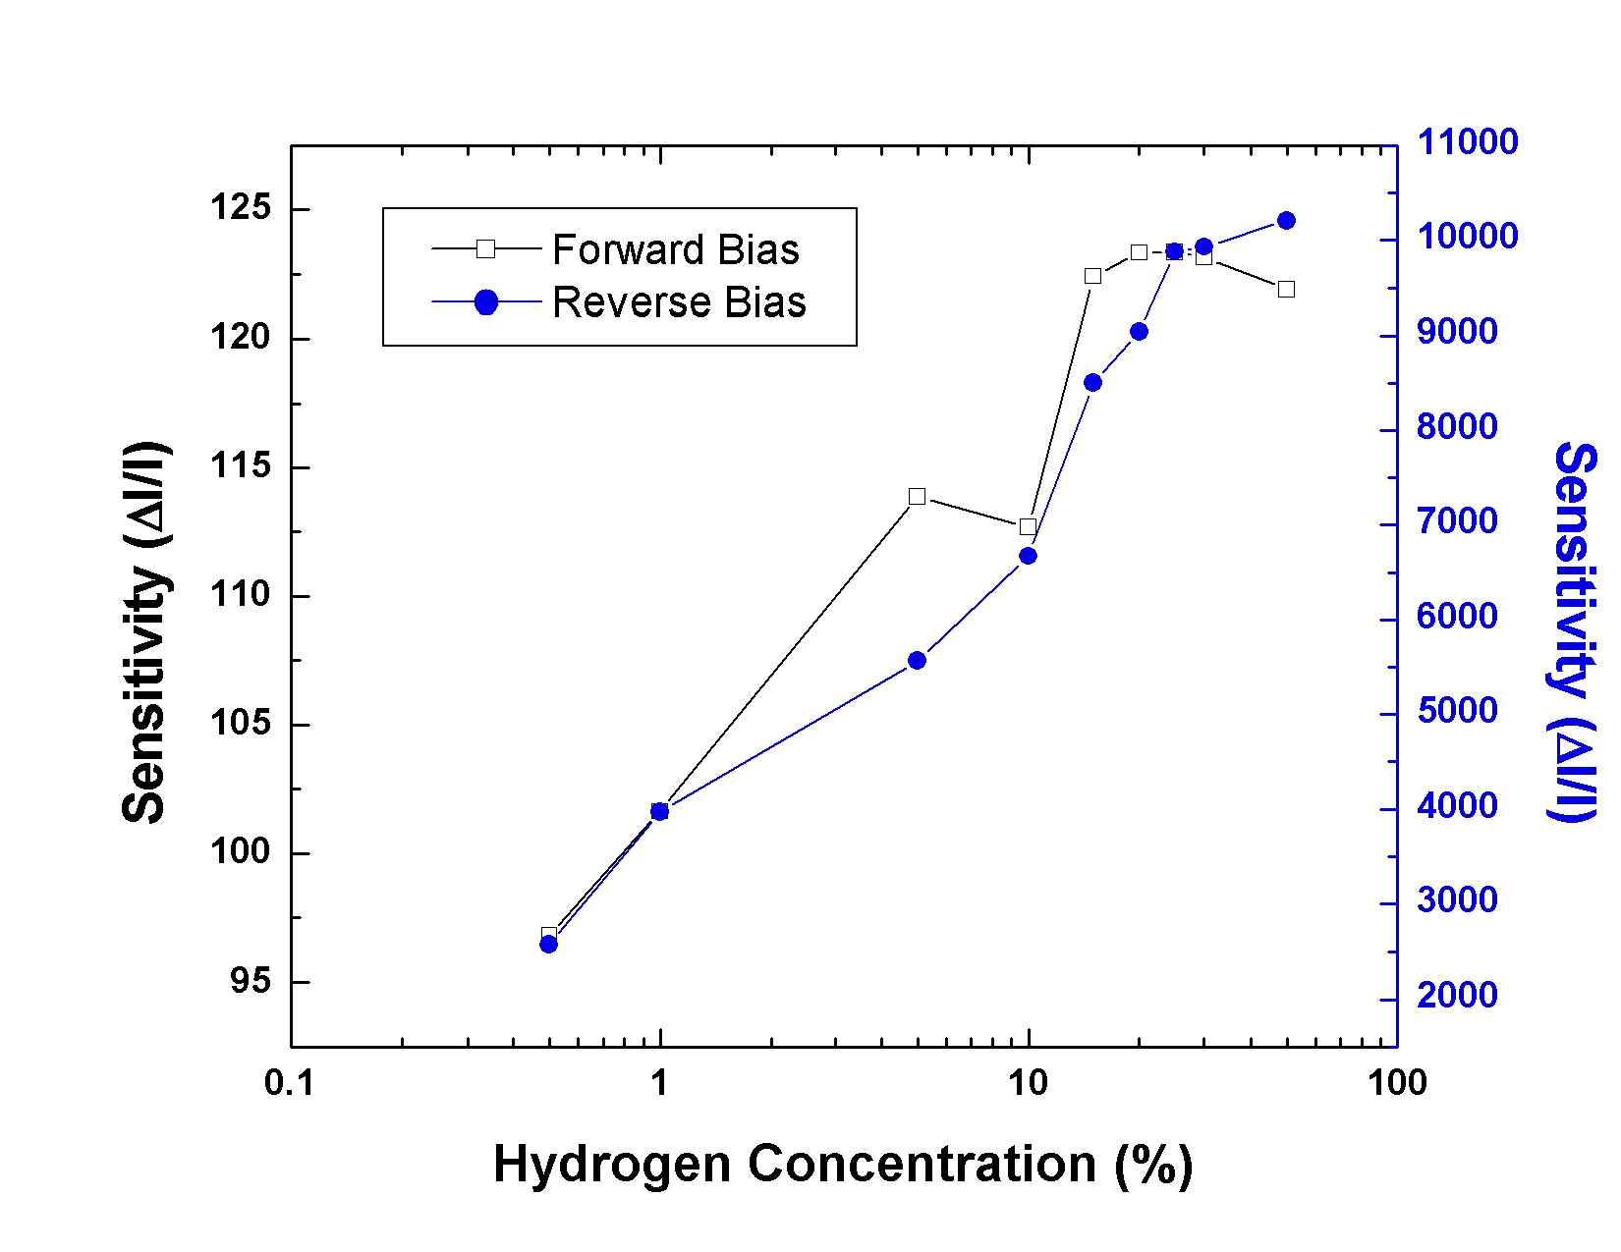
Figure 4. Percentage change in current as a function of hydrogen concentration under both forward and reverse bias on a ppm scale (top) and percentage scale (bottom).

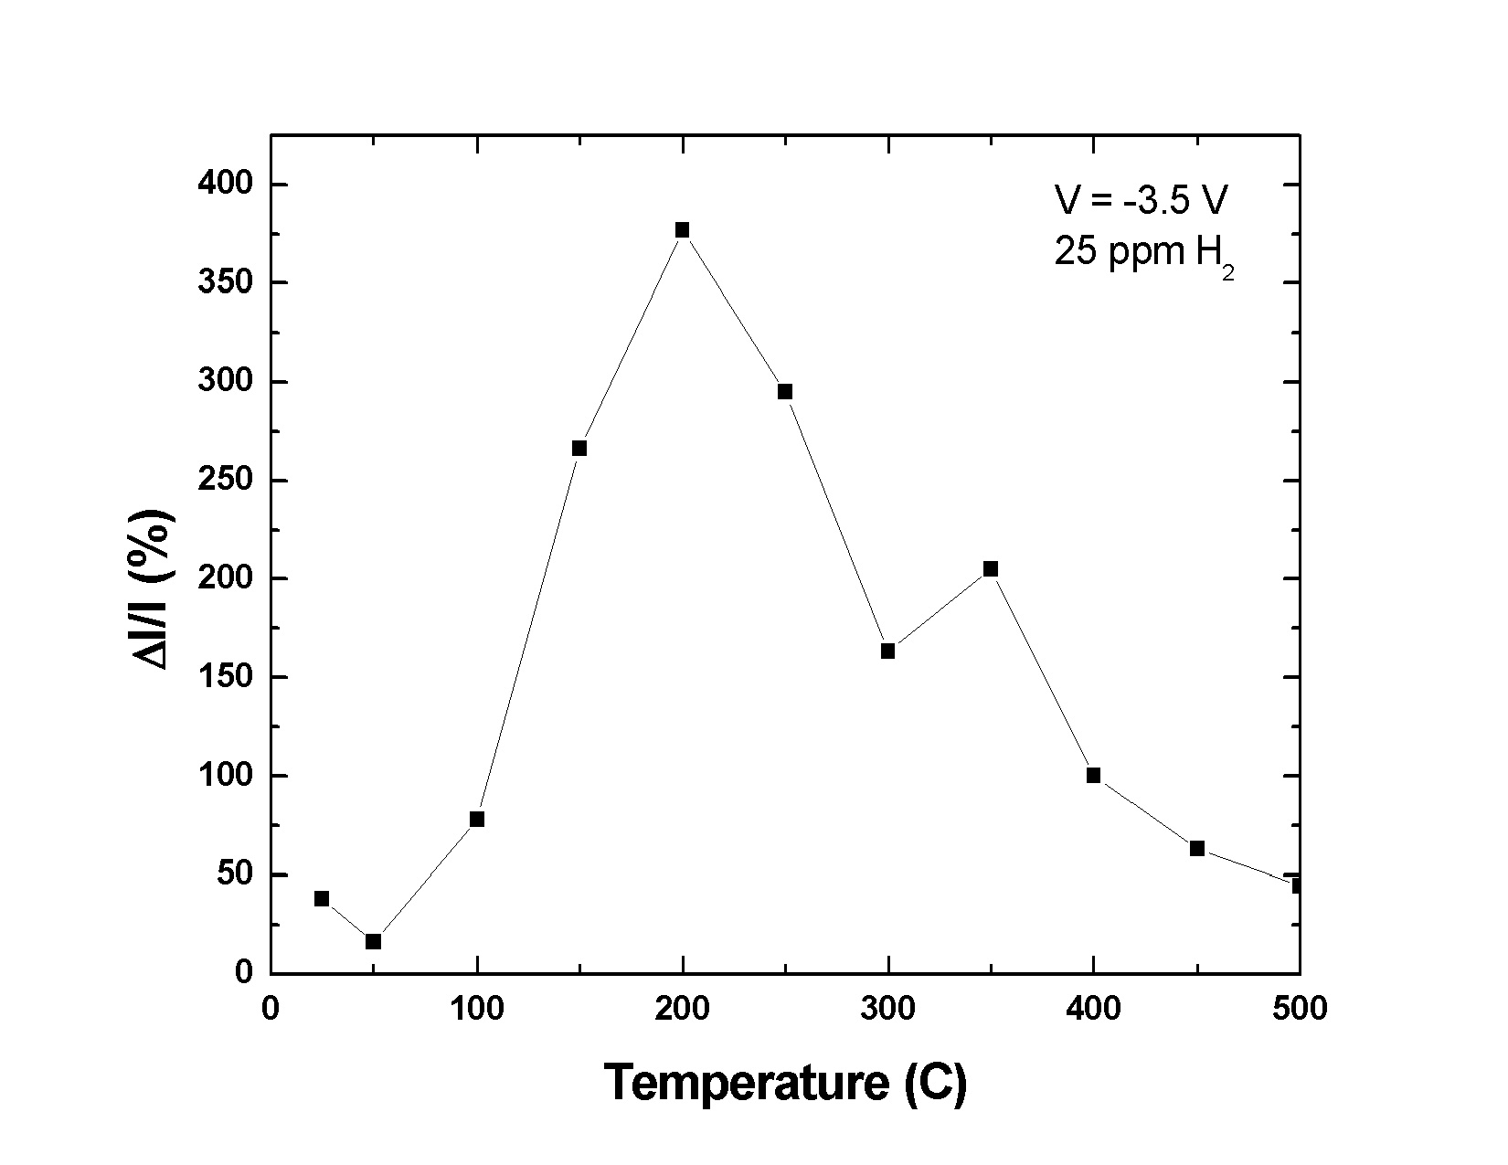
Figure 5. Percentage change in current as a function of temperature at a hydrogen concentration of 25 ppm.

The Zigbee compliant wireless network supports the unique needs of low-cost, low-power sensor networks, and operates within the ISM 2.4 GHz frequency band. When the sensor module is turned on, it is programmed to power up for the first 30 seconds. Following the initialization process, the detection circuit is periodically powered down for 5 seconds and powered up again for another 1 second, achieving a 16.67% duty cycle. The ZigBee transceiver is enabled for 5.5ms to transmit the data only at the end of every cycle. This gives a RF duty cycle of only 0.09%.
A web server was developed to share the collected sensor data via the Internet. If any of the sensor’s current increases to a level that indicates a potential hydrogen leakage, the alarm would be triggered. A client program was also developed to receive the sensor data remotely, and a full data log was obtained via accessing the server via a ftp client as the server program incorporates a full data logging functionality. The data is available via the internet at the following website: http://ren.che.ufl.edu/app/realtimesensing.htm. The server program for the wireless sensor network could also report a hydrogen leakage emergency through phone line. When the current of any sensors exceeded a certain level, indicating a potential hydrogen leakage, the server would automatically call the phone-dial program, reporting the emergency to the responsible personnel.

The sensor module was fully integrated on an FR4 PC board and packaged with battery as shown in Figure 6 (a). The dimension of the sensor module package was: 4.5 × 2.9 × 2 inch³. The maximum line of sight range between the sensor module and the base station was 150 meters. The base station of the wireless sensor network server was also integrated in a single module (3.0 × 2.7 × 1.1 inch) and ready to be connected to laptop by a USB cable, as shown in Figure 6(b) and (c). The base station draws its power from the laptop’s USB interface, thus do not require any battery or wall transformer.

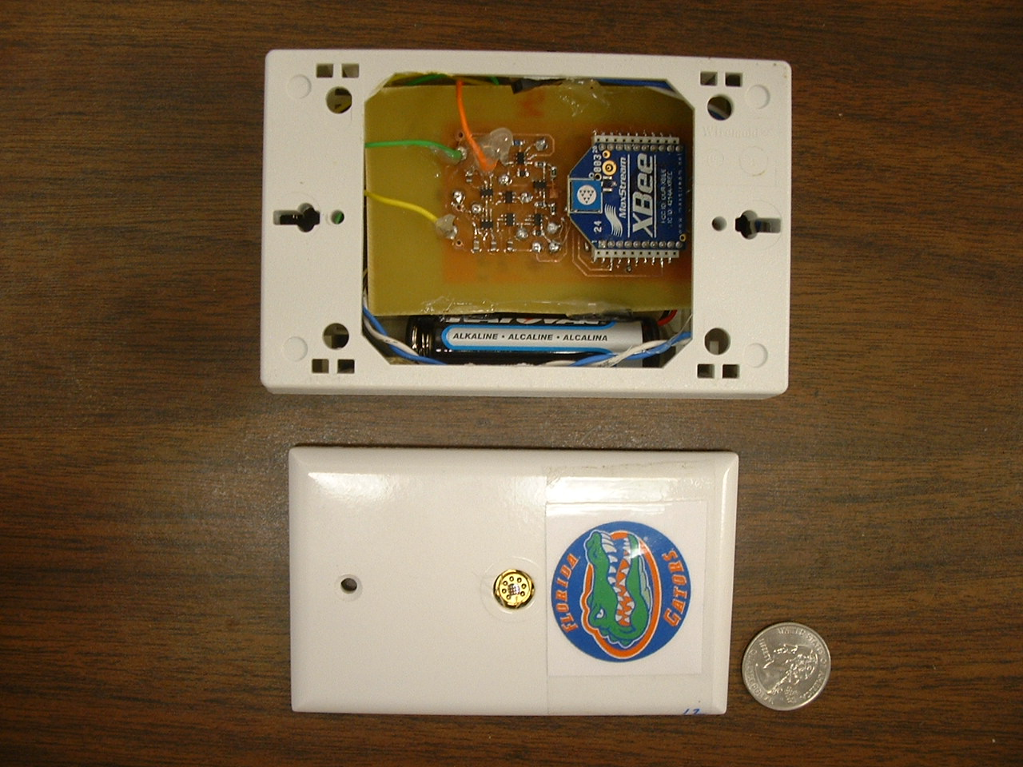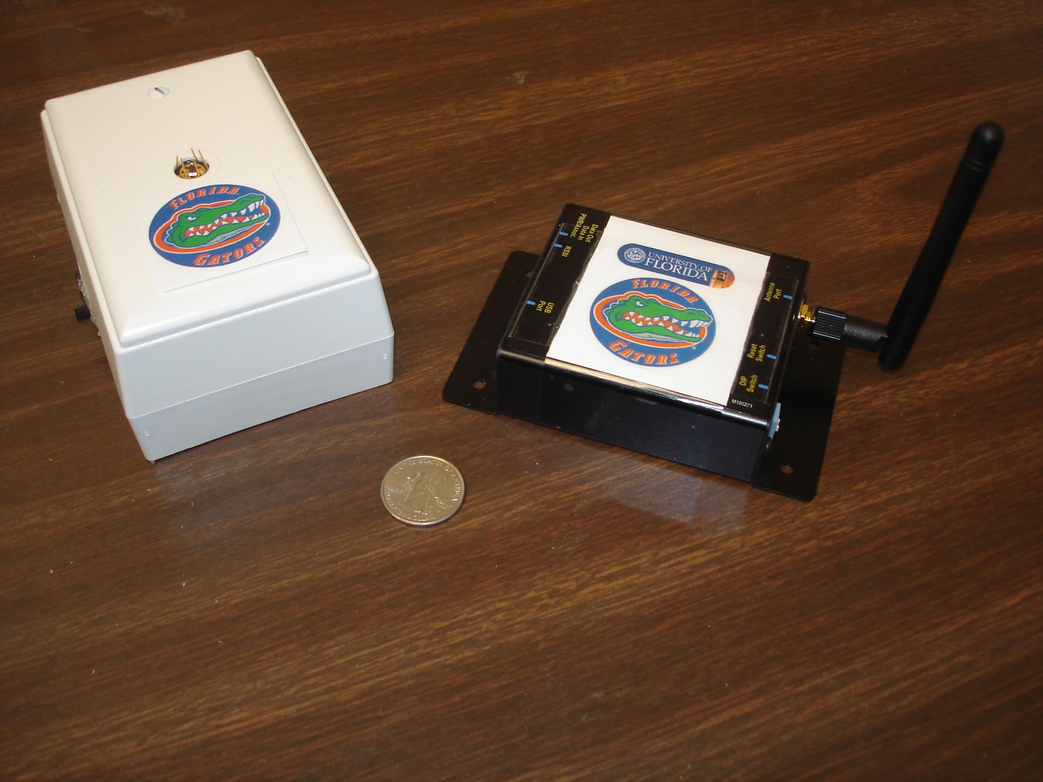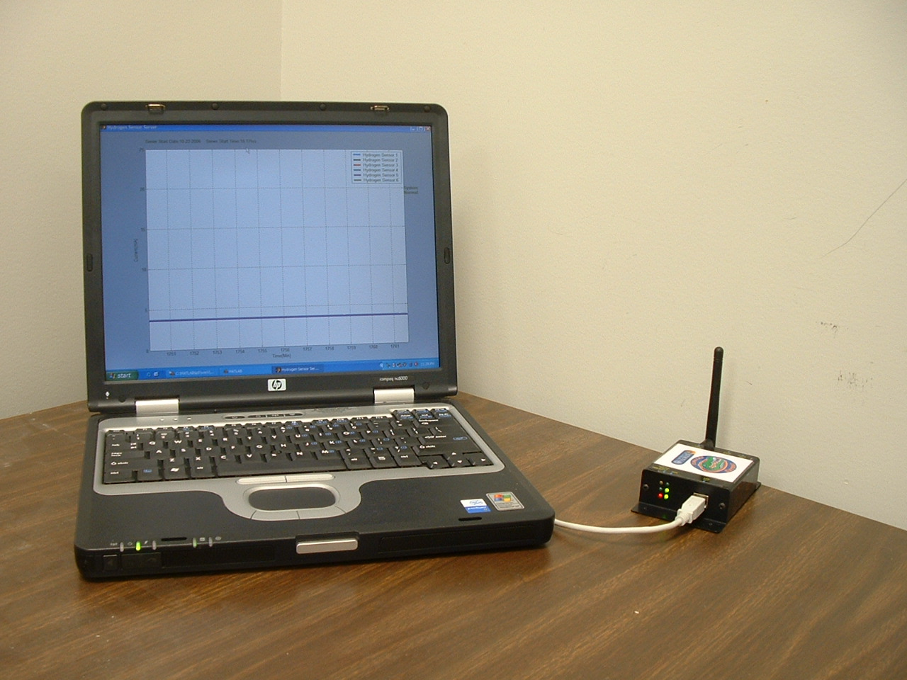
(a) (b) (c)
Figure 6. Photo of sensor system (a) Sensor with sensor device; (b) Sensor and base station; (c) Computer interface with base station.

Field tests have been underway at Greenway Ford in Orlando, FL since August of 2006. The setup at Greenway Ford was aimed to test the stability of the sensor hardware and the server software under actual operational environment. Based on these tests, we have been able to redesign the sensor node to implement the differential diode detection scheme discussed previously, as well as the boride-based ohmic contact scheme to improve reliability

4. Conclusion
A wireless sensor network which meets the IEEE 802.15.4 standards has been constructed to transmit data from an arbitrary number of hydrogen sensors to a base station. A user friendly program has been developed to share the data collected by base station to Internet, so that the data can be analyzed and monitored from anywhere with an internet connection. A cell phone alarm has been realized to report any potential hydrogen leakage to responsible personnel. AlGaN/GaN HEMT diodes show excellent sensitivity from in hydrogen environments ranging from 50% down to 10 ppm. The sensitivity is increased under reverse bias due to the amplification of the dipole layer at the interface instead of screening under forward bias conditions. By using reverse bias condition combined with the improved stability from boride contacts and a differential detection scheme, the overall stability of the GaN system is very attractive for long-term applications requiring high sensitivity.

5. Acknowledgement
The work at UF is partially supported by ONR (N00014-98-1-02-04, H. B. Dietrich), NSF(CTS-0301178, monitored by Dr. M. Burka and Dr. D. Senich), by NASA Kennedy Space Center Grant NAG 10-316 monitored by Mr. Daniel E. Fitch and also by Florida Department of Environmental Protection, U.S. Dept. of Energy(DE-FG26-05R410962 by Jill Stoyshich).

6. References
1. P. Tobias, A. Baranzahi, A. L. Spetz, O. Kordina, E. Janzen and I. Lundstrom, IEEE Electron. Dev. Lett. 18 287(1997).
2. A. Vasiliev, W. Moritz, V. Fillipov, L. Bartholomäus, A. Terentjev and T. Gabusjan, Sens. Actuators B49 133(1998).
3. J. Kim, F. Ren, B. Gila, C. R. Abernathy, and S. J. Pearton, Appl. Phys. Lett. 82 739 (2003).
4. J. Kim, B. Gila, C. R. Abernathy, G. Y. Chung, F. Ren, and S. J. Pearton, Solid State Electronics, 47 1487 (2003).
5. A. Lloyd Spetz, P. Tobias, L. Unéus, H. Svenningstorp, L.-G. Ekedahl and I. Lundström, Sens. Actuators B70 67(2000).
6. E. J. Connolly, G. M. O'Halloran, H. T. M. Pham, P. M. Sarro and P. J. French, Sens. Actuators A99 25(2002).
7. G. W. Hunter, P. G. Neudeck, R. S. Okojie, G. M. Beheim, V. Thomas, L. Chen, D. Lukco, C. C. Liu, B. Ward and D. Makel, Proc. ECS Vol 01-02 212(2002)
8. R. Neuberger, G. Muller, O. Ambacher, M. Stutzmann, Phys Status Solidi A 185 85 (2001).
9. J. Schalwig, G. Muller, O. Ambacher, M. Stutzmann, Phys Status Solidi A 185 39 (2001).
10. G. Steinhoff, M. Hermann, W. J. Schaff, L. F. Eastmann, M. Stutzmann, M. Eickhoff, Appl. Phys. Lett. 83 177 (2003).
11. M. Eickhoff, R. Neuberger, G. Steinhoff, O. Ambacher, G. Muller, M. Stutzmann. Phys. Status Solidi B 228 519 (2001).
12. J. Schalwig, G. Muller, M. Eickhoff, O. Ambacher, M. Stutzmann. Sens Actuat B 81 425 (2002).
13. M. Eickhoff, J. Schalwig, G. Steinhoff, O.Weidmann, L.Gorgens, R. Neuberger, M. Hermann, B.Baur, G.Muller, O. Ambacher, and M. Stutzmann, Phys. Stat. Solidi C 6 1908 (2003)
14. H. Svenningstorp, P. Tobias, I. Lundström, P. Salomonsson, P. Mårtensson, L.-G. Ekedahl and A. L. Spetz, B57 159(1999).
15. L. Chen, G. W. Hunter, and P. G. Neudeck, J. Vac. Sci. Technol A 15, 1228 (1997); J. Vac. Sci. Technol. A16 2890(1998).
16. A. Baranzahi, A. Lloyd Spetz and I. Lundström, Appl. Phys. Lett. 67 3203 (1995).
17. B.S. Kang, R. Mehandru, S. Kim, F. Ren, R. Fitch, J. Gillespie, N. Moser, G. Jessen, T. Jenkins, R. Dettmer, D. Via, A. Crespo, B.P. Gila, C.R. Abernathy and S.J. Pearton, Appl. Phys. Lett. 84 4635 (2004).
19. B.S. Kang, Y.W. Heo, L.C. Tien, D.P. Norton, F.Ren, B.P. Gila and S.J. Pearton, Appl. Phys. A 80 1029 (2005).
20. A. El. Kouche, J. Lin, M.E. Law, S. Kim, B.S. Kim, F. Ren and S.J. Pearton, Sensors and Actuators B: Chemical 105 329 (2005).
21. S.J. Pearton, B.S. Kang, S. Kim, F. Ren, B.P. Gila, C.R. Abernathy, J. Lin and S.N.G. Chu, J. Phys: Condensed Matter 16 R961 (2004).
22. S. Kim, B. Kang, F. Ren, K. Ip, Y. Heo, D. Norton and S.J. Pearton, Appl. Phys. Lett. 84, 1698 (2004).
23. C.-W. Hung, H.-L. Lin, H.-I. Chen, Y.-Y. Tsai, P.-H. Lai, S.-I Fu, W.-C. Liu. Electron Device Letters, 27, 12 (2006)
24. Koudymov, M.S. Shur, G. Simin, R. Gaska. Phys. Stat. Sol. (RRL) 1, No. 3, 116-118 (2007).

University of Florida, Department of Chemical Engineering, Gainesville, FL 32611
University of Florida, Department of Electrical and Computer Engineering, Gainesville, FL 32611
SVT Associates, Eden Prairie, MN 55344 ⁵NASA Hydrogen Research Program, University of Florida, Gainesville, FL 32611 ⁶J. Painter Consulting, LLC. Deltona, FL 32738
University of Florida, Department of Materials Science and Engineering, Gainesville, FL 32611

