A proposal of increasing the safety of the nuclear plant by using the potential energy of water.

Akiyoshi T. Ueda
Electrical Engineer
Energy Engineering
2-6-10-905, Kujyou-minami, Nishi-ku, Osaka, 550-0025 Japan
Tel.: +81 6 6584 1021
Fax: +81 6 6584 1021
email: t.ueda@cotton.ocn.ne.jp

Abstract

A proposal discussed in this paper is method of increasing the safety of nuclear plant by using the potential energy of water. A reactor is built in the low place than a source of cooling water level. A water gate is installed between the source of cooling water and the place where reactor is built. A water gate becomes safety devices. In addition, this paper proposes the handling method of nuclear reactor which caused an accident or finished a duty. And this paper shows the dream for the next generation. It is a safe nuclear plant than now.

Introduction

Because cooling water is necessary, a nuclear plant and thermal power plant are built at the seashore and a lake shore or a riverside. Generally, people are thinking that danger of thermal power plant is small. So, thermal power plant was built near the city to avoid transmission loss. And nuclear plant was built in the location far from a city by the image of the danger. Transmission loss of nuclear plant is generated by this.
Though carbon dioxide isn't discharged from the nuclear plant, the carbon dioxide of large amount is discharged from the thermal power plant. Carbon dioxide is the big cause of the climate change. The damage from a heavy rain, powerful typhoons and droughts caused by the climate change is not completely predictable now. The result of the present climate change was shown by a hurricane called Katrina. This damage photograph⁽¹⁾ is shown in Fig.1 and 2.

Fig.1 The photograph of the bridge which broke.

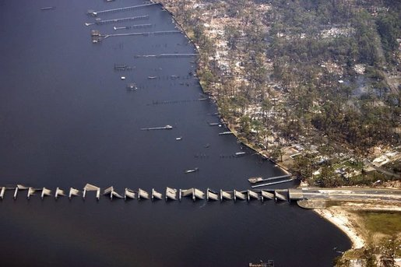

Fig.2 The photograph of residence that is under water.

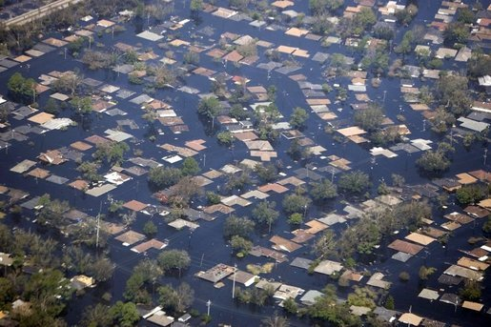

People showed a denial response to the nuclear power generation by the nuclear reactor coolant loss accident of the American Three Mile Island nuclear plant ⁽²⁾ and the Russian Chernobyl nuclear plant accident ⁽³⁾. Radiant ray was scattered to the environment by the Russian Chernobyl nuclear plant accident.
After the nuclear reactor coolant loss accident of the American Three Mile Island, the construction of new nuclear plant was frozen in America.
The photograph of the American Three Mile Island is shown in Fig.3. The photograph of the accident of the Chernobyl nuclear plant is shown in Fig.4.

Fig.3 The photograph of the Three Mile Island.

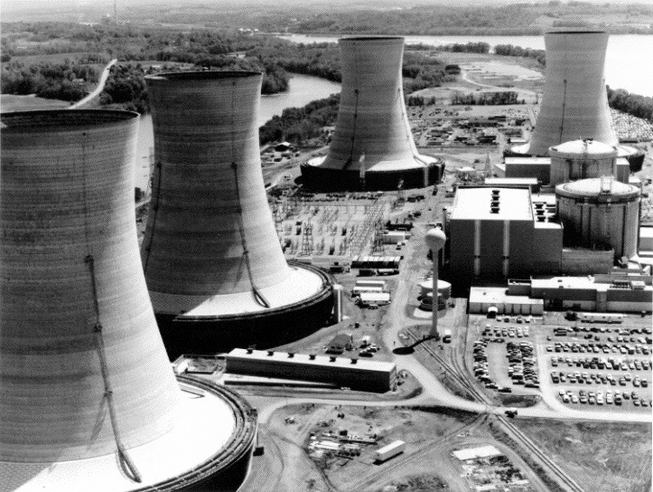
Three Mile Island Nuclear Generating Station consisted of two pressurized water reactors manufactured by Babcock & Wilcox each inside its own containment building and connected cooling towers. TMI-2, which suffered a partial meltdown, is in the background.

Fig.4 The photograph of the accident of the Chernobyl nuclear plant.

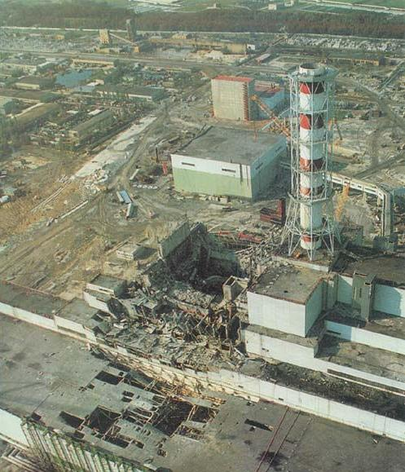
Chernobyl reactor number four after the disaster, showing the extensive damage to the main reactor hall (image center) and turbine building (image lower left)

No.4 reactor of the Chernobyl nuclear plant was surrounded by a sarcophagus after the accident⁽³⁾. But, collapse of sarcophagus has been predicted when it was completed because it deteriorates with the radiation. The photograph of the sarcophagus is shown in Fig.5.

Fig.5 The photograph of the sarcophagus of the Chernobyl power plant.
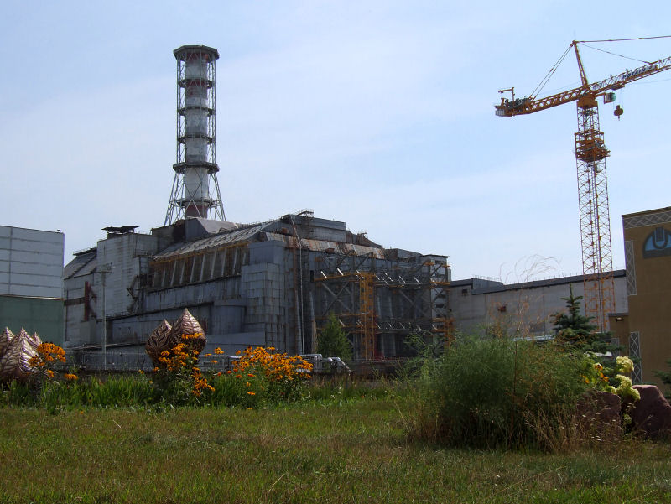
The completed (but deteriorating) sarcophagus surrounding Chernobyl reactor 4, viewed from the northwest.

The plan to cover the Chernobyl power plant again was announced recently⁽⁴⁾. That cost is 1.4 billion dollar.

Nuclear reactor built till now was built in the higher place than the water level. Changing this, nuclear reactor is built in the low place than the water level to increase the safety. By this, the nuclear power generation which the people have gets rid of a fixed idea of the danger. Next, a nuclear plant is built near the city, and transmission loss is reduced. Waste heat is used for the district heating and cooling of the city at the same time. This proposal aims at easing a climate change by these.

Outline

1 Nuclear reactor is built as shown in Fig.1 at the low place from the water level.
2 Gate is installed as shown in Fig.6 and Fig.7 in the wall to the water side.
3 A gate is opened when all the safety devices installed in the reactor didn't work at accident.

Fig.6 Figure of installed nuclear reactor and plant.
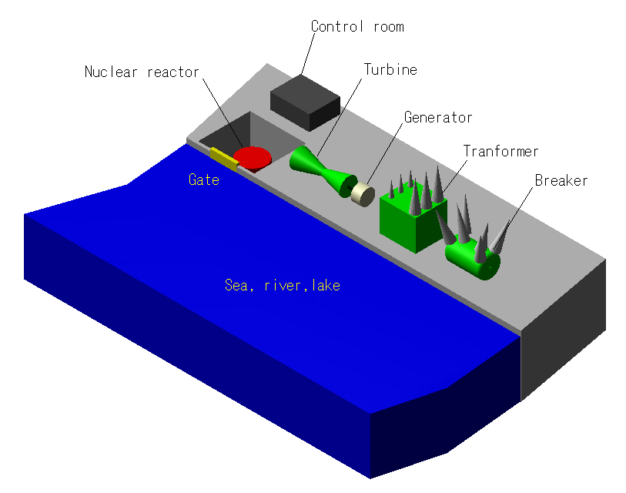

Fig.7 Cross section of gate and the nuclear reactor

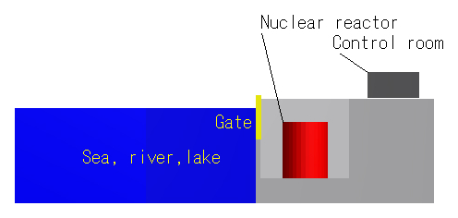

Advantage

1 Safety against the terrorism increases.
2 The safety of the reactor increases.
3 Close at the upper part of the nuclear reactor part becomes possible. The decreasing of the contamination in the accident can be done by this.
4 An underground part shakes as well as a surrounding soil when shaking due to the earthquake because it moves with the soil. In addition, safety to the earthquake rises because power to shake an underground part at the earthquake is always smaller than the soil pressure and hydraulic pressure.
5 Safety against the earthquake rises more when it was dug into to not the subsurface layer but the bedrock and a reactor was built.
6 In the case of accident, pouring concrete to the part of the reactor core becomes easy to prevent discharge of radiant ray in the environment.
7 The poured concrete never collapses like Chernobyl’s sarcophagus even if it deteriorates by the radiant ray, because it is the same elevation of the ground.
8 To the collapse of sarcophagus like Chernobyl, this proposal doesn't need to take the new method.
9 It becomes possible that it is filled up with the concrete like Fig.8 in that place without dismantling the nuclear reactor which finished a duty or an accident.

Fig.8 Cross section of the nuclear reactor part after pouring concrete
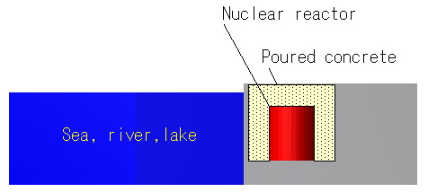

A dream to the next generation.

It is a submarine type nuclear plant. It is a safe nuclear plant than now.

Outline

1 A nuclear plat is installed to the submarine.
2 It is submerged in the sea during the operation period as shown in Fig.9.
3 It is connected to the land plant.
4 It is floated on the sea during the inspection time as shown in Fig.10.

Fig.9 is the figure of submerged nuclear plant, and Fig.10 is the figure of floated nuclear plant. Fig.11 is a detail of connection part.

Fig.9 Figure of submerged nuclear plant.
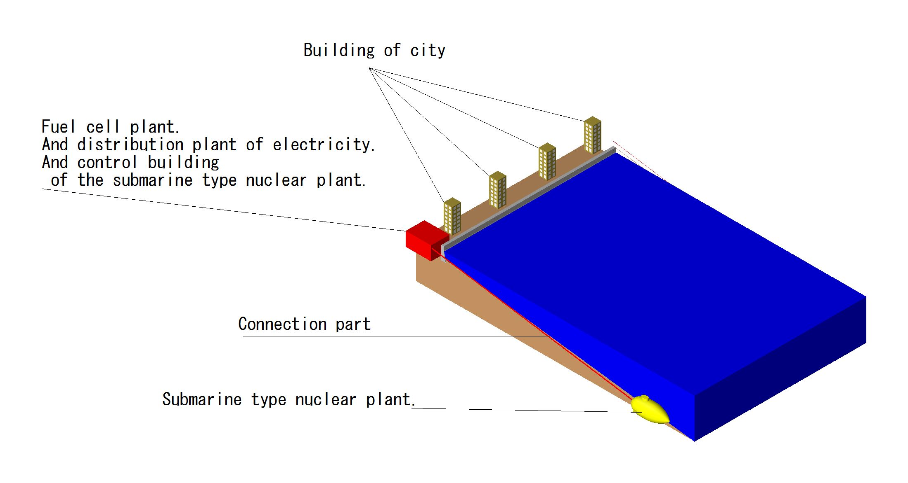

Fig.10 Figure of floated nuclear plant.
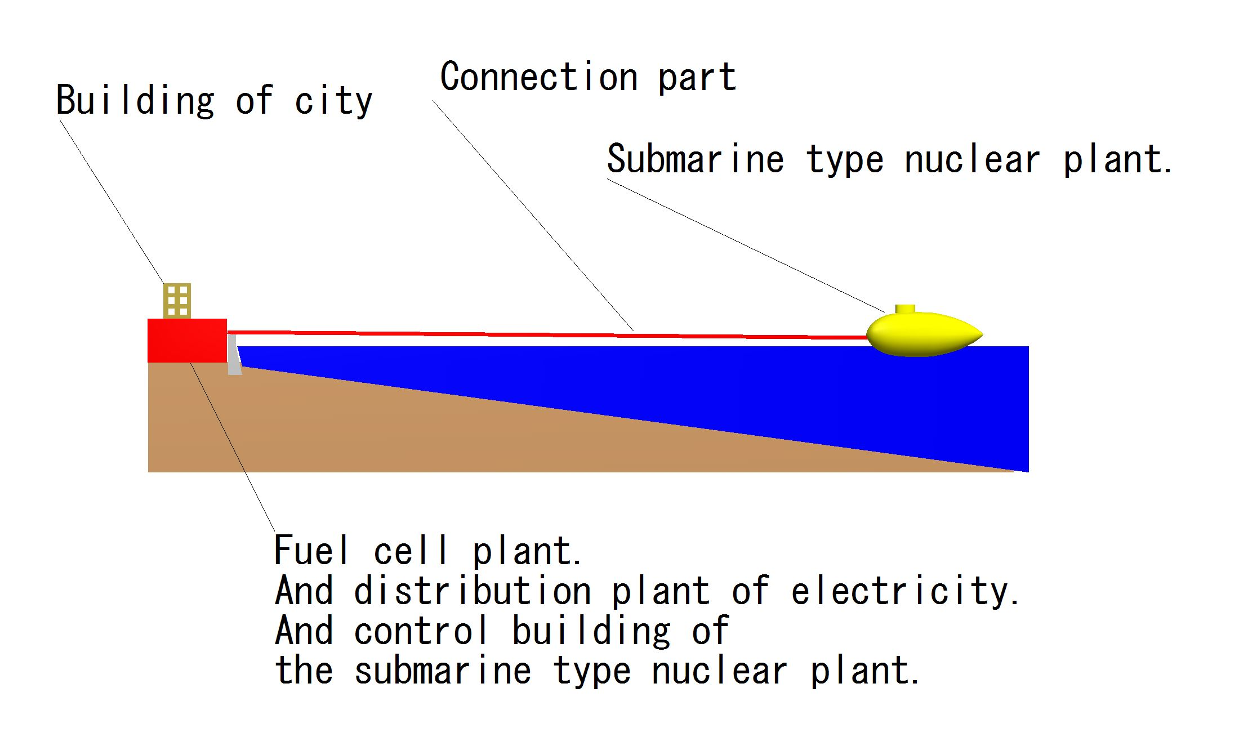
Fig.11 Detail of connection part.

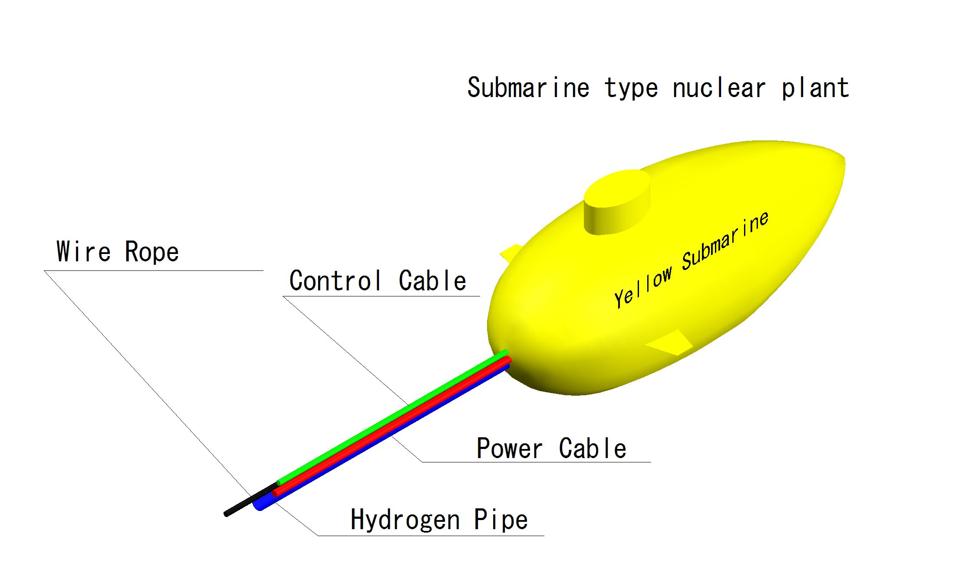

Advantage

1 Safety against the terrorism increases than the nuclear plant mentioned above.
2 The safety of the reactor increases than the nuclear plant mentioned above.
3 Dismantling of the nuclear plant which caused an accident or finished a duty is easy than the nuclear plant mentioned above.

Conclusion

This proposal has the possibility to wipe away a fixed idea of the danger which people have to nuclear plant.
Because this proposal showed the method that increases the safety of the nuclear plant. And this proposal showed options of handling method of nuclear reactor that caused an accident or finished a duty.

Acknowledgment

I sincerely appreciate Prof. Volker Hartkopf at Carnegie Mellon University for encouragement and inspiration.
I also appreciate Mr. Kunitsugu Nakata at Habshin Expressway Company Limited for giving me advice.

Reference

- hurricane (Katrina)
http://ja.wikipedia.org/wiki/%E3%83%8F%E3%83%AA%E3%82%B1%E3%83%BC%E3%83%B3%E3%83%BB%E3%82%AB%E3%83%88%E3%83%AA%E3%83%BC%E3%83%8A
- From Wikipedia, the free encyclopedia. Three Mile Island Nuclear Generating Station. : http://en.wikipedia.org/wiki/Three_Mile_Island_accident
- From Wikipedia, the free encyclopedia. Chernobyl disaster : http://en.wikipedia.org/wiki/Chernobyl_disaster
(4) From BBC NEWS, http://news.bbc.co.uk/2/hi/europe/6999140.stm

