HYBRID ELECTRIC HYDROGEN FUELED BUSES
IN TRANSIT SERVICE

David M. Mazaika and Paul B. Scott,

Abstract: SunLine Transit and AC Transit have operated hydrogen fueled hybrid electric buses in daily revenue service for the past couple years. SunLine introduced its hydrogen fueled HHICE bus into service in December 2004, and the fuel cell buses have entered service in late 2005-early 2006. The HHICE bus has over 50,000 miles of revenue service, the four fuel cell buses have, together, accumulated some 70,000 miles. The text describes the buses and the in-service experience with the buses.

1. Introduction: Hybrid electric drive system architecture allows recapture of braking energy and hence allows energy saving and increased range, of critical importance for fuel cell vehicles operating on hydrogen in the city. Here we describe and discuss two types of hydrogen fueled city transit buses.

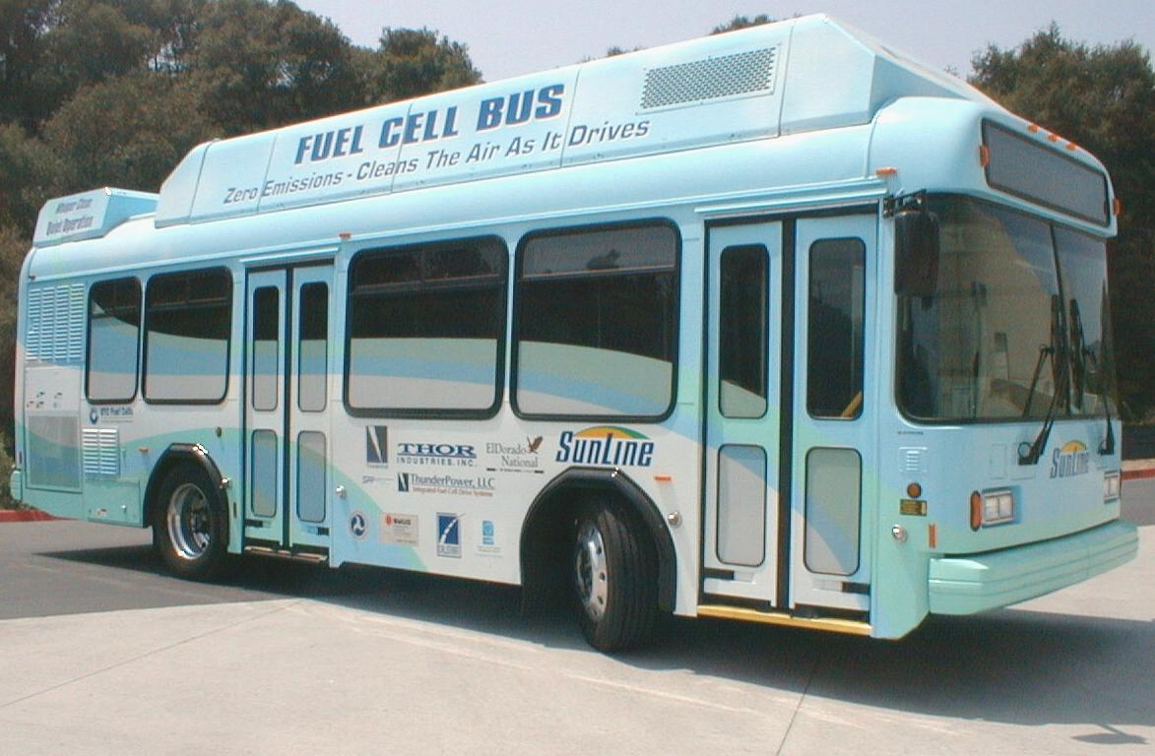
The hybrid electric drive is well suited to the stop and go service of transit buses. ISE Corporation has developed hybrid electric drive buses for transit service fuelled (at the choice of the facility) with gasoline, diesel or hydrogen. The Thor/ISE fuel cell hybrid electric bus – shown Figure 1 at left - was the first hybrid electric fuel cell bus. It was in demonstration and revenue service during 2002-2004 at sites including SunLine Transit, Chula Vista Transit, Los Angles County Metropolitan Transit Authority, and AC Transit in Oakland. By taking advantage of ISE’s advanced hybrid-electric drive technology, this 30-foot bus operated with a much smaller fuel cell than those used in conventional buses of this class. The automotive size (60 kW) fuel cell was available at lower cost and used less fuel, while the low speed acceleration of the bus depended largely on power drawn from the batteries. Further, stress on the fuel cell was diminished by limiting the sudden changes in electrical load, while allowing the electric drive components to provide both the sudden acceleration and the regenerative braking.

Based on the exceptional performance of this prototype bus, transit agencies have concluded that hybrid electric hydrogen fueled buses are attractive, and have ordered improved fuel cell buses and – due the high cost of fuel cells – the use of a hydrogen fueled internal combustion engine generator for electrical charging in a hybrid electric bus.

2. The HHICE (Hydrogen Hybrid Internal Combustion Engine) Bus

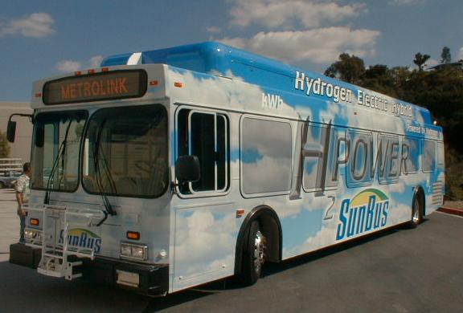
Until the advent of reliable and competitively priced fuel cells, a lower cost alternative, the Hybrid electric Hydrogen fueled Internal Combustion Engine (HHICE) bus has been developed and introduced into service in California. (Figure 2, below) This bus is similar to the noted fuel cell buses but that the fuel cell is replaced with a hydrogen fueled internal combustion engine driven electrical generator. A 6.8 liter Ford V10 engine, in a turbocharged version adapted to hydrogen fuel, is mounted (with the electrical drive components) where the conventional drive engine would otherwise be located. A standard New Flyer Chassis is used, with several additions:
- Eight fuel tanks, which together are capable of containing 58kg of 5000 psi hydrogen, are mounted atop the bus,
- A 150kw Siemens electrical generator is mounted at the transmission end of the engine,
- An ultracapacitior pack (144 2.8Farad Maxwell capacitors in series) is mounted on the roof, just aft of the hydrogen storage,
- The inverters which convert the AC electrical to DC at a voltage suitable for charging the ultracapacitors or converting the DC to AC to power drive motors are mounted just curbside of the engine,
- Electrically powered auxilaries (to provide compressed air for brakes and high pressure hydraulics for steering) are also provided as a part of the engine package. (However, no engine shaft power is directly used for air or hydraulics, the power is electrical!) The auxiliaries are rotary pumps which are much quieter and more efficient than have conventionally been used.

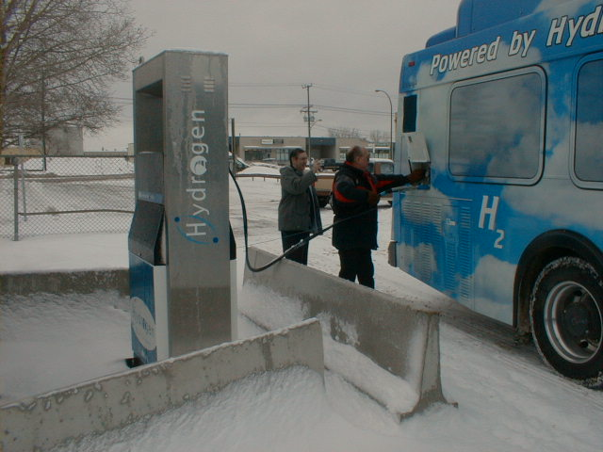
The prototype HHICE bus was introduced into service by SunLine Transit late in 2004. In January 2005 it was shipped to Canada for cold weather tests and demonstration. It was operated in revenue service by Winnipeg Transit (in Manitoba, Canada) at temperatures as low as –27ºC in winter testing (January-March 2005).

Figure 3 shows the HHICE bus being refueled at Winnipeg’s Red River College electrolytic hydrogen fueling station on a February morning prior to going on route. Assuring adequate dryness of the hydrogen fuel was a key challenge, as to fuel to 5000 psi at temperatures of -30ºC demands a dew point of -80ºC.

Following the winter testing (and after an east coast tour) the bus was returned to service at SunLine Transit. During the summer operation ambient temperatures to +45ºC were experienced. Under such circumstances the fans cooling the engine coolant and the electronic coolant (a distinct cooling loop) run at high speed. Likewise, the bus air conditioning is taxed to meet the cooling demand. Consequently, it has been observed that summer months milage is notably lower (as low as 3.5mi/kg) than that of winter months (where it approches 4.5mi/kg).

This prototype bus presently has over 53,000 miles in revenue service. This has not been entirely without difficulty:
- Hydrogen fuel injectors are much improved, but still are the first suspect if the engine misfires. A common symptom is leakage of hydrogen while the injector is closed, causing hydrogen accumulation in the intake manifold
- A vibroelastic damper is used to reduce crankcase vibriations, and the stock damper was found to overheat and fail within a few weeks of service. This was ameliorated with an improved damper design.

3. The New Hybrid Electric Fuel Cell Buses
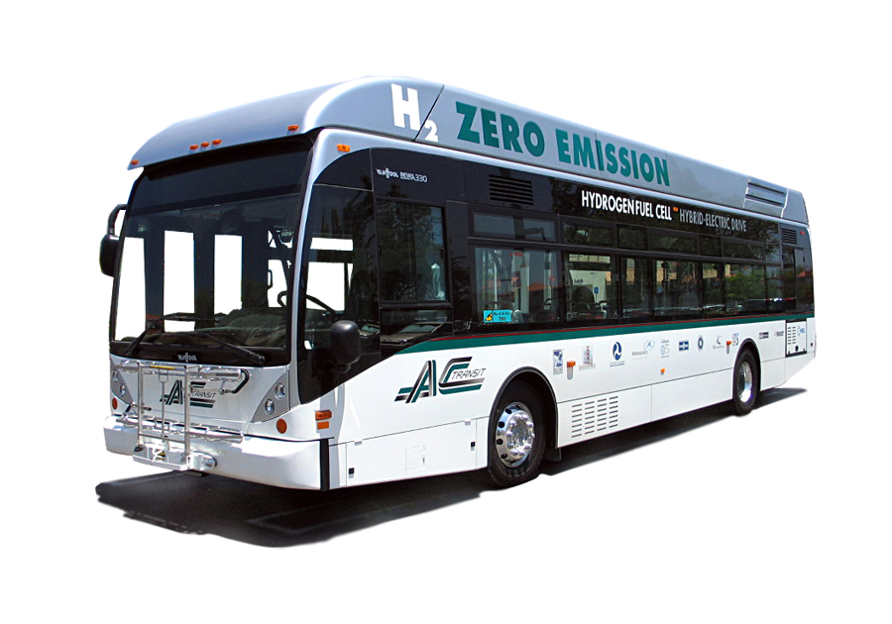
ISE has in recent years collaborated with AC Transit, UTC Fuel Cell, and the European bus manufacturer Van Hool to design an improved hybrid electric fuel cell bus on a 40 foot chassis. This bus uses a 120 kW rated fuel cell, warranteed for 4000 hours in combination with three “Zebra” brand Nickel Sodium Chloride batteries. Bus performance characteristics include:
- Quiet operation, the air conditioning is now the biggest contribution to background noise (as well as passing diesel vehicles!),
- Maximum speed capability in excess of 65 mph,
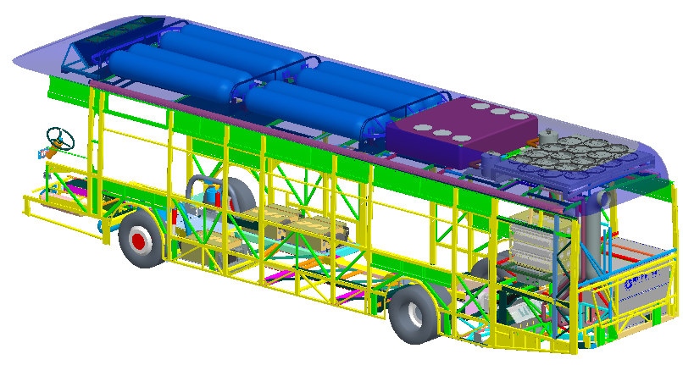
Five of these buses have been delivered, three to AC Transit one to SunLine Transit and one recently to Connecticut Transit. The SunLine bus has been in revenue service for over a year and has accumulated 30,000 miles, the AC Transit buses are also in daily service with some 15,000 miles per bus.

These buses incorporate a 120kW UTC fuel cell, three “Zebra” batteries (high temperature nickel sodium-chloride) of capacity totaling 53kWh, 50 kg hydrogen storage, and rooftop air conditioning and fuel cell cooling.

Experience with the bus is mostly good, with some areas needing improvement:
- The rider experience is superb, the bus is beautiful, quiet and clean,
- Reliability has been less than acceptable, as
  - An air conditioning motor keep the SunLine bus out of operation for over a month in the summer of ’06,
  - The high technology Zebra battery used in this bus is troublesome at best, we are looking for improved batteries,
  - Fuel cell problems have also caused notable inavailability.

The interested reader can find comprehensive reports about the SunLine and AC Transit programs on the NREL website.

4. What’s Next?
The CUTE programs, by which 39 buses have been in operation in 13 cities, and the USA programs such as discussed herein show that buses offer a most appropriate application of hydrogen technologies. Thus there is a lot of interest in city transit buses using hydrogen, nearly all of it focused on fuel cell powered buses.
- CUTE buses continue to operate, with nine of them operating in Hamburg, three each in Perth and Beijing. China has indicated their intent of using fuel cell buses for teh 2008 Olympics.
- The US Department of Transportation held a competition in 2006 for fuel cell bus concepts, and in October indicated intent to negotiate with several properties for new fuel cell bus designs. As part of this program AC Transit and SunLine will do accelerated life test operation – in two shifts – of their fuel cell buses, followed by retrofitted improvements to the buses.
- Also in 2006 the City of London announced the intent to purchase ten hydrogen buses, a mix of fuel cell and HHICE vehicles, which will be used to service a London route.
- Berlin is in process of purchase of a number of Hydrogen ICE buses. We understand that four have been delivered and the number on order may be as high as 250. However these buses have high fuel consumption, reportedly 19kg/100 km. This suggests the range is limited to about 300km, and the cost of fuel may well be above that of diesel.
- Other cities in Europe, such as Rotterdam, have indicated interest in major purchases.
- In Canada, procurement is underway for twenty fuel cell buses which are targeted to serve the 2010 Winter Olympics.
- In California, the ZEB ruling has been revised, doubling the requirement for demonstration ZEBs and stipulating widespread purchases of hydrogen buses beginning in 2011.
- As transit agencies become more aware of the possibility of significant fleets of hydrogen vehicles, they are becoming more insistant that the suppliers offer to take responsibility for the day to day operation of the vehicles. There is pressure on suppliers to offer advantageous warranties. Ballard, for instance, announced late in 2006 that they would offer a 12,000 hour – five year warranty (whichever comes first) on their fuel cell system for buses.

The Hydrogen Age is upon us!

Conclusion:
Hydrogen fuelled buses serve riders in California daily at AC Transit and SunLine Transit. These buses provide a superior ride experience, being quiet and clean as is essential to provide a pleasant ride. The HHICE bus offers clean and quiet transport which is competitive with gasoline or diesel fuelled vehicles, given hydrogen fuel availability at reasonable cost. The fuel cell bus is more than competitive in fuel cost, and the high capital cost of the prototype buses is expected to fade into the past as the fuel cell durability is proven and more of the fuel cell vehicles are delivered.

Worldwide, there is a growing awareness that hydrogen buses are a better way, and purchases of tens of new design buses are in process. Whereas only the CUTE program has fielded tens of buses, it appears that in 2008 there will be at least three programs in which distinct hydrogen bus designs are delivered in numbers of ten or more to specific fleets. Further, there will be a variety of bus designs using fuel cells or hydrogen engines from distinct manufacturers will be placed into daily service is cities such as Berlin, London and – in British Columbia – Victoria and Whistler. In such widespread places such as Beijing, Europe, Canada and California there are plans for hydrogen bus fleets offering daily service and demands from transit agencies for durability and reliability.

ISE Corporation, 12302 Kerran Street, Poway, CA 92064; Corresponding author: pscott@isecorp.com, 858-413-1742
Substantial public and private monies have supported the development of these buses. The Thor/ISE bus is the result of the substantial grant of funds by Thor Industries, with additional support from the South Coast Air Quality Management District, the California Energy Commission. CalStart and the Federal Transit Administration have also added their support to the HHICE program, and the Ford Motor Company and SunLine Transit have been essential partners. The new fuel cell buses are supported by a consortium of state and local funding agencies assembled by AC Transit with support from SunLine Transit.
Similar hybrid electric drive buses using gasoline for fuel are being provided for several California cities. Over a hundred of these buses have gone into service in 2004-2005, and in aggregate have logged over four million miles. The HHICE prototype was shown at the 2005 NHA Conference in Washington, DC, where the bus was used for conferee shuttle service. It presently serves SunLine’s Transit Route 50.
Similar to conventional diesel, compared to a maximum of 11kg/100 km for the hybrid electric fuel cell bus reported herein or 14 kg/100 km for the HHICE bus.

