Characterization Studies on PEM Metallic Bipolar Plates and Membrane Electrode Assembly after one thousand hours of Operation

H. Tawfik ^{1, 2}, Y. Hung ¹, and D. Mahajan^{2, 3, 4}
1. Abstract

Metallic bipolar plates are much more appropriate for PEM fuel cell operation because of their higher mechanical strength, easier manufacturability, and lower interface contact resistance than graphite composite, that are currently considered the industry standard. Characterization studies were conducted on aluminum coated bipolar plates with carbide based alloy to examine the durability of both coating and binder materials used in this application.

Bipolar plates and the Membrane Electrode Assembly (MEA) samples were collected and tested from both the cathode and anode side of a single cell after a one thousands hours of normal operating conditions under a cyclic loading. Scan Electron Microscope (SEM), and EDX analysis were performed on the land and valley surfaces of the reactant flow fields at both the anode and the cathode. The measurements were supper imposed to identify the locations and zones of anomalies to conduct further analysis focused on these zones. X-ray Diffraction (XRD) analysis were also conducted on samples scraped from the anode and cathode electrodes of the MEA that was also performed for 1000 hrs in metallic bipolar plate fuel cell. Moreover, samples of water as a byproduct produced during the single fuel cells operation were also collected and tested for the existence of chromium, nickel, carbon, iron, sulfur and aluminum using mass spectroscopy analysis technique.

The analysis of the SEM measurements indicated the possibility of the dissociation and the dissolution of the nickel chrome that is used as the binder for the carbide based corrosion resistant coating with the substrate. The X-ray study yielded the tendency for the catalyst growth that could result in power degradation.

2. Introduction

Metallic bipolar plates are more durable, less permeable to gases, safer and more economical with less hydrogen consumption than graphite. In addition, metals have excellent potential for cost effective high volume manufacturing techniques such as stamping and die casting fabrication processes, unlike graphite [1]. Six single PEM fuel cells were identically deigned, manufactured and operated under similar conditions 70ºC, 96% R.H. and 10 psi pressure for both hydrogen and Air (Oxygen) as reactant gases. Four out of the six cells were fabricated of aluminum bipolar plates that are coated with high corrosion resistant carbide based alloy. The other two cells were fabricated of graphite composites to provide a reference of comparison and benchmarking for PEM fuel cell performance. Both metal and graphite PEM cells showed steady performances with no power degradation, however the average electric power output from the metallic cell has exceeded considerably that of the graphite. This is attributed to the fact that both the bulk and interfacial contact resistances (ICR) of the corrosion resistant coatings on the aluminum bipolar plates are considerably lower than graphite composite [1].
¹Farmingdale State College, State University of New York, Farmingdale, NY 11735
²Advanced Energy Research and Technology Center (AERTC), Stony Brook University, Stony Brook, NY 11794-2275
³Materials Science and Engineering Department, Stony Brook University, Stony Brook, NY 11794-2275
⁴Energy Sciences and Technology Department, Brookhaven National Laboratory, Upton, NY 11973

Two different highly corrosion-resistant conductive coatings were used by Tawfik et al [2] in their study and were applied to each pair of the metallic plates. An MEA with carbon cloth GDL, thickness of Nafion < 50 microns, < 1mg/cm² total platinum content (anode & cathode) and 6.45 cm² active electrode areas was fitted to each cell and operated under identical conditions. The obtained data from the two graphite cells were averaged and plotted and the other aluminum cell data were similarly treated and plotted on the same graph for comparison. Generally, the metallic treated bipolar plate provided at least a 22% savings in hydrogen consumption when compared to graphite [2]. This is attributed to lower bulk and surface contact resistance of the coated aluminum plates used in this study in relation to graphite. The results of the lifetime testing conducted at temperature of 70º C under loading condition ranging from 0 to 0.6 W that showed no indication of power degradation due to metal corrosion for at least 1000 hours of real time testing [3].

The characterization studies were deemed necessary to explore any chemical changes that may have occurred on the surface of the bipolar plates’ coating and/or the Membrane Electrode Assembly (MEA) during or after these long hours of operation under the harsh corrosive environment that was taking place inside the fuel cell.

3. Characterization Studies

In this study two main characterization tools were utilized in this study namely Scanning Electron Microscope (SEM) with EDX analysis and X-ray Diffraction (XRD). SEM optical light and electron micrographs as well as EDX analysis of both the cathode (O) and anode (H) were performed as shown in Figure (1). The inactive areas of the bipolar plates and fresh unused MEA were used as a control reference and benchmarking for comparison between before and after 1000 hrs of operation.
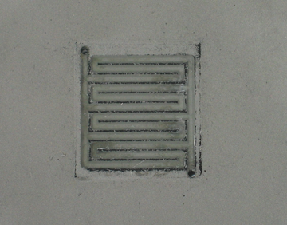
Inactive reference area
Land area of reactants of flow field
Valley area of channel flow field
Active area of a bipolar plate

Figure (1) Anode (H) and Cathode (O) of coated aluminum bipolar plates

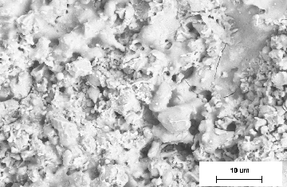
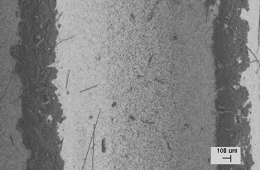
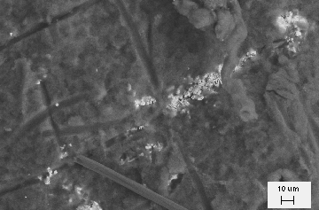
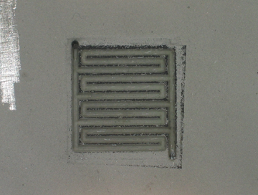
Possibility of the existence of a nano Crack

Figure (2) SEM optical light and electron micrographs for the cathode plate

The upper right picture in Figure (2) is taken at high magnification factor on the inactive area of the bipolar plate in the cathode side of the single hydrogen fuel cell. Nano-scale crack in the surface layer of the coating may be observed, but it is not expected to constitute a through crack to the surface of the aluminum substrate. Both the peaks (lands) of the channels (bottom left) and valleys (bottom right) in the reaction zone showed evidence of a carbonaceous material that is attributed to debris from the gas diffusion layer GDL material. The debris from the GDL was stuck to the surface layer of the coating that needed to be removed by a cleaning solution.

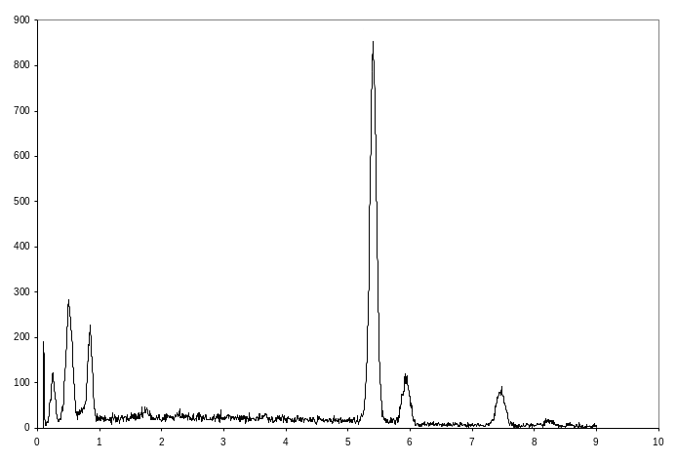
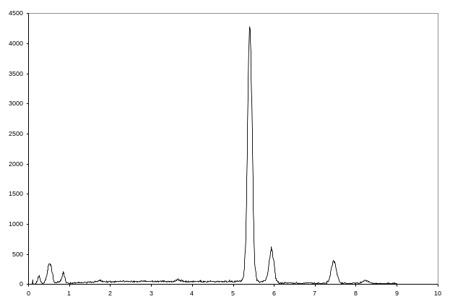
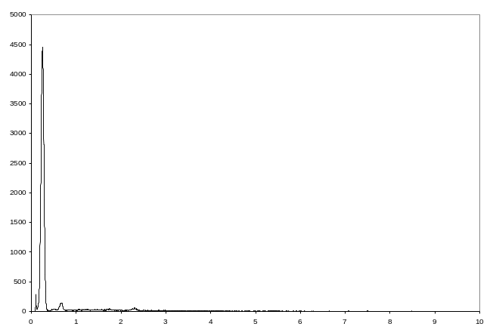

Figure (3) EDX Analysis that correspond to the electron micrographs shown in Figure (2)

The EDX analysis clearly confirmed that carbonaceous material has dominated the surface of the serpentine’s land flow field as the GDL has imparted this carbon during the one thousand hours of operation and was stuck to the land surface. Thus, both the anode and the cathode of the bipolar plates were immersed in a cleaning solution for a few days.

Similar observations were noted for the anode as shown in Figures (4) and (5), and therefore the anode plates were treaded accordingly.

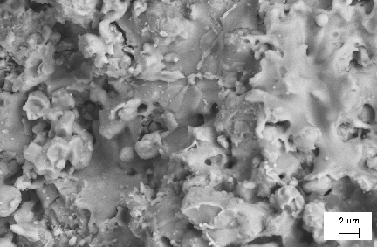
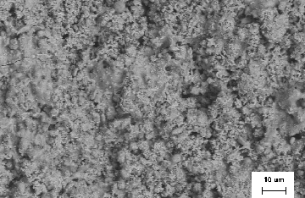
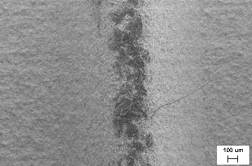
Possibility of the existence of Nano Cracks

Figure (4) SEM optical light and electron micrographs for the anode plate

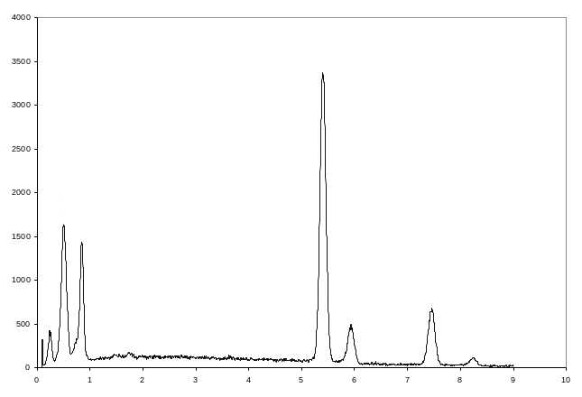

Figure (5) EDX Analysis corresponds to the electron micrographs shown in Figure (4) for the anode plate

Once again, the analysis confirmed the need for removing the carbonaceous material and retesting. The new results of the EDX analysis did not show the dominance of carbon as shown in Figures (6) and (7).

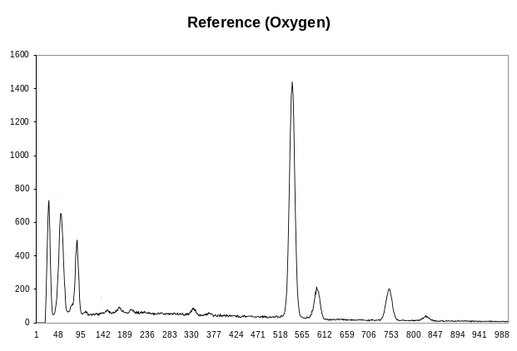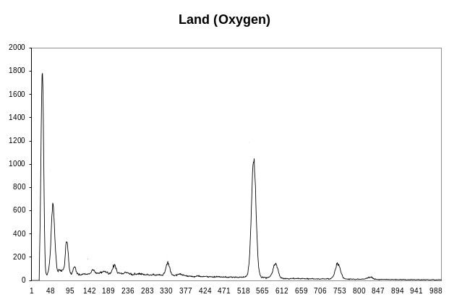
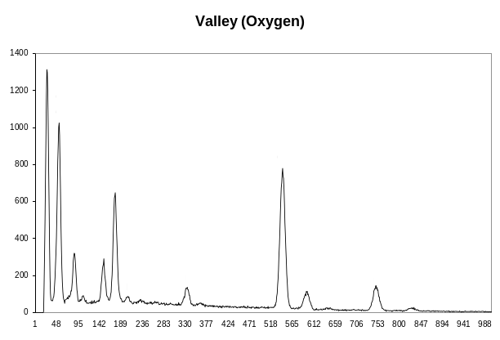
Figure (6) Exhibits EDX analysis for the Cathode (Oxygen) reference, land and valley

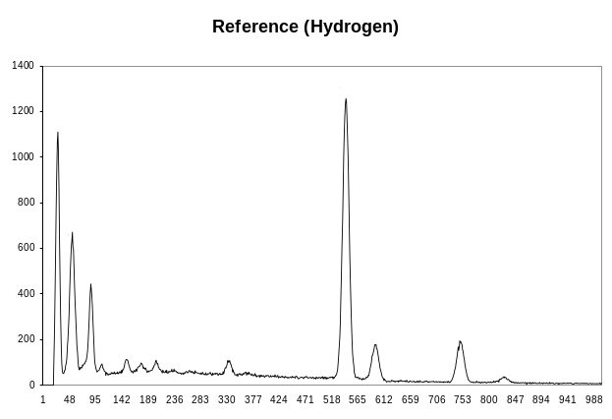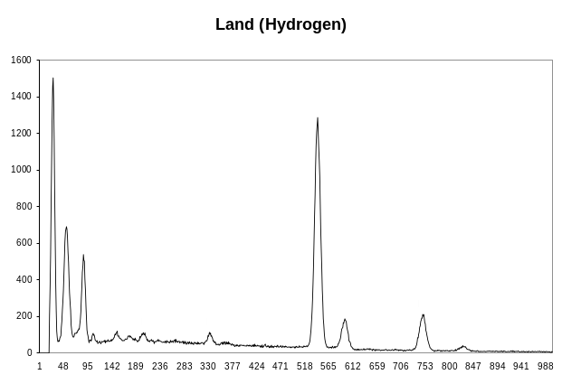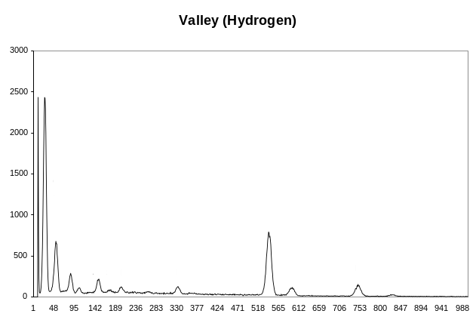
Figure (7) Exhibits EDX analysis for the anode (Hydrogen) reference, land and valley

The EDX analysis of all the three zones indicated the comparable compositions of the coating in all the three locations, namely the reference inactive area (top left), the top of land (top right) and the valley of the flow field channels (bottom left). All the EDX results were superimposed for comparison as shown in Figure (8).

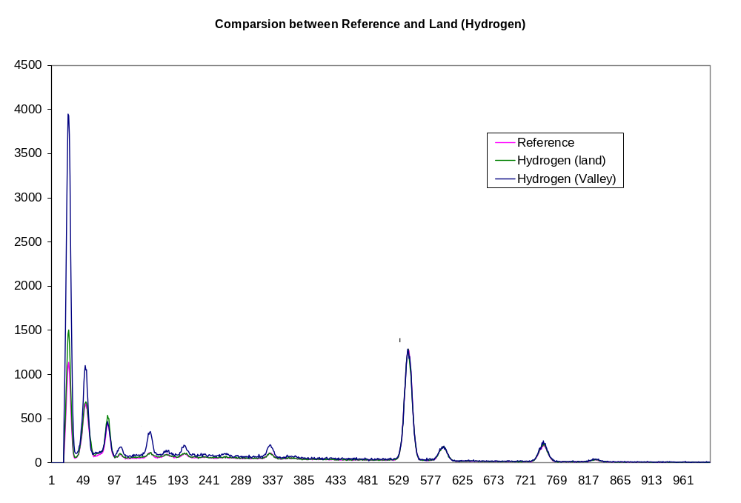
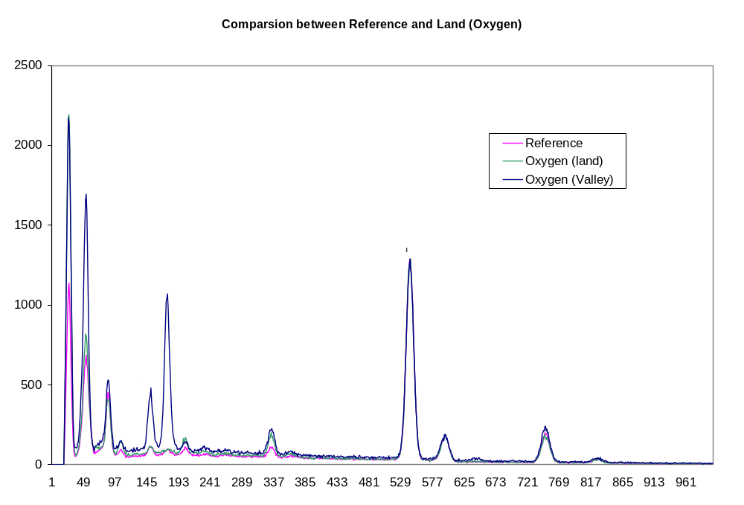

Figure (8) Superimposed XDS Analysis of the three zones for comparison

The comparison shown in Figure (8) above indicated the similarity of the material composition of the coating after 1000 hours of operation at the reference inactive zone, the land and the valley of the follow field. In addition, the possibility of partial dissociation of the binding material (NiCr) of the coating layer to the substrate was demonstrated by the extra Ni shown in the EDX analysis.

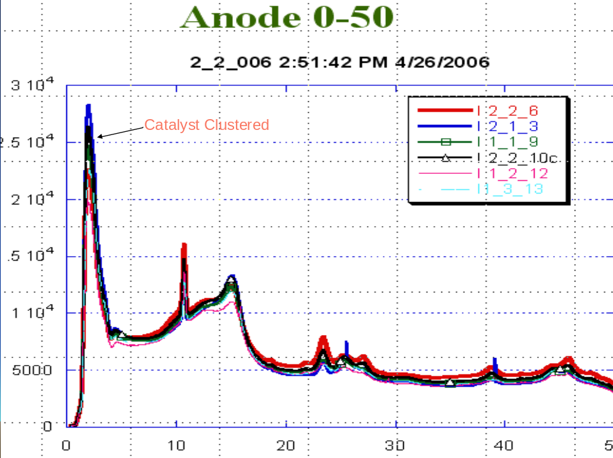

Figure (9) XRD Analysis for the MEA on the anode side
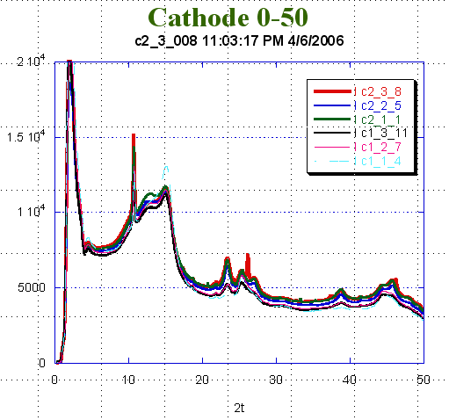

Figure (10) XRD Analysis for the MEA on the cathode side

The XRD study indicated the clustering of the catalyst in the MEA at the anode after the 1000 hours of operation as shown in Figure (9). Similar observations were noted by other researchers in Los Alamos National laboratory. This is explained by the tendency of the catalyst to minimize its surface energy that causes this clustering effect. However, a similar study at the cathode as shown in Figure (10) did not clearly exhibit that same phenomenon.

4. Mass Spectroscopy

Samples of the byproduct water collected during the operation of the fuel cell were passed into argon plasma at the testing laboratory. The emission intensity is measured for each element of interest and compared to the calibration curve to yield a concentration of each element in the sample solution. The results showed that Al, Cr, Pt, Fe and Ni, are all < 1ppm each, only carbon was less than 0.12%. The carbon resulted from the gas diffusion layer. The lack of existence of Al in large quantities indicated that the nano crakes shown in the

5. Conclusions:

- Catalyst (Pt) Clustering effect was observed in the XRD analysis for the anode side
- SEM/EDX showed no variation in the surface composition after 1000 hrs of operation
- Water Analysis also exhibited the Stability of the corrosion resistant coating with no loss of Pt, Al, Fe, Cr and Ni, are all at < 1ppm each.

6. Acknowledgement:

The contributions of Dr. Henry White and Dr. Jim Quinn of Stony Brook University to the SEM optical light and electron micrographs work are greatly appreciated. Also, the authors would like to thank Dr. Jonathan Hansen of Brookhaven National Laboratory for his XRD work and analysis.

7. References

1. Tawfik, H.; Hung, Y.; and Mahajan, D.; “Metallic Bipolar Plates for PEM Fuel Cells, A Review”; J. Power Sources, 2006.

2. Hung, Y.; and Tawfik, H.; ASME- The 3rd International Conference on Fuel Cell Science, Engineering and Technology, Ypsilanti Marriott Hotel at Eagle Crest, Ypsilanti, MI. May 23-25, 2005.
3. Hung, Y; Tawfik, H.; “Corrosion Resistant, Lightweight, and Inexpensive Metallic Bipolar plates with excellent manufacturability for PEM Fuel Cell power systems”, ASME –RIT 2nd International Conference on Fuel Cell Science, Engineering and Technology, Rochester, NY. 2004.

