HYDROGEN PRODUCTION FROM PLASMA-GENERATED SYNGAS: A DEMONSTRATION TEST USING IET’S PEM™ AND AIR PRODUCTS’ PRISM™ H2 PSA SYSTEM

R. A. Merrill, J. A. Batdorfª, W. J. Quappª
D. Tyndall

Introduction
Worldwide energy shortages combined with the political instability in countries producing much of the world’s oil supplies have stimulated enhanced efforts to produce energy from renewable sources such as wind, solar and hydropower. One of the often overlooked renewable energy sources is the organic wastes disposed by industrial societies. In the USA, the major sources include agricultural wastes (crop residues and animal wastes), municipal solid wastes, and industrial wastes. These wastes can be converted into a useful product such as hydrogen using steam reforming gasification.

Integrated Environmental Technologies (IET) has been developing plasma based gasification systems to recover energy values from organic waste materials using steam reforming gasification to produce a clean syngas. The IET Plasma Enhanced Melter™ (PEM™) has been used in commercial applications to convert a wide variety of waste streams into syngas. These applications have included nuclear waste, medical waste, municipal waste, and many varieties of hazardous industrial wastes.

In most past applications, IET has combusted the syngas in internal combustion engines to produce electrical power. Another use of the syngas is to produce hydrogen. Hydrogen then has many uses in the chemical and petroleum industries. It can also be used as a vehicle fuel in future transportation systems such as envisioned by the hydrogen transportation programs in California, Texas and New York. This paper describes the results of an effort to extract the hydrogen content in the syngas into a separate high purity gas stream using Air Products PRISM™ H₂ PSA.

Recycling Technology
Integrated Environmental Technologies, LLC (IET) has developed an innovative gasification and vitrification system – the Plasma Enhanced Melter™ (PEM™) -- that is capable of utilizing a wide range of waste materials to produce syngas and valuable commercial products. The PEM™ process uses a DC plasma arc to produce a very high temperature in the process vessel. At the high temperature, typically about 1200◦C, the carbon in the waste reacts with high temperature steam according to the following simplified reaction to form hydrogen and carbon monoxide (syngas):
Heat
C + H₂O → CO + H₂

Some CO₂ and minor quantities of CH₄ are also produced depending upon the specific waste stream and PEM™ operating conditions. More complex organic materials react similarly. Inorganic materials are melted and are incorporated into a molten glass bath. Partial oxidation is used to supply some of the energy for the endothermic gasification reactions. The resulting syngas mixture has a typical energy content of 250 to 290 Btu/scf. Most importantly, the syngas has minimal organic impurities that would interfere with subsequent catalytic or extraction processes.

An integrated and independently controlled AC power system is used to heat the molten glass bath which incorporates the inorganic residues (ash) from the process. The glass immobilizes hazardous metals (as oxides) into a leach-resistant glass solution. Extensive testing of this glass with RCRA metals content of several percent has tested non-hazardous by TCLP testing.
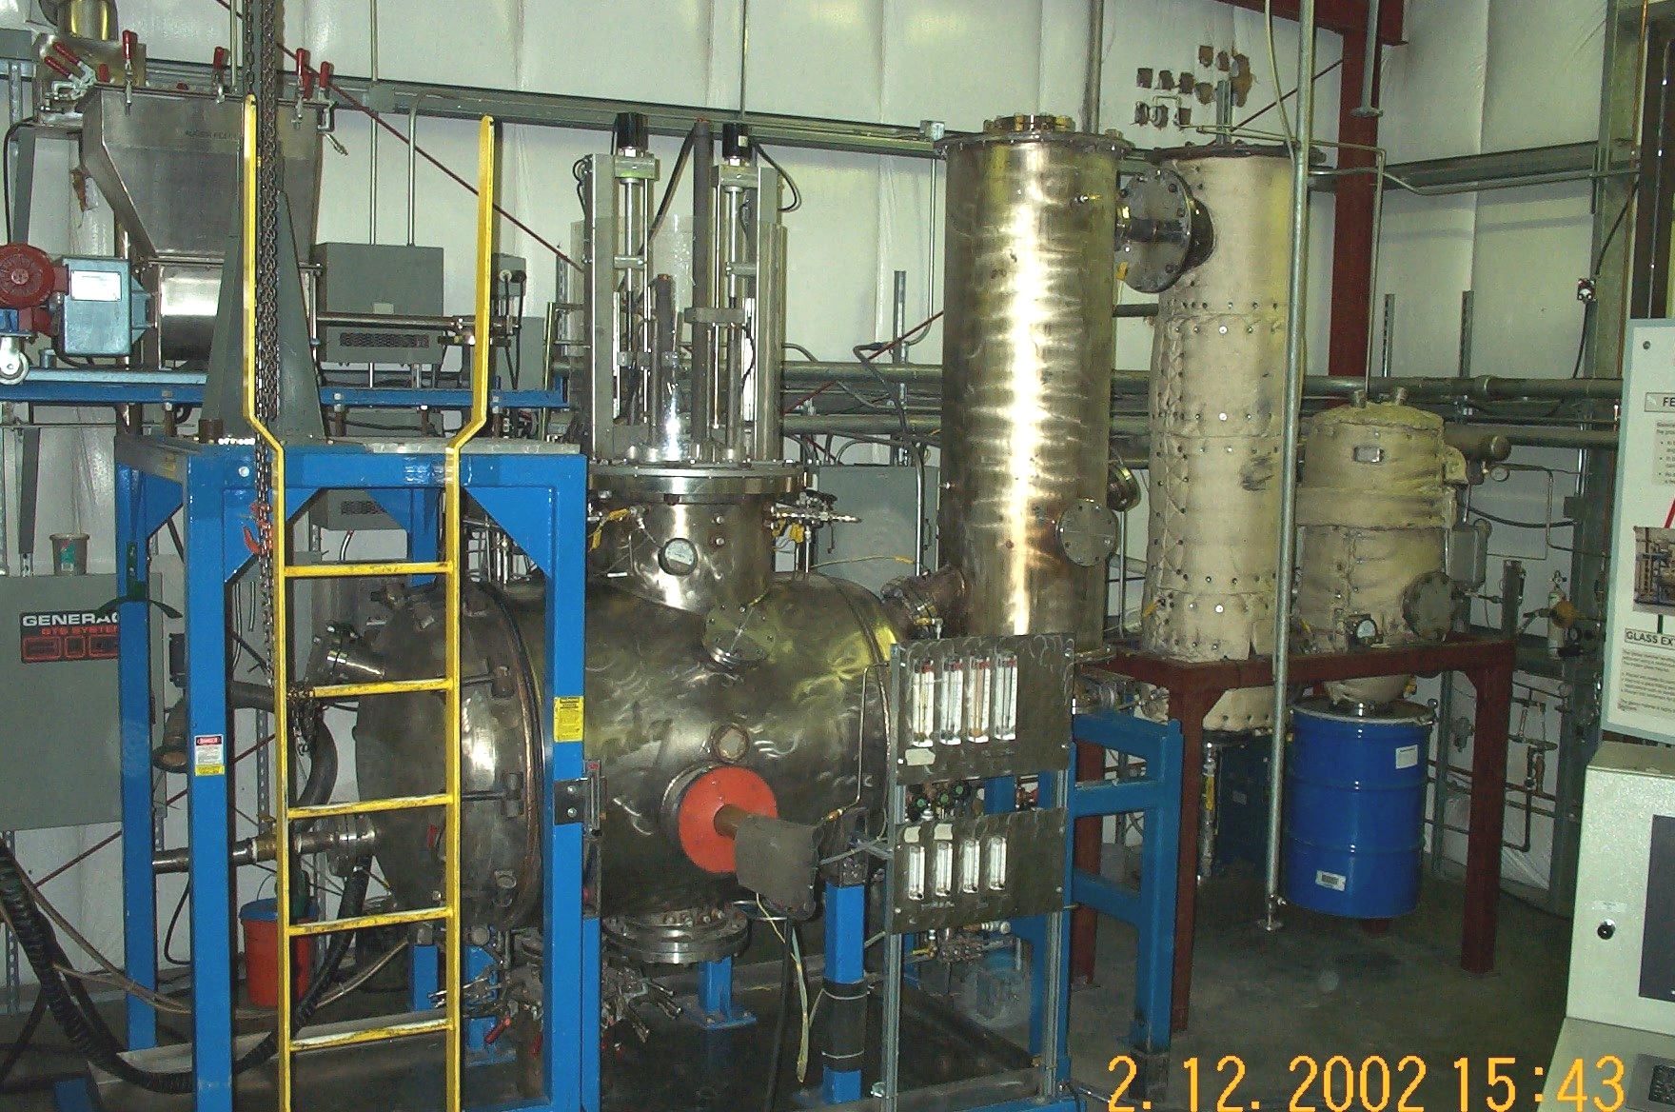
Figure 1. Engineering Scale PEM™ Used for the Hydrogen Demonstration Test

Test Facility
The IET Engineering Scale Test Facility is shown in Figure 1. A simplified PFD is shown in Figure 2. The system has all of the unit operations associated with a commercial scale PEM™. For the hydrogen production demonstration, an Air Products PRISM™ H2 Pressure Swing Adsorption (PSA) system was brought to the site and connected to the PEM™ system down stream of the syngas compressor. The Air Products PSA is shown in Figure 3.

The Air Products PSA is a small-scale system with a design production capacity of 4.1 scfm hydrogen. The patented PSA system is principally composed of four absorption columns filled with proprietary adsorbents, a rotary valve, a mass flow controller on the product gas outlet line, and associated piping, valves, regulators, and gages. For a given supply pressure, the performance of the PSA system is optimized by varying the speed of the rotary valve, which controls the frequency of the pressure swing cycles on each column.
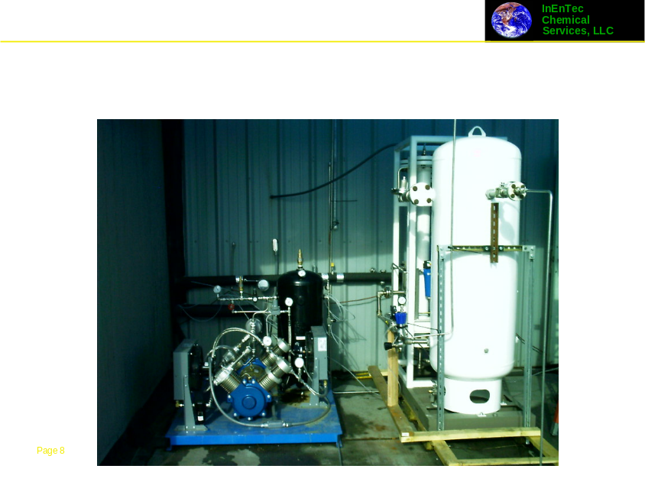
Figure 3. The Air Products PSA is shown along with the Syngas Compressor

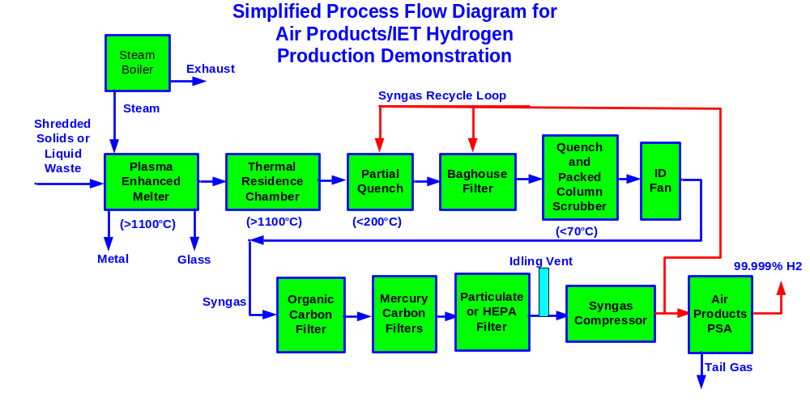
Figure 2. Simplified Process Flow Diagram for the Hydrogen Demonstration Test

Test Objectives and Test Conduct
The primary test objective was to demonstrate that the Air Products H₂ PSA could produce high purity hydrogen product from the PEM™ low-pressure syngas product stream. The proof-of-concept test program was conducted over a period of two days during March 2005. Although optimization of hydrogen recovery was not an objective of this test, it was desirable to demonstrate >99.9% H₂ purity with hydrogen recovery a high enough level to be potentially commercially viable (i.e., >99.9% purity would be of no use if only 5% of the hydrogen was recoverable at that purity). For commercial scale applications, optimization of process parameters would need to be conducted to produce the lowest cost H₂ from the integrated system.

Diesel fuel was chosen as the feed material for the initial demonstrations since it generates a large volume of syngas per pound of feed and is easy to feed into the PEM™ at a steady rate using a simple peristaltic pump. In addition to the diesel feed, one test was conducted using a mixture of organic solvent and ground carpet materials to demonstrate hydrogen production from an organic waste material.

Syngas was produced in the PEM™ following standard procedures for the Engineering Scale Test Facility. The feed material, steam, and oxygen were injected into the process chamber, where they react in the presence of the DC arc to form syngas. A small amount of oxygen was also injected into the thermal residence chamber (TRC) in order to maintain the high temperatures required to drive the gasification reactions to completion. The syngas then passed through the off-gas cleaning system including the primary quench, baghouse, caustic wet scrubber, and carbon filters. Recycled, compressed syngas is used as the quench atomizing gas and as the baghouse pulse gas. The baghouse was pulsed regularly throughout the test.

The H₂ PSA system was fed syngas from the syngas compressor receiver tank at a pressure of about 110 psig. Syngas production commenced using a diesel fuel as the feed material. During the tests, all data normally acquired by the process control system and regular operator rounds were logged. In addition, a gas chromatograph (GC) was periodically used to collect sample spectra frequently during the test.

Samples of the hydrogen product were taken from the PSA product outlet downstream of the mass flow controller, and syngas samples were taken from the inlet line to the PSA. Samples were collected in flow-through sample containers that were pressurized and vented multiple times to ensure a clean sample. A total of eight gas samples were taken during the two day testing program – four hydrogen and four syngas. The sample canisters were numbered sequentially.

After initiation of the test, the syngas was produced for approximately two hours to allow conditions in the PEM™ system to stabilize. The PSA was then started and the hydrogen product flow from the PSA was gradually increased to 1.9 scfm while monitoring the product gas stream composition using a GC to ensure hydrogen purity. At a flow of 1.9 scfm, the recovery was estimated to be about 60%. After about 100 minutes of operation, no indication of CO was seen in the product gas stream and a sample of the syngas inlet was taken (Test Segment 1, syngas sample 1). No hydrogen sample was taken at this time.

The hydrogen product flow was increased to 2.25 scfm while monitoring its purity on the GC in an attempt to maximize the recovery. A small CO peak was observed on the GC at this flow, so the flow was then decreased to 2.0 scfm and the CO peak disappeared. After 45 minutes of operating at this flow, samples of the hydrogen product and syngas inlet streams were taken (Test Segment 2, hydrogen sample 2, syngas sample 3).

The following morning syngas production commenced and continued for about 85 minutes before bringing the PSA online. The PSA was then run for 55 minutes at a hydrogen product flow of 1.0 scfm and 25 minutes at a flow of 1.7 scfm before samples were taken of the hydrogen and syngas streams (Test Segment #3, hydrogen sample 4, syngas sample 5).

The hydrogen product flow was then increased to 1.9 scfm to duplicate the hydrogen production rate of Test Segment #1. Several interruptions in the diesel feed occurred over the next couple hours due to gasifier operational issues. When a significant interruption occurred, the PSA was shut off and isolated, and once a stable syngas flow had again been established, the PSA was restarted. As long as the composition of the gas at restart of the PSA was similar to the composition of the gas at the time of the shutdown, there should be minimal impact on the composition of the product streams from the PSA. After operating for 75 minutes at a H₂ product flow of 1.9 scfm (excluding the shutdown time), a sample of the hydrogen stream was taken (Test Segment #4, hydrogen sample 6). No syngas sample was taken at this time.

Near the end of the planned testing, the feed to the PEM™ was switched to a mixture of shredded carpet and organic solvent while the PSA system continued to run at a product flow of 1.9 scfm. After 45 minutes, a sample of the syngas was taken, and 25 minutes later the hydrogen product stream was sampled (Test Segment #5, syngas sample 7, hydrogen sample 8). At the conclusion of the test, syngas production in the PEM™ was stopped and the PSA system was shut down and purged with nitrogen.

Test Results
A summary of the operating conditions applicable to hydrogen production is provided in Table 1 for each of the test segments identified above. The feed rates were measured directly by recording the loss in weight of the feed container versus time using the load cell mass flow measurement system. The total syngas flow was measured by a vortex flowmeter located in the system downstream of where syngas is removed for use in the PSA. This location is obviously not optimum but it was impractical to move it for this test program. The facility does not have a separate flowmeter in the syngas bypass loop as it is normally returned to the system at the baghouse and quench locations.
Table 1. Test Segment Operating Data Summary for Hydrogen Production Test Using an Air Products PSA
 | Test Segment
 | 1 | 2 | 3 | 4 | 5
Feed Material | Diesel | Diesel | Diesel | Diesel | Carpet/ Solvent
Feed Rate (lb/hr) | 11.4 | 11.4 | 14.7 | 12 | 10.5/11.3
Total Syngas Flow (scfm) | 8.60 | 8.60 | 11.50 | 8.23 | 9.32ª
Syngas to Vent (scfm) | 1.54 | 1.54 | 4.84 | 1.71 | 2.6
Syngas to PSA - Calculated (scfm) | 7.06 | 7.06 | 6.66 | 6.52 | 6.72
H₂ Production Rate (scfm) | 1.9 | 2 | 1.7 | 1.9 | 2.1
Syngas Sample Number | 1 | 3 | 5 | n.a. | 7
Hydrogen Sample Number | n.a. | 2 | 4 | 6 | 8
Notes: a) Estimated from the increase in vent and hydrogen product flow relative to test segment 4

Thus, the total syngas flow was obtained by averaging the electronically logged data over time periods when the PEM™ system was being fed at the stable rate of the test segment, but the PSA was not operating (no syngas diversion). There was not such a time period for test segment 5; therefore, the total syngas flow was estimated to be increased from test segment 4 by the measured increase in flow plus the increased hydrogen production flow. The hydrogen production rate was set by the operator and controlled by the mass flow controller. This approach will slightly underestimate the total flow.

The data reported in Table 2 appear to be reasonably consistent within the bounds of accuracy of this testing. For example, a 29% increase in the mass feed rate of diesel from test segment 2 to 3 resulted in a 34% increase in measured total syngas flow. Although other data points are not as consistent, there are not large discrepancies. Therefore, the calculated syngas flow to the PSA system should be reasonably accurate.

Gas Sample Analysis
The syngas and hydrogen samples taken during the testing were analyzed by Air Products’ analytical laboratory. Results of these analyses for the syngas are presented in Table 2 along with the average composition recorded by the NOVA analyzer during the period of each test segment. The process gas analyzer manufactured by NOVA Analytical Systems is an extractive design that conditions and then analyzes a continuous sample of the syngas product. The syngas is drawn through a heated filter and membrane dryer prior to analysis for CO, CO₂, CH₄, H₂, and O₂. Detection is by three separate NDIR (infra red) detectors for CO, CO₂ and CH₄, temperature controlled thermal conductivity cell for H₂, and long-life electrochemical sensor for O₂.
Table 2. Syngas Sample Analysis (Vol% Dry Basis)
 | Test Segment Number
Test Number | 1 | 2 | 3 | 4 | 5
Analytical Laboratory Data
Air Products Sample Number | 1 | 3 | 5 | n.a. | 7 | D.L.
N₂ | 6.04 | 5.74 | 3.73 | n.a. | 6.40 | 0.01
O₂ | 0.40 | 0.38 | 0.26 | n.a. | 0.30 | 0.01
CO₂ | 11.4 | 10.7 | 8.29 | n.a. | 7.13 | 0.05
CO | 36.7 | 37.2 | 35.8 | n.a. | 39.9 | 0.05
H₂ | 44.5 | 45.3 | 50.1 | n.a. | 43.7 | 0.05
Ar | nd | nd | nd | n.a. | nd | 0.05
CH₄ | 0.56 | 0.62 | 1.67 | n.a. | 2.49 | 0.01
C₂H₄ | 0.001 | 0.0006 | 0.009 | n.a. | 0.007 | 0.001
C₂H₆ | 0.013 | 0.009 | 0.129 | n.a. | 0.053 | 0.001
NOVA Readings
CO | 34.8 | 38.2 | 39.1 | 37.1 | 38.9 | n/a
CO₂ | 11.4 | 12.6 | 9.9 | 9.5 | 8.2 | n/a
CH₄ | 0.6 | 0.8 | 2.2 | 2 | 3.4 | n/a
O₂ | 0.2 | 0.1 | 0.1 | 0.1 | 0.1 | n/a
H₂ | 39.7 | 41.9 | 43.2 | 44.4 | 41.4 | n/a
N₂ (by difference) | 13.3 | 6.5 | 5.5 | 6.9 | 8.0 | n/a

The lab results and the NOVA readings are in general agreement, but there appear to be some discrepancies between the measurements. The hydrogen content measured by the NOVA is consistently a few percentage points lower than the laboratory results, while most of the other gases tend to run a little higher. The NOVA measured compositions generally track the laboratory results in the change from sample to sample, but are offset higher or lower. It appears that the accuracy of the NOVA is less than expected based on the manufacturer’s claims at the concentrations seen in these tests.
Another anomaly in the syngas data is the presence of oxygen in the laboratory samples. A likely explanation for the low amounts of oxygen seen in the laboratory syngas samples is in-leakage of air into the system at the inlet of the syngas compressor. The syngas line can be less than atmospheric pressure at this point, which is downstream from the NOVA sample point.
For the purposes of the hydrogen recovery calculations presented later in this section, the laboratory data were used when available. For test segment 4 where no syngas sample was taken, the hydrogen concentration from the NOVA analyzer was used in the calculations.
The nitrogen levels from the NOVA readings are higher than the laboratory sample results, and both are higher than would be present in a full scale PEM™ system. The principle source of nitrogen in the syngas is from purges into the PEM™ vessel. The total purge flow rate does not scale linearly with system size, therefore, the purge flow for a full-scale system is a much smaller percentage of the total off-gas flow compared to this laboratory system. The expected nitrogen content in a full-scale system will be in the range of one percent or less of total syngas, depending on the purity of the injected oxygen. Since the nitrogen concentration reported by the NOVA is calculated by difference, and the NOVA hydrogen channel has been shown to read low, it is reasonable that the NOVA nitrogen reading would be higher than the laboratory analysis.
Results of the hydrogen analyses are presented in Table 3. From the data in the table it is apparent that there were some problems with the analysis of these samples. The presence of nitrogen, oxygen, and argon in samples 2 and 8 is indicative of air contamination. It is uncertain if this contamination is due to sampling or analytical error. Air Products did report that the laboratory had difficulty with the hydrogen samples because the samples were at a very low pressure compared to what they were used to working with. Sample 2 appears to be almost all air contamination as the nitrogen/oxygen/argon ratios closely approximate that of air. Sample 8 is only slightly contaminated.
Table 3. Hydrogen Sample Analysis
 | Test Segment
 | 1 | 2 | 3 | 4 | 5
Air Products Sample Number | n.a. | 2 | 4 | 6 | 8 | D.L.
CO (ppm v/v by GC) | n.a. | nd | nd | nd | nd | 1
CO₂ (ppm v/v by MS) | n.a. | 170 | 12 | nd | 63 | 4
N₂ (ppm v/v by MS) | n.a. | 685,230 | nd | nd | 175 | 4
O₂ (ppm v/v by MS) | n.a. | 185,000 | nd | nd | 6,050 | 4
Ar (ppm v/v by MS) | n.a. | 8,600 | nd | nd | 1,380 | 4
H₂ (% v/v by MS) | n.a. | 12.1 | 99.9+ | 99.9+ | 99.2+ | --

Most significant with respect to hydrogen purification is the complete lack of carbon monoxide in any of the samples. This indicates a complete separation of hydrogen from carbon monoxide in the PSA (even in the contaminated samples). Two of the samples showed hydrogen purity of greater than 99.9% (the method detection limit). Given the low levels of impurities measured in the two uncontaminated samples, Air Products staff believes it likely that the purity in these samples approached 99.999%. Despite the contamination, the Air Products staff reported that they are confident in the ability to produce high purity hydrogen from the PEM™ syngas stream.

Performance of H₂ PSA System
Table 4. Hydrogen Recovery from Syngas
 | Test Segment
 | 1 | 2 | 3 | 4 | 5
Feed Material | Diesel | Diesel | Diesel | Diesel | Carpet/ Solvent
Syngas to PSA - Calculated (scfm) | 7.06 | 7.06 | 6.66 | 6.52 | 6.72
H₂ in Syngas (vol%) | 44.5 | 45.3 | 50.1 | 44.4ª | 43.7
H₂ to PSA (scfm) | 3.14 | 3.20 | 3.34 | 2.89 | 2.94
H₂ Production Rate (scfm) | 1.9 | 2 | 1.7 | 1.9 | 2.1
H₂ Product Purity | n.a. | 12.1 | 99.9 | 99.9 | 99.2
H₂ in Product (scfm) | n.a. | 0.24 | 1.70 | 1.90 | 2.08
H₂ Recovery - Measured (%) | n.a. | 8 | 51 | 66 | 71
H₂ Recovery - Projected (%)^{b} | 60 | 62 | 51 | 66 | 71
Notes:
- H₂ in syngas for test segment 4 is taken from the NOVA reading; no sample was taken
- H₂ purity for projected recovery is assumed to be 99.9%

Given the gas flows and compositions, the percentage of hydrogen in the syngas stream recovered as a high purity hydrogen stream may be calculated. Details and results of these calculations are presented in Table 4. Since reasonable data for the hydrogen concentration was not available for test segments 1 and 2, hydrogen recovery was calculated based on an assumed product purity of 99.9%. With this assumption, the hydrogen recovery was estimated to be just above that required for economic viability. In test segment 4, a syngas sample was not taken for laboratory analysis, so the NOVA concentration was used to estimate the hydrogen flow into the PSA. With this assumption, a recovery of 66% is calculated. Even if the actual hydrogen concentration were 4% higher (since the laboratory results were typically several percentage points higher than the NOVA values), the measured recovery would still be above the economic viability point. The syngas flow into the PSA was estimated as previously described for test segment 5, which showed 71% recovery.
Table 5. Tail Gas Composition (Calculated vs. Measured)
Component | Calculatedª | Measured
CO | 37.9 | 37.4
CO2 | 12.2 | 12.1
CH4 | 0.7 | 0.8
O2 | 0.1 | 0.1
H2 | 20.7 | 19.1
N2 | 28.4 | 30.5
Note: a) Calculated from NOVA data just after
the tail gas measurement assuming 60%
hydrogen recovery.

The general trend here is as expected as the recovery should increase as the hydrogen (syngas) flow increases. Although there were problems with some of the data, results of this testing provide good evidence that a high purity hydrogen stream can be recovered from the low-pressure PEM™ syngas with an acceptable recovery rate. This is an impressive accomplishment given the relatively low hydrogen content and low pressure of the syngas stream. PSA optimization for a full scale PEM™ system should increase the recovery fraction and reduce the energy required for hydrogen production in an integrated system. Furthermore, the syngas pressure can be readily increased when hydrogen production is the end objective (In this system, the compressor was originally installed to provide a pressurized gas for the quench and baghouse gas. It is limited to the 110 psig previously reported.). While maximizing hydrogen recovery is the objective in a commercial operation, any hydrogen in the tail gas is beneficially used to produce electric power in a genset so the energy value is not wasted.

As a final check of the hydrogen balance in the system, the tail gas composition was measured by briefly disconnecting the NOVA analyzer from the syngas line and connecting it to the tail gas from the PSA. The data for the NOVA were averaged over the time period the analyzer was connected to the tail gas. These results were compared to the tail gas composition calculated by removing 60% of the hydrogen from the syngas stream composition measured immediately following the tail gas measurement. As can be seen from the data in Table 5, there is good agreement between the measured and calculated tail gas composition, indicating that the measured tail gas composition is in agreement with that expected with a hydrogen recovery in the range of 60% in the PSA system.

Conclusions
This test program demonstrated that the syngas produced by the PEM™ from two different feed matrices was very good quality and could be readily processed in the Air Products PRISM™ H₂ PSA to produce very high purity hydrogen, even at relatively low operating pressure. Hydrogen recovery fraction was established at above the minimum acceptable levels for economic viability. Future optimization of the process and PSA is expected to increase this recovery fraction.

The tests further demonstrate the ability of the PEM™ system to convert renewable waste streams into hydrogen for subsequent use in the chemical industry or for transportation applications. While this test focused mostly on the hydrogen extraction process, IET has previously demonstrated the gasification of many other waste matrices,,, to produce syngas which, when processed through a PSA, can then be converted into high purity hydrogen.

References

Integrated Environmental Technologies, LLC
Air Products, Inc.
The NOVA instrumentation is for process monitoring and the associated uncertainty is much higher than the reported detection levels from the Air Products Analytical Laboratory. Thus, the laboratory measurements are believed to be much more accurate.
CERF, Environmental Technology Verification Report for the Plasma Enhanced Melter™, CERF/IIEC Report: 40633, December 2002, http://www.cerf.org/about/reports/40633.htm
William J. Quapp, David Lamar, Integrated Environmental Technologies, and Nick Soelberg, Idaho National Engineering and Environmental Laboratory, Waste Gasification - Test Results From Plasma Destruction of Hazardous, Electronic, and Medical Wastes, IT3 2003 Conference, May 12-16, 2003, Orlando, Florida
Masayuki Okita, Kawasaki Heavy Industries, Ltd., William J. Quapp, James A. Batdorf, Rick Merrill, and David A. Lamar, Integrated Environmental Technologies, LLC, Ken Funaki, Future Integrated Technologies, Ltd., Destruction of Electrical Equipment and PCB Oil in a Plasma Enhanced Melter™, IT3 2004 Conference, May 10-14, 2004, Phoenix, AZ
James A. Batdorf, David A. Lamar, William J. Quapp, Demonstration of Mercury Capture Efficiency During Medical Waste Processing in a PEM™, July 2004, Submitted for Publication at IT3 2005

