Potential Energy and Greenhouse Gas Emission Effects of Hydrogen Production from Coke Oven Gas in U.S. Steel Mills

Fred Joseck¹, Michael Wang², and Ye Wu²

¹ Office of Hydrogen, Fuel Cells, and Infrastructure Technologies, U.S. Department of Energy

² Center for Transportation Research, Argonne National Laboratory

Abstract

Fuel cell vehicles (FCVs) powered with hydrogen have the potential to achieve significant energy and environmental benefits relative to petroleum-powered internal combustion engine vehicles. As an energy carrier, hydrogen offers an opportunity to diversify transportation energy supply sources. Hydrogen-powered FCVs also produce zero emissions during vehicle operation.

Hydrogen is currently produced mostly from natural gas (NG) via steam methane reforming (SMR). For FCV applications, both near- and long-term hydrogen production options are being explored. One of the hydrogen production options that has not been examined is the potential for hydrogen production from coke oven gas (COG), a by-product of the coking process in steel mills.

For this study, we examined the energy and emission effects of this production option on a well-to-wheels basis and compared these effects with those of other hydrogen production options, as well as with those of conventional gasoline and diesel production options. We then estimated the magnitude of hydrogen production from COG in the United States and the number of hydrogen FCVs that could potentially be fueled with the hydrogen produced from COG. Our analysis shows that this production pathway can achieve energy and GHG emission reduction benefits. This pathway is especially worth considering because first, the sources of COG are concentrated in the upper Midwest and in the Northeast United States, which would facilitate cost-effective collection, transportation, and distribution of the produced hydrogen to refueling stations in these regions. Second, the amount of hydrogen that could be produced may fuel about one million cars, thus providing a vital near-term hydrogen production option for FCV applications.

Introduction

Over one-half of the petroleum consumed in the United States is imported, and that percentage is expected to rise to 60% by 2025 (EIA, 2006a). America’s transportation sector relies almost exclusively on refined petroleum products, accounting for over two-thirds of the oil used (EIA, 2006a). Air quality is also a major national concern. It has been estimated that about 50% of Americans live in areas where levels of one or more air pollutants are high enough to affect public health and/or the environment (DOE, 2006). Motor vehicles contribute a large share of emissions of criteria pollutants such as hydrocarbons, nitrogen oxides (NO_{X}), and particulate matter (PM). Meanwhile, the U.S. transportation sector accounts for about 26% of the total U.S. greenhouse gas (GHG) emissions each year (EPA, 2006).

Fuel cell vehicles (FCVs) powered with hydrogen (H₂) have the potential to achieve significant energy and environmental benefits relative to petroleum-powered internal combustion engine (ICE) vehicles. Such vehicles can help eliminate our nation’s dependence on foreign oil and significantly reduce GHG emissions. As an energy carrier, hydrogen offers an opportunity to diversify transportation energy supply sources. Hydrogen-powered FCVs also generate zero emissions during vehicle operation. To realize these potential benefits, tremendous research and development (R&D) efforts are being undertaken by governments and industries worldwide to advance FCV technologies and reduce the costs of hydrogen production, transportation, and storage.

Approximately 90% of hydrogen is currently produced from natural gas (NG) via steam methane reforming (SMR) (NRC and NAE, 2004). For FCV applications, both near- and long-term hydrogen production options are being explored. One of the options that has not been examined is the potential for hydrogen production from coke oven gas (COG), which results from the coking process in steel mills. For this study, we examined the energy and emission effects of this production option in comparison with those of other hydrogen production options, as well as with those of conventional gasoline and diesel production options. We then estimated the magnitude of potential hydrogen production from the amount of COG available in the U.S. steel industry.

Figure 1 shows the locations of coking plants (most of which are co-located with steel mills) in operation in the United States. (The figure also shows petroleum administration defense districts [PADDS], which are discussed later in the paper). Most U.S. coking plants are located in the upper Midwest and in the Northeast United States. The fact that the plants are concentrated in a relatively small region will allow for cost-effective use of the produced hydrogen in that region.

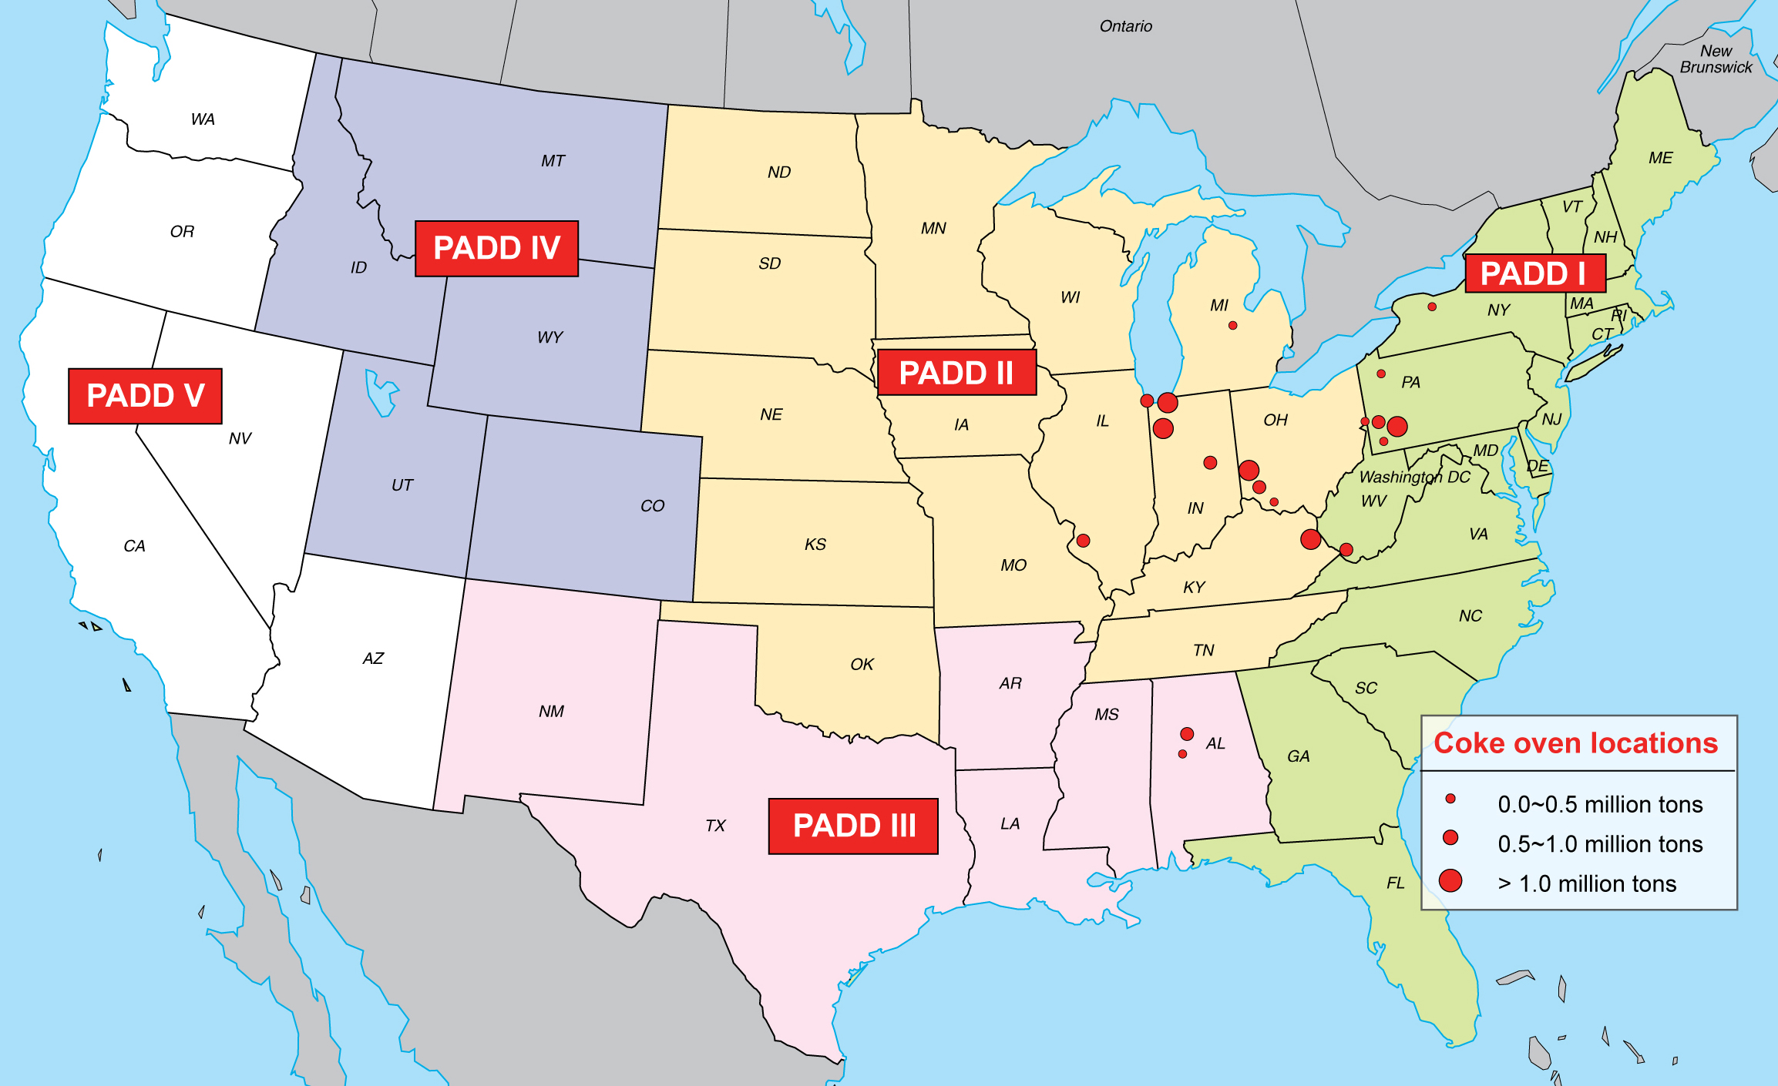

Figure 1. Locations of U.S. Coking Plants for Steel Production (million tons of coke production per year, from ACCCI, 2006)

Steel Mills and Coke Oven Gas Production

Figure 2 shows a simplified schematic flowchart of a steel mill from an energy perspective. Coke is needed to produce steel from pig iron in blast furnaces. The coke can be produced from coal in coke oven units in the steel mills or in separate coking plants nearby steel mills. Besides coke, these ovens produce a significant amount of COG. Raw COG is cleaned of impurities and used as a process fuel for steel mill operations (EnergyManagerTraining.com, 2006). In certain circumstances, the excess gas is flared. Table 1 shows the composition of cleaned COG, which contains, on average, about 55% hydrogen by volume. The hydrogen could be separated from COG for other uses, such as FCV applications.

Table 1. Typical Composition of Coke Oven Gasª
 | Percent by Volume
H₂ | 55
Methane (CH₄) | 25
Nitrogen (N₂) | 10
Carbon monoxide (CO) | 6
Carbon dioxide (CO₂) | 3
Hydrocarbons (ethane, propane, etc.) | 1
Lower heating value (LHV), Btu/standard cubic feet (scf) | 443
ª Source: EnergyManagerTraining.com, 2006.

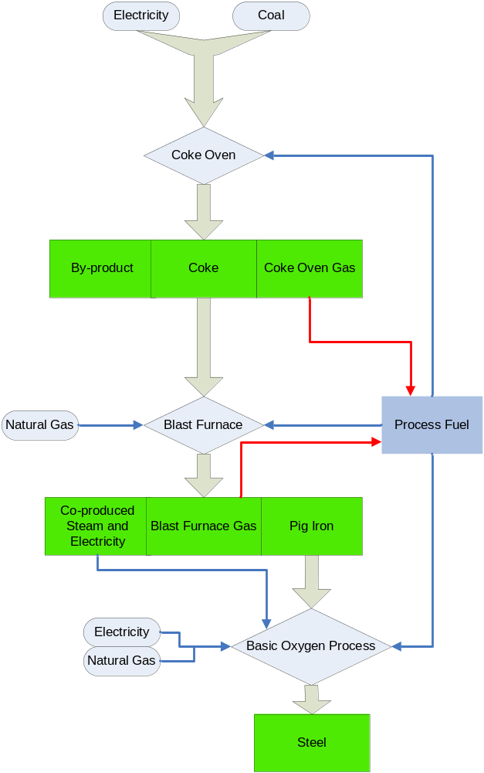

Figure 2. Schematic Flowchart of Steel Mills

Figure 3 schematically shows hydrogen production from COG with a one-step pressure swing adsorption (PSA) system. The produced hydrogen could be transported to refueling stations for FCV applications, while the remaining COG could be used as a process fuel for steel mill operations. At present, the COG is used as a process fuel in the steel mills where it is produced. With the withdrawal of hydrogen from COG, steel mills would need supplemental process fuels such as NG for their operations.

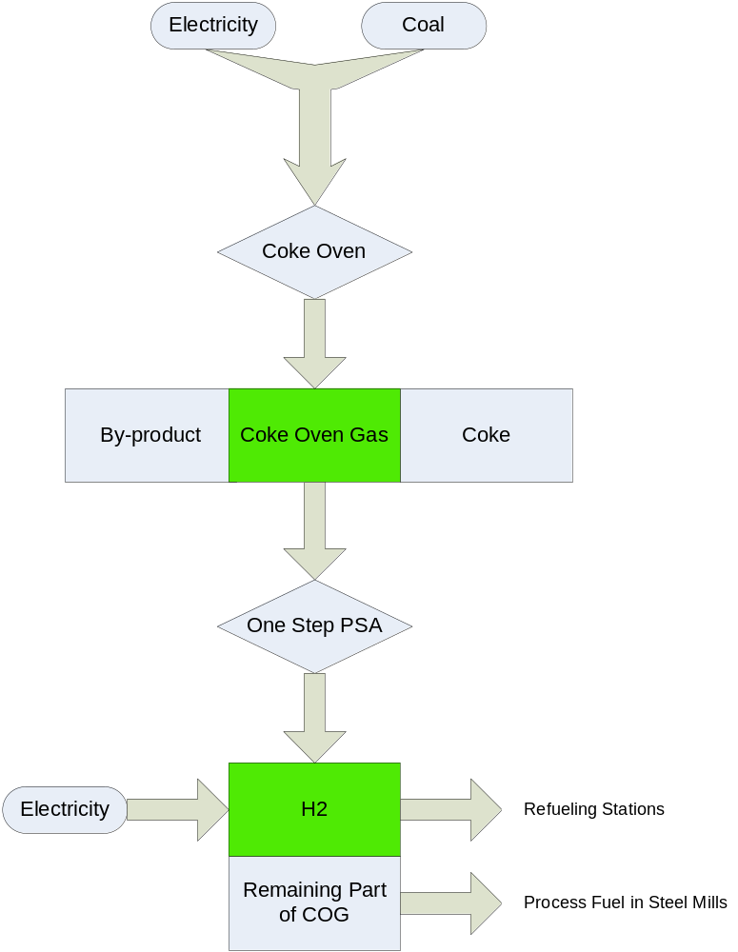

Figure 3. Flowchart of Hydrogen Production from Coke Oven Gas in Steel Mills

Well-to-Wheels Analysis of Coke-Oven-Gas-to-Hydrogen Production

Key Parameters and Scenarios

The GREET (Greenhouse gases, Regulated Emissions, and Energy use in Transportation) model was developed at Argonne National Laboratory to examine the life-cycle energy and emission effects of advanced vehicle technologies and new transportation fuels. The model has been applied to provide well-to-wheels (WTW) results for various vehicle/fuel combinations (see Brinkman, Wang, Weber, and Darlington 2005). In particular, the GREET model has been used to examine the energy and emission effects of different hydrogen production pathways for the U.S. Department of Energy (DOE). For this study, the model was modified to conduct WTW analysis of hydrogen production from COG and the use of the resulting hydrogen in FCVs.

For WTW evaluation of the COG-to-H₂ pathway, two key steps in steel mills need to be examined: (1) the coking process by which coke and COG are produced, and (2) the hydrogen separation process with the PSA system by which the hydrogen is separated from COG. The PSA system would be a new system added to steel mills specifically for hydrogen production.

With inputs of coal and electricity, coke ovens produce coke and COG (which is a by-product of the process). The coking process has an LHV-based energy efficiency of about 81.5% (Scientific Certification Systems, Inc., 2000). This efficiency is derived from both coal and electricity as the inputs and both coke and COG as the outputs. Of the total energy inputs to coking plants, coal input accounts for 98.5% and electricity for 1.5% on average.

Table 1 shows that cleaned COG contains about 55% hydrogen by volume. We assumed that a one-step PSA system would be used to separate hydrogen from COG. By using a process engineering analysis, we estimated an energy efficiency of 92% for separating the hydrogen by means of the PSA system. The PSA system would be driven by electric power purchased from the electric grid. The remainder of the COG — after hydrogen separation — would contain roughly 56% CH₄, 22% N₂, 13% CO, 7% CO₂, and 2% HC by volume (derived from the COG composition in Table 1) and would be used as a process fuel in steel mills.

Figure 4 shows simplified steel mill flowcharts without and with hydrogen separation from COG. In the case without hydrogen separation, the COG is used as a process fuel in steel mill operations. In the case with hydrogen separation, some of the energy (Btu) is withdrawn from the COG when the hydrogen is extracted. To have sufficient process fuels for steel mill operations following hydrogen separation, we assumed that some amount of NG must be added to the steel mills.

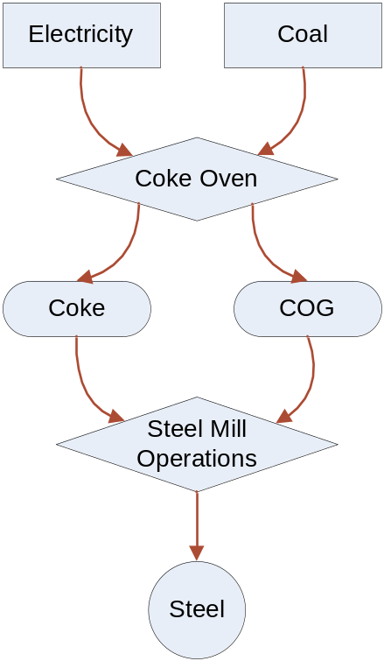

- Simplified Steel Mill Flowchart without Hydrogen Separation

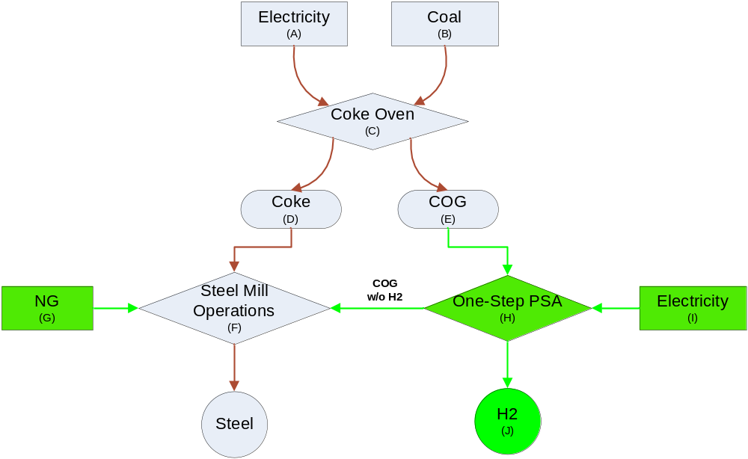

- Simplified Steel Mill Flowchart with Hydrogen Separation

Figure 4. Steel Mill flowcharts without and with Hydrogen Separation
There are different ways of treating the hydrogen produced from COG in the WTW analysis. We established three scenarios to address the fact that hydrogen is produced from a by-product in steel mills. The first scenario is based on the relative energy efficiencies of the coking process and the PSA system. Under this scenario, COG from the coking process is treated as a co-product (together with coke). Energy use and CO₂ emissions from the coking process are allocated between coke and COG according to the energy output split of coke and COG from the process.

Under the second scenario, only the energy use of the PSA system is taken into account for hydrogen production. This scenario treats COG as a by-product. For this scenario, we started the energy accounting for the COG-to-H₂ production pathway with the energy content of COG.

The third scenario takes a displacement approach. Under this scenario, the difference in steel mill operations between the case without hydrogen separation and the case with hydrogen separation is attributed to hydrogen production, i.e., the difference between (a) and (b) in Figure 4. In particular, energy use by the PSA unit for hydrogen separation and the amount of supplemental NG used by steel mills to make up for the Btu withdrawal from hydrogen separation are taken into account for hydrogen production.

Table 2 summarizes the three scenarios of the COG-to-H₂ production pathway for our WTW analysis.

Table 2. Three WTW Analysis Scenarios for COG-to-H₂ Production
Scenario | Processes Considered | Energy Inputs Considered | Process Energy Efficiency (%) | Included Items as Shown in Figure 4(b)
Scenario 1 | Coking process; PSA | Coal; electricity | 76.1 | Inputs of A (electricity) and B (coal) to coke ovens are split between D (coke) and E (COG) according to their energy output;  I (electricity for PSA)
Scenario 2 | PSA | Coal embedded in H₂; electricity | 91.9 | Coal Btu embedded in H₂;  I (electricity for PSA)
Scenario 3 | PSA | NG;  Electricity | 91.9 | Supplemented NG (G);  I (electricity for PSA)

For a WTW analysis, the vehicle fuel economy (in miles per gasoline-equivalent gallon) is needed. Table 3 presents the fuel economy rates for four vehicle types. Of the four, three (gasoline car, gasoline hybrid, and diesel hybrid) are reference technologies to which the hydrogen fuel cell hybrid is compared.

Table 3. Fuel Economy of Four Vehicle Typesª
Vehicle | Gasoline Car | Gasoline Hybrid | Diesel Hybrid | H₂ Fuel Cell Hybrid
Fuel Economy (miles per gasoline-equivalent gallon) | 24.3 | 34.0 | 38.9 | 57.1
ª The fuel economy values represent on-road fuel economy. The results were generated for DOE in 2005 for a midsize car platform by using Argonne’s PSAT model.

WTW Results

Figures 5–8 present WTW results for the eight vehicle/fuel systems examined in this study. The gasoline car is the baseline vehicle. Gasoline hybrid and diesel hybrid vehicles represent advanced technologies powered by petroleum-based fuels. The fuel cell hybrid vehicle fueled with hydrogen produced from distributed NG via SMR and from coal gasification at central plants with carbon capture and storage (CCS) are options already of interest to many. The three COG-to-H₂ cases, as presented in Table 2, are evaluated specifically in this study. The hydrogen fueled in the fuel cell hybrid vehicle is gaseous hydrogen, which is transported by pipeline from plants to refueling stations for all the hydrogen production pathways except the distributed NG SMR case.

Figure 5 presents the per-mile total energy use results for the eight systems. Total energy use includes all energy sources (fossil and non-fossil energy). The chart shows that the two ICE hybrid technologies reduce total energy use as a result of their fuel economy gains. Fuel cell hybrids reduce total energy use because of the reductions in energy use during vehicle operation (the pump-to-wheels stage). All the five fuel cell hybrid options powered by hydrogen achieve energy reduction benefits. The three COG-based options involve H₂ separation only, thus have additional energy reductions.

Figure 6 presents per-mile fossil energy use results. Fossil energy includes petroleum, NG, and coal. Because all of the fuels for the eight vehicle/fuel options are derived from petroleum, NG, or coal (all are fossil fuels), the fossil energy use results in Figure 6 are similar to those for total energy use in Figure 5.

Figure 7 shows per-mile petroleum use results. Gasoline and diesel hybrids achieve moderate petroleum reductions as a result of vehicle efficiency gains. The five FCV options almost eliminate petroleum use because of the switch from petroleum to NG (for the distributed NG case and the COG-to-H₂ case [Scenario 3]) or coal (for the remaining three hydrogen cases).

Figure 8 shows per-mile GHG emissions results. GHG emissions in this study are CO₂-equivalent emissions of CO₂, CH₄, and N₂O. While FCVs fueled by hydrogen produced with NG SMR achieve moderate GHG emission reductions, the other four hydrogen FCV options achieve larger reductions. The large reduction by coal-based hydrogen FCVs is a result of the assumption that CO₂ in coal-to-hydrogen plants would be captured and stored. The large reductions by COG-based hydrogen FCVs under COG-to-H₂ Scenarios 1 and 2 are attributable to the fact that most of the carbon in coal is converted into carbon in coke during the coking process in steel mills. In addition, COG-to-H₂ production under these two scenarios involves only separation of hydrogen from COG. This separation process itself does not generate CO₂ emissions, while the electricity used for the PSA unit bears emissions in electric power plants, which we took into account in GREET simulations; all of the carbon in COG ends up in the remaining portion of COG, which would be used as a process fuel in steel mills. Under COG-to-H₂ Scenario 3, CO₂ emissions from combustion of supplemental NG in steel mills are charged to hydrogen production. The GHG emissions under the COG-to-H₂ scenario are low because only H₂ separation is involved and because COG is a by-product of coking units.

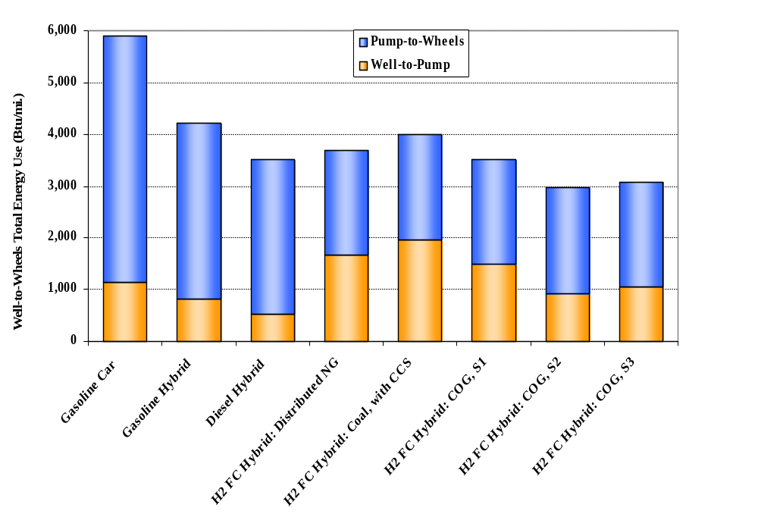

Figure 5. Well-to-Wheels Total Energy Use of Eight Vehicle/Fuel Systems (Btu/mi)

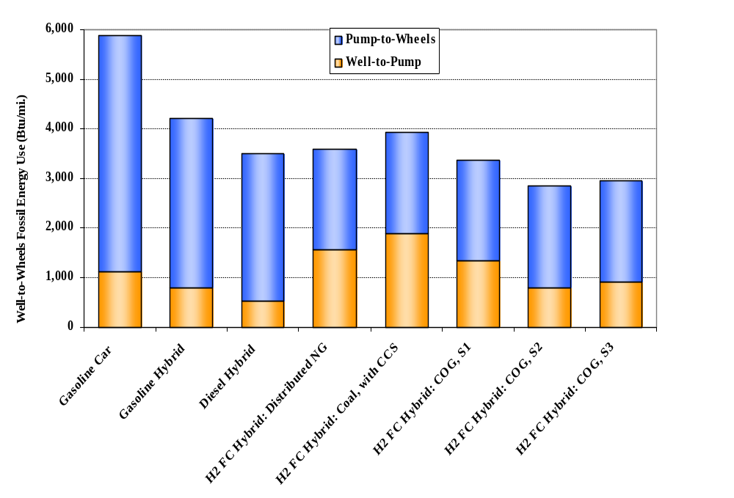

Figure 6. Well-to-Wheels Fossil Energy Use of Eight Vehicle/Fuel Systems (Btu/mi)

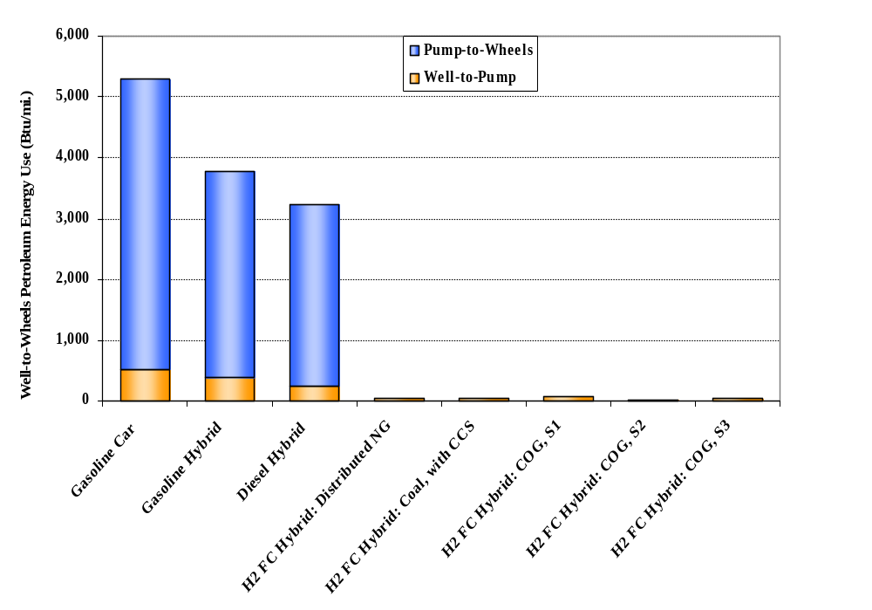
Figure 7. Well-to-Wheels Petroleum Energy Use of Eight Vehicle/Fuel systems (Btu/mi)

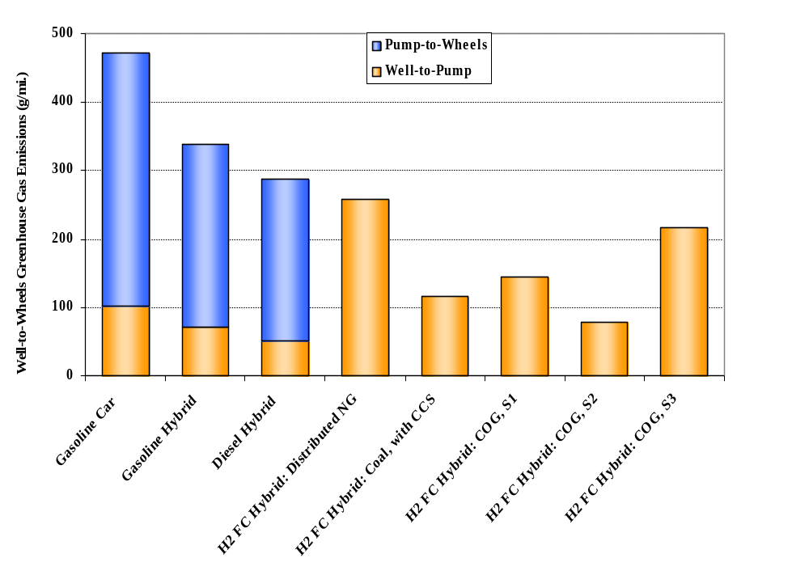

Figure 8. Well-to-Wheels GHG Emissions of Eight Vehicle/Fuel Systems
(g of CO₂-equivalent/mi)

Potential Amount of Hydrogen Produced from COG Available in U.S. Steel Mills

Figure 9 shows the historical trend of annual production volumes of pig iron, coke, and COG in the U.S. steel industry between 1990 and 2005. The coke production data are from EIA statistics (EIA, 2005, 2006b). The total production volume includes that in steel mills and in coking plants for steel mill operations. Of the total production volume, 70% is from the production within steel mills and the remaining 30% from coking plants (EIA, 2006b; ACCCI, 2006; EPA, 2005). The pig iron production data are from the U.S. Geological Survey (USGS, 2006). The COG production volume in the chart is estimated on the basis of the coke-to-COG production ratio, as presented in Table 4.

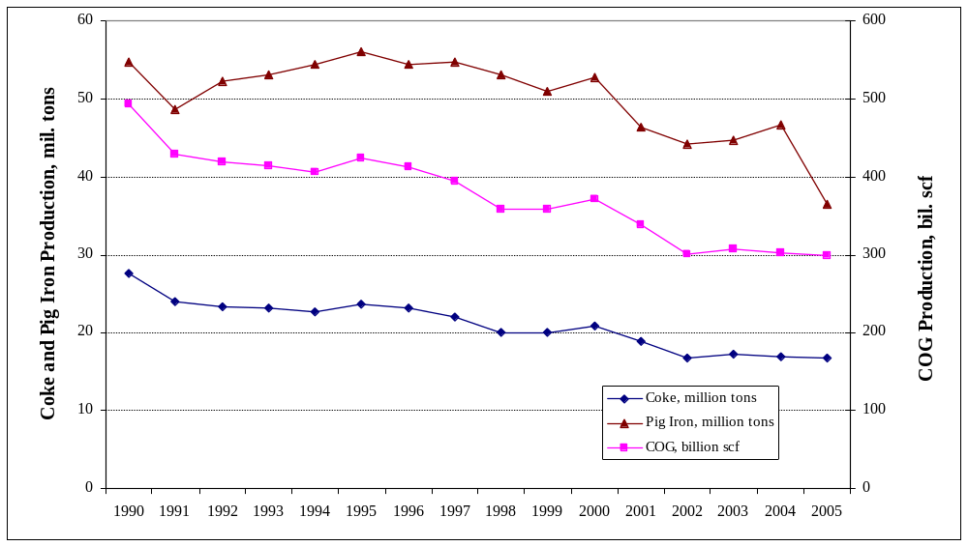
Figure 9. Historical Trend of Coke and Pig Iron Production in the U.S. Steel Industry

Table 4. Production Ratios of Coke vs. Coal, COG vs. Coke, and H₂ vs. COG
 | Coke/Coal (ton/ton)ª | COG/Coke (scf/ton)^{b} | H₂/COG (g/scf)^{c}
Ratio | 0.72 | 17,880 | 1.23
ª Source: EIA (2005).
^{b} This value is the average from two data sources: (1) Scientific Certification Systems, Inc. (2000); and (2) EnergyManagerTraining.com (2006).
^{c} This value is our own estimate based on the one-step PSA process.

By using the conversion ratios presented in Table 4, we estimated the total amount of hydrogen that could be produced from the COG generated in U.S. steel mills. Table 5 presents our estimated results with 2004 and 2005 data. As the table shows, about 370,000 metric tons of hydrogen could be produced each year from COG available in U.S. steel mills. We further estimated potential hydrogen production in three petroleum administration defense districts (PADDs; see Figure 1 for PADD locations) according to the location and size of individual steel mills. Table 6 shows the geographic distribution of COG-based hydrogen production in the United States. Of the three regions, PADD II, which covers the upper Midwest, accounts for 57% of the total production.

Table 5. Potential Annual Hydrogen Production from COG Available in U.S. Steel Mills
 | Coke Productionª (million short tons) | COG production, (billion scf) | H₂ production from COG (metric tons)
2004 | 16.9 | 302.152 | 370,482
2005 | 16.7 | 298.576 | 366,097
ª Source: EIA (2005 and 2006b).
Table 6. Estimated Annual COG-Based Hydrogen Production by U.S. Regionª (in metric tons/yr)
 | 2004 | 2005 | Share (Based on 2005 Data)
PADD I | 122,259 | 120,812 | 33%
PADD II | 211,175 | 208,675 | 57%
PADD III | 37,048 | 36,610 | 10%
Total | 370,482 | 366,097 | 100%
ª The regional allocation is based on the location and capacity information of U.S. coking plants. Data sources include: (1) EIA (2006b); (2) ACCCI (2006); and (3) EPA (2005).

To put the potential amount of COG-based hydrogen into perspective, we estimated the number of FCVs that could be powered by the COG-based hydrogen that could be produced in steel mills. To do so, we assumed a fuel economy of 57 miles per gasoline-equivalent gallon for FCVs and an annual vehicle-miles-traveled value of 12,500 miles per car (FHWA, 2005). This results in an annual hydrogen consumption of 220 gasoline-equivalent gallons per FCV — or about 220 kg of hydrogen. On the basis of the 2005 data presented in Table 6, COG-based hydrogen could fuel 1.7 million mid-size FCVs in the three U.S. PADD regions. The greatest potential is in the PADD II region, where nearly 1 million FCVs could be fueled by COG-based hydrogen.

At present, almost all the COG produced in steel mills is used internally in the mills as the process fuel in blast furnaces and basic oxygen processes. If hydrogen is separated from the COG, additional process fuels, such as NG, may be needed in the mills to supplement the energy lost by extracting the hydrogen. For example, on the basis of the 2005 data, if hydrogen is separated from COG, the steel mills will lose 42 trillion Btu of process fuels in the COG stream. To make up for this loss, about 42 billion standard cubic feet (scf) of NG may need to be provided to steel mill operations — this amount is equivalent to about 0.2% of current U.S. NG consumption.

Conclusions

In the United States, a large amount of COG is produced from coking plants in steel mills. With 55% hydrogen content by volume, this amount of COG could provide a significant hydrogen source. Our analysis shows that this production pathway can achieve energy and GHG emission reduction benefits. This pathway is especially worth considering because first, the steel mills at which COG is generated are concentrated in the upper Midwest and Northeast United States, allowing for concentrated collection, transportation, and distribution of the hydrogen to refueling stations. Second, the amount of hydrogen that could be produced could fuel about one million FCVs, thus providing a vital near-term hydrogen production option for FCV applications in this region.

Separation of hydrogen from COG will require installation of a separation system, such as the PSA system, in steel mills. If there is a vital hydrogen market, steel mill operators may be convinced to install such systems to produce hydrogen for additional revenue. If so, some additional process fuels, such as NG, may be required to make up for the energy loss caused by hydrogen withdrawal from COG, which we examined in one of the three scenarios. While this study shows that such a hydrogen production option achieves energy and emission benefits, the economics of this pathway need to be examined, and the business case needs to be presented to steel mill operators.

Acknowledgments
This work was sponsored by Office of Energy Efficiency and Renewable Energy of the U.S. Department of Energy. Argonne National Laboratory is a U.S. Department of Energy laboratory managed by UChicago Argonne, LLC, under contract No. DE-AC02-06CH11357.

References

American Coke and Coal Chemicals Institute (ACCCI), 2006, Operating U.S. Coke Plants, April 24, available at http://www.accci.org/Coke_Plant_Listing.pdf.

Brinkman, N., M. Wang, T. Weber, T. Darlington, 2005, Well-to-Wheels Analysis of Advanced Fuel/Vehicle Systems – A North American Study of Energy Use, Greenhouse Gas Emissions, and Criteria Pollutant Emissions, General Motors Corporation and Argonne National Laboratory, May.

Energy Information Administration (EIA), 2006a, Annual Energy Outlook 2006, DOE/EIA-0383 (2006), Washington, DC, Feb.

Energy Information Administration (EIA), 2006b, Quarterly Coal Report: Jan.–Mar. 2006, DOE/EIA-0121 (2006/01Q), Washington, DC, June.

Energy Information Administration (EIA), 2005, Annual Energy Review 2004, DOE/EIA-0384 (2004), Washington, DC, Aug.

EnergyManagerTraining.com, 2006, The Coke Oven By-Product Plant: What Is It and What Does It Do? available at http://www.energymanagertraining.com/iron_steel/
coke_oven_steel.htm.

National Research Council (NRC) and National Academy of Engineering (NAE), 2004, The Hydrogen Economy: Opportunities, Costs, Barriers, and R&D Needs, National Academy Press, Washington, DC.

Scientific Certification Systems, Inc., 2000, Analysis of Galvanized Steel Production Suitable for Residential Construction Based on Life-Cycle Stressor-Effects Assessment: A U.S. Case Study, Oakland, Calif.

Federal Highway Administration (FHWA), 2005, The Highway Statistics 2004, U.S. Department of Transportation, Washington, DC.

U.S. Department of Energy (DOE), 2006, Record 5017: Air Quality and Population, available at http://www.hydrogen.energy.gov/program_records.html.

U.S. Environmental Protection Agency (EPA), 2006, Inventory of U.S. Greenhouse Gas Emissions and Sinks: 1990–2004, Washington, DC, April.

U.S. Environmental Protection Agency (EPA), 2005, Background Report, AP-42 Section 12.2, Coke Production, prepared by Pacific Environmental Services, Inc., Research Triangle Park, NC.

U.S. Geological Survey, 2006, Iron and Steel Statistics and Information, U.S. Department of the Interior, January, available at http://minerals.usgs.gov/minerals/pubs/
commodity/iron_&_steel/.

