TAILORED SYNTHESIS OF NITROGEN DOPED CARBON NANOFIBERS AND AMORPHOUS CARBONS FOR PEMFC

Z. Ismagilov, A. ShalaginaError: Reference source not found, O. PodyachevaError: Reference source not found, Ch. Barnakov, A. KozlovError: Reference source not found
R. KvonError: Reference source not found, I. IsmagilovError: Reference source not found, M. KerzhentsevError: Reference source not found

1. Introduction
At present, platinum and its alloys supported on carbon black are used as oxygen reduction catalysts in proton exchange membrane fuel cells (PEMFC) due to their high catalytic activity and stability in fuel cell environment [1, 2]. The performances of the cathode catalysts depend substantially on characteristics of carbon support, such as porous structure, surface area, electrical conductivity, etc. [3, 4]. Recently, carbon nanostructured materials, like carbon nanofibers (CNF), have attracted great interest as suitable catalyst support materials [3-8] due to their exceptional structural and textural properties, electrophysical characteristics and chemical stability as well as progress in controlled large-scale synthesis of such materials with predetermined characteristics. Carbon nanofibers can be produced using CVD method from catalytic decomposition of hydrocarbon precursors over iron subgroup metals. It is well-known [9-14] that CNF properties can be tailored by controlling of growth conditions, such as catalyst used, feed composition, temperature. By regulating these parameters one can produce CNF with graphite planes arranged in perpendicular direction to fiber axis (‘platelet’ structure), at an angle of 45° (‘herringbone’ structure) or parallel to the axis (‘nanotubes’). The surface area of CNF ranges from 100 to 300 m²/g, depending upon the particular structural conformation. The unique structural and textural features of these materials make them possible candidates as improved supports for Pt cathode catalysts and, as it has been shown yet [5-8], application of CNF allows to increase platinum utilization as compared with commercial carbon supports.
Another type of nanocarbon materials having a considerable potential for the preparation of the active electrocatalysts is a class of amorphous microporous carbon materials (AC) because of a very high surface area – up to 3300 m²/g and large microporous volume – up to 2 cm³/g [15-17]. Our previous studies have shown that Pt cathode catalysts prepared on these supports exhibits better performance in membrane/electrode assembly (MEA) tests as compared with Pt/Vulcan XC-72R [8, 18].
However, surface of as-produced carbon supports is usually inert, making it a difficult to attach uniformly the high-dispersed metal particles. Physisorbed platinum clusters may be easily removed in a liquid medium, and also tends to agglomerate into larger particles. High dispersity of platinum on carbon achieves by interaction of metal with the surface functional groups. Therefore, presence of nitrogen sorption sites on the carbon surface improves adhesion of metal nanoparticles, leading to high dispersion of active component, more uniform distribution upon support and higher stability, resulting in high electrocatalytic mass activity of Pt nanoparticles [6, 9, 19]. Hence, the nanostructured carbon materials, such as CNF and AC, doped with nitrogen are promising catalyst supports for PEMFC.
Moreover, enhanced electroconductivity of nitrogen-doped carbons in comparison with non-modified counterparts [20, 21] favours high electrocatalytic activity.
On the other hand, the replacement of platinum by non-noble metal catalysts for the cathode oxygen reduction reaction (ORR) is possible. Since the 1970s, much attention has been paid to the catalysts obtained from the heat treatment at T > 600°C of carbon with a transition metal (Fe or Co) and nitrogen source [22-30]. The precursors of metal and nitrogen can be organometallic macrocycles, like porphyrins, phthalocyanines, tetraazaannulenes, and other N₄-metal chelates. But the nitrogen and metal sources can be separated and active ORR catalysts are also produced by pyrolysis of Fe (or Co) salts adsorbed onto nitrogen-containing carbon support or under nitrogen-containing atmosphere (ammonia, acetonitrile, etc.). Heat treatment at high temperature of 600 – 1000°C range is required to increase the activity, selectivity and stability of the catalyst. During this treatment Met-N₄ units (where Met = Fe or Co) or Met-N₂ ones, depending on metal nature and pyrolysis temperature, become bound to the carbon surface. From the results of XPS and secondary ion mass spectroscopy, Dodelet and coworkers [31-33] established that, in order to obtain an active catalyst, nitrogen atoms have to be of pyridinic type in phenanthroline-like structure (Met-N₂ site) or pyrrole type (Met-N₄ site) similar to phthalocyanine. Activity of these non-noble catalysts increases with nitrogen content on the support surface. Thus, nitrogen content and its electronic state are important for the preparation of active electrocatalysts, and ability to finely tune these parameters on the stage of support synthesis is very desirable.

2. Experimental
2.1. N-CNF synthesis
Nitrogen-containing CNF were synthesized by catalytic decomposition of C₂H₄/NH₃ mixture at 450 – 675°С and 1 bar pressure over metal catalysts. The catalysts with high (70 – 90 wt. %) loading of iron-subgroup metals were prepared by coprecipitation of active component and alumina from nitrate solution as described elsewhere [11, 30]. The following catalysts were used: 90Ni-Al₂O₃, 82Ni-8Cu-Al₂O₃, 65Ni-25Cu-Al₂O₃, 45Ni-45Cu-Al₂O₃, 90Fe-Al₂O₃, 85Fe-5Co-Al₂O₃, 62Fe-8Co-Al₂O₃, and 62Fe-8Ni-Al₂O₃. Herein and after in catalyst code, number before the element symbol indicates the metal content in initial catalyst, wt %. Alumina content equals to the rest and ranges between 10 – 30 wt. %. The initial C₂H₄/NH₃ mixture contained 25, 50 and 75 vol. % of ammonia. Synthesis of N-CNF was carried out in a flow reactor with a fluidized catalyst bed. Catalyst loading was 0.1 g and feed flow rate – 22.5 l⋅h⁻¹⋅ g_{cat}⁻¹. Ethylene conversion was analyzed using a gas chromatograph with a thermal conductivity detector. Carbon yield G (g_{C}/g_{cat}) was calculated as a ratio of the mass of produced carbon to that of initial catalyst.

2.2. N-AC synthesis
Microporous N-AC materials were prepared by chemical and subsequent thermal treatment of various nitrogen-containing organic compounds, like 8-oxyquinoline, o-nitroaniline, 1,2,3-benzotriazole (Fig. 1), or their equimolar mixtures. The typical synthetic procedure was based on chemical treatment of an organic precursor with concentrated aqueous solution of sodium hydroxide in ratio of m(NaOH)/m(precursor) = 1 ÷ 3. The mixture was heated to evaporate water and form a melt. Then the melt was subjected to carbonization at 700 – 900°C for 20 – 80 min under reductive medium of carbonization gases or in inert atmosphere. The obtained material was cooled in air, thoroughly washed with hydrochloric acid and, next, with water until neutral medium. The washed product was dried at 105 – 115°C up to constant weight.

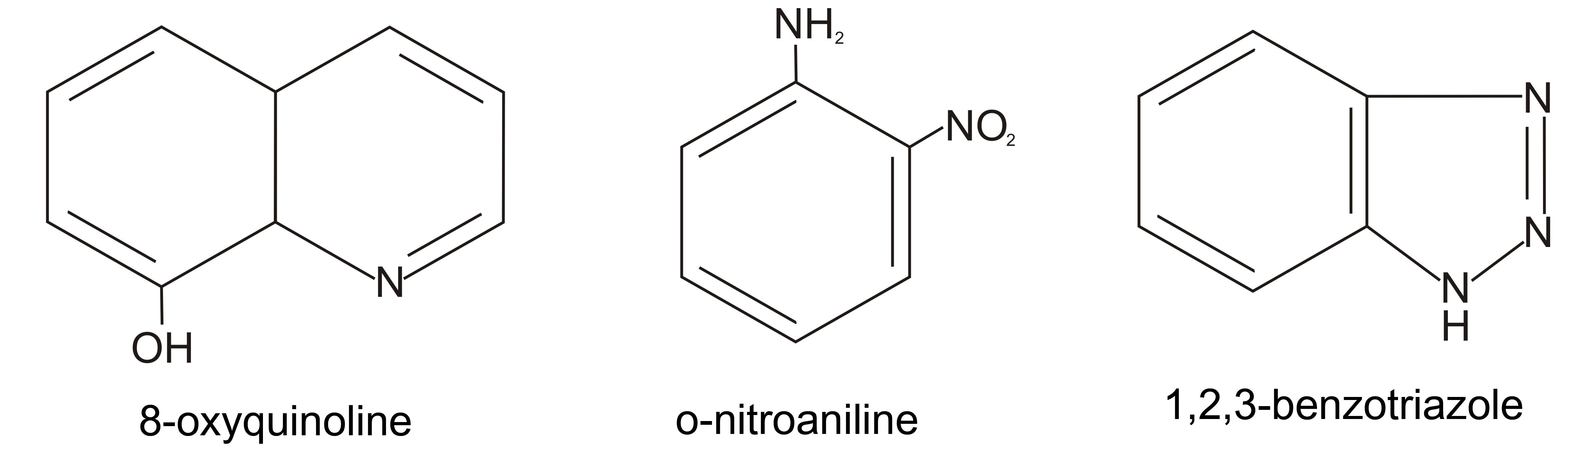
Fig. 1. Nitrogen-containing organic precursors of N-AC.

2.3. Physicochemical characterization
Synthesized samples were analyzed by employing XRD (HZG-4), SEM (JSM-6460, 20 kV), TEM (JEM-2010, 200 kV), N₂ adsorption at 77 K (ASAP-2400). The composition of synthesized carbon materials and cobalt catalysts was determined using elemental analysis (Carlo Erba 1106) and X-ray photoelectron spectroscopy (VG ESCALAB HP). Cobalt dispersion was evaluated by XRD and CO chemisorption at room temperature (Auto Chem II 2920).

3. Results
3.1. Synthesis and properties of N-CNF
Numerous recent investigations on synthesis and characterization of N-CNF indicated that nitrogen incorporation strongly depends on synthesis conditions, such as catalyst and precursor compositions, reaction temperature, gas flow etc. [34-38]. Although a significant work was carried out with respect to the composition/structure relationship of N-CNF, the influence of preparation conditions on physicochemical properties of N-CNF is not fully understood and sometimes contradictory conclusions were drawn about these materials. Therefore, systematic information on the effect of synthesis parameters on N-CNF characteristics is very desirable to understand fundamentals of their growth on metal catalysts, formation of composition, structure, electrophysical and textural properties. This knowledge will provide a powerful tool for tuning and precise control of N-CNF characteristics for diverse applications.
Activity of different metal catalysts in N-CNF formation by decomposition of 75%C₂H₄/25%NH₃ mixture at 550 – 625 °С for 1 h were compared on the basis of the following parameters: ethylene conversion (χ_{C2H4}), carbon yield (G) and nitrogen content in the material. It was found that 90Ni-Al₂O₃, 82Ni-8Cu-Al₂O₃, 65Ni-25Cu-Al₂O₃ and 45Ni-45Cu-Al₂O₃ catalysts are substantially more active in comparison with 90Fe-Al₂O₃, 85Fe-5Co-Al₂O₃, 62Fe-8Co-Al₂O₃, and 62Fe-8Ni-Al₂O₃ ones. The nickel catalysts are characterized by 100 % conversion of ethylene under given condition, whereas for iron catalysts χ_{C2H4} is about 4 %. It is significant that the same iron catalysts are very active in decomposition of pure ethylene and produce high quantity of multiwalled carbon nanotubes. For example, carbon yield from 100%C₂H₄ on 62Fe-8Co-Al₂O₃ was equal to 22 g_{C}/g_{catalyst}. When the 75%C₂H₄/25%NH₃ mixture was used carbon yield decreased to 1.3 g_{C}/g_{catalyst}.
To compare the effectiveness of nickel and nickel-copper catalysts we raised feed space velocity up to 90.0 l⋅h⁻¹⋅ g_{cat}⁻¹. Again, for all the catalysts the initial ethylene conversion (at 0.25 h of reaction) remained close to 100 %. However, it rapidly decreased for 90Ni-Al₂O₃, 82Ni-8Cu-Al₂O₃ and 45Ni-45Cu-Al₂O₃ samples, and only 65Ni-25Cu-Al₂O₃ catalyst reserved high activity. Apparently, this catalyst is the most stable among the studied ones. Moreover, the maximum nitrogen content was observed in N-CNF prepared using the 65Ni-25Cu-Al₂O₃ catalyst (Table 1). So, this catalyst was found to be the most efficient for the preparation of nitrogen containing CNF and it was selected for further detailed studies.

Table 1
Catalytic properties of Ni-Cu-Al₂O₃ (Cu = 0 ÷ 45 wt. %) catalysts in 75%C₂H₄/25%NH₃ mixture decomposition

Catalyst | χ ^{0.25 h}, % | χ ^{1 h}, % | G, g_{C}/g_{catalyst} | N, wt. %
90Ni-Al₂O₃ | 98 | 0.3 | 29.0 | 0.5
82Ni-8Cu-Al₂O₃ | 100 | 0.4 | 37.0 | 0.9
65Ni-25Cu-Al₂O₃ | 92 | 87.9 | 45.6 | 1.7
45Ni-45Cu-Al₂O₃ | 99.8 | 1.8 | 19.0 | 0.7
T = 550°C, catalyst loading = 0.1 g, space velocity = l⋅h⁻¹⋅ g_{cat}⁻¹, reaction time = 1 h.

Morphology of N-CNF samples was investigated by SEM. Figure 2 shows the SEM images of N-CNF prepared from 50%C₂H₄/50%NH₃ mixture on 65Ni-25Cu-Al₂O₃ catalyst. The images reveal that the sample consists of grains of 150 – 350 μm in size. The SEM photographs indicate that only filamentous carbons were obtained and no amorphous carbon was found within the product (Fig. 2 (b)). The nanofibers form entangled nanostructures.
As shown by TEM (Fig. 3) the nanofibers are of 25 – 100 nm in diameter with a ‘herringbone’-type arrangement of graphite planes. It was found that the higher ammonia concentration in initial reaction mixture was used, the smaller diameters of nanofibers were obtained. So, the nanofibers of 20 – 45 nm in size were produced by decomposition of 25%C₂H₄/75%NH₃ mixture. This fact may result from etching of catalytic particles by ammonia action. As is well known, the catalyst particle size determines the diameter of growing nanofibers.
The cone-shaped graphite layers forming the nanofiber are oriented at 45 – 75° angles to the fiber axis. Such CNF arrangement is generally observed on nickel and its alloys, and the similar morphology was found with non-diluted methane and ethylene gas as precursors. According to XRD data N-CNF are graphite-like materials. The interplanar spacing d₀₀₂ is varied from 0.343 to 0.347 nm depending on the synthesis conditions.

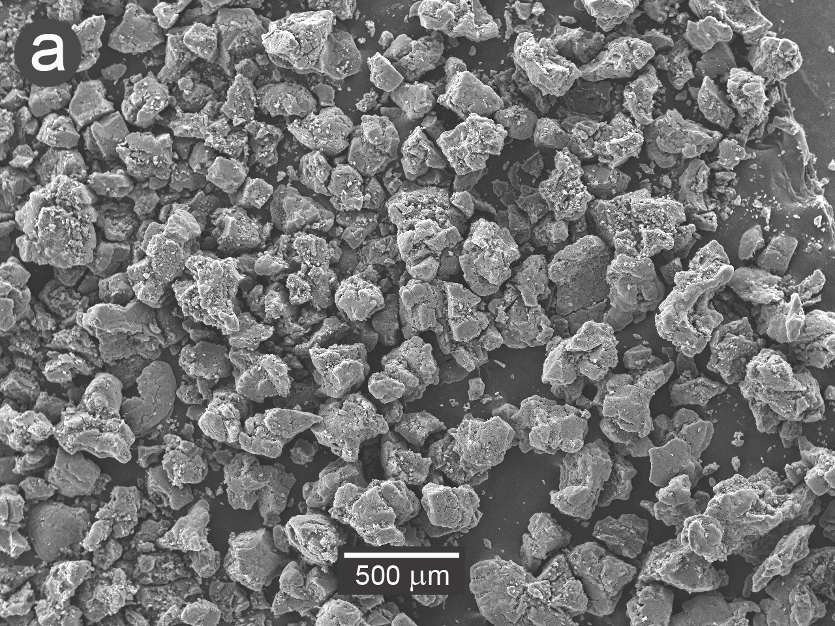 | 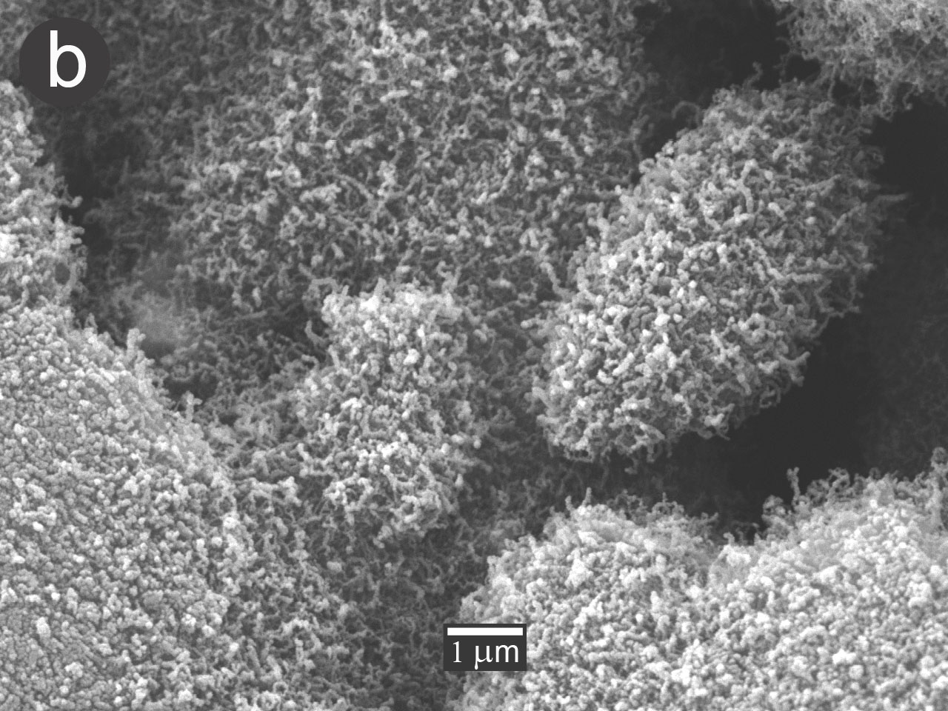
Fig. 2. SEM micrographs of N-CNF grown on 65Ni-25Cu-Al₂O₃ catalyst at 550°C from 50%C₂H₄/50%NH₃ mixture.

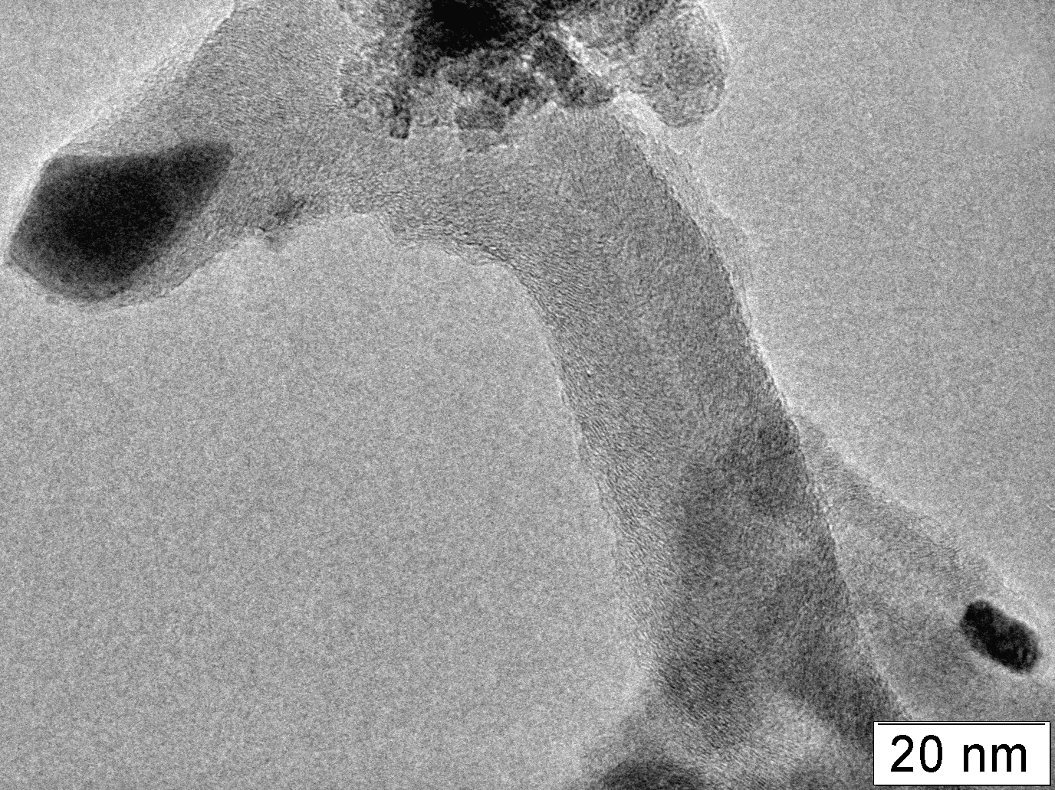

Fig. 3. TEM image of N-CNF grown via decomposition of ethylene/ammonia mixture on 65Ni-25Cu-Al₂O₃ catalyst demonstrating a ‘herringbone’ structure of nanofiber.

Investigation of pore structure and textural characteristics of N-CNF showed that all materials are mesoporous with specific surface area (S_{BET}) strongly dependent on the synthesis conditions and varying from 30 to 350 m²/g. Figure 4 presents the typical N₂ sorption isotherms (Fig.4 (a)) and pore size distribution (PSD) (Fig.4 (b)) for N-CNF produced for 1 and 20 h of synthesis duration. The PSD curve of 1h sample has two maxima at 3 – 4 nm and 15 – 30 nm regions. It was found that the maximum at 15 – 30 nm shifts to the lower values of 9 – 20 nm when the duration of process is increased to 20 h. At the same time, the BET pore volume (V_{pore}) diminishes as it is seen from the isotherms in Figure 4 (a). Decrease of mesopore volume is probably caused by deposition of a new carbon form inside the pores on the surface of nanofibers generated in the first hours of reaction.
Specific surface area reduces when the synthesis temperature is increased (Table 3). At all studied reaction temperatures within the interval of 550 – 675°C, the S_{BET} dependence on time reveals a maximum at 1 – 3 h. Evidently, the reaction time of 1 – 3 h is the optimum for ethylene/ammonia decomposition when nanofiber growth occurs. After that time catalytic particles, apparently, become deactivated and ethylene pyrolysis is catalyzed by CNF surface leading to formation of pitch-like carbon plugging the CNF pores initially produced.
Investigation of reaction condition effect on nitrogen content in N-CNF showed the following observations (Table 3):
- Increase of the synthesis temperature from 550 to 675°C results in decrease of nitrogen content. This finding was obtained for C₂H₄/NH₃ mixtures of different composition. So, for 25%С₂Н₄/75%NH₃ mixture an increase of decomposition temperature from 550 to 675°C leads to decrease of nitrogen content in N-CNF from 7 to 4 wt. %;
- Increase of reaction duration from 15 min to 1 h leads to rise of nitrogen concentration. Further increase of the reaction time up to 20 h does not result in increase of the nitrogen content, on the contrary, it tends to go down by 10 – 20 %;
- Rising of ammonia concentration in the feed from 25 to 75 vol. % leads to growth of nitrogen content from 1.3 – 1.7 to 3.9 – 7.0 wt. %, depending on the reaction temperature.

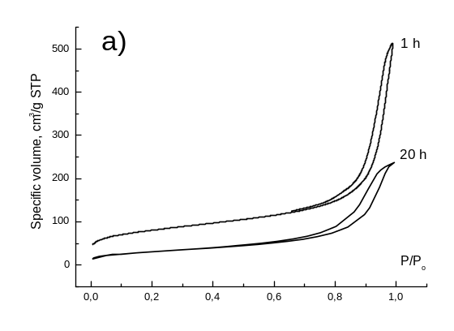 | 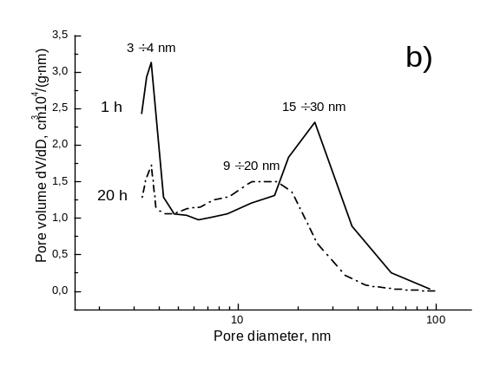
Fig. 4. N₂ sorption isotherms (a) and pore size distribution (b) for N-CNF formed on 65Ni-25Cu-Al₂O₃ catalyst from 50%C₂H₄/50%NH₃ mixture at different synthesis duration.

Table 3
Effect of precursor composition, temperature and duration on properties of N-CNF synthesized on 65Ni-25Cu-Al₂O₃ catalyst

# | Precursor | T, °C | t, h | N,  wt. % | Textural characteristics
 |  |  |  |  | S_{BET,} m²/g | S_{μ} ª, m²/g | V_{pore}, cm³/g | V_{μ} ^{b}, cm³/g
1 | 75%C₂H₄/25%NH₃ | 550 | 1 | 1.58 | 282 | 33 | 0.51 | 0.02
2 | 75%C₂H₄/25%NH₃ | 675 | 1 | 1.27 | 199 | 0 | 0.31 | 0
3 | 50%C₂H₄/50%NH₃ | 550 | 1 | 3.13 | 287 | 32 | 0.82 | 0.02
4 | 50%C₂H₄/50%NH₃ | 550 | 20 | 2.44 | 112 | 0 | 0.37 | 0
5 | 25%C₂H₄/75%NH₃ | 550 | 1 | 7.00 | 191 | 0 | 0.71 | 0
ª Micropore surface area
^{b} Micropore volume

3.2. Synthesis and properties of N-AC
It was found that use of equimolar mixtures of organic precursors for N-AC synthesis produces the improved nitrogen content and higher surface area of the materials as compared with individual nitrogen-containing organic compounds. The best results were attained using binary mixtures of 8-oxyquinoline, o-nitroaniline and 1,2,3-benzotriazole. To formation of N-AC with high nitrogen content up to 8 wt. % the lower values of NaOH/precursor ratio (< 2), carbonization temperature (700°C) and pyrolysis duration (< 40 min) are required (Table 4). Under severe conditions – high NaOH/precursor ratio, high temperature (900°C) or long duration of carbonization – the materials with the high specific surface area (S_{BET}) attaining 3100 m²/g and large micropore volume (V_{μ}) up to 1.88 cm³/g are produced. However, the inverse relationship for nitrogen content and textural properties (S_{BET} and V_{μ}) of N-AC was found (Fig. 5). The surface area and the micropore volume are always lower in the samples with a higher N content. Therefore, it can be concluded that the conditions leading to high values of S_{BET} and V_{μ} result in a loss of nitrogen.
The TEM studies of N-AC showed that the material consists of disordered bended graphite layers placed at an average distance of 1 nm from each other. The N-AC structure is similar to that on non-doped amorphous carbon materials [15, 16].

Table 4
Effect of synthesis conditions on nitrogen content and textural properties of N-AC
# | Precursor | m(NaOH)/  m(precursor) | T, °C | t, min | N,  wt. % | Texture
 |  |  |  |  |  | S_{BET,} m²/g | S_{μ}, m²/g | V_{pore}, cm³/g | V_{μ}, cm³/g
1 | o-nitroaniline/  1,2,3-benzotriazole | 1.25 | 700 | 20 | 8.02 | 472 | 465 | 0.25 | 0.22
2 | o-nitroaniline/  1,2,3-benzotriazole | 1.50 | 700 | 25 | 4.66 | 1643 | 1588 | 0.81 | 0.75
3 | o-nitroaniline/  1,2,3-benzotriazole | 2.50 | 700 | 25 | 1.94 | 2352 | 1766 | 1.59 | 1.00
4 | 8-oxyquinoline/  1,2,3-benzotriazole | 1.75 | 700 | 45 | 1.74 | 2401 | 2242 | 1.31 | 1.14
5 | 8-oxyquinoline/  1,2,3-benzotriazole | 2.00 | 900 | 25 | 1.42 | 2458 | 2418 | 1.24 | 1.20
6 | 8-oxyquinoline/  1,2,3-benzotriazole | 2.50 | 700 | 80 | 0.92 | 3436 | 3183 | 2.16 | 1.88
7 | 8-oxyquinoline/  1,2,3-benzotriazole | 3.00 | 700 | 30 | 1.47 | 3002 | 2536 | 1.97 | 1.50
8 | o-nitroaniline/  8-oxyquinoline | 1.55 | 700 | 35 | 5.29 | 840 | 840 | 0.40 | 0.40
9 | o-nitroaniline/  8-oxyquinoline | 2.00 | 700 | 30 | 2.11 | 2559 | 2507 | 1.42 | 1.26
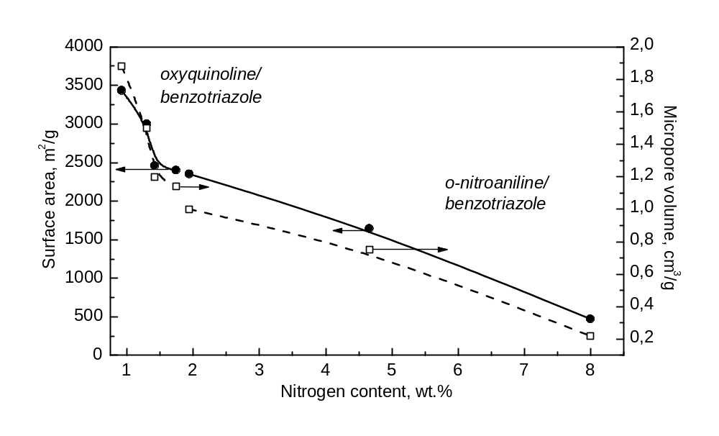
Fig. 5. Correlation between nitrogen content and textural properties of N-AC (surface area S_{BET} and micropore volume V_{μ}).
3.3. Electronic state of nitrogen atoms in N-CNF and N-AC
Figure 6 shows N 1s spectra for N-CNF samples with different content of nitrogen. The spectra consist of two main components centered at 398.5 eV (pyridinic nitrogen, N_{Py}) and 400.8 eV (quaternary nitrogen, N_{Q}). The relative intensity of N_{Py} band grows from 1.1 to 1.7 with increase of total nitrogen content from 1 to 7 wt. %, indicating that pyridinic functionalities become predominant.
Similarly to N-CNF the N 1 s spectrum of N-AC sample contains the peaks at 398.5 and 400.8 eV corresponded to pyridinic and quaternary nitrogen, respectively. Additionally, a new signal at 400.0 eV, not observed previously in the N-CNF spectra, appears. This peak is dominating in the spectrum and may be assigned to pyrrolic nitrogen.

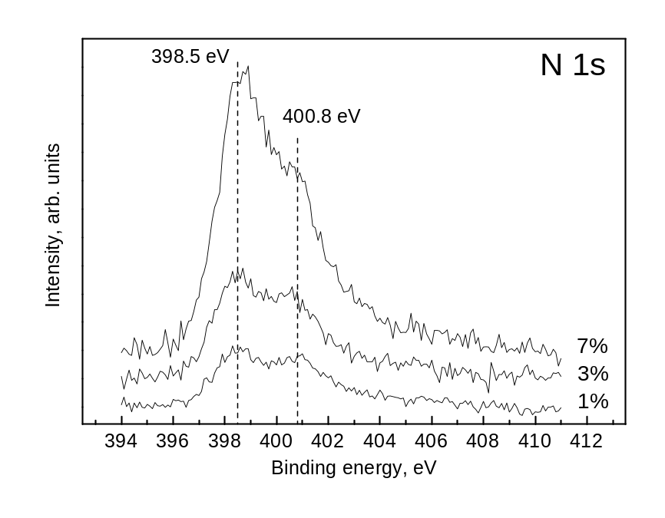
Fig. 6. N 1s spectra of N-CNF samples with different nitrogen concentrations: 1, 3 and 7 wt.%.

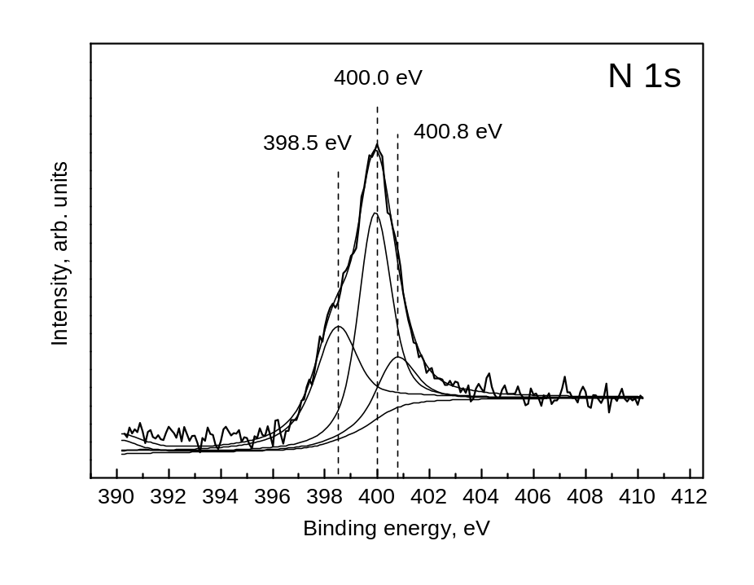
Fig. 7. N 1s spectrum of N-AC sample containing 5.3 wt. % of nitrogen (N-AC#5 in Table 5).

Conclusions
In summary, nanostructured nitrogen-containing carbon supports, namely carbon nanofibers and microporous amorphous carbon, were synthesized and characterized. It has been demonstrated that it is possible to regulate the structure, texture and nitrogen content of the materials by the synthesis conditions.
Catalytic synthesis way produces the mesoporous filamentous carbon material formed by chaotically entangled nanofibers which have a well-ordered graphitic structure. Amorphous microporous carbons with very high surface area (up to 3436 m²/g) are generated by carbonization of organic precursors. It was found that nitrogen content in both types of nanocarbon is determined by specific synthesis parameters. Increase of temperature and duration results in decrease of nitrogen in the materials. The higher concentration of nitrogen in the precursor, i.e. ammonia percentage in C₂H₄/NH₃ mixture or amount of nitrogen atoms in organic molecule, leads to higher nitrogen content in resulted material. So, carbon supports with nitrogen content up to 8 wt. % were prepared.
Two main electronic states of nitrogen corresponding to pyridinic (BE 398.5 eV) and quaternary (BE 400.8 eV) species were observed in N-CNF by XPS. The ratio between these forms was shown to depend on reaction time and ammonia concentration in the feed. The study of nitrogen electronic state in N-AC showed that pyridinic and quaternary nitrogen also exist, but pyrrolic state at 400.0 eV prevails in N 1s spectrum of N-AC.
Dependences of textural properties on synthesis parameters are absolutely different for N-CNF and N-AC. So, milder conditions (lower temperature ≤ 550°C and duration < 3 h) are needed for larger surface area of N-CNF. However, severe conditions of carbonization (high temperature, 900°C, and duration > 40 min) favour the high surface area of N-AC.
Thus, the systematic investigation of synthesis of N-CNF and N-AC allowed us to determine parameters for tailored synthesis of N-containing carbon materials with desired surface area, pore structure, content and electronic state of nitrogen.

Acknowledgements
The present research has been supported by INTAS (05-1000005-7726), NWO-RFBR (047.017.028) and SB RAS Integrated Project # 4.5 grants.

References
1. Paola Costamagna, Supramaniam Srinivasan: Quantum jumps in the PEMFC science and technology from the 1960s to the year 2000. Part I. Fundamental scientific aspects, J. Power Sources, 2001, V. 102 (1-2), P. 242-252.
2. Hubert A. Gasteiger, Shyam S. Kocha, Bhaskar Sompalli, Frederick T. Wagner: Activity benchmarks and requirements for Pt, Pt-alloy, and non-Pt oxygen reduction catalysts for PEMFCs, Appl. Catal. B, 2005, V. 56, P. 9-35.
3. Scott D. Thompson, Larry R. Jordan, Maria Forsyth: Platinum electrodeposition for polymer electrolyte membrane fuel cells, Electrochim. Acta, 2001, V. 46, P. 1657-1663.
4. T.R. Ralph, M.P. Hogarth: Catalysis for low temperature fuel cells, Platinum. Met. Rev., 2002, V. 46, P. 3-14.
5. Carol A. Bessel, Kate Laubernds, Nelly M. Rodriguez, R. Terry K. Baker: Graphite nanofibers as an electrode for fuel cell applications, J. Phys. Chem B, 2001, V. 105 (6) P. 1115- 1118.
6. T. Matsumoto, T. Komatsu, H. Nakano, K. Arai, Y. Nagashima, E. Yoo, T. Yamazaki, M. Kijima, H. Shimizu, Y. Takasawa, J. Nakamura: Efficient usage of highly dispersed Pt on carbon nanotubes for electrode catalysts of polymer electrolyte fuel cells, Catal. Today, 2004, V. 90, P. 277-281.
7. M. Gangeri, G. Centi, A. La Malfa, S. Perathoner, R. Vieira, C. Pham-Huu, M.J. Ledoux: Electrocatalytic performances of nanostructured platinum–carbon materials, Catal. Today, 2005, V. 102-103, P. 50-57.
8. Z.R. Ismagilov, M.A. Kerzhentsev, N.V. Shikina, A.S. Lisitsyn, L.B. Okhlopkova,
Ch.N. Barnakov, Masao Sakashita, Takashi Iijima, Kenichiro Tadokoro: Development of active catalysts for low Pt loading cathodes of PEMFC by surface tailoring of nanocarbon materials, Catal. Today, 2005, V. 102-103, P. 58-66.
9. Philippe Serp, Massimiliano Corrias, Philippe Kalck: Carbon nanotubes and nanofibers in catalysis, Appl. Catal. A, 2003, V. 253, P. 337-358.
10. Krijn P. De Jong, John W. Geus: Carbon nanofibers: catalytic synthesis and applications, Catal. Rev. – Sci. Eng., 2000, V. 42 (4), P. 481-510.
11. Lyudmila B. Avdeeva, Tatyana V. Reshetenko, Zinfer R. Ismagilov, Vladimir A. Likholobov: Iron-containing catalysts of methane decomposition: accumulation of filamentous carbon, Appl. Catal. A, 2002, V. 228 (1-2), P. 53-63.
12. T.V. Reshetenko, L.B. Avdeeva, V.A. Ushakov, E.M. Moroz, A.N. Shmakov, V.V. Kriventsov, D.I. Kochubey, Yu.T. Pavlyukhin, A.L. Chuvilin, Z.R. Ismagilov: Coprecipitated iron-containing catalysts (Fe-Al₂O₃, Fe-Co-Al₂O₃, Fe-Ni-Al₂O₃) for methane decomposition at moderate temperatures. Part II. Evolution of the catalysts in reaction, Appl. Catal. A, 2004, V. 270, P. 87–99.
13. T.V. Reshetenko, L.B. Avdeeva, Z.R. Ismagilov, A.L. Chuvilin: Catalytic filamentous carbon as supports for nickel catalysts, Carbon, 2004, V. 42, P. 143-148.
14. T.V. Reshetenko, L.B. Avdeeva, Z.R. Ismagilov, V.V. Pushkarev, S.V. Cherepanova, A.L. Chuvilin, V.A. Likholobov: Catalytic filamentous carbon: Structural and textural properties, Carbon, 2003, V. 41, P. 1605-1615.
15. Ch.N. Barnakov, S.K. Seit-Ablaeva, A.P. Kozlov, Yu.V. Rokosov, V.B. Fenelonov, V.N. Parmon, RU Patent#2 206 394 (2003).
16. Ch.N. Barnakov, A.P. Kozlov, S.K. Seit-Ablaeva, V.B. Fenelonov, S.V. Cherepanova, Z.R. Ismagilov, V.N. Parmon, Neftekhimiya, 2004, V. 6, P. 436 (in Russian).
17. Ch.N. Barnakov, A.P. Kozlov, S.K. Seit-Ablaeva, A.I. Romanenko, N.T. Vasenin, V.F. Anufrienko, Z.R. Ismagilov, V.N. Parmon, Russ. Chem. J., 2006, V. 50 (1), P. 54 (in Russian).
18. M. Sakashita, T. Takahashi, Y. Kaneda, Z.R. Ismagilov, M.A. Kerzhentsev, Ch.N. Barnakov, N.V. Shikina, A.S. Lisitsyn, JP Patent#2005135817 (2005).
19. T. Maiyalagan, B. Viswanathan, U.V. Varadaraju: Nitrogen containing carbon nanotubes as supports for Pt – Alternate anodes for fuel cell applications, Electrochem. Commun., 2005, V. 7, P. 905-912.
20. Yoshiyuki Miyamoto, Marvin L. Cohen, Steven G. Louie: Theoretical investigations of graphitic carbin nitride and possible tubule forms, Solid State Commun., 1997, V. 102 (8), P. 605-608.
21. D. Golberg, P.S. Dorozhkin, Y. Bando, Z.-C. Dong, C.C. Tang, Y. Uemura, N. Grobert, M. Reyes-Reyes, H. Terrones, M. Terrones: Structure, transport and field-emission properties of compound nanotubes: CN_{x} vs. BNC_{x} (x<0.1), Appl. Phys. A, 2003, V. 76, P. 499-507.
22. M. Bron, J. Radnik, M. Fieber-Erdmann, P. Bogdanoff, S. Fiechter: EXAFS, XPS and electrochemical studies on oxygen reduction catalysts obtained by heat treatment of iron phenanthroline complexes supported on high surface area carbon black, J. Electroanal. Chem., 2002, V. 535, P. 113-119.
23. Raymond Jasinski: A new fuel cell cathode catalyst, Nature, 1964, V. 201, P. 1212-1213.
24. H. Jahnke, M. Schönborn, G. Zimmermann: Organic dyestuffs as catalysts for fuel cells, Top. Curr. Chem., 1976, V. 61, P. 133-181.
25. J.A.R. van Veen, H.A. Colijn, J.F. van Baar: On the effect of a heat treatment on the structure of carbon-supported metalloporphyrins and phthalocyanines, Electrochim. Acta, 1988, V. 33, P. 801-804.
26. Bob van Wingerden, J.A. Rob van Veen, Cees T. J. Mensch: An extended X-ray absorption fine structure study of heat-treated cobalt porphyrin catalysts supported on active carbon, J. Chem. Soc., Faraday Trans. 1, 1988, V. 84, P. 65-74.
27. G. Lalande, R. Côté, G. Tamizhmani, D. Guay, J.P. Dodelet, L. Dignard-Bailey, L.T. Weng, P. Bertrand: Physical, chemical and electrochemical characterization of heat-treated tetracarboxylic cobalt phthalocyanine adsorbed on carbon black as electrocatalyst for oxygen reduction in polymer electrolyte fuel cells, Electrochim. Acta, 1995, V. 40, P. 2635-2646.
28. G. Tamizhmani, J.P. Dodelet, D. Guay, G. Lalande, G.A. Capuano: Electrocatalytic activity of Nafion-impregnated pyrolyzed cobalt phthalocyanine, J. Electrochem. Soc., 1994, V. 141 (1), P. 41-45.
29. G. Faubert, R. Côté, J.P. Dodelet, M. Lefèvre, P. Bertrand: Oxygen reduction catalysts for polymer electrolyte fuel cells from the pyrolysis of Fe^{II} acetate adsorbed on 3,4,9,10-perylenetetracarboxylic dianhydride, Electrochim. Acta, 1999, V. 44 (15), P. 2589-2603.
30. Sh.K. Shaikhutdinov, L.B. Avdeeva, O.V. Goncharova, D.I. Kochubey, B.N. Novgorodov, L.M. Plyasova: Coprecipitated Ni–Al and Ni–Cu–Al catalysts for methane decomposition and carbon deposition. I. Genesis of calcined and reduced catalysts, Appl. Catal. A, 1995, V. 126, P. 125-139.
31. Frédéric Jaouen, Sébastien Marcotte, Jean-Pol Dodelet, Göran Lindbergh: Oxygen reduction catalysts for polymer electrolyte fuel cells from the pyrolysis of iron acetate adsorbed on various carbon supports, J. Phys. Chem. B, 2003, V. 107, P.1376-1386.
32. M. Lefèvre, J. P. Dodelet, P. Bertrand: Molecular oxygen reduction in PEM fuel cells: Evidence for the simultaneous presence of two active sites in Fe-based catalysts, J. Phys. Chem. B, 2002, V. 106, P. 8705-8713.
33. M. Lefèvre, J. P. Dodelet, P. Bertrand: Molecular oxygen reduction in PEM fuel cell conditions: ToF-SIMS analysis of Co-based electrocatalysts, J. Phys. Chem. B, 2005, V. 109, P. 16718-16724.
34. R.I. Kvon, G.N. Il’inich, A.L. Chuvilin, V.A. Likholobov: XPS and TEM study of new carbon material: N-containing catalytic filamentous carbon, J. Mol. Catal. A, 2000, V. 158, P. 413-416.
35. Ch. Tang, Y. Bando, D. Golberg, F. Xu: Structure and nitrogen incorporation of carbon nanotubes synthesized by catalytic pyrolysis of dimethylformamide, Carbon, 2004, V. 42, P. 2625-2633.
36. Paul H. Matter, Eugenia Wang, Umit S. Ozkan: Preparation of nanostructured nitrogen-containing carbon catalysts for the oxygen reduction reaction from SiO₂- and MgO-supported metal particles, J. Catal., 2006, V. 243, P. 395-403.
37. Stephen Maldonado, Stephen Morin, Keith J. Stevenson: Structure, composition, and chemical reactivity of carbon nanotubes by selective nitrogen doping, Carbon, 2006, V. 44, P. 1429-1437.
38. C.P. Ewels, M. Glerup: Nitrogen doping in carbon nanotubes, J. Nanosci. Nanotech., 2005, V. 5, P. 1345-1363.

Boreskov Institute of Catalysis, Novosibirsk, Russia
Institute of Coal and Coal Chemistry, Kemerovo, Russia

