Infrastructure Analysis as Part of the European Hydrogen Energy Roadmap (HyWays)

C. Stiller*, P. Seydel, U. BüngerError: Reference source not found, M. WietschelError: Reference source not found
on behalf of the HyWays Consortium

Introduction
The implementation of advanced, highly innovative technologies such as hydrogen applications is not just a matter of achieving the right payback time. A transition towards a sustainable energy system involves changes at various levels of the economy and society. In order to facilitate a smooth and beneficial introduction of hydrogen into their energy systems, besides the global roadmapping activities planned by the IEA, many industrial countries and regions are currently working on their own hydrogen roadmaps. One comparatively large multiregional roadmapping activity in Europe is the HyWays project (1).
HyWays aims to develop a validated and well-accepted roadmap for the introduction of hydrogen to the energy system. The main characteristic of this roadmap is that it reflects real life conditions by taking into account not only technological but also country-specific, institutional, geographic and socio-economic barriers and opportunities. Both stationary and mobile applications are addressed, including possible synergies (‘spillover effects’) between them. HyWays systematically describes the steps to be taken in the large-scale introduction of hydrogen as an energy carrier to the power market and transport sector and as a storage medium for renewable energy. An action plan to support the introduction of hydrogen technologies will be derived from this roadmap.
Besides modelling energy chains and the energy system, socio-economic modelling and stakeholder discussions, infrastructure analysis is one of the project's crucial tasks. The essence of this task in HyWays is to create regional hydrogen demand and supply build-up scenarios over time by considering the available resources as well as national policies and stakeholder interests. The purpose is to evaluate different infrastructure options in economic terms and to derive recommendations for introducing hydrogen as a transportation fuel in the next decades.
This paper first describes the methodology used for infrastructure analysis in HyWays and then the key results and recommendations derived from this activity.

Infrastructure analysis methodology
The economics and aspects of developing a hydrogen infrastructure have been studied by several groups for Europe (2, 3) and on a country level (4, 5). The HyWays infrastructure analysis goes further than these, however, by studying the 10 member countries of HyWays individually based on country-specific inputs agreed by a wide group of stakeholders. The results thus provide insights into the situation of each specific country as well as, on an aggregated level, into a large part of Europe.
Figure 1 shows an overview of how the different infrastructure analysis subtasks are organized. Inputs from other parts of the project or from the partners and stakeholders are shown on the left side, and the subtasks on the right. The tasks can basically be divided into the demand and the supply sides, where the hydrogen supply of each region is required to be in line with the corresponding demand, but does not impose any feedback to the demand. The subtasks will be explained in the following section after a short introduction to the underlying key assumptions.
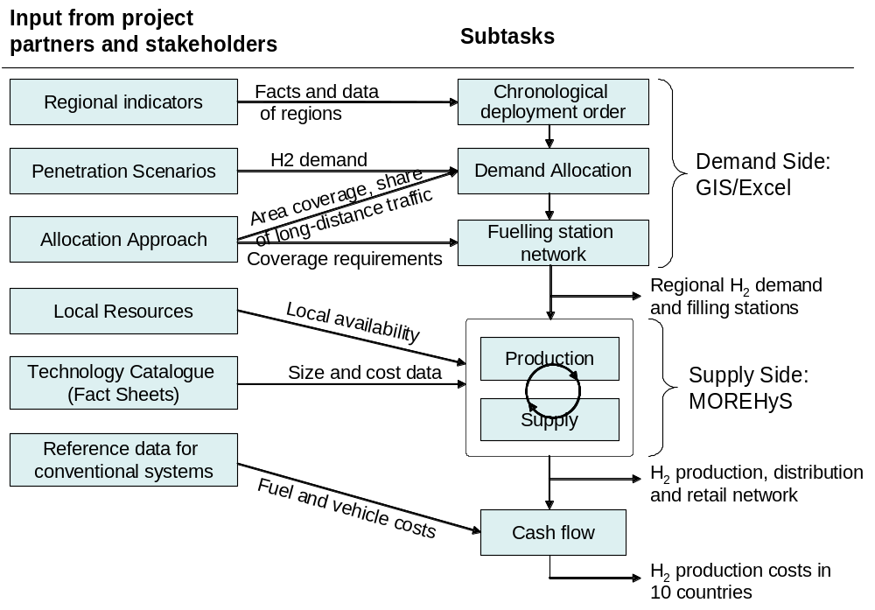
Figure 1: Overview methodology

Key assumptions
The infrastructure build-up is divided into three phases:
- Phase I: early start-up phase with very low hydrogen penetration (demonstration phase). A few large-scale first user centres are situated in Europe. Due to its case-by-case selection of the technology options, this phase is not considered in the infrastructure analysis.
- Phase II: early commercialization phase with approx. 2-5 early user centres per country (snapshot T1: 10,000 hydrogen vehicles EU-wide/0.005% of all vehicles).
- Phase III: full commercialization phase characterized by the extension of existing user centres, the development of new hydrogen regions and the installation of a dense local and corridor network (snapshots T2, T3 and T4: approx. 500,000, 4 million and 16 million hydrogen vehicles EU-wide, respectively or 0.25%, 2% and 8% of all vehicles, respectively).
These phases are defined by the number of hydrogen cars on European roads rather than by calendar years. A connection to the calendar years can be established through the hydrogen vehicle market penetration curves elaborated by the automotive partners in HyWays (see Table 1). For the infrastructure analysis, the four snapshots T1-T4 mentioned above are used as time discretization (see also Table 1). The focus is placed on the early phase of hydrogen deployment with a relatively low penetration of hydrogen vehicles (up to 8%) because, in this phase, regional aspects are crucial – for higher penetrations, aggregated energy system calculations are sufficient.
The regional resolution is based on the NUTS3 classification (7), resulting in approx. 1000 regions in the 10 HyWays countries. The advantage of this method over e. g. a uniform grid is the good availability of data for the NUTS areas and consideration of the spatial structures. Its disadvantage is the uneven resolution levels in the different countries (e. g. 439 NUTS3 regions in Germany but only 40 in Spain).
The hydrogen energy demand is split into three types of usage: local traffic, long-distance traffic and stationary applications. Fuelling stations for local and long-distance traffic differ mainly in that the latter imply a continuous network along main roads (also in regions where there is no local use), while the former are only situated in the regions where hydrogen users reside. These three types of usage are treated separately in the scenarios studied.

Chronological deployment order and demand allocation
As a first step in the model sequence, it was determined in which order the different NUTS3 regions in a country will gain access to hydrogen. In T1, the local use of hydrogen is restricted to the “early user centres”, which are determined in each country by qualitative evaluation of a list of regional indicators including local pollution, cars per household, size of cars, stationary use possibility, availability of experts, existing demo-projects, favourable hydrogen production portfolio (renewable energy, by-product), customer base, political commitment, and stakeholder consensus. The order of the regions supplied after T1 is determined by a ranking based on weighted socio-economic indicators (catchment population, purchasing power, cars per person). This was performed within each country, but there was no cross-national comparison (instead, it is assumed that countries emerge simultaneously and independently).
Subsequently, a spreadsheet-based routine calculates the hydrogen energy demand for local traffic, long-distance traffic and stationary applications in each region and each snapshot. Based on the chronological order of supply and the scenario-specific share of population reached (area coverage), the snapshot of first access is determined for each region. The expected country-wide hydrogen demand is an exogenous input, and traffic demand is divided into local and long-distance according to demand scenario definitions (see below). Subsequently, the country-wide local traffic hydrogen demand is allocated to all areas supplied in a specific snapshot, proportional to the number of users. For the distribution it is assumed that the time gradient in hydrogen penetration (%-points) is equal in all supplied areas (see Figure 2). However, the regional penetration in areas has a constant offset depending on when these are first supplied. This is seen as a realistic trade-off between the extreme cases “each supplied region has the same penetration – no matter when it was first supplied” and “each region needs the same time period from first supply to achieving a certain penetration – only shifted in time”.
The long-distance road network is supplied by fuelling stations in two steps: the “early corridors” which mainly serve to connect the early user centres and allow for daily commuting in their vicinity in an early phase, and the “full highway network” which includes all long-distance roads in later phases. For the allocation of long-distance traffic hydrogen demand, the simplifying assumption was made that the same amount of hydrogen is used on each kilometre of road segment. The amount allocated to the NUTS3 regions is determined according to the length of roads they contain.
A similar method as that used for local traffic demand is used for allocation of the stationary demand, mostly with the same chronological order of region supply as for traffic hydrogen demand. The difference is that here it is assumed that each supplied region has the same regional penetration at a specific snapshot (no matter when it was first supplied). Moreover the percentage of population reached is substantially lower than for the traffic applications, because the total penetration in the stationary sector is expected to be lower than for transport.
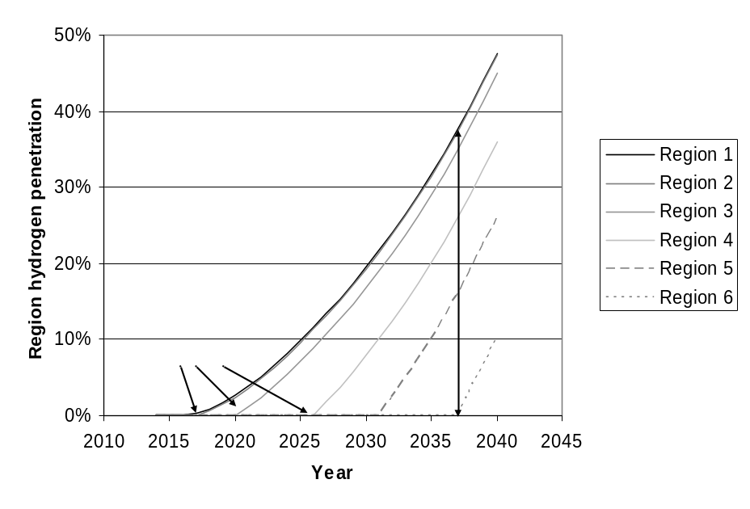
Figure 2: Approach for the distribution of hydrogen demand among regions

Fuelling station network
In HyWays, three different fuelling station capacities are considered (small, medium and large, with 80, 320, and 800 refuellings per day respectively, assuming 4 kg/refuelling). Please note that these sizes are already dedicated to the early market phase; i.e. the “small” station is already significantly larger than today’s hydrogen fuelling stations. The number and size share of fuelling stations required in each region is not only a matter of the local traffic hydrogen demand. Accessibility must be guaranteed by having a certain minimum number of fuelling stations in a region with a certain overcapacity to compensate for fluctuations in fuelling station usage. A common assumption is that 10-30% of all conventional FS must dispense an alternative fuel to achieve broad user acceptance (8). Based on assumptions about the ratio of hydrogen to conventional FS for user convenience, a minimum number of fuelling stations was calculated for a region and a snapshot. Together with the assumed refuelling overcapacity (decreasing over time) and the local traffic demand calculated for a region, the specific split of small, medium and large fuelling stations was determined for each region and snapshot.
The required number of long-distance fuelling stations was calculated in non-integer numbers based on the road kilometres in a NUTS3 region and an assumption about the distance between two fuelling stations to ensure convenient travelling (example: if a region contains 45 km of highway network and there should be one FS every 60 km, the region will have 0.75 FS). The siting of these fuelling stations is handled in a locally non-discrete way. The size split is assumed to be equal across all regions of a country. It is determined on a country-level according to the size split for local fuelling stations (see above), considering the total number of long-distance fuelling stations and the estimated long-distance hydrogen demand.

Production and supply
The production and supply side was mainly analyzed using the MOREHyS model (Model or Regional Hydrogen Supply). This is a model specialized to the needs of infrastructure build-up analysis.
MOREHyS was developed by FhG ISI in cooperation with DFIU (5, 6) and is based on the open-source BALMOREL model (Baltic Model of Regional Energy Market Liberalisation), which was initially developed to support analyses of the energy sector in the Baltic Sea region, with emphasis on the electricity and combined heat and power sectors (see http://www.balmorel.com). The model is implemented in the algebraic modelling language GAMS.
MOREHyS is a technology-based (bottom-up), mixed-integer, linear optimization model with exogenous demand for electricity, heat and hydrogen. The model determines the minimum cost of production (as well as transport/distribution costs) and new investments required taken into account some constraints for each year such as maximum emission levels or regional limitations for generation capacities and fuel availability which might affect the current energy mix. Possible interconnections with the conventional energy system concern CO₂ emissions, the competition for renewables between ydrogen and electricity generation, the optimum load levelling of electrolysers or the co-production of hydrogen and electricity in IGCC plants.
The objective function used for the optimization, which is carried out sequentially on a year-by-year basis, is cost minimization for the whole region each year. In the optimization procedure, existing technologies with their variable and fixed costs compete with new technologies with their additional annualized investments. Dynamics between the years are introduced by transferring the results of the optimization (i. e. endogenously calculated capacities of production and transport/distribution) from the previous year to the beginning of the following year. Thus, the individual optimization periods are interlinked through capacity accumulations and the yearly decommissioning of old capacities. Since the model has perfect foresight only within the year but not beyond, decision-making can be described as myopic.
The optimization variables of the model include the level of electricity, heat and hydrogen production per time period, technology type and area, investment in new generation capacity per technology type and area, electricity transmission and new investments in transmission capacities and the amount of hydrogen transported between and within all hydrogen areas. At country level, the model also derives the resulting CO₂ emissions or total primary energy consumption.
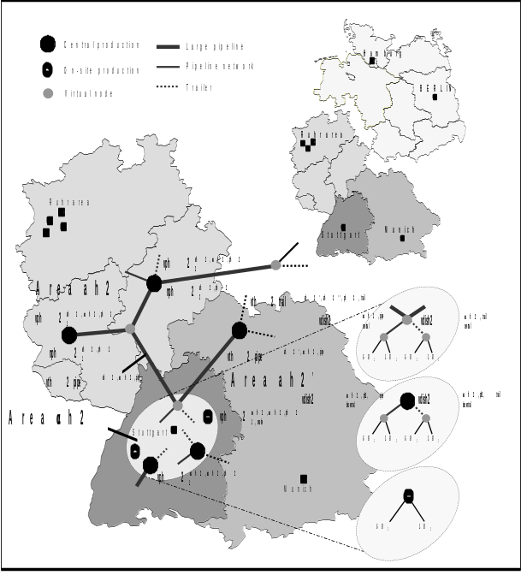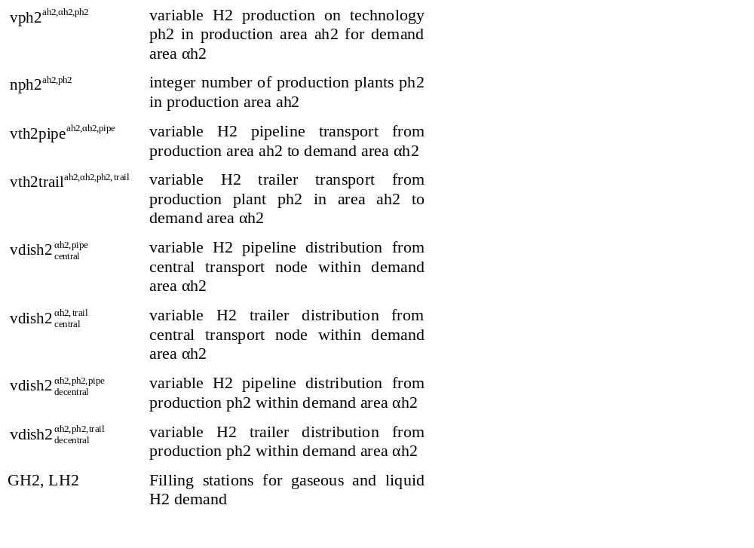
Figure 3: Hydrogen infrastructure options in MOREHyS
MOREHyS allows specifying geographical distinct entities which are countries, regions and areas, where each country is constituted of one or more regions, and each region of zero or more areas. The areas are the building blocks with respect to the geographical dimension: all generation technologies and capacities as well as hydrogen demand are described at the level of areas. Hydrogen demand areas were defined based on NUTS areas. The regions used for modelling in the HyWays project are aggregated NUTS3 areas. Due to computing limitations, areas with similar indicators were combined. In total, 20 – 26 regions were distinguished per country. A distinction was made between urban and rural areas. Both types play an important role in the build-up of a hydrogen infrastructure. Figure 3 shows schematically how the hydrogen infrastructure options are modelled in MOREHyS.

Cash flow
The cash flow analysis compares the expenses for hydrogen production and supply (as calculated by MOREHyS) and vehicles with the savings gained from replacing conventional fuel and conventional vehicles over time. The basic assumption for the cash flow analysis is that each hydrogen vehicle substitutes a conventional vehicle.
Two cumulative cash flow graphs over time result:
- The fuel cash flow shows the balance between the costs for hydrogen fuel provision (accounted negatively; including feedstock, production and supply infrastructure and fuelling stations and taking into account the higher efficiency of hydrogen vehicles) and the savings for conventional gasoline and diesel fuel (accounted positively; projection of the price without tax at the pump).
- The fleet cash flow graphs show the balance between investment in hydrogen vehicles (accounted negatively) and investment savings for conventional vehicles (accounted positively).
The cash flow graphs are scenario-specific, i. e. all assumptions made about hydrogen costs, vehicle costs, penetration rates, fuel economy etc. are reflected in the resulting graphs. To obtain a smooth curve over the time period being considered, polynomial curve fitting was applied between the time snapshots (T1-T4).

Input data and scenarios
To accomplish the work described, a large amount of input data and numerous assumptions and projections had to be used. To achieve coherence within the project, assumptions from the HyWays project were used whenever possible, and also some results from other models (e. g. the projected hydrogen demand from the energy market model Markal).
Figure 4 depicts the baseline forecasts for fossil energy costs which were taken from the WETO-H2 study (9). Electricity costs are calcalculated with the energy market model Markal. Technology costs and performance data were mainly based on the data of the EUCAR-CONCAWE-JRC study (10), reviewed and updated by the project partners. The market penetration curves for hydrogen vehicles are based on scenarios developed by the automotive partners in the project. Table 1 shows the snapshots T1-T4 vehicle population numbers over the snapshots T1-T4 assumed in the penetration scenarios. Furthermore, country-specific data such as anticipated feedstocks for hydrogen production were taken from discussions with the national stakeholders during the workshops and literature research.
For the full set of assumptions and input data used, it is referred to the HyWays website (1), where detailed reports will be publicly available after completion of the project (midyear 2007).

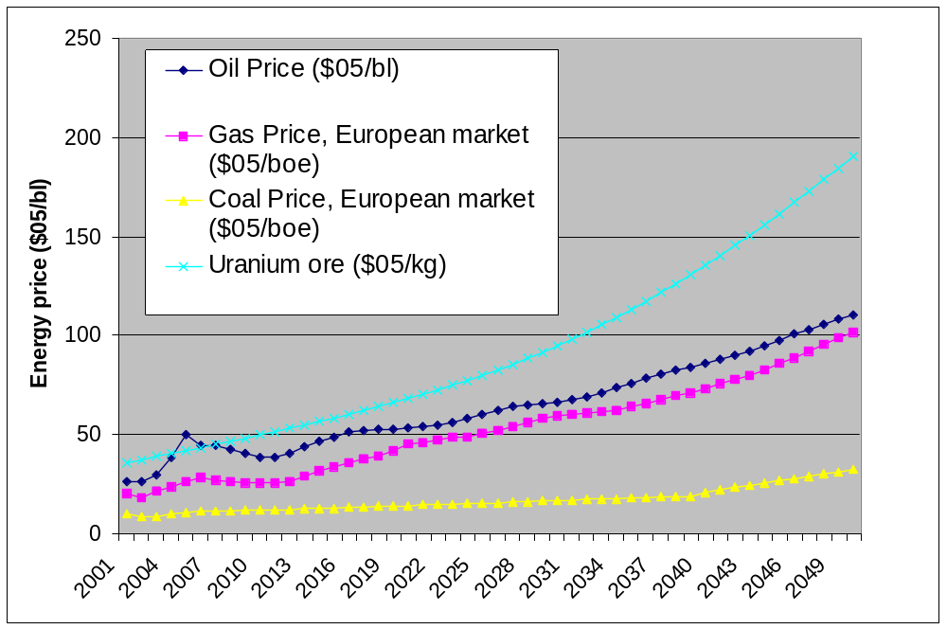
NB: 1 kg Uranium ore is
equivalent to ~600 boe
(heating value basis;
conventional technology)
Figure 4: Baseline feedstock price assumptions for the model runs.
Different demand and supply scenarios were calculated. The demand scenarios differ in the following options:
- Penetration rate (low, medium, high), coupled with high (=fast cost reduction of hydrogen drive train) or moderate technology learning for vehicles (see Table 1).
- Users (concentrated, distributed): In the concentrated users scenario, approx. 25% of the population have access to hydrogen where they reside in T2, 50% in T3 and 85% in T4. In contrast, in the distributed users option, 50% of the population already have access to hydrogen in T2, 90% in T3, and the whole population in T4. The scenarios do not differ in T1 when only the early user centres are covered.
- Road networks (early/late): In the “early network” option, the early corridors are supplied from T1, and the “full highway network” is supplied from T2. In contrast, in the “late network” option, the early corridors are only supplied from T2, and the full highway network from T4.
Table 1: Penetration scenarios
Snapshot |  | T1 | T2 | T3 | T4
Hydrogen vehicles EU-wide |  | 10,000 | 500,000 | 4 mill. | 16 mill.
Year | High penetration, high learning | 2012 | 2015 | 2019 | 2024
Year | Medium penetration, high learning | 2014 | 2017 | 2021 | 2027
Year | Low penetration, moderate learning | 2017 | 2021 | 2028 | 2036
Besides the variations in demand, the following options are considered for supply:
- Country-specific feedstock and production technology bounds (such as minimum shares for the use of renewables) or free, unbound choice of feedstock shares (the only decision criterion is then cost minimization);
- 20% of all hydrogen dispensed in liquid form (LH₂) at the fuelling station to vehicles with cryo-tanks (based upon consensus among MS project partners and national stakeholders), or only gaseous hydrogen at the dispenser.
The base case scenario features concentrated users, early network, medium penetration rate - high learning, country-specific bounds and 20% LH₂ (except for Norway where no LH₂ is considered).

Results of infrastructure analysis
This chapter depicts some results of the infrastructure analysis in HyWays and looks at both country-specific findings and aggregated statements.

Expected infrastructure roll-out
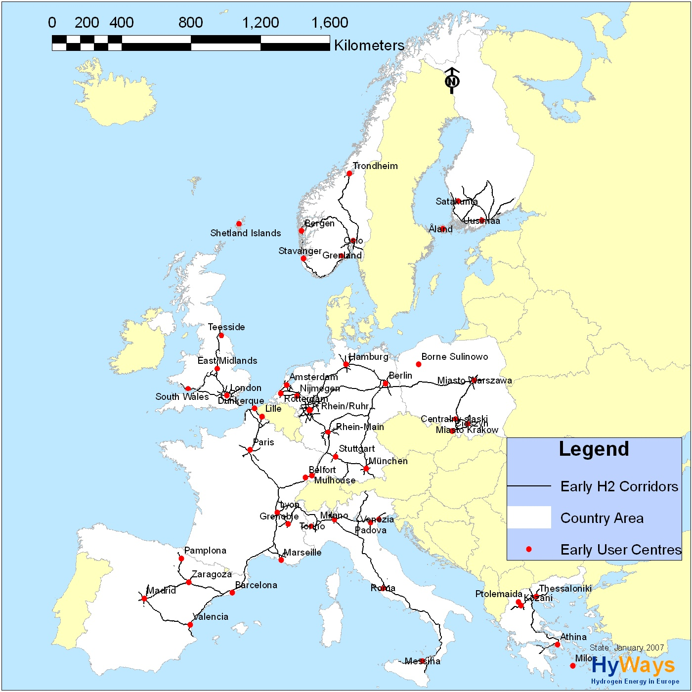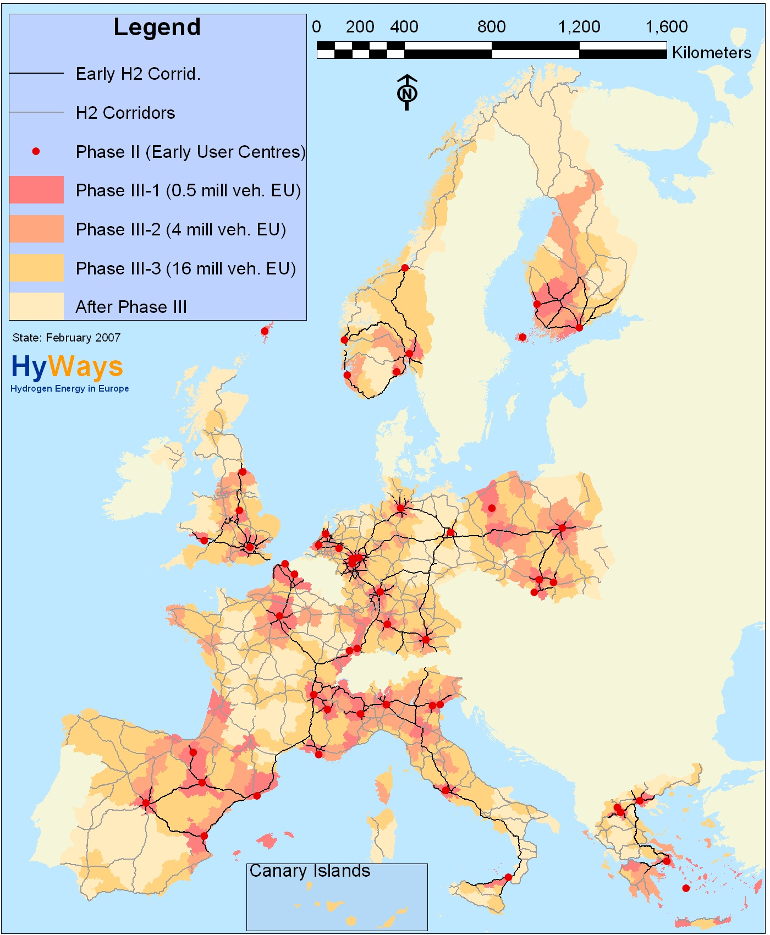
Figure 5: Early user centres for hydrogen in the 10 HyWays countries (left) and time of first supply of all regions (right).
Figure 5 (left) shows the early user centres of all HyWays countries which were elaborated by the country representatives and the stakeholders on the basis of a list of quantitative and qualitative indicators (see above), and the early hydrogen corridors. Note that the size of a user centre does not necessarily show its “weight” in terms of number of cars and fuelling stations or quantitative hydrogen demand.
Most countries focus on densely populated areas for the early adoption of hydrogen due to the obvious infrastructure advantages arising from a high density (shorter distribution distances, more users reached per fuelling station). Besides size, indicators like the availability of hydrogen and technology experts, political commitment, existing demonstration projects and, to some extent, the availability of resources played a major role in selecting the early user centres. Some countries also include remote areas in the early user centre portfolio, namely Navarra (ES), Kyklades (GR), Koszalinski (PL), the Shetland Islands (UK), and the Åland archipelago (FI). This is mainly because stranded renewable energy resources can be tapped, and the need for a transit road network is lower due to the remoteness of these regions leading to a stronger focus on the local use of road vehicles.
The resulting early transit road network focuses on connecting early user centres within the HyWays countries, but also on international links. Furthermore, the motorways around early user centres with high population densities should be equipped with hydrogen fuelling stations to facilitate daily commuting in these regions.
Figure 5 (right) shows the subsequent regional deployment of hydrogen use in the later snapshots (the lighter the colour, the later the region is supplied with hydrogen) for the “concentrated users” scenario, together with the full network of hydrogen corridors. This rollout was estimated by the above described chronological deployment order which was determined based on purchasing power, catchment population and cars per person in the regions, each with weights decided by the national stakeholders. Accordingly, in the later phases, the existing user centres are extended and simultaneously new user centres are developed until almost the entire area of the countries is covered in the last snapshot.
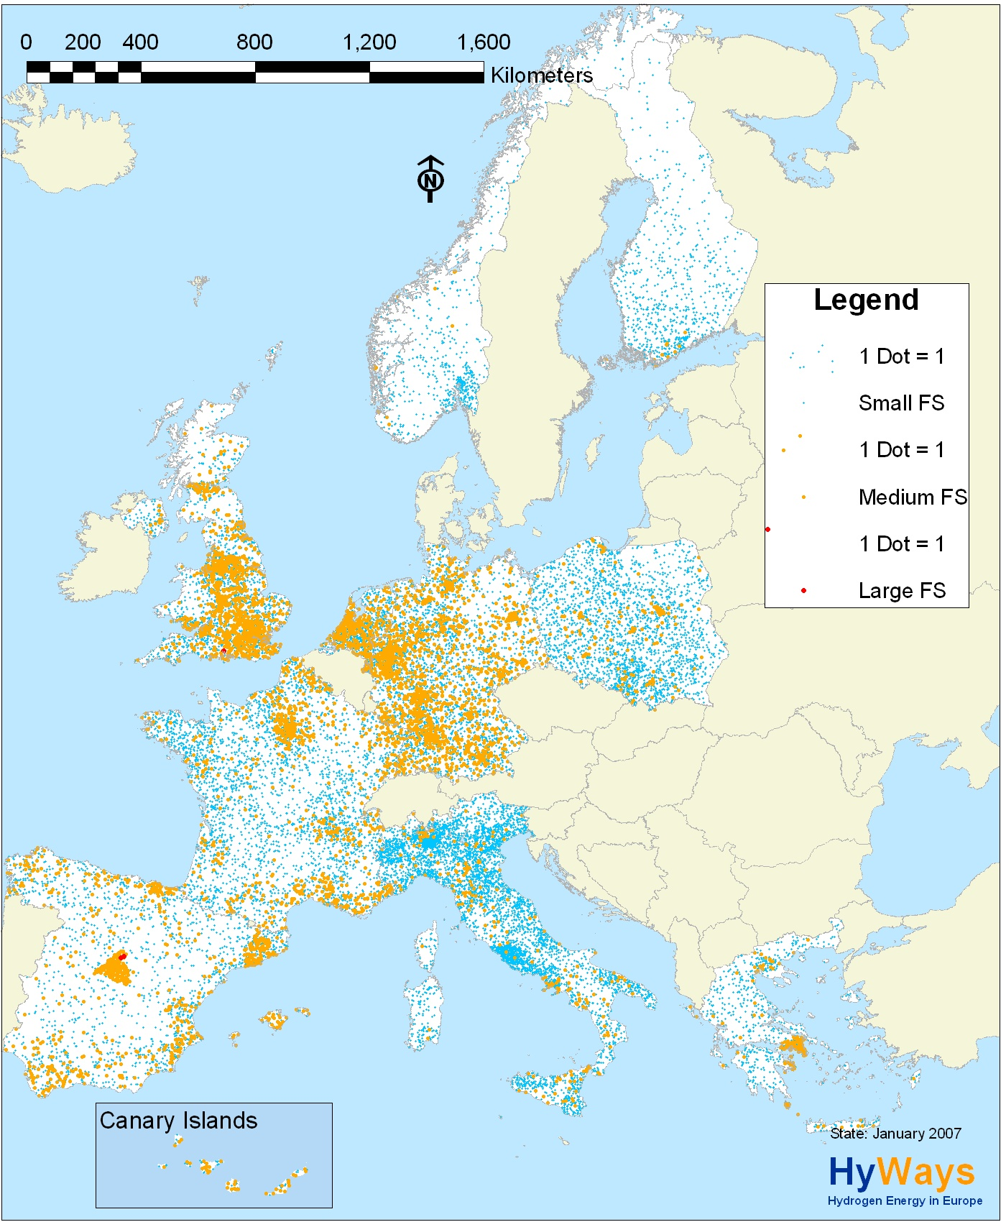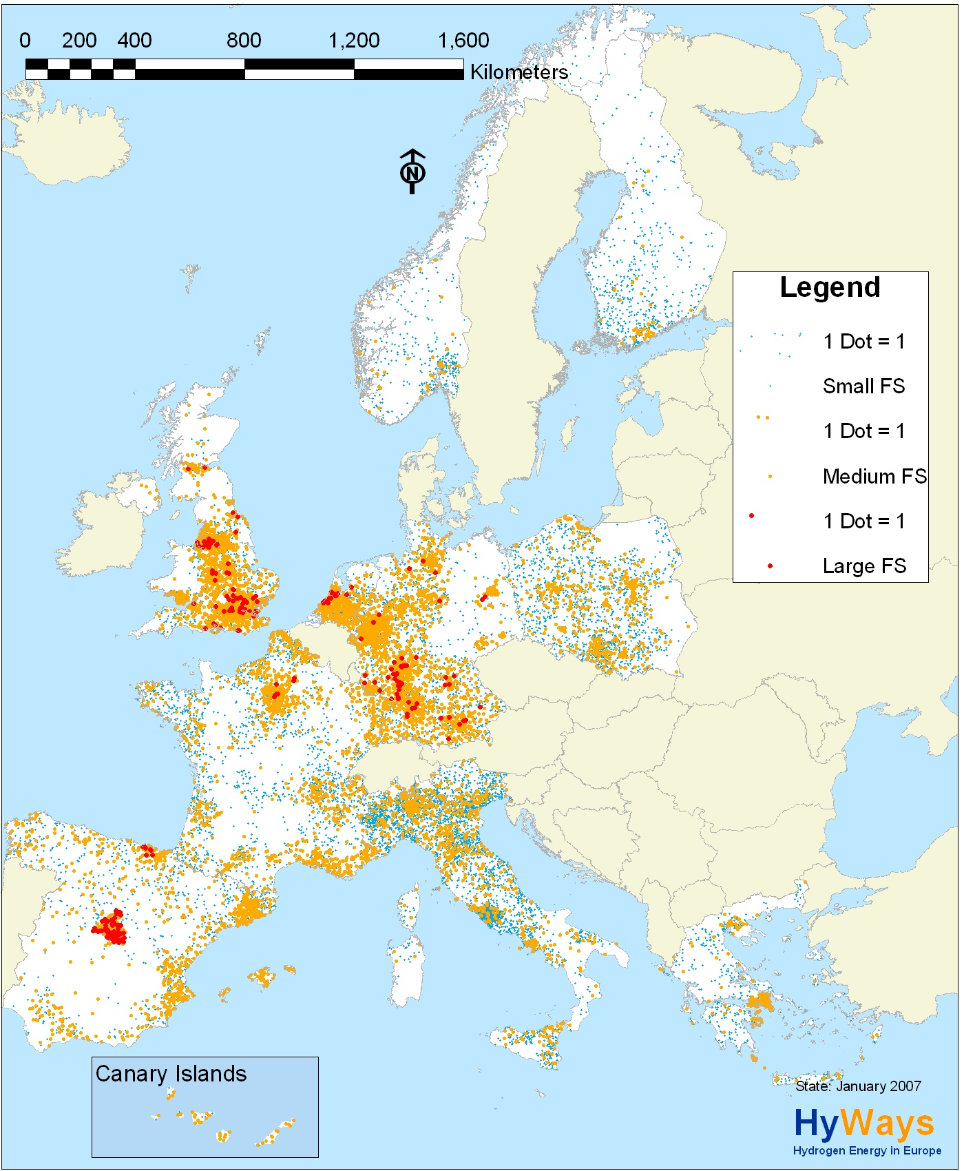
Figure 6: Allocation of small, medium and large fuelling stations in T4 (left: distributed users scenario, right: concentrated users scenario).
Approx. 500 fuelling stations are required to supply the early transit road network in the 10 countries (assuming one fuelling station every 80 km; multi-lane roads have one on each side). For the supply of all dedicated transit roads (motorways and E-roads), between 1500 and 2000 fuelling stations are required.
To supply the early user centres locally during T1, approx. 400 fuelling stations are sufficient for the 10 countries. The number of local fuelling stations increases with the demand increase and the regional expansion of the hydrogen supply and amounts to between 17,000 (concentrated scenario) and 25,000 (distributed scenario) in T4. The approximate regional spread of small, medium and large fuelling stations in the concentrated and distributed users scenarios in T4 can be seen in Figure 6. For the distributed users scenario (left), many more small and almost no large hydrogen fuelling stations would be required for the same total hydrogen demand as in the concentrated users scenario (right).

Optimized production and supply infrastructure
The estimated rollout of hydrogen use and the regional numeric hydrogen demand development were used to calculate economically optimized production and supply infrastructure in the 10 HyWays countries, while satisfying the bounds set by the country stakeholders for the application of feedstocks and technologies.
Figure 7 shows the average specific hydrogen costs (including feedstock, production, transport and refuelling), and the cumulated investment in hydrogen infrastructure aggregated for all countries for the base case scenario.
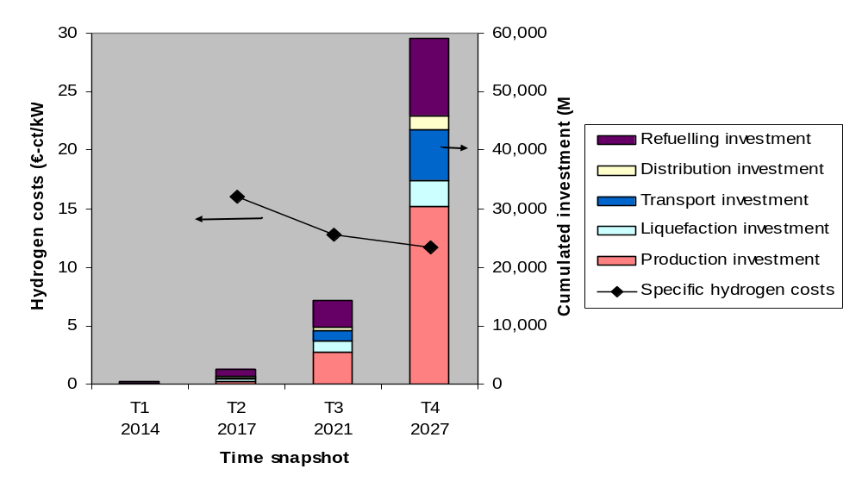
Figure 7: Aggregated total hydrogen costs (base case scenario with country-specific feedstock bounds and 20% LH₂ demand)
While refuelling dominates infrastructure investments in the early phases, in the later phases it is superseded by production. The total investment of the 10 countries until T4 (i. e. to reach a hydrogen vehicle penetration rate of approx. 8%) is around 60 billion €. However, also conventional fuels required large investment: e.g., the IEA recently assumed that a global investment of as much as 4,300 billion US-$ will be required in the oil sector until 2030 in order to maintain current production levels (11). Even though a direct comparison of these numbers is not valid, this may be helpful for a placement of the investment needed for hydrogen infrastructure.
The early phase of hydrogen deployment (i. e. approx. 10,000 hydrogen vehicles EU-wide) would show high specific costs of hydrogen (intentionally left out in Figure 7). The main reason for this is the underutilization of the production and supply infrastructure due to technology-related capacity thresholds and the overcapacity of refuelling infrastructure required for user convenience. The overall hydrogen costs are very sensitive to the required number of fuelling stations; establishing an early transit corridor network therefore leads to a drastic cost increase. Furthermore, if liquid hydrogen is to be available in all supplied areas (e. g. 20% of the total demand), or if other large-scale production technologies are enforced by the bound setting of the country stakeholders, this will result in a further cost increase due to plant underutilization. Cost differences between countries can mainly be explained by the use of different feedstocks and differences in population density.
Still, the total investment on country level for the early infrastructure is limited to 30 - 120 M€. Assuming approx. 1000 vehicles per country, this represents a high specific infrastructure investment per vehicle because the fuelling station utilization is assumed to be very low. However, this is believed to be required for the initialization of hydrogen deployment and must be overcome by adequate policy measures. Substantially higher vehicle penetration rates will level out the costs to values between 11 and 16 ct/kWh hydrogen (3.7-5.4 €/GGE) in the medium term. When comparing these numbers to today’s fuel costs, the substantially reduced consumption through improved fuel efficiency must be taken into account.
The rollout strategy for hydrogen in the snapshots T2-T4 (concentrated users or distributed users) substantially shapes the development of the hydrogen landscape; the distributed user strategy with its early widespread use leads to a more even penetration of hydrogen because more users will have early access to hydrogen. In the concentrated user strategy, areas supplied later will have a backlog in penetration compared to areas supplied earlier. This also affects the fuelling stations: If a certain hydrogen demand is “spread” over a larger area, a greater number of smaller fuelling stations will be required than if the same demand is concentrated in denser areas. As a consequence of the higher number of fuelling stations, the distributed user strategy leads to 10-20% higher specific hydrogen costs in the early phases (T2), which level out to 5-10% later (T4).
Table 2 summarizes the specific features for each of the 10 countries. It must be mentioned that the different price levels do not only derive from the choice of feedstock for hydrogen production but also from regional differences in distribution costs.
Table 2: Characteristics for each of the 10 countries
Country | Hydrogen demand in T4 (GWh) | Relevant feedstocks in T4 (later phase), roughly in order of declining importance | Hydrogen costs in T4 (€-ct/kWh), range of scenarios
Finland | 1.7 | Natural gas (NG), biomass, hard coal, wind, grid electricity, nuclear | 10-11
France | 25.8 | Nuclear, grid electricity, wind power, NG, biomass (electricity dominated) | 9-11
Germany | 26.1 | Hard coal, biomass, wind, by-product, NG, grid electricity | 8-11
Greece | 4.6 | Wind, biomass, lignite, NG (strong focus on domestic energy sources) | 9-16*
Italy | 17.8 | Wind, biomass, NG, coal, waste, solar | 10-14*
Netherlands | 6.2 | NG, hard coal, biomass, by-product (focus on central production) | 10-13
Norway | 1.6 | Wind, biomass, by-product, grid electricity, NG (no existing NG grid) | 11-12
Poland | 9.6 | Biomass, hard coal, lignite, NG, wind (in-situ coal gasification considered) | 8-13
Spain | 14.9 | Wind, biomass, solar, hard coal, NG (high renewable share) | 12-16*
UK | 21.1 | NG, coal, wind, nuclear, waste | 10-13
* The high maximum prices mainly result from scenarios with a high share of renewables (particularly wind)

Role of feedstocks
Figure 8 shows the shares of feedstocks used in the 10 countries in T4 (scenario with country-specific bounds). It can be seen that, according to the perceptions of the stakeholders, more than 50% of hydrogen production in the later phase will be covered by coal and natural gas (mostly with carbon capture and storage). Renewables contribute approx. 25%, mainly wind and biomass, plus some renewables coming in via the grid electricity pathway.
Natural gas is mainly used for small-scale production from the early phase onwards, either onsite or decentrally (0.4-15 MW) with gaseous truck distribution. In later phases it also plays a role for central production with CCS (>300 MW). However, looking at the long term period after 2030 this option becomes more and more unattractive due to the assumed increase of gas prices.

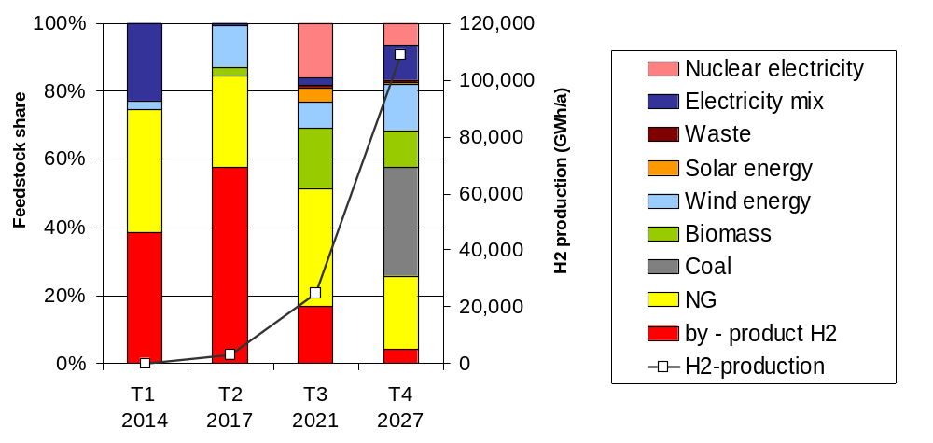
Figure 8: Feedstocks used for hydrogen production in T1-T4 in the scenario with country-specific bounds
Hard coal can only be gasified economically in large-scale central plants (~800 MW). Due to low initial demand these are restricted to the later phases. Most countries expect the application of CCS (carbon capture and storage) to coal gasification from 2020-25 onwards, and Poland also plans on operating lignite gasification as well as in-situ hard coal gasification after 2020. The usage of hard coal and lignite is heavily dependent on the large-scale availability of CCS technology.
Biomass gasification is the cheapest renewable hydrogen supply option; however it has restricted potential and competition of end-use with biofuels and other sectors must also be taken into account. Biomass gasification is applied by the model in decentral (~50 MW) and central plants (>300 MW) in later periods.
Wind energy is mainly utilised with green certificates and onsite electrolysis (0.4-2.7 MW) or direct hydrogen production and transportation. To what extent the grid is capable of this depends on characteristics of the grid and the electricity production mix. Many countries do expect hydrogen to be produced from wind, even if the specific costs cannot compete with most other options. However, further research is needed (e. g. into storage of hydrogen in underground caverns) because integrating wind electricity adequately into an energy system is a complex issue.
Onsite electrolysis from grid-mix electricity is expected to some extent in countries where excess electricity may become available (e. g. in Norway due to the phasing out of heavy industry, in France due to the high nuclear power share). However, it is questionable whether excess electricity will be used in the hydrogen market or the European electricity market. Given that hydrogen will come into its own in a world with high conventional energy prices, it might be misleading to assume the availability of cheap excess electricity for hydrogen production. This has an impact on liquefaction, too, because cost competitiveness here is sensitive to electricity prices. Choosing onsite electrolysis from grid-mix is, however, also linked to the interest of using lean-CO2 electricity in the respective countries, as long as CCS is not available.
Nuclear power plants dedicated to hydrogen production are envisaged by the stakeholders in France, Finland, Spain, Poland and the UK during later periods. The latter three countries will also rely on nuclear thermocycles (such as the sulphur-iodine cycle, ~1 GW), while Finland and France envisage standard central water electrolysis and high temperature electrolysis (~2.4 MW per module), respectively. This is a stakeholder view and not necessarily coherent with the government positions (e.g. in Spain no new nuclear power plants are considered by the government).
Solar energy for hydrogen production is currently only seen in Spain and Italy to a lower share in later phases. Thermo-chemical cycles (sulphur-iodine, mixed ferrites) are envisaged here.
Hydrogen occurring as a by-product of the chemical industry which is already used thermally today in conventional plants (various capacities) is seen as a cheap option especially for the initial phase because it can be substituted by natural gas. However investments in purification might be needed and have to be evaluated case by case. This type of hydrogen is mainly used where user centres are nearby. It will also contribute to a certain extent during later phases, but with a lower share due to its limited potential.
Sensitivity analyses have examined the possibility of importing renewable hydrogen from countries like Iceland or Norway. This option seems to be attractive especially in later phases with significant hydrogen demand.

Role of supply options for transport and distribution
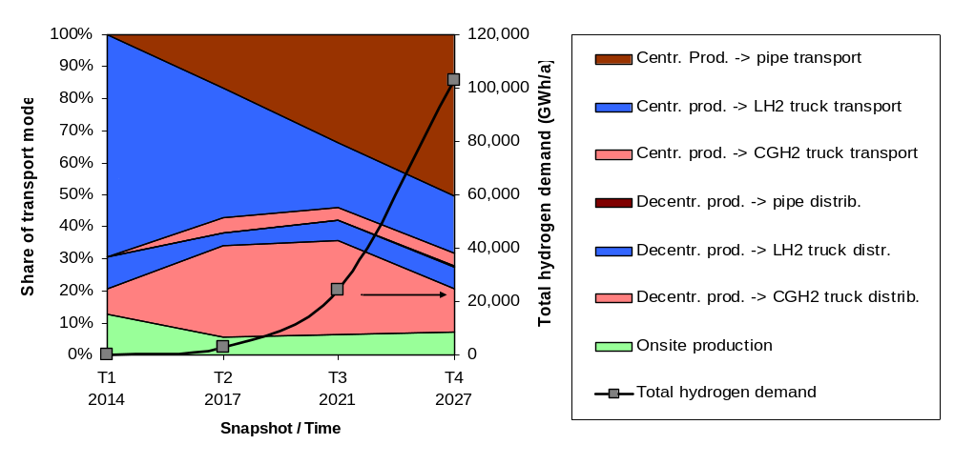
Figure 9: Share of hydrogen delivery options over time for the 10 countries (base case scenario)
Figure 9 shows the shares of transport and distribution options over time. Central production means that inter-regional transport is necessary, while decentral production is located within the same region and only requires distribution to the fuelling stations. Centrally produced hydrogen that is transported to the target region via pipeline can be distributed from the pipeline terminal via distribution pipeline or CGH₂ truck. For CGH₂ and LH₂ a distinction is made between trucks transporting within the same region (i. e. from decentral production or a reception terminal, i. e. from a long-distance pipeline) and long-distance trucks from central plants.
Figure 10 shows a static sensitivity analysis for a region with 100 fuelling stations (compare (12)). The transport costs have been calculated to show the influence of the different parameters based on certain assumptions about transport distance and cars per fuelling station. In the sensitivity analysis shown, the assumptions were 10 km dedicated distribution pipeline for each fuelling station and 60 €/MWh electricity costs for liquefaction. Onsite technologies are considered if transportation costs exceed 9 ct/kWh of hydrogen and if utilization is not too low (no fewer than 100 cars per fuelling station).
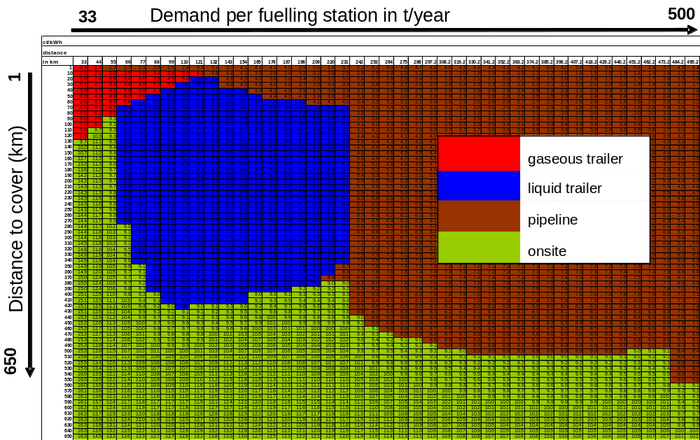
Figure 10: Sensitivity of transport cost (€ct/kWh) and mode depending on the number of vehicles per fuelling station (NB: not refuellings per day) and transport distance in an area with 100 fuelling stations.
From the accumulated results and more detailed scenario evaluations, the following role of the supply options can be derived:
- Hydrogen production at the fuelling station (onsite) from natural gas or electricity is considered over the whole period studied in areas where there is too sparse demand for more centralized schemes. Practical problems may hinder the application of onsite technology. For instance, in densely populated areas, the space requirement can be disadvantageous and onsite SMR might not be an option for fuelling stations with very low initial utilization due to its limited part-load ability and very high specific investments compared to central plants with higher utilization. Due to the fact that low initial fuelling station utilization is assumed in this study, and that natural gas and electricity become more expensive in later phases, on-site production has a relatively low share here. However, this is strongly sensitive to the ingoing assumptions and it can be stated that in most imaginable scenarios onsite production will be indispensable in certain locations.
- Tube trailer trucks delivering compressed gaseous hydrogen (CGH₂) have high variable costs (also per distance) due to the small volume of hydrogen they hold, but they are flexible and have comparatively low fixed costs. Under the current assumptions they appear to be advantageous for the distribution of decentrally produced hydrogen within regions of intermediate density. The highest share can be observed in the middle of the period studied, making CGH₂ trucks a technology for the transition to pipeline delivery. Their flexibility is also advantageous where fuelling station utilization is too low to apply onsite production in a technically and economically reasonable way, given that the delivery distance is smaller than app. 100 km.
- Truck delivery of liquid hydrogen (LH₂) results in lower variable costs per distance (LH₂ trucks can store approx. 8 times as much hydrogen as CGH₂ trucks) and therefore longer distances can be covered between production and use location. One drawback, however, is the required liquefaction process which implies high investment and variable costs (due to high energy demand). In the very early phase, the capacity of existing liquefiers may be sufficient. Due to the 20% LH₂ demand assumption, LH₂ delivery dominates the early phase when most fuelling stations receive only LH₂ and evaporate some of this to dispense CGH₂. Because onsite and small-scale liquefaction are not considered to be economically viable, vehicles with LH₂ storage can only be supplied with LH₂ trucks. These are mostly used to supply small and medium fuelling stations, both outlying ones (e. g. along motorways) and in centres where neither onsite production nor CGH₂ trucks are preferable options due to space restrictions and high delivery frequencies, respectively. The decision as to whether hydrogen should be distributed as a liquid or a gas is very sensitive to the liquefaction energy costs, the transport distance and volume involved.
- Pipeline delivery implies high investment, but negligible variable costs. The investment is in proportion to the delivery distance; while the influence of capacity is lower (i. e. halving the pipeline capacity will only bring about 9% cost reduction for the same pressure drop). Therefore pipelines are most economic with relatively short distances and high turnover. Distribution pipelines are envisaged for the long-term supply of medium and large FS in centres as well as around production sites. For the transportation of hydrogen from a central plant to neighbouring regions, pipelines are used to a large extent in later phases. Pipeline distribution is mainly an option for densely populated areas and larger fuelling stations. This indicates that they will become more attractive as hydrogen penetration advances. A positive side effect is that their intrinsic storage capacity may facilitate the use of intermittent renewable energy sources.
- The dual supply of LH₂ and CGH₂ is an option for later phases. In early phases and for small fuelling stations where 20% of the hydrogen dispensed is liquid (the rest gaseous), the economic option is to deliver all the hydrogen in liquid form and then vaporize the part to be dispensed as a gas (by applying cryogenic compression). For medium and large-size FS in later phases, dual hydrogen supply may also make sense, i. e. with gaseous hydrogen from either onsite or pipeline supply. A positive side-effect is that liquid hydrogen vaporization could serve as a backup for CGH₂ at little extra cost.
It must be pointed out that Figure 9 shows the model results of a scenario which is exposed to many sensitivities (e. g. transport distances, fuelling station turnover/cars served, demand for LH₂, energy prices, density of fuelling stations in a region) and should not be regarded as an “ultimate strategy”. The results show that each of the transport options may play a role under specific conditions. The distance to be covered has the strongest impact on transport costs which have a much larger impact on the total supply costs of hydrogen than is the case for today’s liquid fuels. The primary optimisation goal should therefore be to minimize the average hydrogen transport distances through well planned and distributed siting of the production plants.

Additional costs and savings through hydrogen
Figure 11 shows the result of the cash flow analysis described above. From the fuel graphs, it can be seen that hydrogen is expected to break even with conventional fuels after 2030, almost independently of the infrastructure roll-out and penetration scenario assumptions. Of course, energy prices (especially oil) play an important role in the balance. Furthermore it can be seen that the high specific hydrogen cost in the early phase does not cause high economic losses on the macro scale; in fact the period after 2020 is the most costly with still significantly higher costs for hydrogen than for conventional fuels despite the already high vehicle penetration.
The savings through hydrogen after reaching the break-even point are enormous. If the growth in hydrogen demand takes place slowly, the cost of the infrastructure build-up increases significantly (long period of underutilization of capacities). For the full commercialization phase it can be concluded that hydrogen costs at the filling station in comparison to oil-based fuels are not a relevant barrier for hydrogen as long as the crude oil prices are above 50 $/b for densely populated countries (such as Germany) and 60 - 70 $/b for less populated countries (such as Norway or Finland).
For the fleet cash flow graphs it was assumed that either 1,000 or 2,000 € per vehicle would be covered by government funding or the willingness of the customer to pay more for an environmentally friendly and quiet vehicle (see (13)). The fleet graphs show that the scenario assumptions play a much more important role for reaching the economic break-even point of hydrogen vehicles; i. e. the number of vehicles built and the learning rate determine the shape of the curve. The overall cash flow (including 1,000 € per vehicle) for the hydrogen fuel and vehicle fleet shows a break even between 2025 and 2035.

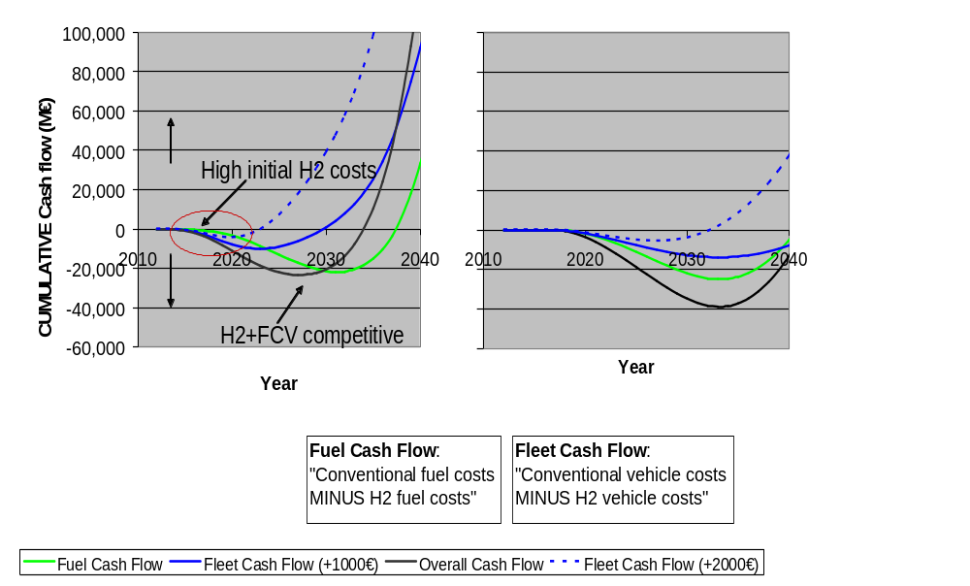
Figure 11: Results of the cash flow analysis

Conclusions and recommendations
The HyWays project performed modelling optimization of the hydrogen infrastructure build-up in 10 European countries, respecting the specific views of the industry partners and national stakeholders. The conclusions drawn here are thus based on both the modelling results and the consensus of the stakeholders involved.
The initiation of hydrogen infrastructure rollout is seen predominantly in population centres and also to some extent in remote or less populated areas. Further drivers for the manual selection of such seedpoints are the political commitment and importance of the regions as well as their activities and innovation in research and development (mainly in hydrogen and fuel cells) with the intention to ensure political support of the process and also visibility among interested individuals. The availability of cheap, local, primary energy resources for hydrogen production is only seen as a minor point. It can be concluded that a purely economic optimization of the regional demand allocation adapted to the supply options is not really desired in an industrial context.
The specific hydrogen costs in the early phase are high due to the required overcapacity of the supply infrastructure and high technology investments because of the early phase of technology learning. However, the cash flow analysis shows that the total economic impact of the early phase is small compared to later phases due to the comparatively low turnover. It can be concluded that a gradual build-up of the infrastructure with an initial concentration on agreed user centres efficiently diminishes the often cited chicken-and-egg problem. In order to make hydrogen an attractive fuel and facilitate its deployment among the users, hydrogen supply along an early road network may be required, but this also keeps the total initial investment in infrastructure comparatively small. Long-term hydrogen costs of 11-16 ct/kWh (3.7-5.4 €/GGE) can be achieved. The technology progress of end-use technologies, and particularly the cost reductions and improved performance of fuel cells and on-board storage technologies constitute the most influential cost factor.
Assuming that 20% of the hydrogen demanded will be in liquid form, initially most of the hydrogen will be delivered by LH₂ trucks (with evaporation for CGH₂ demand). In later phases, supplying gaseous hydrogen will gradually be taken over by pipeline transport and distribution. Pipelines for medium and large fuelling stations may become relevant once a significant market penetration of hydrogen vehicles has been achieved, but these are mostly used for local distribution in highly populated areas and for large-scale interregional energy transport. Along with the appearance of decentral, regional production, CGH₂ truck distribution is a solution for the transition phase to pipelines. In less populated and remote areas, onsite supply and LH₂ transport remain the most economic choice even in later phases.
Despite the high contribution of transport costs, more than half of the hydrogen required may come from central production combined with inter-regional transport in all phases. This proves that the consideration of larger regions and the interconnections between them is important when aiming at an economically optimised build-up of hydrogen infrastructure. Well planned and distributed siting of the production plants is essential to minimise transport costs.
The cash flow shows that hydrogen fuel and fuel cell vehicles can become competitive with conventional fuel (with oil price over 60 $/b) between 2025 and 2035 under the given framework of assumptions, both for scenarios with high penetration and quick technology improvement and for lower penetration and moderate technology learning, with a later break-even point in the second case.

Acknowledgement
HyWays is an integrated project, co-funded by the participating research institutes, industry, national agencies and by the European Commission (EC) under the 6th Framework Programme [contract N° 502596].

References
- HyWays – Hydrogen Energy in Europe, Integrated Project under the 6th Framework Programme of the European Commission, 2004-2007, http://www.hyways.de
- Tzimas, E., Castello, P., Peteves, S., The evolution of size and cost of a hydrogen delivery infrastructure in Europe in the medium and long term, International Journal of Hydrogen Energy, in press, available online 28 November 2006.
- HyNet - The European Thematic Network on Hydrogen Energy, Network of Excellence under the 5th Framework Programme of the European Commission, 2001-2004, http://www.hynet.info
- Smit, R., Weeda, M., de Groot, A., Hydrogen infrastructure development in The Netherlands, International Journal of Hydrogen Energy, in press, available online 30 November 2006.
- Ball, M., Wietschel, M., Rentz, O., Integration of a hydrogen economy into the German energy system: an optimising modelling approach, International Journal of Hydrogen Energy, in press, available online 1 December 2006.
- Ball, M., Integration einer Wasserstoffwirtschaft in ein nationales Energiesystem am Beispiel Deutschlands, Dissertation, VDI Fortschritt-Berichte 16, Nr. 177, VDI Verlag, Düsseldorf, 2006.
- Nomenclature des unités territoriales statistiques - NUTS, http://ec.europa.eu/comm/eurostat/ramon/nuts/codelist_en.cfm?list=nuts.
- Nicholas, M., Weinert, J., Miller, M., Estimating Hydrogen Station Infrastructure Cost in the LA Region, EVS21 Conference, 2005.
- European Commission, Directorate-General for Research, Directorate Energy, World Energy Technology Outlook – WETO H2, ISBN 92-79-01636-9, January 2007.
- EUCAR, CONCAWE and JRC, Well-to-Wheels Analysis of Future Automotive Fuels and Powertrains in the European Context, 2nd edition, May 2006, http://ies.jrc.cec.eu.int/wtw.html
- International Energy Agency, World Energy Outlook 2006, Paris, 2006.
- Yang, C., Ogden, J., Determining the lowest-cost hydrogen delivery mode, International Journal of Hydrogen Energy 32 (2007) 268 – 286.
- Potoglou, D.; Kanaroglou, P.S., Household Demand and Willingness to Pay for Alternative Fuelled Vehicles, Center for Spatial Analysis, McMaster University, Canada, 2006, http://www.science.mcmaster.ca/cspa/papers/CSpA%20WP%20018.pdf

Ludwig-Bölkow-Systemtechnik GmbH (LBST), Daimlerstr. 15, D-85521 Ottobrunn
Fraunhofer-Institute for Systems and Innovation Research (ISI), Breslauer Strasse 48, D-76139 Karlsruhe * Corresponding author, email stiller@lbst.de, tel. +49 89 608 110 41
except Norway which is not anticipating use of LH2.
GGE=galleon of gasoline equivalent; 1 GGE = 33.7 kWh

