WIRELESS HYDROGEN SENSOR NETWORKS USING GaN-BASED DEVICES

T. Anderson, H.T. Wang¹, C. Li, Z.N. Low², B.S. Kang¹, J. Lin²,
S. J. Pearton, F. Ren¹, A. Osinsky, A. Dabiran⁴, P. Chow⁴

Abstract
We have demonstrated a wireless hydrogen sensing system using commercially available wireless components and GaN Schottky diodes or AlGaN/GaN High Electron Mobility Transistors (HEMTs) as the sensing devices. Our sensors have achieved ppm level detection, with the added advantages of a very rapid response time within a couple of seconds, and rapid recovery. The sensors have shown current stability for more than 8 months in an outdoor environment. Our wireless network sensing system enables wireless monitoring of independent sensor nodes and transmits wireless signals. This is especially useful in manufacturing plants and hydrogen-fuelled automobile dealerships, where a number of sensors, possibly with each detecting different chemicals, would be required. We have also developed an energy-efficient transmission protocol to reduce the power consumption of the remote sensor nodes. This enables very long lifetime operation using batteries. Experimental results showed that a 150 meter transmission distance can be achieved with 10 mW total power consumption. The entire sensor package can be built for less than $50, making it extremely competitive in today's market.

1. Introduction
There is significant interest in developing GaN diodes for use in applications such as gas sensing and power flow control [1-11]. The GaN materials system has a high breakdown field and can operate at high temperatures (~500°C) and in harsh environments. The use of simple Schottky diode structures using thin Pt contacts allows for detection of hydrogen at concentrations of hundreds of ppm at wide tempaerature range temperatures (room temperature-500°C) [12-22]. There is a strong need to develop hydrogen sensors for use with proton-exchange membrane (PEM) and solid oxide fuel cells for space craft and other long-term applications. Higher detection sensitivity can be obtained with more advanced structures such as High Electron Mobility Transistors (HEMTs) with the penalty of relatively processing complexity [22]. There are also applications for detection of combustion gases for fuel leak detection in spacecraft, automobiles and aircraft, fire detectors, exhaust diagnosis and emissions from industrial processes [12-17].

Simple two-terminal semiconductor Schottky diodes with Pt or Pd gates have been shown to be particularly effective hydrogen sensors. Typically the sensing mechanism is ascribed to the dissociation of the molecular hydrogen on the Pt gate contact, followed by diffusion of the atomic species to the oxide/semiconductor interface where it changes the piezo-induced channel charge and effective barrier height on Schottky diode structures. This effect has been used in Si, SiC, ZnO and GaN–based Schottky diode combustion gas sensors [1-16]. Three-terminal transistor structures have been investigated to a much less extent but may have advantages because of the presence of the capability for current gain. AlGaN/GaN HEMTs are an attractive option as the hydrogen sensor because they can operate over a broad range of temperatures and form the basis of next-generation microwave communication systems so an integrated sensor/wireless chip is possible.

2. Experimental
Both HEMT and Schottky diode devices were fabricated for testing. The device layer structures were grown on C-plane Al₂O₃ substrates by Metal Organic Chemical Vapor Deposition (MOCVD). The layer structure included an initial 2μm thick undoped GaN buffer followed by a 35nm thick unintentionally doped Al_{0.28}Ga_{0.72}N layer. Mesa isolation was achieved by using an inductively coupled plasma system with Ar/Cl₂ based discharges. The Ohmic contacts was formed by lift-off of e-beam deposited Ti (200Å)/Al (1000Å)/Pt (400Å)/Au (800Å). The contacts were annealed at 850 °C for 45 sec under a flowing N₂ ambient in a Heatpulse 610T system. A 200 Å thick Pt Schottky contact was deposited for the schottky metal. The final step was deposition of e-beam evaporated Ti/Au (300Å/1200Å) interconnection contacts. The gate dimension of the HEMT device was 1 × 50 µm². The devices were bonded to electrical feed-through and exposed to either pure N₂ or 500 ppm H₂ in N₂ ambients in an environmental chamber in which the gases were introduced through electronic mass flow controllers.

3. Results & Discussion
There is an increase in current upon exposure to hydrogen, which is consistent with the hydrogen molecules dissociating into atoms through the catalytic action of the Pt gate contact and diffusing to the Pt/AlGaN interface where it screens some of the piezo-induced channel charge⁽¹¹⁾. Figure 1 shows some of the recovery characteristics of the devices upon multiple cycling of the ambient from N₂ to 500ppm H₂ in N₂ and back again. The sensors show good recyclability and recovery for both types of device. The change in current is much larger for the FET. The initial response to hydrogen in both cases is rapid (< 5 sec), while the recovery back to the N₂ ambient value takes much longer (100-200 secs) because of the mass transport characteristics of gas in our test chamber.
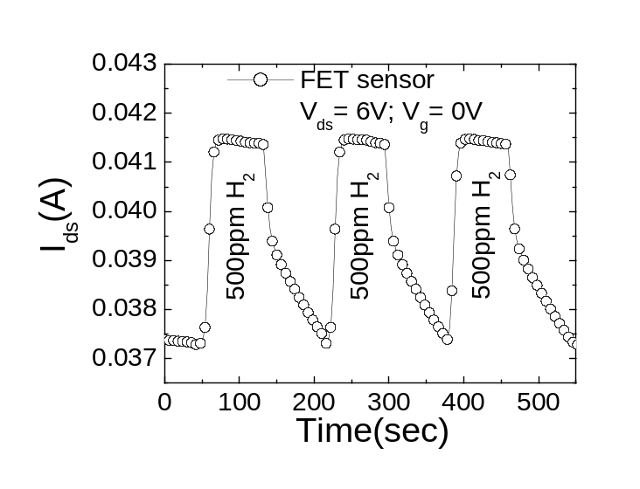
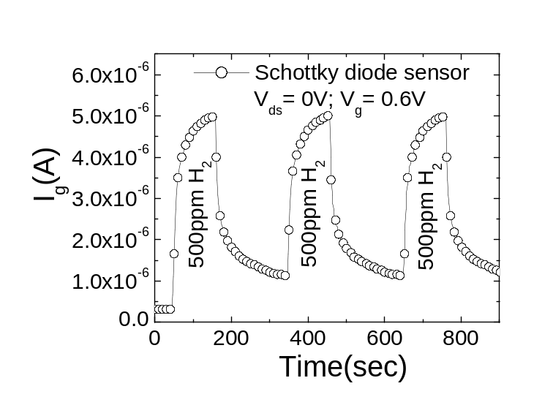
Figure 1. Time dependence of FET (top) or Schottky diode (bottom) when switching from pure N₂ ambient to a 500 ppm H₂ in N₂ ambient and back again.

An instrumentation amplifier is used for the detection circuit to sense the change of current in the device. The current variation, embodied as a change in the output voltage of the detection circuit, is fed into the microcontroller. The microcontroller calculated the corresponding current change and controlled the ZigBee transceiver to transmit the data to the wireless network server. The block diagram of the sensor module and the wireless network server are shown in Figure 2.

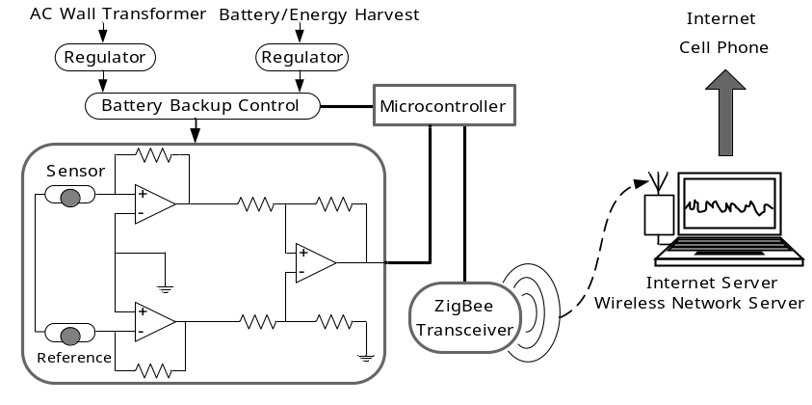
Figure 2. Block diagram of sensor module and wireless network server.

The Zigbee compliant wireless network supports the unique needs of low-cost, low-power sensor networks, and operates within the ISM 2.4 GHz frequency band. The transceiver module is completely turned down for most of the time, and is turned on to transmit data in extremely short intervals. The timing of the system is shown in Figure 3. When the sensor module is turned on, it is programmed to power up for the first 30 seconds. Following the initialization process, the detection circuit is periodically powered down for 5 seconds and powered up again for another 1 second, achieving a 16.67% duty cycle. The ZigBee transceiver is enabled for 5.5ms to transmit the data only at the end of every cycle. This gives a RF duty cycle of only 0.09%.

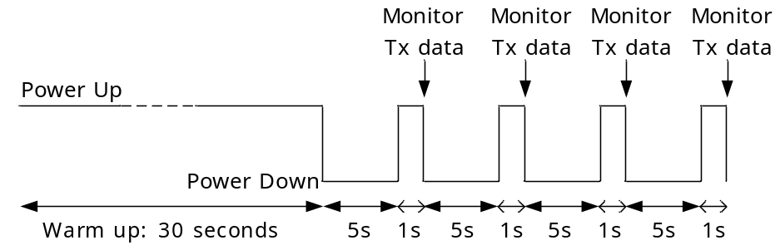
Figure 3. System timing of at wireless sensor node.

A web server was developed using MATLAB to share the collected sensor data via the Internet. The interface of the server program, shown in Figure 4, illustrates three emulated sensors with different baseline currents. If any of the sensor’s current increases to a level that indicates a potential hydrogen leakage, the alarm would be triggered. A client program was also developed to receive the sensor data remotely. As shown in Figure 4, the remote client was able to get a real time log of the system for the past 10 minutes via the client program. In addition, a full data log obtained via accessing the server via a ftp client as the server program incorporates a full data logging functionality. When an alarm was triggered, the client was able to deactivate the alarm remotely by clicking a button on the interface. The server program for the wireless sensor network could also report a hydrogen leakage emergency through phone line. When the current of any sensors exceeded a certain level, indicating a potential hydrogen leakage, the server would automatically call the phone-dial program, reporting the emergency to the responsible personnel.

Figure 4. Interface of online hydrogen level monitoring
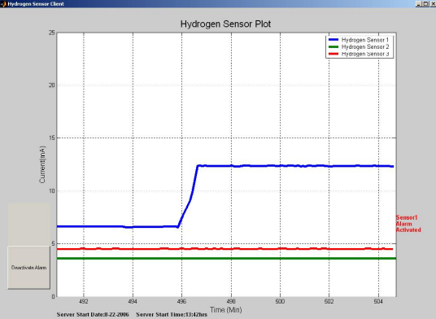

Client can deactivate alarm

The sensor module was fully integrated on an FR4 PC board and packaged with battery as shown in Figure 5 (a). The dimension of the sensor module package was: 4.5 × 2.9 × 2 inch³. The maximum line of sight range between the sensor module and the base station was 150 meters. The base station of the wireless sensor network server was also integrated in a single module (3.0 × 2.7 × 1.1 inch) and ready to be connected to laptop by a USB cable, as shown in Figure 5(b) and (c). The base station draws its power from the laptop’s USB interface, thus do not require any battery or wall transformer.

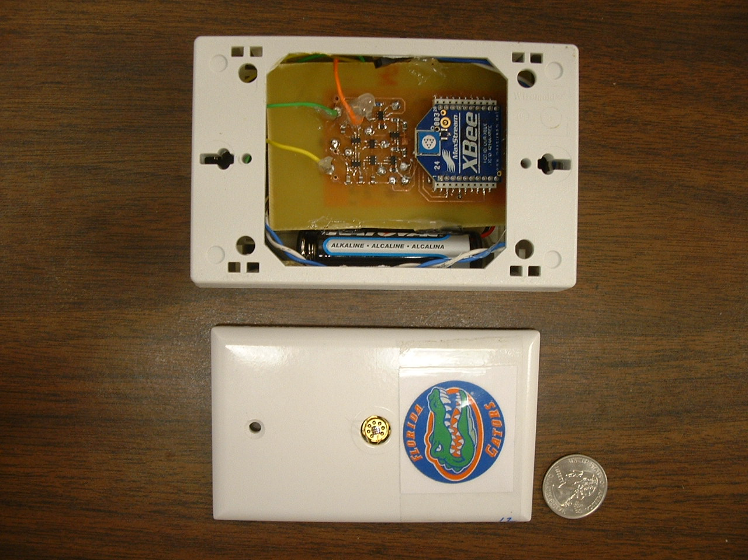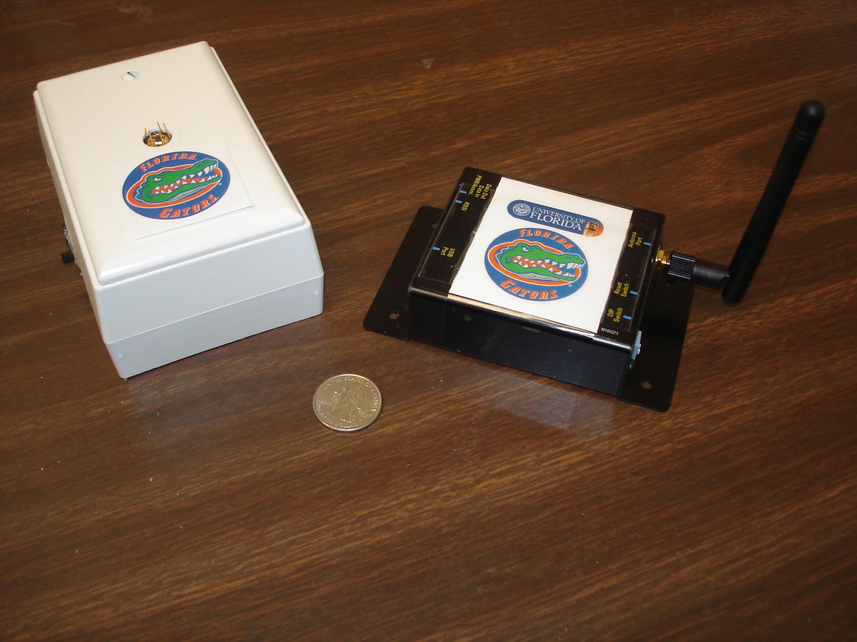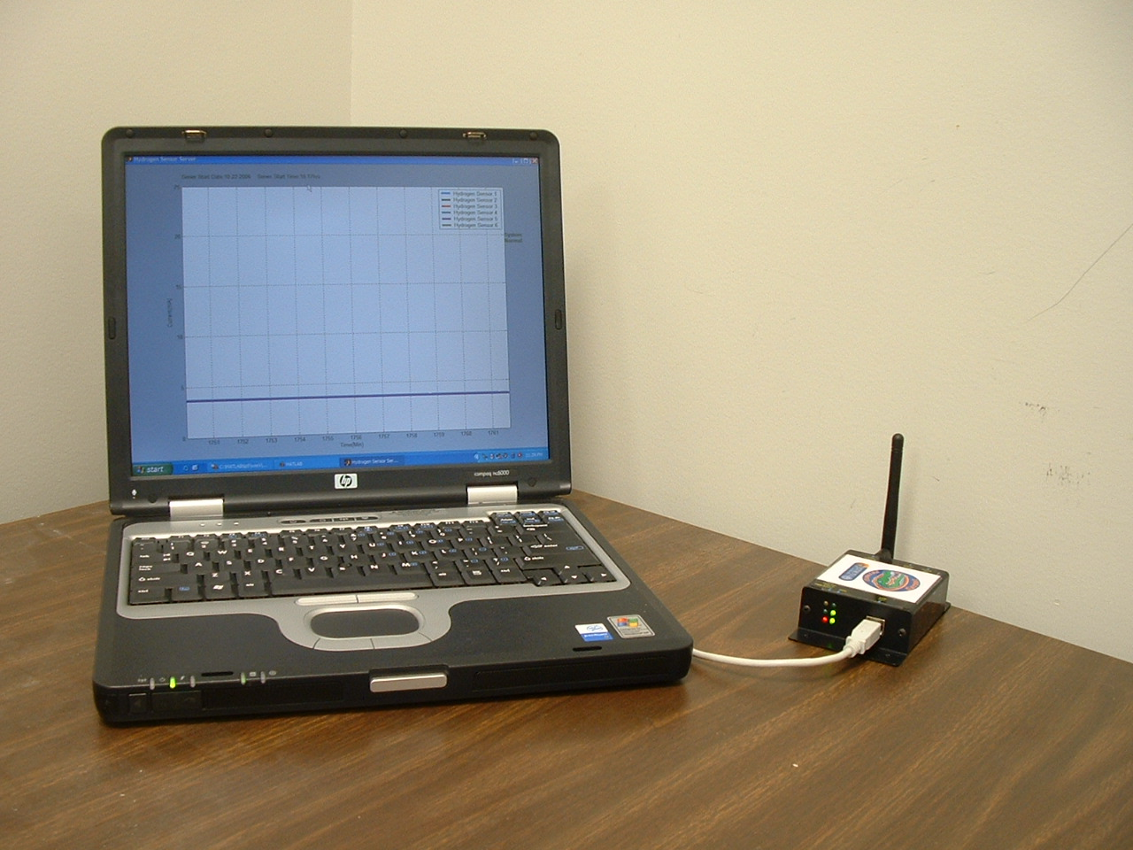
(a) (b) (c)
Figure 5. Photo of sensor system (a) Sensor with sensor device; (b) Sensor and base station; (c) Computer interface with base station.

Field tests have been conducted both at University of Florida and at Greenway Ford in Orlando, FL. The setup at Greenway Ford was aimed to test the stability of the sensor hardware and the server software under actual operational environment. Two sensor nodes were installed and the test was started on the 30th of August 2006 until the time of this report. Six sensor modules and the server have been functioning for the past eight months.

The outdoor tests at University of Florida have been conducted for several times, to test the sensor’s response to different concentrations of hydrogen at different distances. The tested hydrogen concentrations include: 1%, 4%, and 100%, and the distance from the outlet of hydrogen to the sensor ranges from 1 foot to 6 feet. Hydrogen leakage was successfully detected for all these cases, triggering the program to send alarm to cell phone. Figure 6 shows the test result with four running sensor modules and 4% hydrogen at 3 feet away from the hydrogen outlet. The sensors were tested sequentially so the effects of each sensor can be isolated. The test results also display the reliability of the wireless network as it is able to collect the data from each individual sensors.
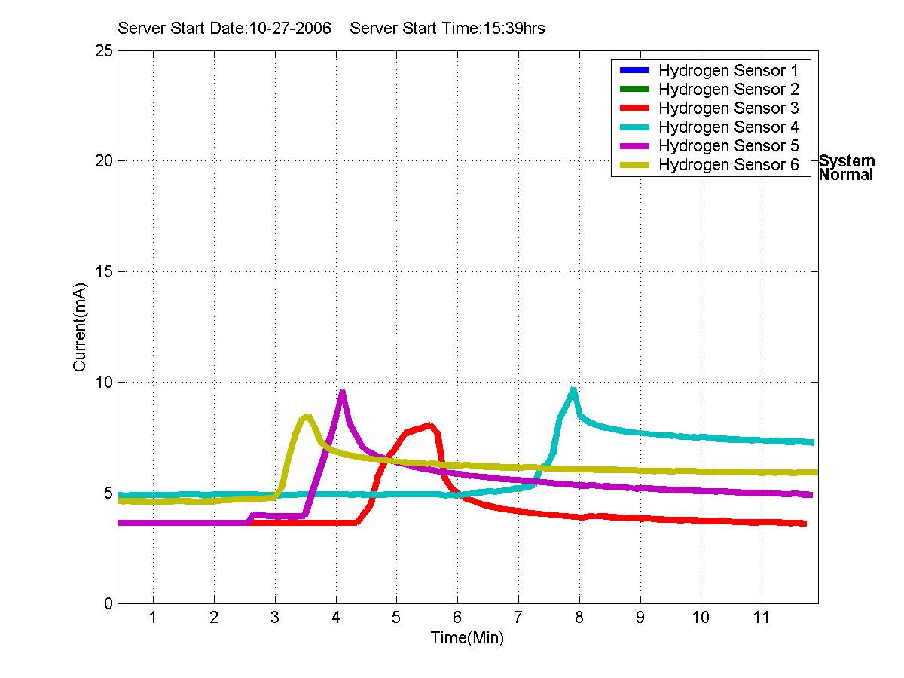
Figure 6. Field test results of four sensors.

4. Conclusion

A wireless sensor network which meets the IEEE 802.15.4 standards has been constructed to transmit data from an arbitrary number of hydrogen sensors to a base station. A user friendly program has been developed to share the data collected by base station to Internet, so that the data can be analyzed and monitored from anywhere with an internet connection. A cell phone alarm has been realized to report any potential hydrogen leakage to responsible personnel. The entire system has been tested for functionality and stability both at the University of Florida and at Greenway Ford in Orlando. Field tests show that the low-power hydrogen sensor can work stably and react quickly to possible hydrogen leakage.

5. Acknowledgement
The work at UF is partially supported by ONR (N00014-98-1-02-04, H. B. Dietrich), NSF(CTS-0301178, monitored by Dr. M. Burka and Dr. D. Senich), by NASA Kennedy Space Center Grant NAG 10-316 monitored by Mr. Daniel E. Fitch and also by Florida Department of Environmental Protection, U.S. Dept. of Energy(DE-FG26-05R410962 by Jill Stoyshich).

6. References
1. P. Tobias, A. Baranzahi, A. L. Spetz, O. Kordina, E. Janzen and I. Lundstrom, IEEE Electron. Dev. Lett. 18 287(1997).
2. A. Vasiliev, W. Moritz, V. Fillipov, L. Bartholomäus, A. Terentjev and T. Gabusjan, Sens. Actuators B49 133(1998).
3. J. Kim, F. Ren, B. Gila, C. R. Abernathy, and S. J. Pearton, Appl. Phys. Lett. 82 739 (2003).
4. J. Kim, B. Gila, C. R. Abernathy, G. Y. Chung, F. Ren, and S. J. Pearton, Solid State Electronics, 47 1487 (2003).
5. A. Lloyd Spetz, P. Tobias, L. Unéus, H. Svenningstorp, L.-G. Ekedahl and I. Lundström, Sens. Actuators B70 67(2000).
6. E. J. Connolly, G. M. O'Halloran, H. T. M. Pham, P. M. Sarro and P. J. French, Sens. Actuators A99 25(2002).
7. G. W. Hunter, P. G. Neudeck, R. S. Okojie, G. M. Beheim, V. Thomas, L. Chen, D. Lukco, C. C. Liu, B. Ward and D. Makel, Proc. ECS Vol 01-02 212(2002)
8. R. Neuberger, G. Muller, O. Ambacher, M. Stutzmann, Phys Status Solidi A 185 85 (2001).
9. J. Schalwig, G. Muller, O. Ambacher, M. Stutzmann, Phys Status Solidi A 185 39 (2001).
10. G. Steinhoff, M. Hermann, W. J. Schaff, L. F. Eastmann, M. Stutzmann, M. Eickhoff, Appl. Phys. Lett. 83 177 (2003).
11. M. Eickhoff, R. Neuberger, G. Steinhoff, O. Ambacher, G. Muller, M. Stutzmann. Phys. Status Solidi B 228 519 (2001).
12. J. Schalwig, G. Muller, M. Eickhoff, O. Ambacher, M. Stutzmann. Sens Actuat B 81 425 (2002).
13. M. Eickhoff, J. Schalwig, G. Steinhoff, O.Weidmann, L.Gorgens, R. Neuberger, M. Hermann, B.Baur, G.Muller, O. Ambacher, and M. Stutzmann, Phys. Stat. Solidi C 6 1908 (2003)
14. H. Svenningstorp, P. Tobias, I. Lundström, P. Salomonsson, P. Mårtensson, L.-G. Ekedahl and A. L. Spetz, B57 159(1999).
15. L. Chen, G. W. Hunter, and P. G. Neudeck, J. Vac. Sci. Technol A 15, 1228 (1997); J. Vac. Sci. Technol. A16 2890(1998).
16. A. Baranzahi, A. Lloyd Spetz and I. Lundström, Appl. Phys. Lett. 67 3203 (1995).
17. B.S. Kang, R. Mehandru, S. Kim, F. Ren, R. Fitch, J. Gillespie, N. Moser, G. Jessen, T. Jenkins, R. Dettmer, D. Via, A. Crespo, B.P. Gila, C.R. Abernathy and S.J. Pearton, Appl. Phys. Lett. 84 4635 (2004).
19. B.S. Kang, Y.W. Heo, L.C. Tien, D.P. Norton, F.Ren, B.P. Gila and S.J. Pearton, Appl. Phys. A 80 1029 (2005).
20. A. El. Kouche, J. Lin, M.E. Law, S. Kim, B.S. Kim, F. Ren and S.J. Pearton, Sensors and Actuators B: Chemical 105 329 (2005).
21. S.J. Pearton, B.S. Kang, S. Kim, F. Ren, B.P. Gila, C.R. Abernathy, J. Lin and S.N.G. Chu, J. Phys: Condensed Matter 16 R961 (2004).
22. S. Kim, B. Kang, F. Ren, K. Ip, Y. Heo, D. Norton and S.J. Pearton, Appl. Phys. Lett. 84, 1698 (2004).

University of Florida, Department of Chemical Engineering, Gainesville, FL 32611
University of Florida, Department of Electrical and Computer Engineering, Gainesville, FL 32611
University of Florida, Department of Materials Science and Engineering, Gainesville, FL 32611
SVT Associates, Eden Prairie, MN 55344

