Design, Application, and Evaluation of a Fuel Cell Vehicle

J. Gardner, R. Fifield, R. Hurt, Y. Baghzouz, and R. Boehm
Center for Energy Research, UNLV, Las Vegas, NV 89154

Abstract
As part of a project to develop a hydrogen filling station for the Las Vegas Valley Water District (LVVWD), the Center for Energy Research (CER) at the University of Nevada Las Vegas (UNLV) has as a major thrust the development of hydrogen powered vehicles. The purpose of this thrust is multifaceted, including: the desire to have vehicles that operate on hydrogen, the need to develop local expertise in this technology, and the need to evaluate how these kinds of vehicles operate in the generally hot, dry local climate. Fuel Cell (FC) performance in these kinds of climatological conditions is of very practical interest to FC development companies, as FCs may not perform as well in these environments as in more temperate ones. Work started with a Taylor Dunn Electruck, a plug-in electric utility vehicle. The vehicle was then modified to operate in a hybrid configuration with a FC. The chosen FC was produced by Nuvera, and it was received as a complete unit that incorporated its own air compressor and water recirculation system. A problem frequently encountered in the conversion of vehicles to hybrid power with stand-alone subsystems is that preassembled components are not sold in a configuration that allows for efficient integration into a vehicle. Since we wished to maintain the complete initial exterior vehicle appearance as nearly as possible, various components of the FC unit had to be disassembled and reconfigured to allow for the most efficient integration in the vehicle frame. Compliance with design parameters set forth by Nuvera required that the saturated water produced by the FC be gravity fed out of the unit into the recirculation system. Satisfying this requirement in a manner that allowed for an efficient integration into the vehicle required further modification to the recirculation system. Once the FC was installed, subsequent testing and data collection provided a means by which to base a comparison of factory performance and performance with FC integration was accomplished. Testing also demonstrated that the modifications made to the recirculation system satisfied the original design parameters. The power unit is self controlled, but load limits on the FC required the installation of additional power control elements which were installed to allow for a satisfactory power sharing between the battery bank and the FC. The power sharing was refined iteratively. Two tanks were installed for fuel storage. Complete design details as well as vehicle performance are presented in the paper.

- Introduction
The Taylor-Dunn electric utility vehicle discussed in this paper has undergone post-production modifications to accommodate a hydrogen polymer electrolyte membrane (PEM) fuel cell (FC) and its respective thermal management and fuel system components. The vehicle was received in its factory condition. The description of the retrofitting process starts with FC module modification and proceeds through to FC water plumbing and electrical system component installation. Also included are results from testing of the finished vehicle.

- Factory Configuration of the FC Module
The particular fuel cell in question was the H2e model produced Nuvera (Figure 1). It is rated to a scalable power output ranging from 2.5 kW to 5.5 kW. It came complete with a thermal management/ water recirculation system that regulated stack temperature through an integral water recirculation system. Figure 1 and Figure 2 illustrate the original configuration of the cell and its plumbing components. The FC system runs water positive and requires an initial fill of 8 L of de-ionized (DI) water to startup. Any excess water is rejected through a vent located on the top of its water reservoir. Exhaust water vapor that came directly from the stack was gravity fed into an air-cooled radiator located directly under the stack. Condensate exiting the radiator was collected in a reservoir located directly below it. Water from the reservoir was pumped up to the fuel cell and filtered before it entered the stack. The unit was received as a self-contained unit where the cell and its water plumbing components were all mounted to a stand. The modifications made to the thermal management components (i.e. radiator, water pump, water and steam exhaust lines) is discussed in the following section on fuel cell modifications.

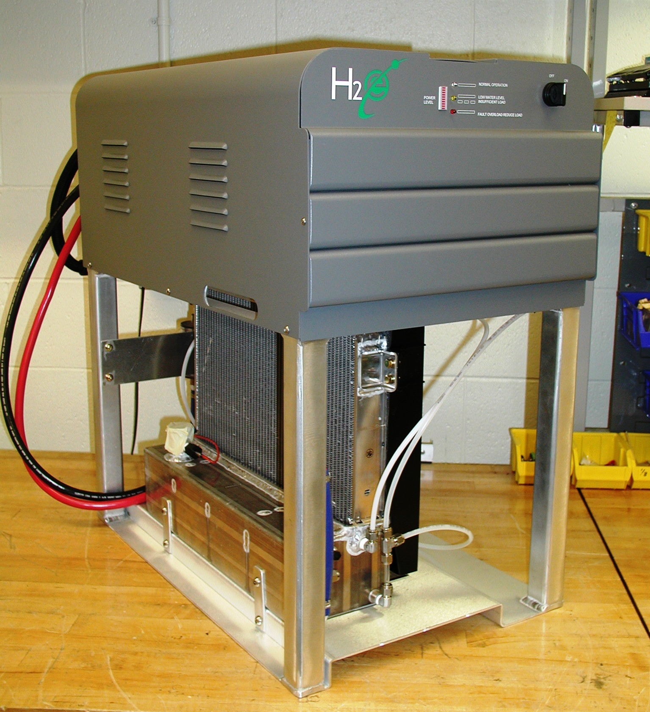
Radiator
Figure 1: Fuel cell as received in its factory condition. (front)

Filters
Water Pump
Exhaust

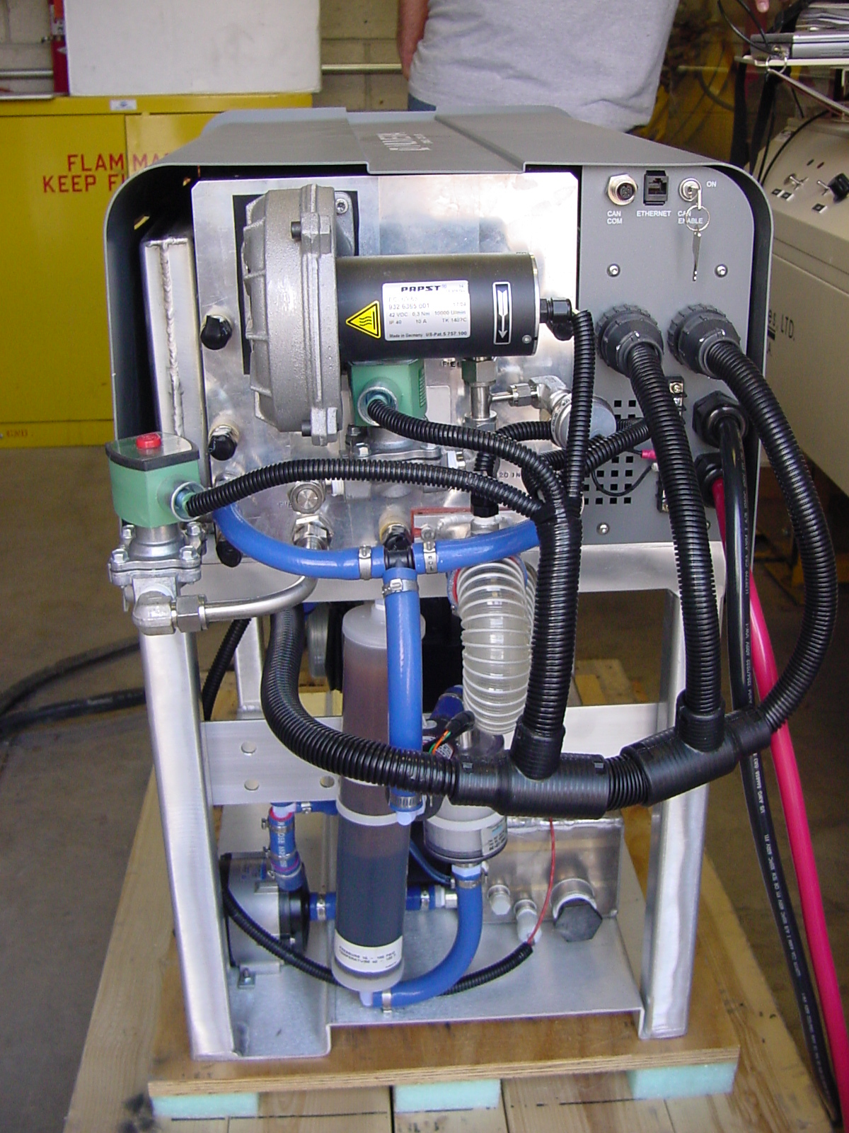
Figure 2: Original fuel cell configuration. (rear)

- Fuel Cell Modifications
Despite the structural modifications made to the vehicle, the height of the FC unit in its factory configuration was larger than what could be efficiently integrated into the vehicle. The thermal management components were reconfigured such that the radiator and water filters are at the level of the PEM stack. Ensuring that the FC system could exhaust water and water vapor without back flow into the stack was preserved by the addition of an accumulator on the rear of the FC. Exhaust water vapor and water from the FC stack are separated and routed to the top of the original radiator and into the water reservoir, respectively. The modified thermal management system is shown in schematic form in Figure 3.

Cooling Coil
Fan
Cooling Water
Hot Vapor, Water,
and Air
Inlet Air
Reservoir
Pump
Hot Water
Accumulator
Hot Vapor
Fuel Cell
Filters
Rejected Heat
Exhaust
Radiator
Overflow
Figure 3: Modified thermal management system (arrows denote flow directions)

The radiator is cooled via a variable speed fan that is controlled by the FC electronics. Fan speed is increased as exhaust temperature increases. As illustrated in Figure 3, a secondary radiator was added to the system between the pump and the water filters. In the factory configuration, the FC did not require this element, as adequate cooling of the water and water vapor produced by the stack was accomplished with the gravity fed radiator. However the addition of the accumulator increases the temperature of the water in the reservoir, so additional cooling of the recirculation water is needed. This increased recirculation water temperature has the potential to adversely affect stack performance. Subsequent testing involving real time data acquisition readings of the system parameters demonstrates the added coil provides the additional cooling needed.

- Vehicle Structural Modifications
The factory configuration of the vehicle bed frame was such that the bed frame as well as existing components welded to the frame would not accommodate the FC in a spatially efficient fashion. It was determined that the forward most section of the vehicle bed frame was the optimal location, as it minimized distance from the FC to the fuel tanks, and likewise simplified fuel system plumbing. Additional modifications to the vehicle bed frame were necessary in order for it to accept the FC, as the existing configuration of the bed frame structural members did not allow the needed room for the FC. These members were replaced by new ones that provided the necessary space.
Replacement of the original structural members increased the plan form area available for the FC, but the height of the FC required modification of the vehicle bed frame and subsequent reconfiguration of the FC thermal management and water recirculation components. The height of the bed frame was increased by installing sections of four inch square box beam between the vehicle frame and the bed frame, as pictured in Figure 4. Both the rising elements and the replacement structural members were bolted to the frame as to simplify any possible future changes made to the implemented design.

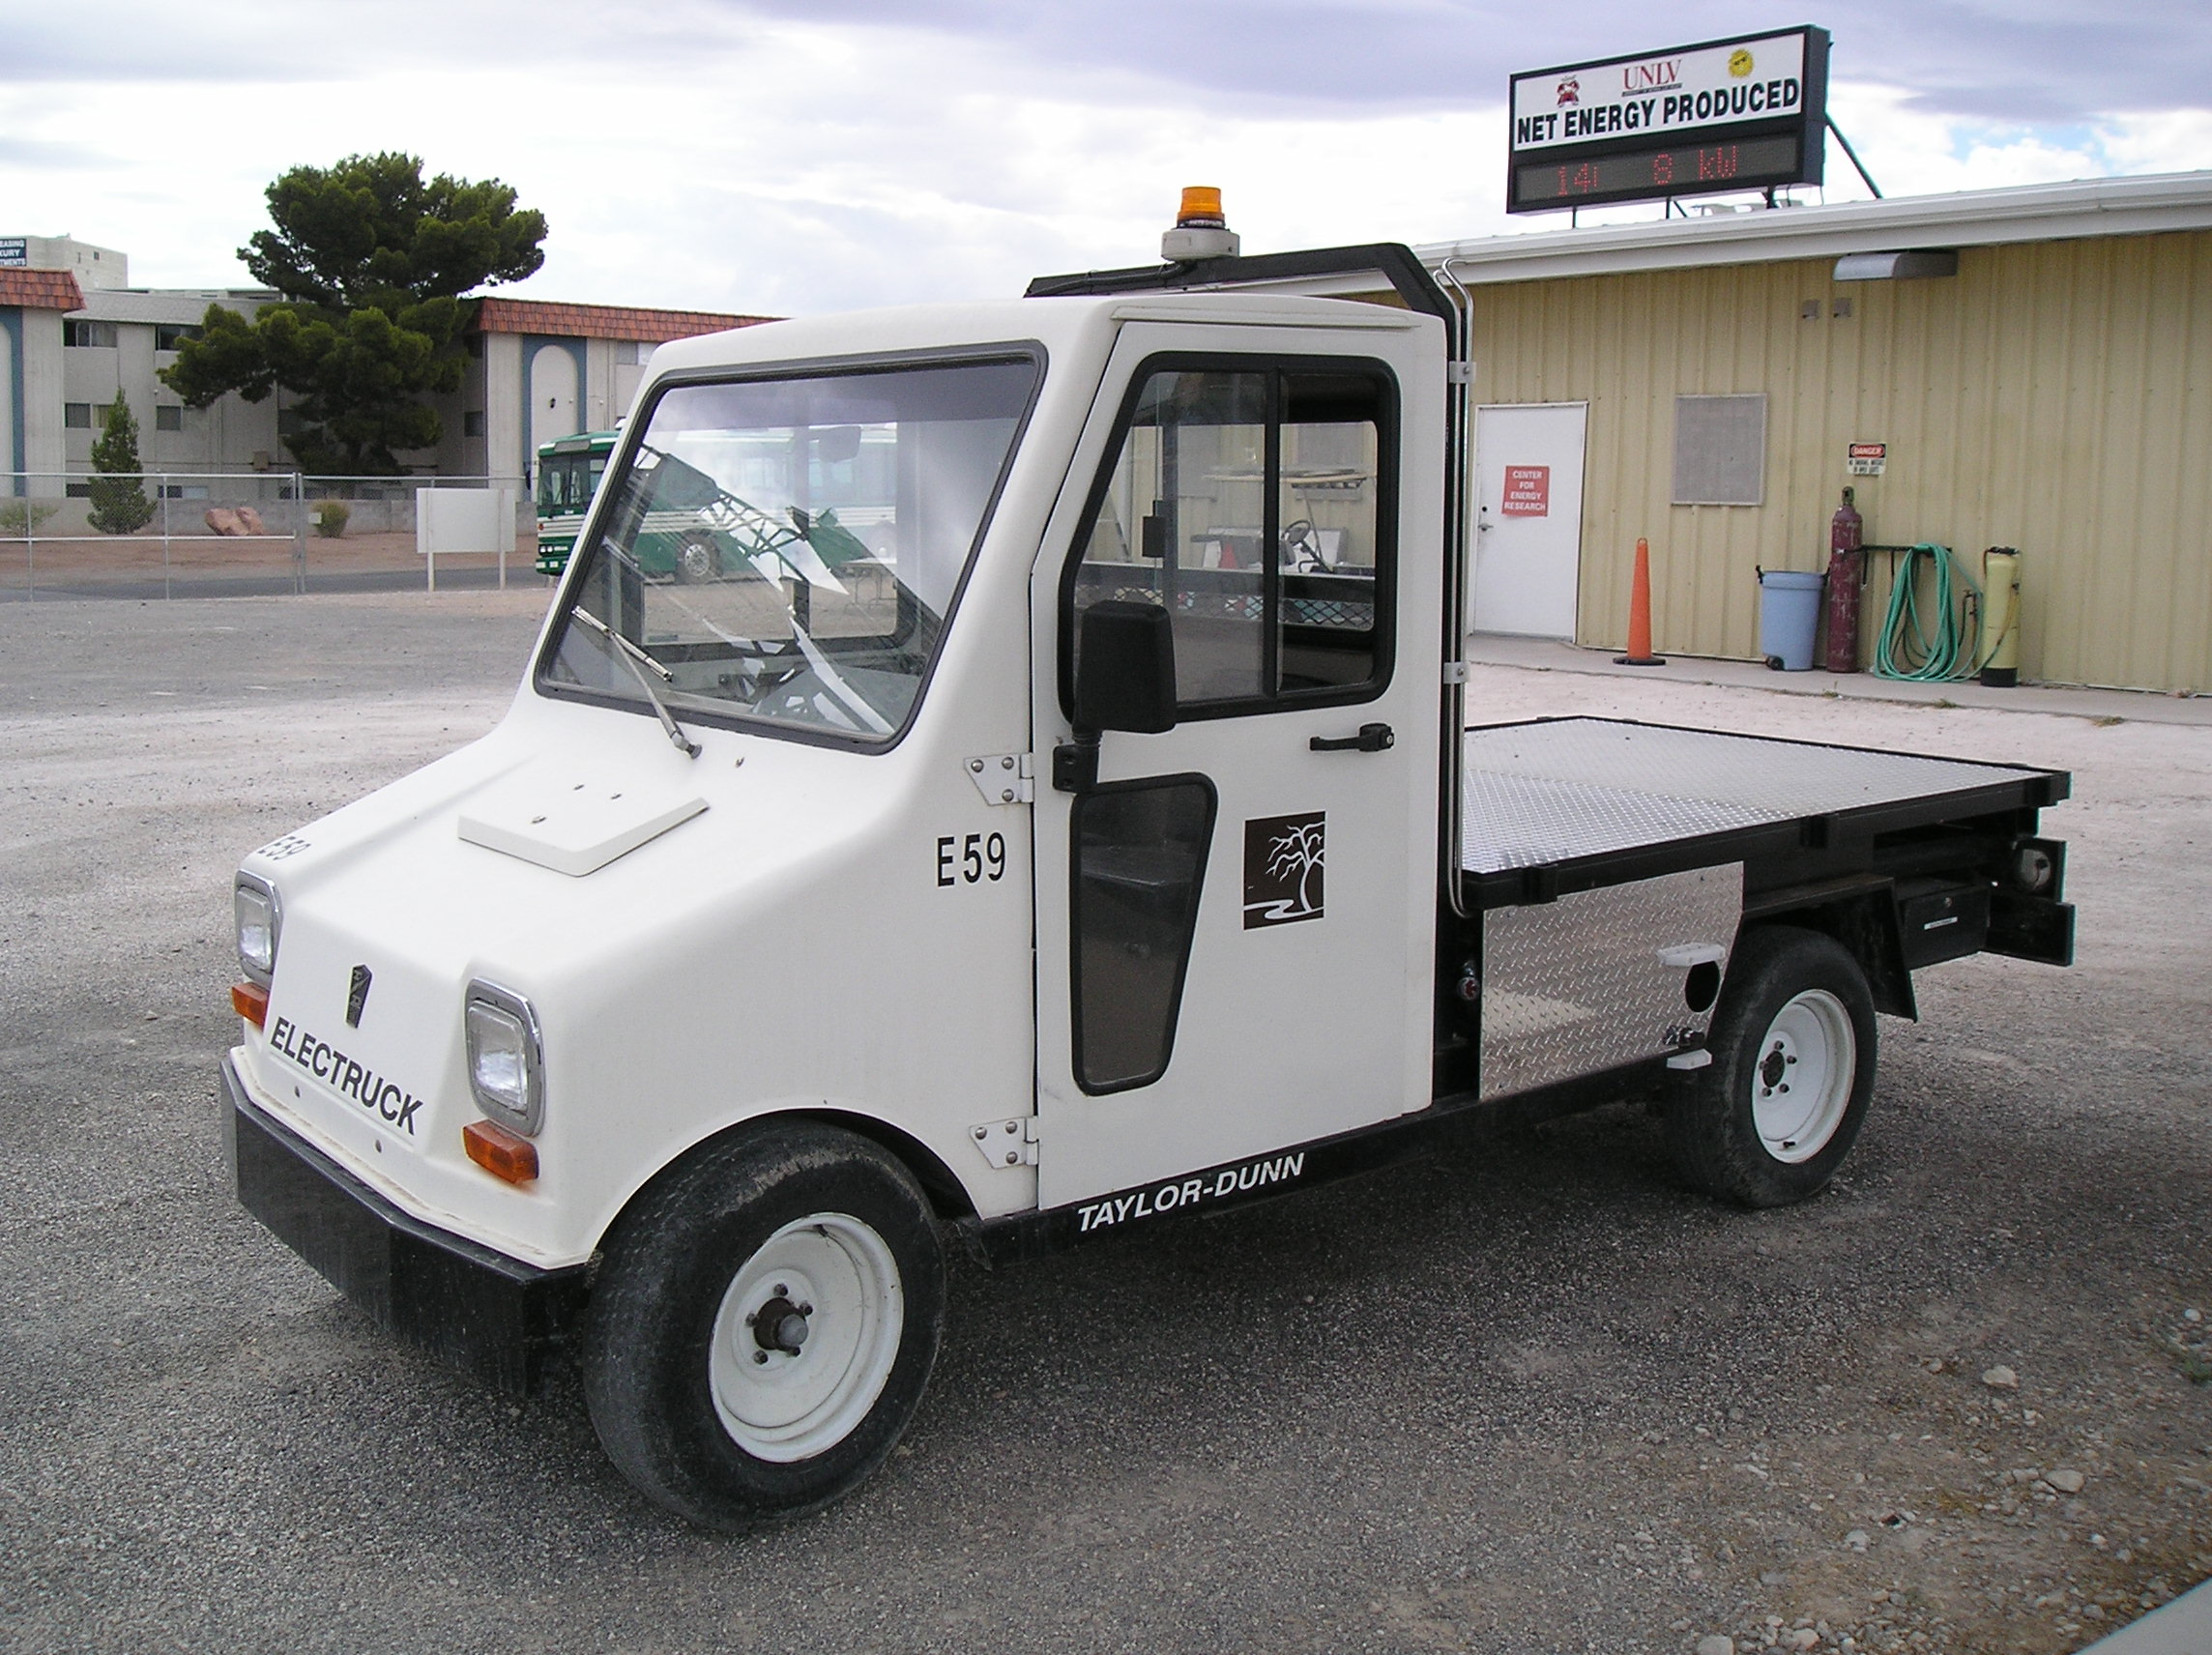
Figure 4: Profile view of vehicle with rising elements installed in forward, middle and aft sections of the vehicle frame.

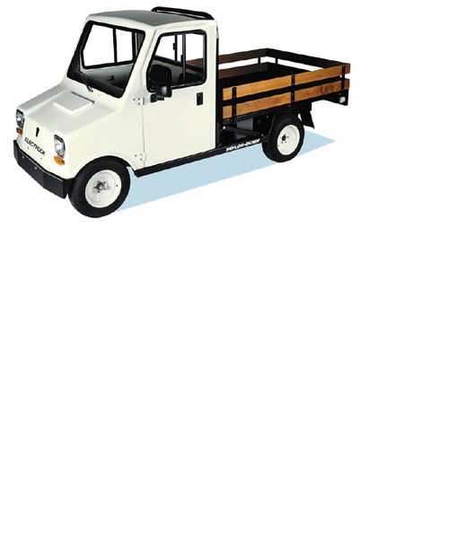
Figure 5: Vehicle without rising elements in place (shown here with bed rails installed).

- Hydrogen Plumbing
The hydrogen fuel for the FC is stored in two 5000 psig, 26 Liter (water volume) tanks produced by Dynetek. Each of the tank manifolds is a Teleflex model TV-115. Each of the tank manifolds has an in-tank solenoid valve with an integral check valve for filling. Also included as integral to the manifold is a pressure relief device (PRD) that releases the compressed hydrogen gas in the event of overpressure or fire. This device is single use and is common to tanks certified for the transport of hydrogen. The tanks are connected in series and are filled through an OPW L5000 filling nozzle. The basic functions of this nozzle are to prevent back flow out of the fuel system by means of an integral check valve, and to provide a means on which to fasten the fueling receptacle during fueling that is compatible with refueling receptacles installed on the grounds of the LVVWD. All tube fittings and tubing in the fuel system have pressure ratings that meet or exceed the rated tank pressure. The length of the high pressure pipe between the fill nozzle, tanks, and regulators is reduced to minimize the volume of hydrogen that can escape in the event of an accident or fitting failure.
A variety of valves are employed that provide various levels of isolation for servicing, safety and component protection against over pressure. Following the flow of hydrogen through the filling nozzle and ending at the fuel cell, the first of these valves is a redundant check valve. This check valve prevents flow out of the hydrogen tanks in the event of fill nozzle failure. A manual valve is installed between the check valve and the first tank to provide a means for manually isolating the fill nozzle from the high pressure fuel system. An intermediate fill valve was installed in the high pressure transfer line between the two tanks for preliminary pressure testing with nitrogen to a pressure of 5500 psig. The hydrogen flowing from the tanks to the fuel cell passes through a series of two regulators that decrease the pressure from 5000 psig to 15 psig. Figure 6 illustrates the use of high and low pressure vent lines as well as the use of a pressure relief valve (PRV). The PRV provides protection to the fuel cell in the event of regulator failure, as exposing the PEMFC stack to the full tank pressure would cause severe damage. The PRV is set to release gases above pressures of 25 psig. Its vent line is shared with the low pressure purge/ service valve, which is normally at atmospheric pressure. The orientation of the vent lines in the system follow safety protocols that are discussed in the section on safety measures. The high pressure vent line in Figure 6 is connected to the outlet of the previously mentioned PRD.

Fill Nozzle
Isolation
Valve
Low Pressure Vent
Fuel Cell Shutoff Valve
Low
Pressure
Vent
Valve
2nd Stage Regulator
1st Stage Regulator
Pressure Transducer
Cylinder Fill Line
Tank 2
Tank 1
High Pressure Relief Vent
Fuel Cell
Pressure
Relief
Valve
Fill Nozzle
Un-pressurized Line
Low Pressure Line (15 psi)
High Pressure Line (5000 psi)
Figure 6: Hydrogen fuel plumbing schematic.

- Electrical System
  - Power Electrical
Energy storage on the vehicle was originally accomplished via a bank of 12 6VDC deep cycle batteries. As part of the vehicle modifications necessary to accommodate the FC, these 12 batteries were removed and replaced with 6 12VDC deep cycle batteries, thus preserving the 72VDC required by the motor. The space provided by eliminating those batteries is occupied by the FC and its fuel system. A DC to DC converter integral to the FC produces a 48VDC voltage, and an external DC to DC converter is used to increase this voltage to 72VDC. Two shunt resistors are installed in the system that allow for data collection on power demand.

  - Control Electrical
To automate the fuel cell operation a control system was added that sequences the fuel cell during startup and shut down. A series of thermally activated relays sequence startup and shutdown of the FC. This reduces the load on the control electronics during startup and allows the FC to purge any remaining power from the stack. Figures 7 and 8 are flow charts describing the startup and shutdown sequences. The control system is given in schematic form in Figure 9. Additional power control elements were installed to control the load sharing between the FC and the battery bank. The load sharing is configured such that most of the demand is met by the battery bank. The FC assists with power demand while the vehicle is moving and charges the battery bank while the vehicle is at rest.

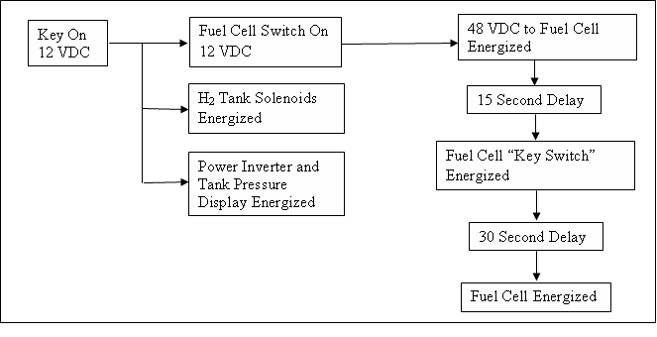
Figure 7: Start-up sequence for the fuel cell system. Due to the nature of the thermal timers used delay times are approximate.

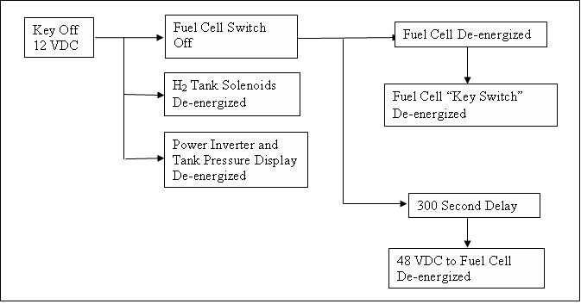
Figure 8: Shut down sequence for the fuel cell system

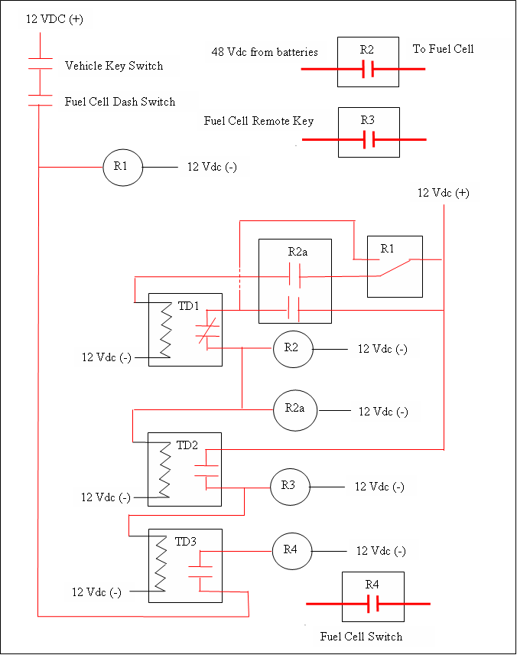
Figure 9: Fuel cell control sequence schematic.

- Future Work
Future work on this vehicle will include installation of a regenerative braking system. This braking system will consist of a three phase AC motor equipped with a dual function speed controller. The speed controller functions as an inverter when the vehicle is moving, converting the DC battery bank and FC power to AC power, and acts as a rectifier when the vehicle is braking, using the motor as an AC generator and the speed controller as a rectifier, converting the AC motor power to a DC power source fed to the battery bank. Also included in future work will be thermal performance evaluation performed on two radiators in the water recirculation system correlated with power output of the FC and power demand from the motor and other electrical loads.

Julian Gardner is an MS student in mechanical engineering at UNLV, and he was involved with the conversion of this vehicle from the initiation of the project.

